Mycotoxins and the occurance of mastitis and laminitis
Process Management
- research
- mycotoxins
419 0

Since their first discovery, more than 200 different trichothecenes (type A e.g., T-2 toxin and type B e.g., deoxynivalenol) have been documented. Even though dairy cows have some capacity to protect themselves against the harmful effects of mycotoxins, these substance are still a menace to ruminants.
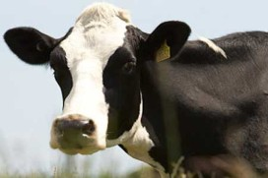
As feed passes more quickly through the rumen of modern dairy cows due to higher feed intake, rumen microbes have less time to detoxify mycotoxins. The combined factors of intensive farming of dairy cattle, incompetent rumen microflora action, nutritional imbalance and mycotoxins in the feed are key factors that allow mycotoxins to escape detoxification and be absorbed by the intestine.
The occurrence of mycotoxins in feed is very often connected to increased incidences of metabolic disorders such as ketosis, retained placentas, displaced abomasum, mastitis, metritis, lameness, elevated somatic cell counts and consequently, slight decreases in milk production. Subclinical mycotoxicoses decrease profitability by lowering milk production and quality while increasing expenses from inappropriate veterinary therapies. The presence of T-2 toxin in cattle feed can result in gastroenteritis and intestinal hemorrhages. T-2 toxin has also been related to feed refusal, gastrointestinal lesions, bloody diarrhea, low feed consumption and decreased milk production.
The impact of deoxynivalenol in dairy cattle is controversial, but data have shown an association between deoxynivalenol intake and poor performance. Besides the effects mentioned above, trichothecenes are also known to trigger metabolic disorders. Exposure to deoxynivalenol can increase inflammatory reactions in the form of mastitis and laminitis. In addition, it was observed that deoxynivalenol may also reduce phagocytic and neutrophil activity, leading to severe symptoms such as the occurrence of mastitis and lameness. Accurate feeding of dairy cows in combination with continuous mycotoxin risk management is the key to managing the optimal performance of the livestock business
http://www.allaboutfeed.net/Process-Management/Feed-Safety/2012/12/Mycotoxins-and-the-occurance-of-mastitis-and-laminitis-1123945W/?cmpid=NLC|AllAboutFeed.net|14-dec-2012|Mycotoxins%20and%20the%20occurance%20of%20mastitis%20and%20laminitis

Counteracting mycotoxin related problems in animals
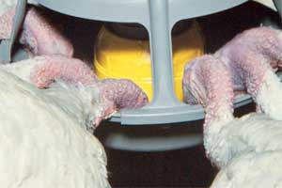Mycotoxins cause a risk for animal health and performance, the management and control of mycotoxins is therefore essential to reduce these harmful effects. Due to the variety of mycotoxin contamination often occurring in animals diets, the negative effects can differ. This requires a multifactorial approach to counteract the impact of these mycotoxins.
By Monique Baecke, mycotoxin specialist, Nutriad, Belgium
It has been estimated that some 25% of the world’s grain crops are affected annually by fungal invasion and mycotoxin contamination. In time of drought, flooding and other natural disasters causing different climatic conditions, mycotoxins are likely to be more prevalent. Consumption of a mycotoxin contaminated diet may result in acute, overt mycotoxicosis with high morbidity and death or chronic disorders which affect production performance. Mycotoxin contamination levels in animal diets are most of the time not high enough to cause acute overt mycotoxicosis but may result in economic loss due to clinically obscure changes in growth, production and immunosuppression. These effects are often difficult to recognise (a hidden threat) because symptoms are associated with infection rather than with the mycotoxin that predisposed the animal to infection; making diagnosis of a mycotoxin related problem difficult and creating unawareness.
Mycotoxin management
Mycotoxins cause a risk for animal health and performance, the management and control of mycotoxins is therefore essential to reduce these harmful effects. Two different approaches are effective solutions to achieve this; monitoring of prevalence of mycotoxins and elimination of mycotoxins in animals diets.
The Toxitest is a unique mycotoxin monitoring tool, developed by Nutriad to provide a quick assessment of mycotoxin contamination in cereals and complete feeds. Nutriad has been on a regular basis since 2007 performing mycotoxin analysis for its worldwide customers to give them insight in the mycotoxin prevalence of their cereals and complete feeds and provide them with cost-efficient solutions to counteract the risk of mycotoxins. Figure 1 shows the results of the Toxitest performed in 2011 from different countries in Europe, Turkey and the CIS countries. A total of 281 samples were analysed on the major mycotoxins: aflatoxins, fumonisins, ochratoxin A, T-2 toxin, deoxynivalenol and zearalenone. The graph shows the percentage positive samples for the different mycotoxins in the diverse commodities.
Detoxification strategies
Diverse extensive surveys and results from Nutriad’s Toxitest show that mycotoxin contamination is significantly present. Not one of the cereals and complete feeds is free from the risk of mycotoxin prevalence. To prevent negative effects of these mycotoxins, successful detoxification strategies are needed. Many approaches have been used to reduce the toxicity of mycotoxin contaminated cereals and complete feeds. The most prevalent method is the addition of a mycotoxin inactivator into the contaminated commodity. However, most methods have been tested on a limited number of specific toxins. Contaminated cereals and feeds are very often contaminated with a number of mycotoxins.
Due to the complexity of all these different mycotoxins, no single strategy has proven completely successful in degrading or removing toxins. Therefore it is desirable that mycotoxin inactivators have broad substrate inactivation capabilities to reduce the toxin’s bioavailability in the gastrointestinal tract and prevent their negative effects in animals. Unike Plus, part of a wider range of products, is such a multifunctional mycotoxin inactivator and is composed out of different components which present a complete solution to counteract a broad range of mycotoxins. The individual components together result in a multifunctional approach to counteract the challenges of mycotoxins and their negative impact on the health and performance of animals by a two way mode of action:
• Detoxification of the mycotoxins
- Adsorption and biotransformation of mycotoxins
• Supporting animal health
- Optimising organs function, boosting immune response, preventing oxidative stress.
Efficacy in animal diets
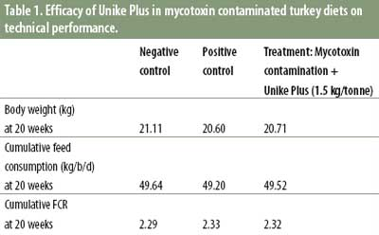Throughout the years several successful in vivo trials have been done with Unike Plus. One of these trials was conducted with mycotoxin contaminated diets in turkeys. The aim of that trial was to evaluate the efficacy of this multi mycotoxin inactivator in turkeys fed mycotoxin contaminated diets. In this trial 216 hybrid large white tom turkey poults were raised to 20 weeks of age in 12 pens with each 12 poults per pen.
There were three treatment groups:
• Negative control: mycotoxin free diets, no inclusion of Unike Plus
• Positive control: mycotoxin contamination
• Treatment: mycotoxin contamination + Unike Plus (1.5 kg/tonne).
Diets with natural deoxynivalenol (0.6-5 ppm) and aflatoxins (26-164 ppb) contamination were fed to the turkeys during the trial period. The efficacy of Unike Plus was evaluated by means of the performance data and physiological parameters.
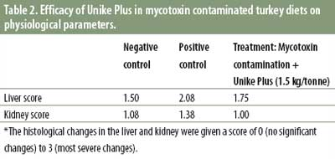The results in Table 1 and Table 2 show that mycotoxins negatively affected the performance and organ status of turkeys. The turkeys fed the mycotoxin contaminated diets (positive control) showed a decreased body weight, feed consumption and increased FCR compared to the negative control group. Also the organ status was negatively affected in the group fed the mycotoxin contaminated diets, the histological changes in liver and kidney were higher in this group compared to the negative control. Inclusion of Unike Plus in the turkey diets improved performance parameters and established a recovery of organ status. Based on the results of the trial it can be concluded that Unike Plus is an efficacious mycotoxin inactivator to protect turkeys against the negative effects of mycotoxins.
References are available upon request.

Mycotoxins and DDGS – Should you worry?
Several mycotoxins can potentially be found in corn. However, the occurrence is dependent on unique environmental conditions that support the growth of specific fungi (moulds) that produce mycotoxins during plant growth. Luckily, mycotoxin contamination of corn is not an annual event throughout the United States.
By Heather Dann, William H. Miner Agricultural Research Institute, New York, USA
When corn is used to make ethanol, about two thirds of the grain in the form of starch is fermented by yeast to make ethanol. The remaining corn co-product is distiller’s dried grains with solubles (DDGS). When mycotoxincontaminated corn is used, mycotoxins will not be found in the ethanol but will be found in the DDGS at a higher concentration than what was found in the contaminated corn before fermentation. In general, the mycotoxin concentration in DDGS will be 3 to 3.5 times more than the concentration in the corn.
During 2009 to 2011, DDGS samples were collected from eight ethanol plants in the Midwest and analysed for mycotoxins. The 2009 growing season had environmental conditions that were favourable for the occurrence of mycotoxins. Key findings for five types of mycotoxins are summarised below.
Aflatoxins (B1, B2, G1, and G2)
• Produced by Aspergillus flavus.
• Corn is susceptible to aflatoxin formation during growth under drought conditions or in high moisture storage.
• Not detected in most DDGS samples collected after 2009.
• Highest level in DDGS was <6 ug/kg which is well below the FDA action level.
Deoxynivalenol (DON)
• Produced by Fusarium graminearum.
• Corn is susceptible to F. Graminearum growth when old infested residue from the previous growing season is left in the field and the environment is cold and moist.
• Detected in every DDGS sample with a range of 0.3 to 12.3 mg/kg.
• 12% of DDGS samples had a deoxynivalenol level higher than the FDA action level.
Fumonisins (B1, B2, and B3)
• Produced by Fusarium verticillioides.
• Environmental conditions necessary for the production of fumonisins are unknown.
• Detected in almost all DDGS samples with a range of not detected to 8.9 mg/kg.
• 6% of DDGS samples had a fumonisins level higher than the FDA action level.
T-2
• Produced by Fusarium sporotrichioides.
• Corn is susceptible to T-2 production when the humidity is increased with temperatures between 43 and 75°F (6-24°C).
• Not detected in DDGS samples.
Zearalenone (ZON)
• Produced by Fusarium graminearum.
• Corn is susceptible to Zearalenone when the growing conditions are moist and cool or the storage conditions are moist (>14% moisture).
• Detected in most DDGS samples with a range of not detected to 560 ug/kg.
• There is no FDA action level.
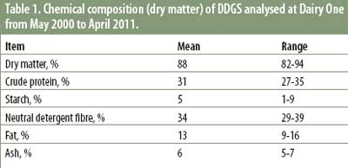Based on the results of the survey, it looks like there is no need to worry about DDGS being a primary source of mycotoxins under normal growth conditions. DDGS is a great feedstuff to use to provide protein, in particular rumen undegradable protein, to cows when the price is right.
* Reference: Y. Zhang and J. Caupert, 2012. Survey of mycotoxins in US distiller’s dried grains with solubles from 2009 to 2011. Journal of Agricultural and Food Chemistry 60:539-543.
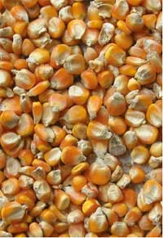
When corn is used for biofuel, moulds or mycotoxins in corn end up in a more concentrated form in the ethanol co-product DDGS.

Evaluating anti- mycotoxin additives in feed
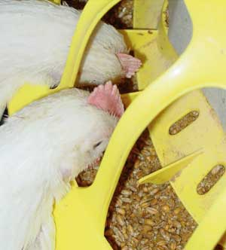The effectiveness of an anti-mycotoxin additive cannot be based only on in vitro trials anymore; it has to be evaluated by conducting in vivo tests using a scientific experimental design measuring the beneficial effects of the product on target organ protection and animal performance.
By Douglas Zaviezo, Special Nutrients, Miami, Fl, USA
Practical methods to detoxify grain or feed contaminated with mycotoxins on a large scale and in a cost-effective manner are not currently available. At present, one of the most practical approaches consists of using adsorbent materials in animal diets to reduce the absorption of mycotoxins from the gastrointestinal tract. Clays are an important group of products that have been used successfully worldwide to reduce mycotoxicosis; and all commercial anti-mycotoxin additives available in the market are clay based products.
Clays
Clays are complex and widely diverse aluminosilicates with a variety of functional properties, but they are often grouped into a single category. This is very misleading since there are many types of clays, which are completely different from one another. Many types of clays do not capture mycotoxins; some can absorb water, others can absorb ammonia, and only certain clays can adsorb mycotoxins. Not all clays that adsorb mycotoxins are equally effective in protecting animals against their toxic effects. Furthermore, similar clays may vary from one geological deposit to another. It is critical that the origin (deposit) of the clay always be from the same source. Any scientific information obtained from a clay-based product is directly related to its origin and does not apply if there is a change in its geological deposit.
There is no significant correlation between any single physical or chemical property of clays and its mycotoxin binding capacity. Therefore, the effectiveness of any mycotoxin adsorbent (clay or its combination with yeast, enzyme or bacteria) has to be tested, performing in vitro and in vivo evaluations, to demonstrate a statistical significant response that it prevents mycotoxicosis. The dosage of the adsorbent and the level of the mycotoxin used in these tests must always be reported. Also, it is important to demonstrate the lack of nutrient adsorption and the innocuity of the product.
Anti-mycotoxin additives (AMA) evaluation
In vitro tests must be conducted with high performance liquid chromatography (HPLC) using a methodology involving two types of solutions: one with pH 3 and another with pH 6, mimicking the gastric and the intestinal juices.
In vivo testing has a standard experimental protocol consisting of four treatments: a control without mycotoxins; a control with adsorbent; a control with mycotoxin; and one group with mycotoxin plus adsorbent. Additional treatments can be added to this experimental design, such as different testing levels of the adsorbent.
In the in vivo trial, the efficacy of adsorption has to be determined by the animal performance (body weight gain, feed consumption and feed efficiency) and the target organ protection (TOP).
It is important to evaluate the TOP since it reflects the specific damage caused by the mycotoxin. It is also necessary because some adsorbents base their effectiveness on a positive change in performance or reduction of a secondary effect caused by the mycotoxin, which is a result of the presence of enzymes, beneficial bacteria, yeast and/or immuno-stimulant in the composition of those products, and not mycotoxin adsorption.
The relation between in vitro evaluation and in vivo effectiveness cannot always be confirmed. In evaluations done by Dr Mallmann and collaborators in LAMIC on 58 AMA for different toxins and species, little more than 55% of AMA approved in vivo, had an in vitro adsorption greater or equal to 90%. For AMA approved in vivo, more than 50% had an in vitro adsorption less than 70%. There was no significant correlation between in vitro and in vivo evaluations when the data of those 58 in vitro and in vivo evaluations were submitted to a linear regression analysis.
It is evident from this data that the results obtained from in vitro evaluations are not sufficient to prove the efficiency of an AMA. Therefore, statistical satisfactory results from the in vivo test are necessary to determine the efficacy of an AMA and only TOP products can be considered to have real protection.
Clays and their myths
During the last 25 years, various scientific studies have demonstrated that some aluminosilicates are very effective in preventing the damage of the most prevalent mycotoxin of the last century: aflatoxin. Three myths were created during the twentieth century:
- Clays only adsorb aflatoxin,
- High inclusion levels (5-20 kg/tonne) are needed,
- Clays adsorb nutrients.
Today, science has disproven these three myths. There are few products that are also effective against other mycotoxins besides aflatoxin; they work at low dosage; and they do not adsorb nutrients, because they are not expandable clay. Among these, Myco- Ad is exceptional because it has been scientifically proven to have TOP results at 2.5 kg/tonne not only against aflatoxin, in poultry, swine and dairy cows; but also preventing the reduced performance and the organ damages caused by ochratoxin, T-2 toxin and fumonisin in broiler chickens, without adsorption of nutrients.
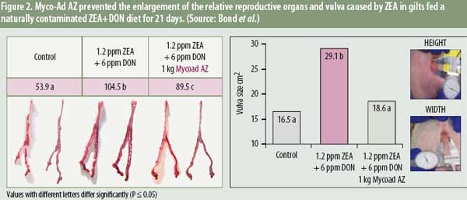
Purified phylosilicates
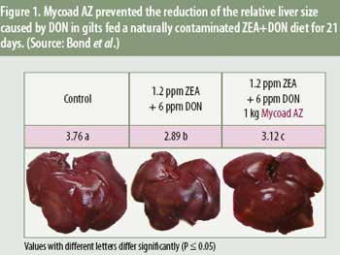Special purified and activated phylosilicate have been developed in recent years. These products are capable at a very low dosage (0.5 to 2.0 kg/tonne) of binding fusariotoxins, the most predominant and difficult to control mycotoxins. Myco-Ad AZ, one of the few purified phylosilicates, has been scientifically proven to have TOP results against fumonisin, deoxynivalenol (Figure 1), and zearalenone (Figure 2) in pigs. Recently, Myco-Ad AZ also has shown to have TOP results against T-2 toxin in broiler chicks at 0.5 kg/tonne, without interfering with nutrient absorption. (Table 1)
