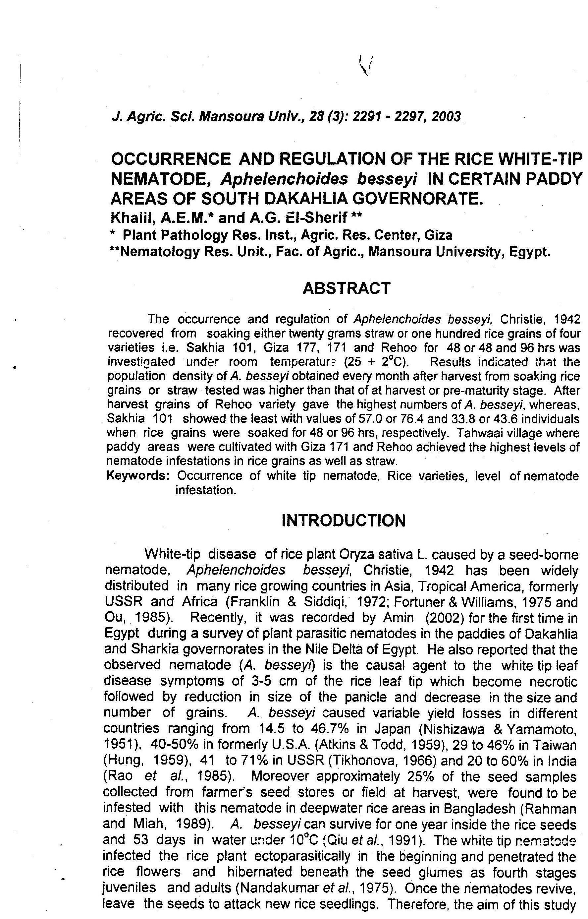

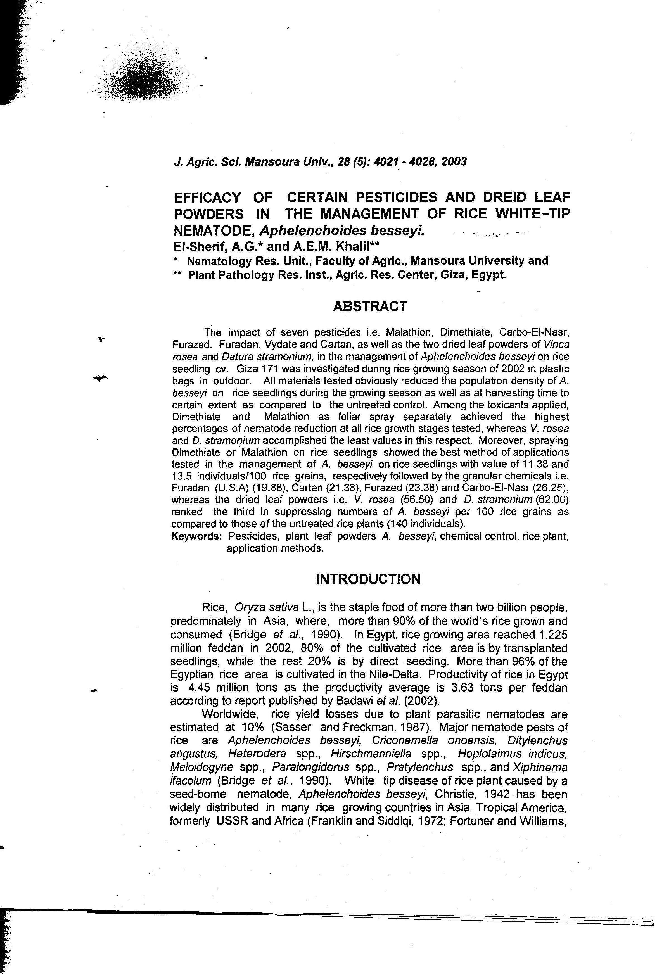

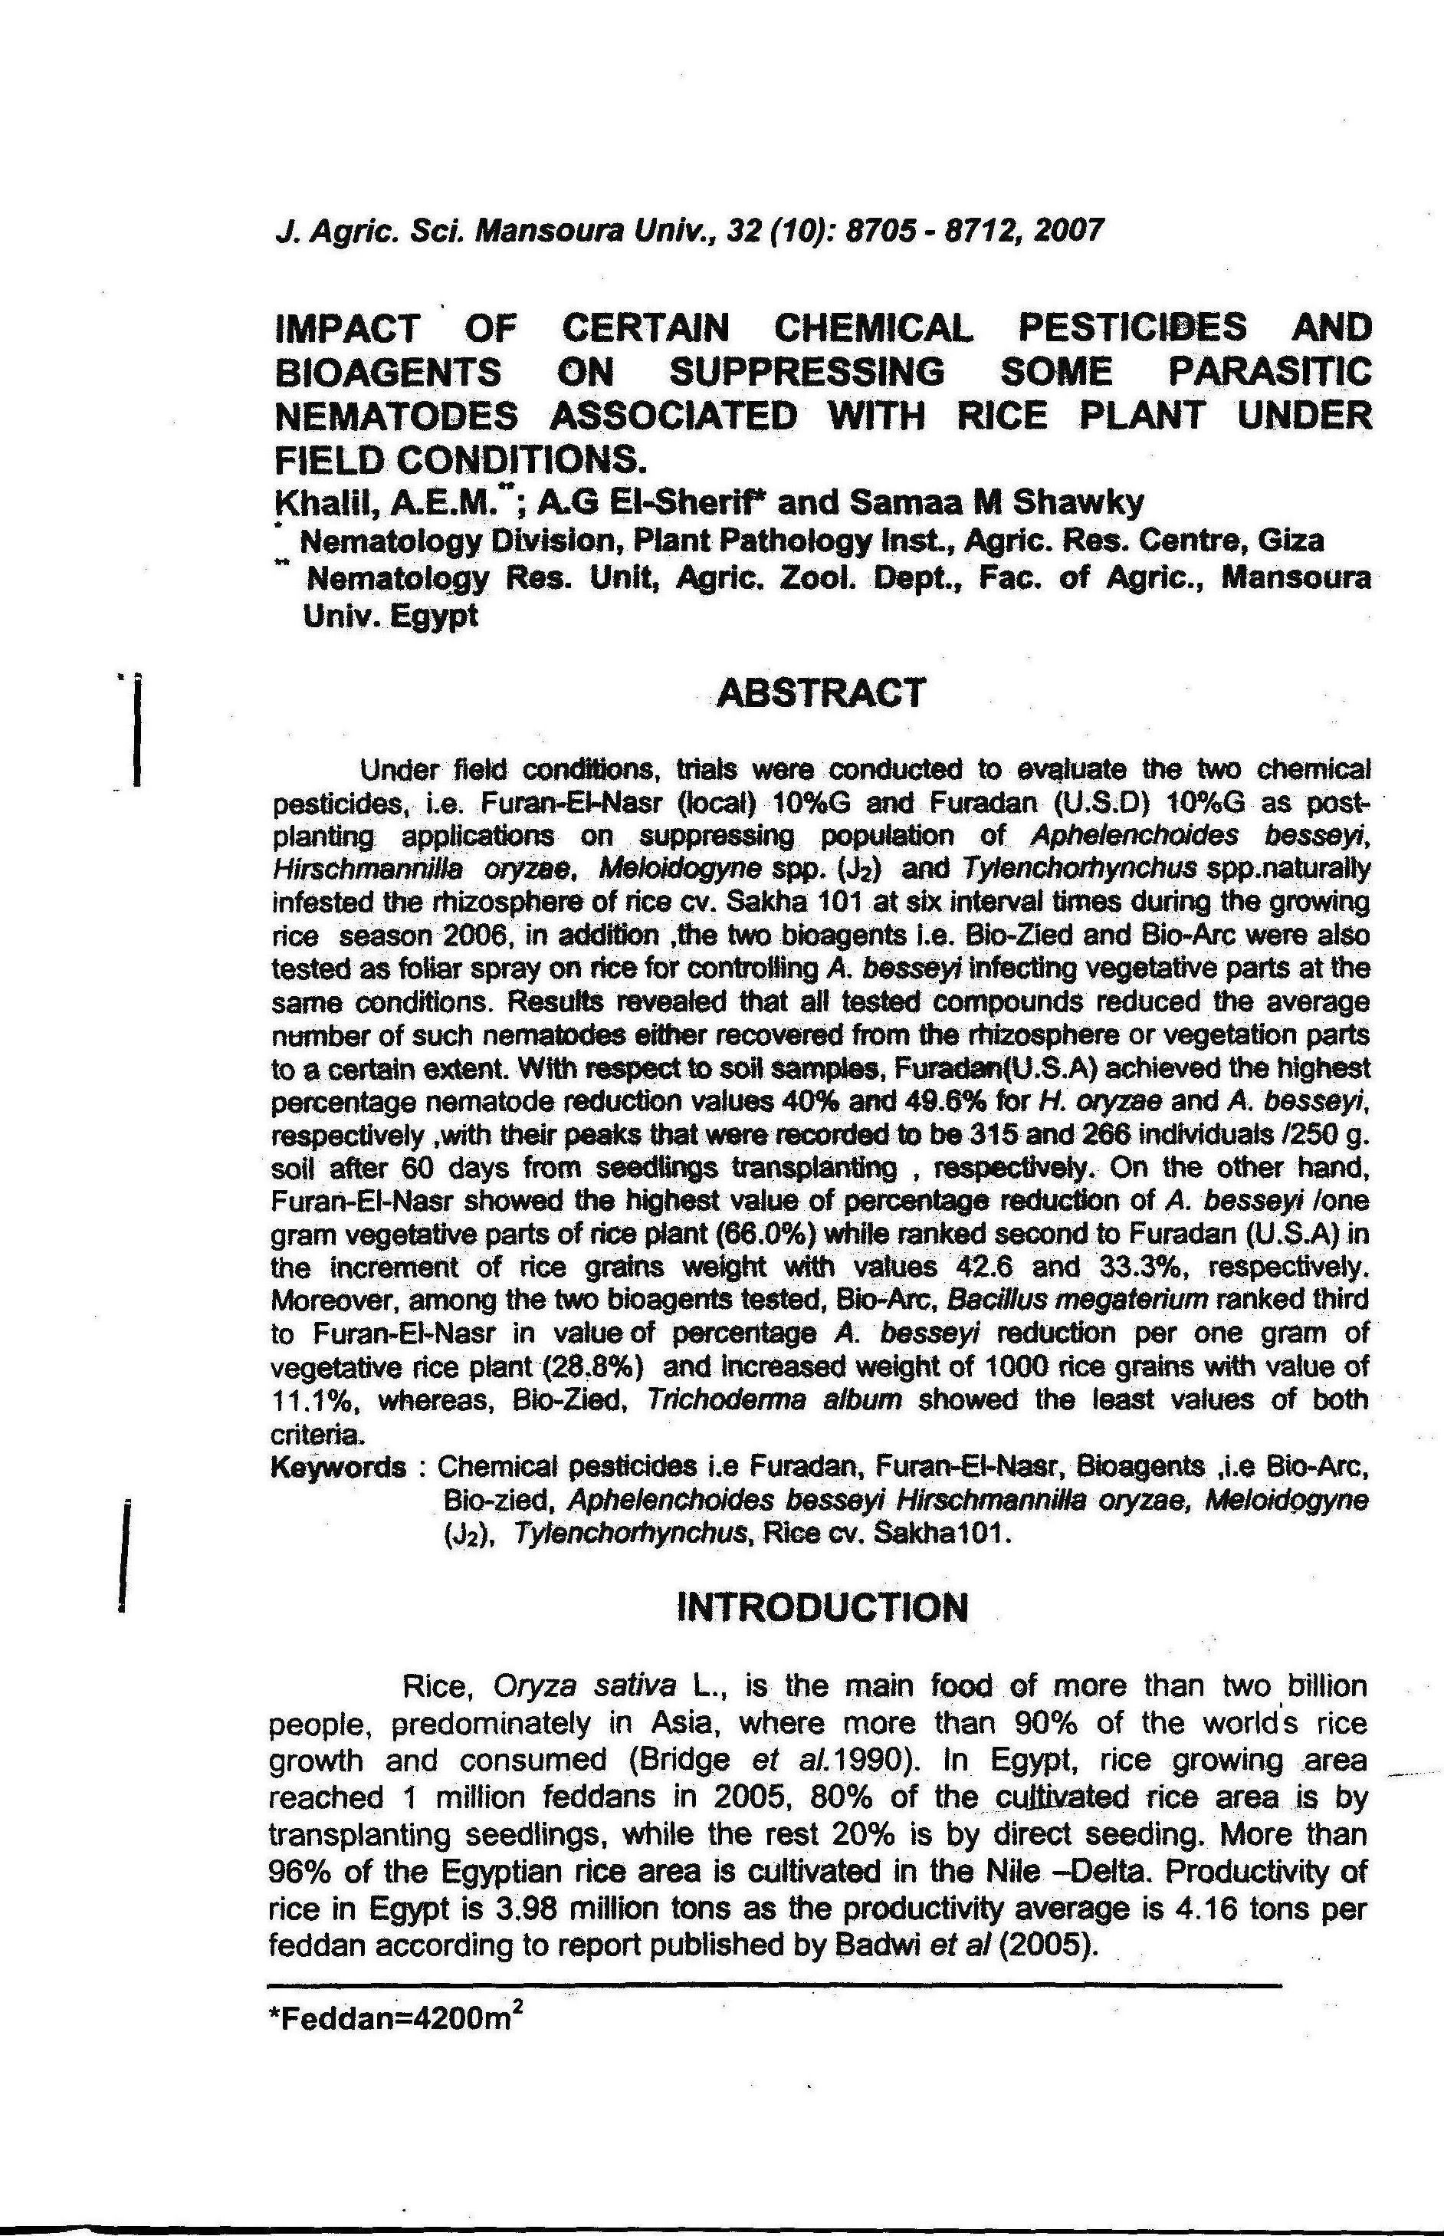

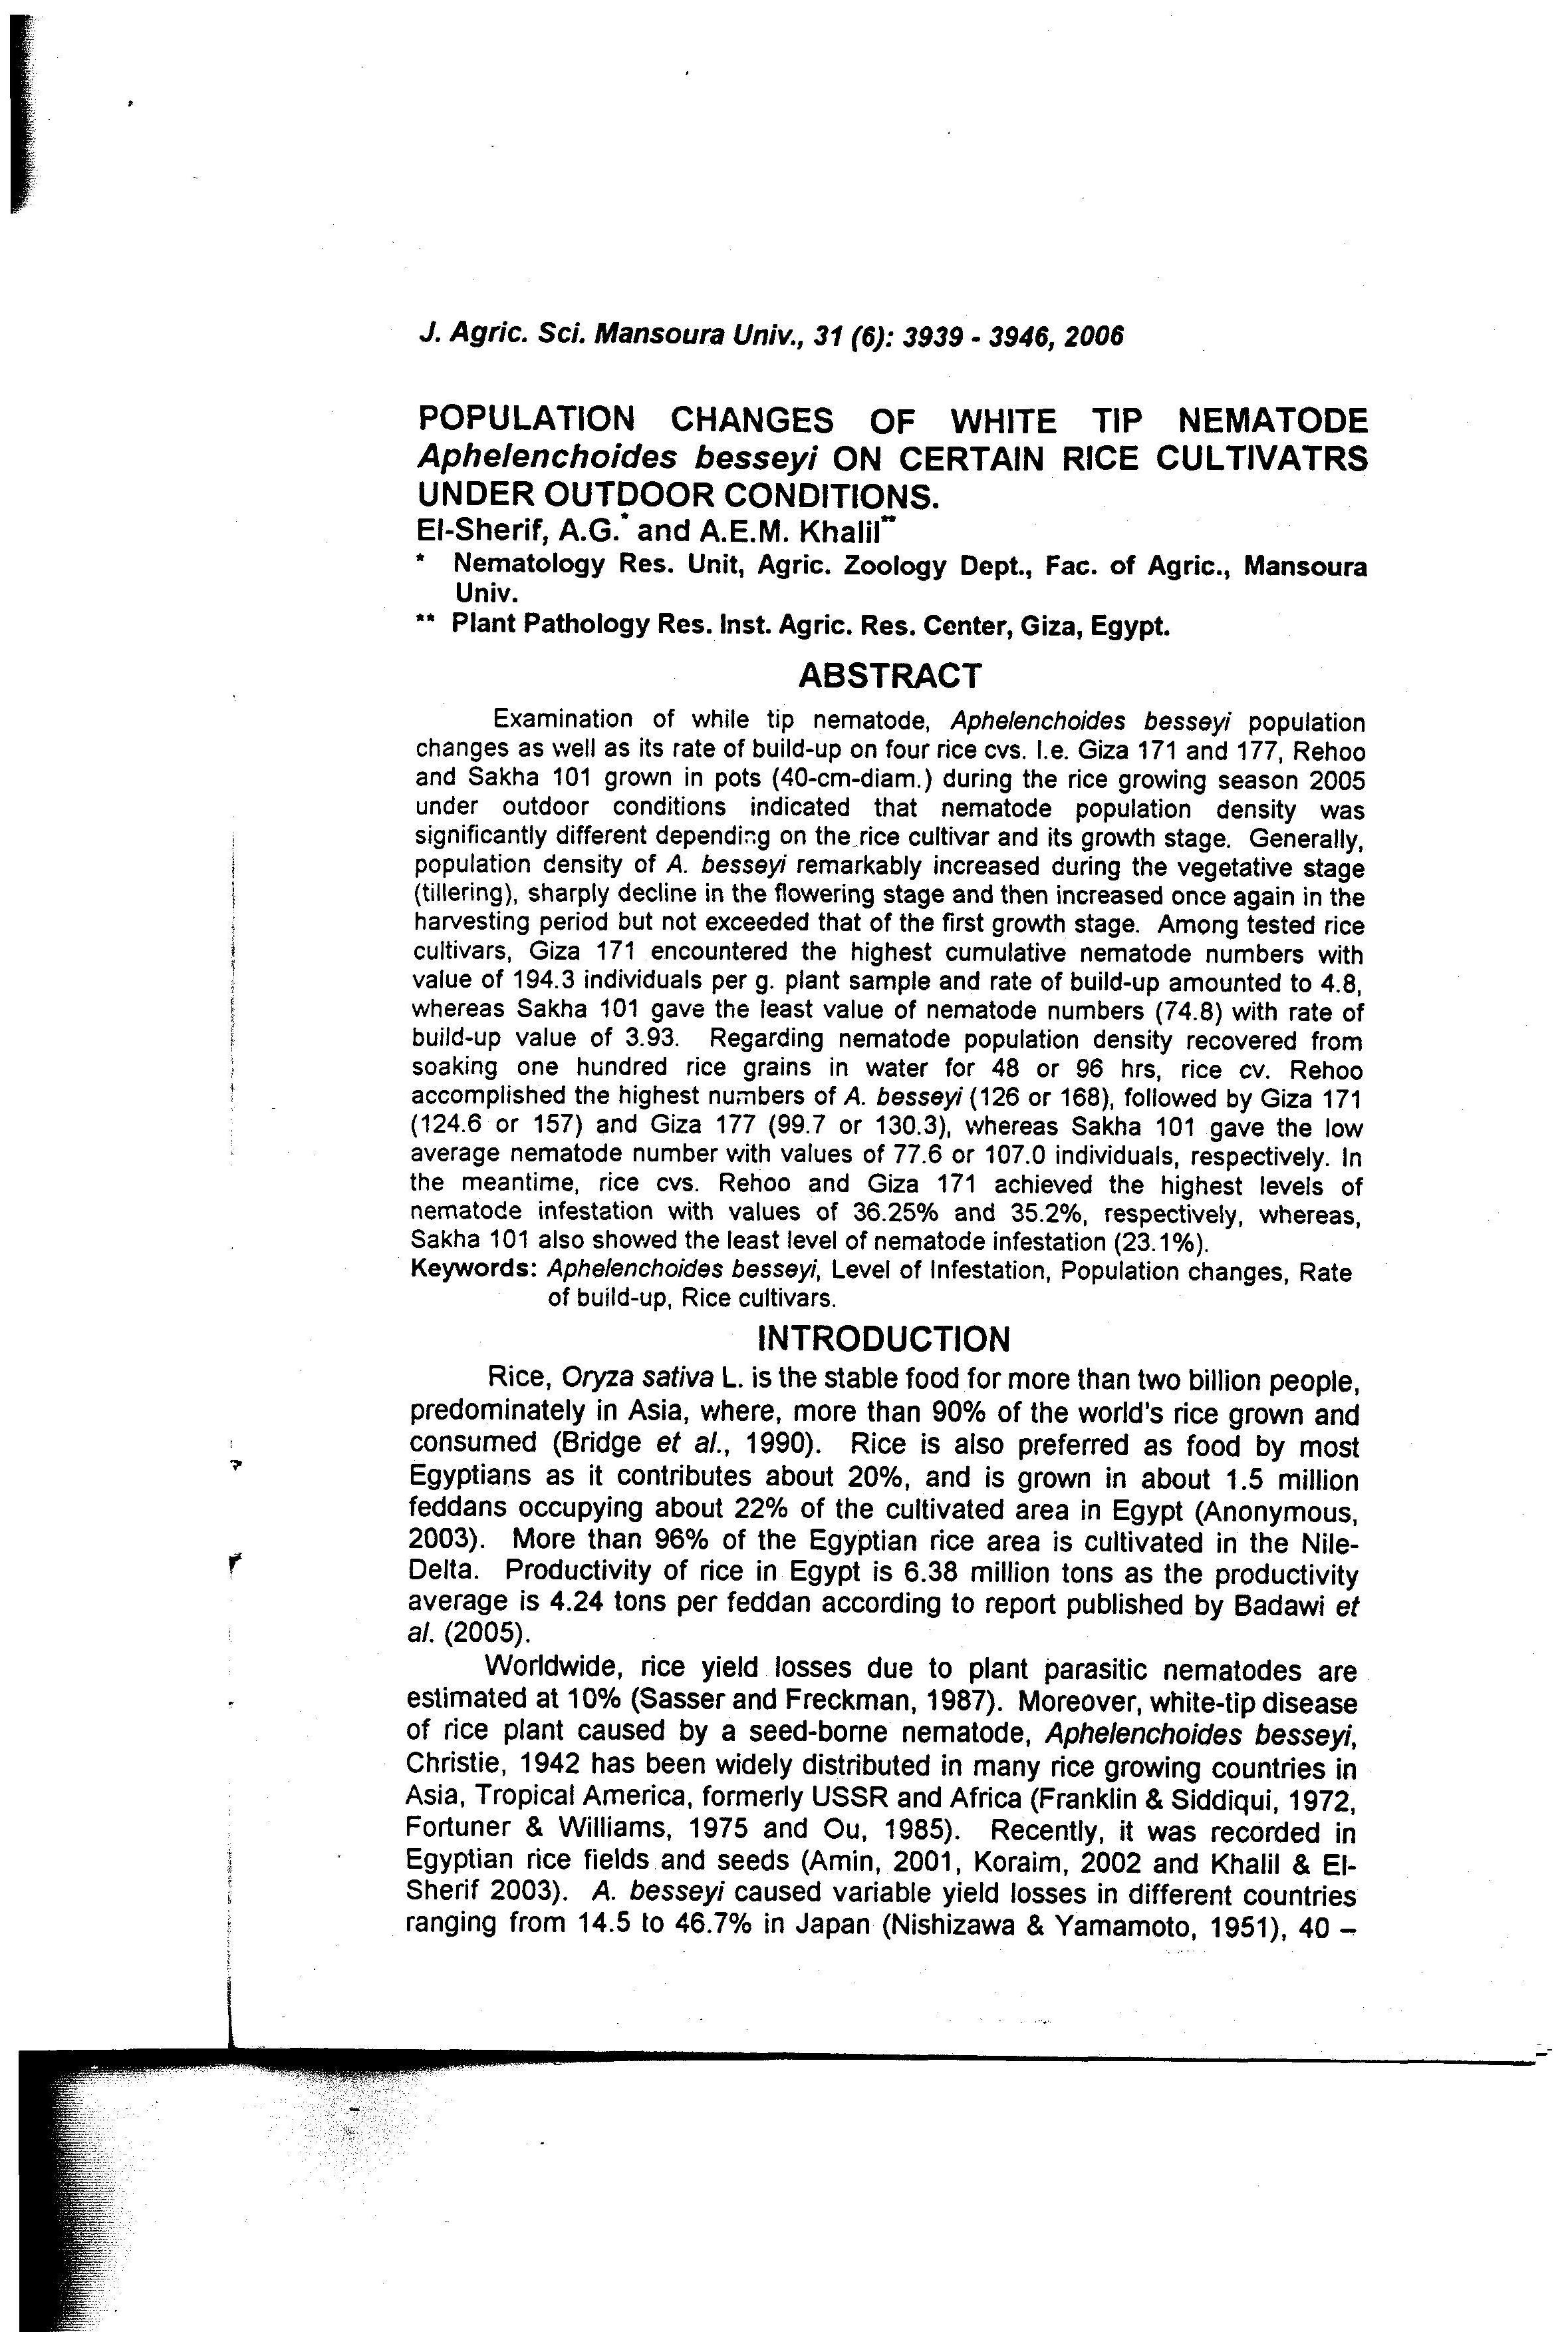

OCCURRENCE OF WHITE-TIP NEMATODE, Aphelenchoides besseyi IN CERTAIN RICE CULTIVATIONS AT SOUTH DAKAHLIA GOVERNORATE, EGYPT AND ITS MANAGEMENT UNDER FIELD CONDITIONS.
El-Sherif, A.G.*; A.E.M. Khalil**; A.F. Refaei* and A.H. Nour El-Deen*
* Nematology Res. Unit, Agric. Zoology Dept., Fac. of Agric., Mansoura Univ.
** Plant Pathology Res. Inst. Agric. Res. Center, Giza, Egypt.
ABSTRACT
Examination of the vegetative stage, as well as panicles at harvest (fresh) and seed samples from farmer’s store (12 months) of rice cvs. Sakha 101 & 103 and Rehio grown in South Dakahlia fields for Aphelenchoides besseyi symptoms on leaves recorded the whitening of the leaf tip for the vegetative stage, and the shortened twisted, chlortic strips along one edge of the leaf for the flowering and harvest stages of the rice cultivars studied. Results also indicated that a total of 18.27% of the stored grains and 6.66% of the fresh grains were obviously infested with A. besseyi. Moreover, rice cv. Sakha 101 appeared to be the most susceptible to A. besseyi with infestation levels amounted to 22.22% and 7.5% and number of nematodes per 100 seeds 115 and 30 individuals for stored and fresh rice seeds, respectively. Panicles of rice cv. Sakha 101 with white-tip disease symptoms were obviously shorter by 16.08%, lighter by 38.63%, decreased by 53.71% of 1000 grains weight with sterile grains amounted to 41.53% as compared to those of panicles without any clear disease symptoms. Number of A. besseyi was higher in the diseased panicles than those without apparent disease symptoms, which was amounted to 160 and 15 individuals per 100 seeds, respectively. Length of flag leaf averaged 5.3 cm in plants with disease symptoms.
With respect to A. besseyi management on rice plant cv. Sakha 103 during the rice growing season 2003 with the tested four chemical pesticides as well as the two plant extracts data revealed that all tested materials obviously reduced nematode population. Moreover, periwinkle Vinca rosea accomplished the highest percentage of nematode reduction with value of 55.71% in shoot, followed by Dimathoate (25.88%), whereas thorne apple, gave the least value of nematode reduction (1.62%) when compared with the untreated plots, respectively. Moreover, the bioagent, V. rosea achieved the highest reduction percentage of nematode population in grains (83.3%) and surpassed all tested compounds in increment grains weight (61.4%) followed by Dimathoate (54.6%).
Keywords: Rice cultivations, Symptoms, white-tip disease, Aphelenchoides besseyi, Infestation level, Yield, pesticides, Plant extracts, periwinkle, Vinca rosea, thorn apple, Datura stramonium.



