F f |  | E e | D d | C c | B b | A a
L l |  | K k | J j | I i | H h | G g
S s |  | R r | P p | O o | N n | M m
Zz | Yy | X x | W w | V v | U u | T t
The alphabet letters
******************************************
5 | 4 | 3 | 2 | 1
five | four | three | two | one
10 | 9 | 8 | 7 | 6
ten | nine | eight | seven | six

Unit 7
العودة الى المدرسة Back to school
قلم جاف | 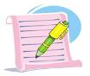 |  | pen | سعيد |  |  | happy
قلم رصاص |  | 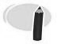 | pencil | حزين |  |  | sad
يد | 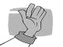 |  | hand | طفل*طفلة |  | 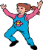 | child
شنطة | 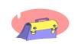 |  | bag | طفل رضيع | 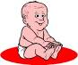 |  | baby
1 | 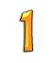 |  | one | ولد |  |  | boy
2 | 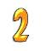 |  | two | منضدة |  |  | table
3 | 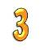 |  | three | برطمان | 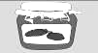 |  | jar
4 | 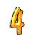 |  | four | جاكت | 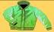 |  | jacket
5 | 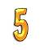 |  | five | يقفز | 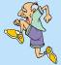 |  | jump
6 | 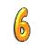 |  | six | علم | 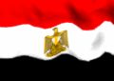 |  | flag
7 | 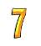 |  | seven | اللون الاحمر |  |  | red
8 | 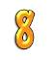 |  | eight | اللون الأبيض |  |  | white
9 | 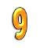 |  | nine | اللون الأسود |  |  | black
10 | 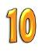 |  | ten | أنف | 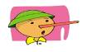 |  | nose
&& Exercises&&
1-Match the words with the pictures:-
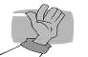
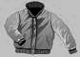
happy
sad
hand
jacket
********************************
2-Match the words with the pictures:-

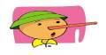
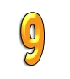

two
ten
nine
nose

**********************************
3-Write the capital letters:-
a - d - e - i - n - b - g

*********************************
4-Write the small letters:-
H - C - Z - R - T - P
*********************************

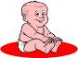

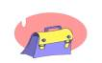
5-Write these words:-

Unit 8
مدرستى My school
أرنب | 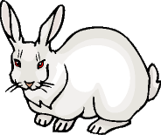 |  |  | rabbit | مدرسة |  | school
جزرة | 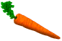 |  |  | carrot | فصل | 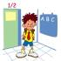 | class
يجري |  |  |  | run | خط |  | line
يقراء |  |  |  | read | وجه |  | face
يكتب | 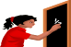 |  |  | write | يغسل | 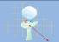 | wash
أحمر |  |  |  | red | يذهب |  | go
أخضر |  |  |  | green | يقف |  | stand
مفتاح | 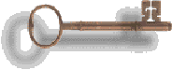 |  |  | key | ليمون | 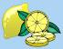 | lemon
لوحة مفاتيح |  |  |  | keyboard | صفارة |  | whistle
طائرة ورق |  |  |  | kite | ذئب | 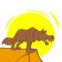 | wolf
مطبخ | 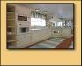 |  |  | kitchen | شباك | 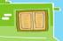 | window
ملعب |  |  |  | playground | بيانو | 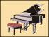 | piano
حمام | 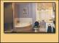 |  |  | bathroom | حجرة |  | room
حجرة الكمبيوتر |  | 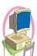 |  | computer room | أسنان | 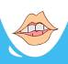 | teeth
حجرة المعيشة |  |  | living room |  | راديو | 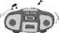 | radio

&& Exercises&&
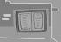
1-Match the words with the pictures:-

a rabbit
a kite
a whistle
a window
********************************
2-Match the words with the pictures:-
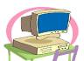
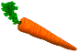
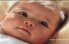
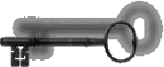
face
key
a carrot
a computer
**********************************
3-Write the capital letters:-
j - k - l - m - n - o - p

*********************************
4-Write the small letters:-
Q - R - S - T - U - V
*********************************
5-Match:- 6-write:-
B g H ……… e………
D i N ……… m………
G d Q ……… r………
I b T ……… c……..
Unit 9
عائلتى My family
لبن | 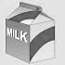 |  |  | milk | عائلة | 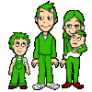 |  | Family
فأر صغير |  | 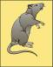 |  | mouse | أب |  |  | father
قطة | 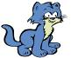 |  |  | cat | أم | 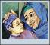 |  | mother
فم | 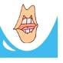 |  |  | mouth | أخت |  |  | sister
قرد | 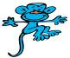 |  |  | monkey | أخ |  |  | brother
سعيد |  |  |  | happy | طفل رضيع |  | 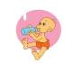 | baby
حزين |  |  |  | sad | سمكة | 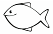 |  | fish
أيس كريم |  |  | 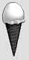 | ice cream | اصبع اليد | 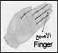 |  | finger
5 |  |  |  | five | 4 |  |  | four

&& Exercises&&

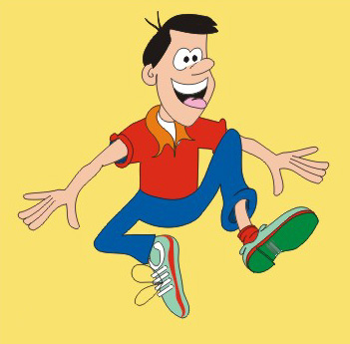
1-Match the words with the pictures:-
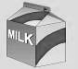
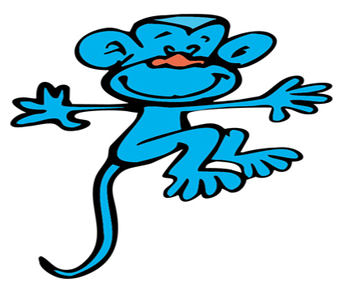
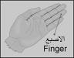
milk
monkey
finger
happy
********************************
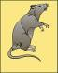
2-Match the words with the pictures:-
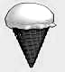
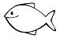
a mouse
family
ice cream
fish
*********************************
3-Rearrange the letters to make a meaningful word:-
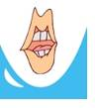
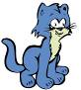
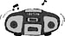
eetht atc rioad pphay
********************************
4-Compelete these letters:-
Aa – …… - …… - Dd - …… - Ee - …… - …… Hh - …… - …… - Kk - …… - …… -Nn – Oo Pp - …… - …… - Ss - …… - …… - …… -Ww …… - …… - Zz.
Unit 10
كل شىء عنا All about us
ملكة | 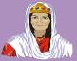 | queen | شمس | 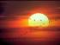 | sun
سؤال | ? | question | 6 | 6 | six
هرم | 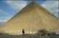 | pyramid | 7 | 7 | seven
برتقالى |  | orange | شجرة |  | tree
ثور | 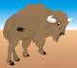 | ox | كرة |  | ball
صندوق | 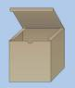 | box | راديو | 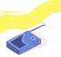 | radio
باب | 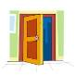 | door | فراشة | 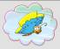 | butterfly
حمار |  | donkey | كلب |  | dog
عنزة | 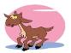 | goat | صفارة |  | whistle

Unit 11
مدينتى My town
فيل |  |  |  | elephant | مدينة | 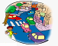 | town
من |  |  |  | from | محل |  | shop
شمسية |  |  |  | umbrella | سيارة | 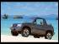 | car
مزرعة |  | 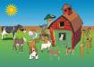 |  | farm | منزل | 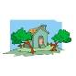 | house
أسد |  | 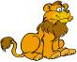 |  | lion | شقة | 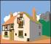 | flat
حمار وحشى |  |  | 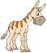 | zebra | حجرة |  | room
حديقة الحيوان |  |  |  | zoo | قرية | 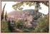 | village
كبير |  |  |  | big | شاحنة | 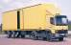 | van
صغير |  |  |  | little | حقل | 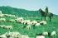 | field
نظيف |  |  |  | clean | مصر |  | Egypt
قذر/متسخ |  |  |  | dirty | بيضة | 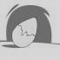 | egg

&& Exercises&&

1-Match the words with the pictures:-
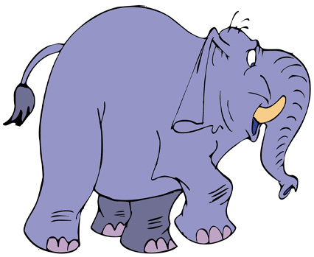
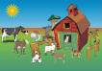
elephant
farm
umbrella
town
********************************
2-Write the missing letters :-
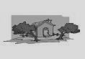
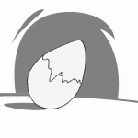
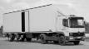
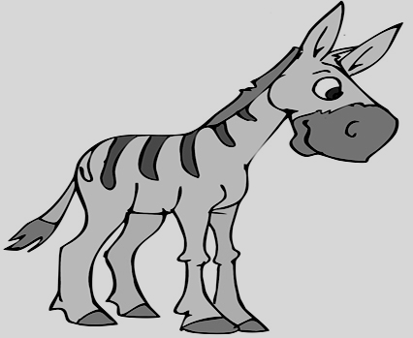

h- -se e - g va - ze - - a
*********************************
3-Rearrange the letters to make a meaningful word:-
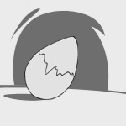

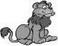
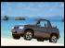
rac nloi labl geg
…………… ……………… ……………… ……………
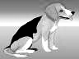
4-Match to make meaningful words:-
do ant

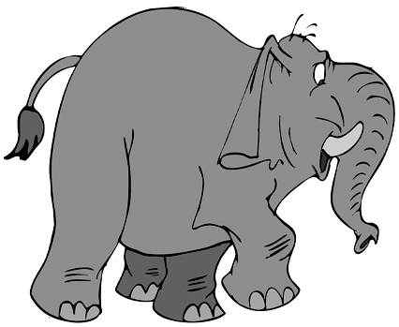
eleph ey


tr g
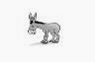
donk ee

Unit 12
مراجعة Review
يدفع | 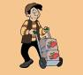 | push | يغنى |  | sing
يشد | 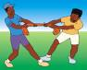 | pull | اغنية |  | song
يذهب |  | go | يصفق |  | clap
لا |  | no | يد | 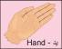 | hand
حقول | 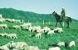 | field | ام |  | mother
حزين |  | sad | طفل رضيع | 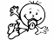 | baby
سعيد | 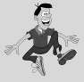 | happy | دائرة |  | circle
يقول |  | say | مربع |  | square
نحلة | 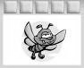 | bee | مثلث |  | triangle
أرنب | 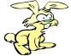 | rabbit | كلب | 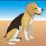 | dog

&& Exercises&&
1-Match the words with the pictures:-
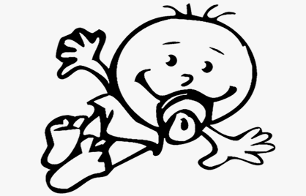
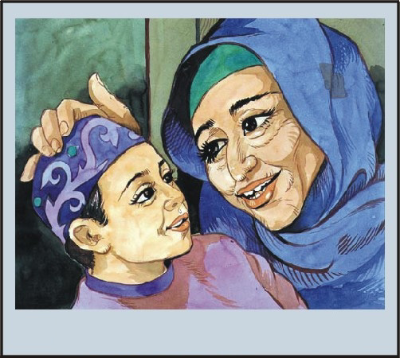
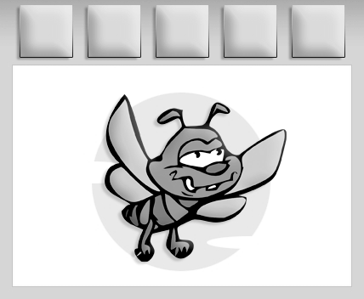
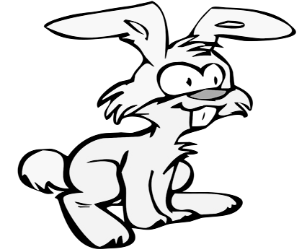
baby
mother
bee
rabbit
********************************
2-Write the missing letters :-
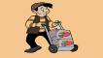
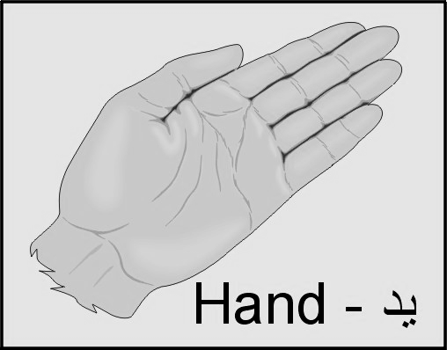
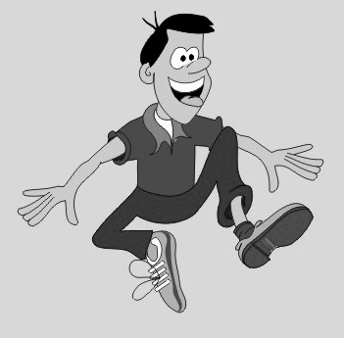

Pu - - p - - h h - - d ha - - y
3-Rearrange the letters to make a meaningful word:-
ybba bbrait ebe thermo
……………… ……………… ……………… …………………
********************************
4-Match to make meaningful words:-
ha re
hap cle


squa nd

cir py

Class one Exam

1-Match the capital with the small letters:-
A c
B a
G b
C g
M r
W n
H m
R w
J i
D q
I j
Q d

2-Match the small with the capital letters:-
d L
l D
k O
o K
v S
z V
s Y
y Z
t R
u X
x U
r T

3-Match the words with the pictures:-
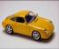
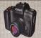
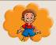
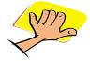
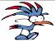
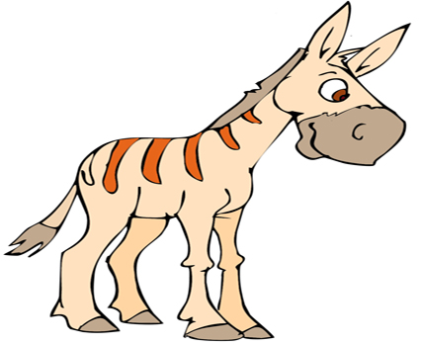
elephant
donkey
monkey
Hodhod

hand
car
camera
boy

4-Write the missing letters:-
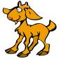
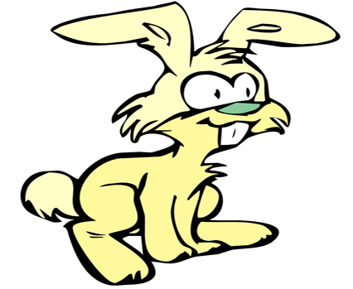
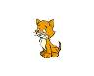
g--t ra--it o-e tw- n- ne
***************************************************
5-Write the word of these pictures:-



    

