Chapter 9
Introduction to Spread Sheet (Excel)

- Excel program is a"SpreadSheet" that enables users to create "Worksheets" that store information in "Workbook" files . the built in functions allow users to create and edit formulas, to copy and move data, to format and set up worksheets for printing. This is functions help in calculations but also provides a variety of charts used to present data.
- Aworkbook is the file in which you and store your data. Excel files are "Workbooks" that contain Worksheets these
- Worksheets are composed of Cells
- Cell is intersection of columns and rows.
A"Cell" contain text, numbers,or mathematical formulas
Each Workbook contains three sheets and it is possible to add other sheets.

Opening Excel
- Click the "Start" button.
- from the "All Programs" menu, select Microsoft Office Excel 2003
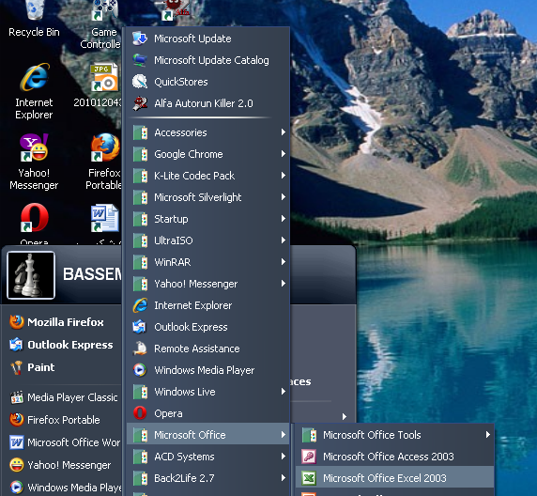

The "Excel" windows appear in the following shape:
Formatting bar
Title bar
Standard bar
Menu bar

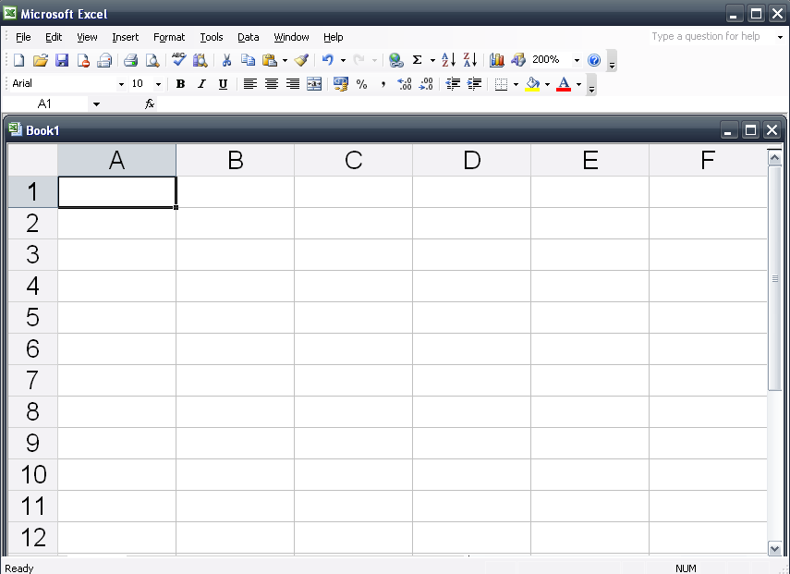

Formula bar
Active Cell

The Worksheets are labeled as Sheet1"sheet2" and "sheet3"
The columns are labeled as "A,B,C,.........,Z,AA,......IV".
Rows are labeled as 1,2,3,.............................................."
"Excel" contains 256 columns and 65.000 rows
The labeled Cell is columns letter followed by row number, for example B5,A2 or G1
The "Active cell" is the selected cell which is marked by a bold border.
The "Control" button are at the bottom of the Worksheet" window which are a used to move from one worksheet to another.

Move to first sheet in workbook
Move to next sheet in workbook
Move to last sheet in workbook
Move to previous sheet in workbook

Entering data into a cell
- A activate the cell in which data is to be entered
- Enter the data
- Press enter key or one of the directional arrow keys
Changing or editing the contents of a cell:
- Double click the cell which is to be changed with the left hand button of the mouse or press the F2 " key after activating the cell.
- Move the mouse pointer to the place which is to be changed
- Make corrections
- Press the key "Enter"
Saving a worksheet:
1- Click the on the standard toolbar
2- Select the disk drive and folder that you wish to store your file in
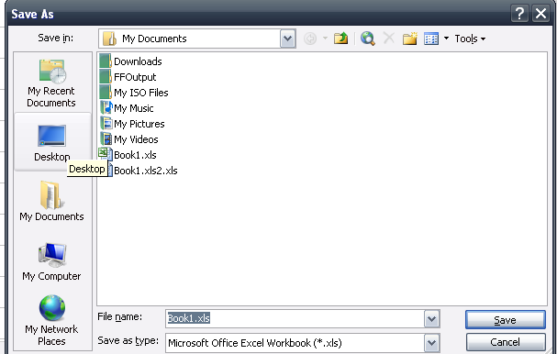

3-type the new name in the file name box
- click the button "Save"
TO close a file
From the "file"menu ,select "Close" Or Click Close icon on the menu bar
To exiting Excel
From the file menu select "Exit"
Or Click "close icon on the Title bar

Chapter Ten
Insert and delete Worksheet, Rows
Columns, and cells

TO insert a row or a column, or to insert cells above or to the left of the active cell
- Press "Insert"on the "menu bar "
- Choose "Cells"
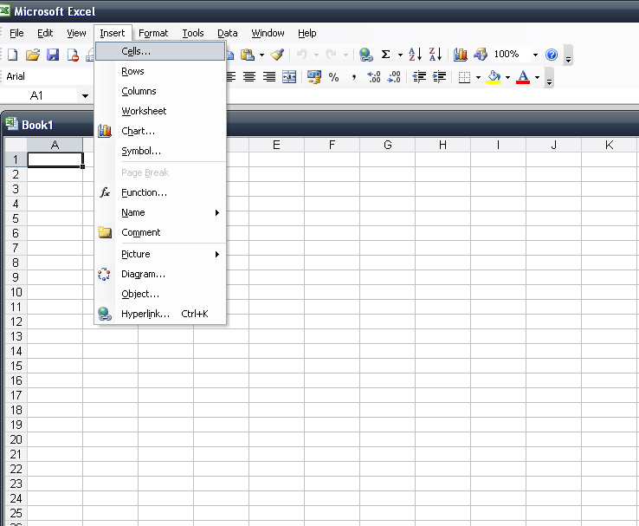

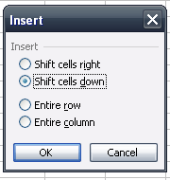

To insert a ROW
-Select the row above which a row is to be inserted
- Choose "Insert" on the Menu bar"
- Click on Rows
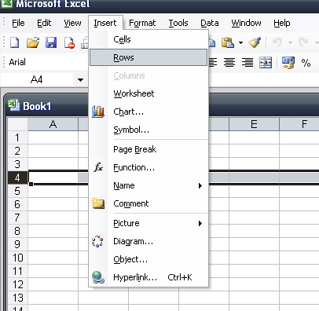

To insert a new Worksheet
- Click "Insert" on the "Menu bar
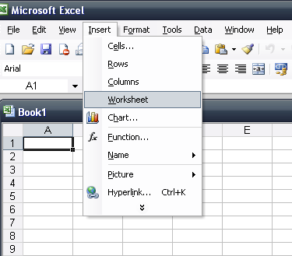
- Click "Workshee
- Rename a worksheet
- To delete a Row or a Column
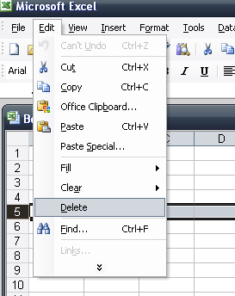
- Select the Row by pressing on the row number or pressing on the column letter.
- Click on "Edite" and select"Delete"
To delete a selection of cells or to move the cells
Down or up or from the left to the right
Select the cells
Click on "Edit" and select "Delete"
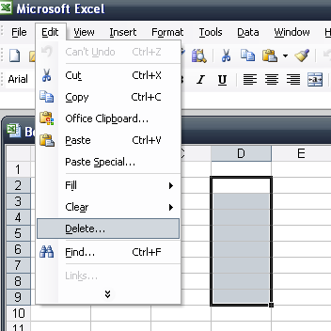

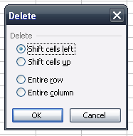
Select " Shift cells left" to move
Cells to the left.
OR Select" Shift cells up "
to move cells upwards
To Rename a worksheet
Select the name of the worksheet with the right hand mouse button
Select "Rename" from the Shortcut" menu.
Type the new name of the worksheet.
TO select a single cell
Click on the cell or press the " arrow" keys to move to the cell.
To select a range of adjacent cells
Click the first cell of the range. Drag to the last cell while holding down the key"shift"
To select non- adjacent cells
Select the cell while holding down the key"Ctrl" on the keyboard
To select arrow or a column
Click the row number or the column letter
To select a worksheet:
Click the name of the worksheet on the Navigation bar at the bottom of the program window.
To copy or Cut data from acell
From " Edit" menu, select"copy" to copy data or select"cut" to cut data.
From "Edit"select "paste"
OR copy or cut or paste from the Shortcut menu
OR by choosing copy icon Cut icon
Paste icon from the standard bar.
Question
complete:
- Excel contains……..columns and …………..rows.
- There are two types of time, one is based on…………..-hour and the other is based on…………….-hour
- By default, each"Workbook" contains…………..sheets.
- The cell may contain text or…………..or………….
- To change the contents of acell,………the cell which contents are to be changed or press the……..key on the keyboard.

Notes:
TO move the cell pointer press
Down one cell the "Down Arrow"button
Left one cell the "Left Arrow "button
Downthe screen the "page Down"button
UP one cell the "Up Arrow"button
Up the screen the "Page Up"button
Right one cell the "Right Arrow"button
.TO move the cell pointer to press Ctrl +
The first cell in the current column the "Up Arrow"button
The last cell in the current column the "Down Arrow" button
The first cell in the current row the " Left Arrow"button
The last cell in the current row the "Right Arrow"button

Chapter 11:Formatting Operations for Sheet,Column,Row And Cells

To format a worksheet:
- Select the worksheet which is to be formatted
- Choose "sheet" from the format menu
- Select "rename" to change the sheet name.
OR select "Hide"to hide a worksheet.
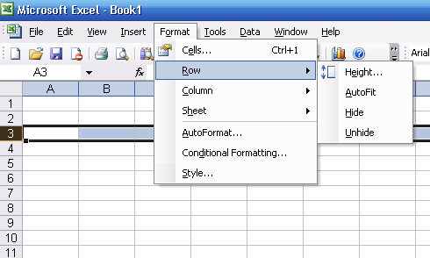
OR by using shortcut menu with right click on the mouse
TO format aRow:
Choose "Row" then from
format menu
Select "Height"to change
the row height
Select Hide to hide arrow
Select "Autofit"to change the size of a row automatically according to the font size.
Select "Unhide" to show the hidden row.
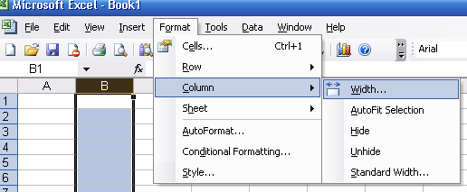
TO format a column
1-Choose "column" from format menu
2- Select "Width"to change
the column width.
Select "Hide" to hide the column
Select "autofit"to change the size of
the column automatically according to the font size.
Select "Unhide"to show the hidden column.
To format a row or a column from the "shortcut menu
By using right click on the mouse on the row or column header.
TO format a cell
- Select the cell.
- Choose "cells" from the format menu.
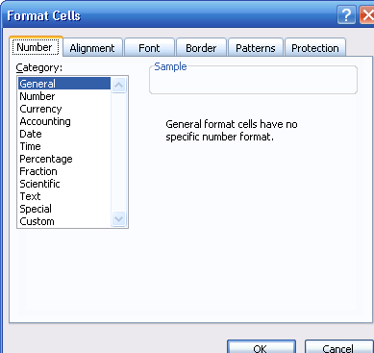
- Or By using shortcut menu by right click on the mouse then select "format cells " command
This window appears
You can change and format
any data of the cell according to the kinds
of data.
Choose the "Alignment"tab
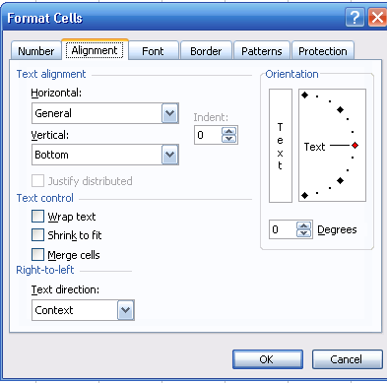
To change the alignment and the center
of a text in a cell and to merge cells.
Choose the "font" tab to change the font style
size, and color
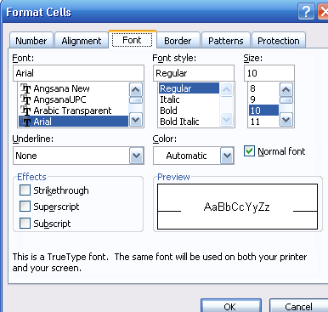

Choose the" border" tab
To change border the cell and color of these borders.
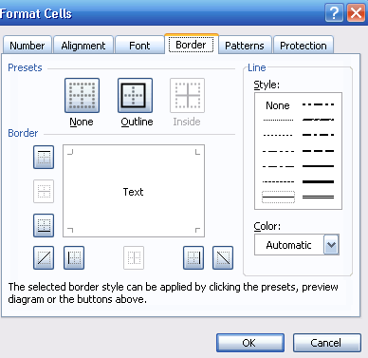

Choose "Pattern" tab to change the background color

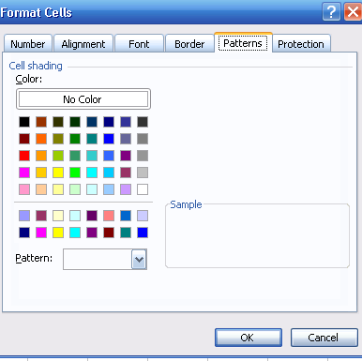

Chapter 12: The formula and function

The " formula" are what make a spreadsheet so useful you use formula in your excel to calculate results from data stored in the worksheet.
Benefits of using formula:
The sum will automatically change as other cell values referenced in the formula change .you do not have to remember to update other cells that rely on that cells information . aformula always begins with an equl sign(=)followed by som combinations of numbers,text,cell references and operators.
Note:
If a formula is entered incorrectly an (Error in Formula)message will appear

- Inserting the "Formula" in one of the cells.
1- Select the cell in which the formula is to be entered.
2- Type the equal sign "="
3- type the value of the first argument
4- next , type an arithmetic operator
5- Next , enter the next argument.
6- Last, press the Enter key or click on the green checkmark on the formula bar.
If you want Cancel the changes , click on the Red marker.
7- The result of the formula appears in the cell.

The Precedence of calculations in the "formula"
-Solve the "formula from the left to the right
- Start with the multiplication "*" or with the division "/"
- then do the addition "+" or the subtraction"-"
- Enclosing part of your calculation in brackets will ensure that this part is calculated first.
Functions are built in formula designed to make your work simpler and faster.
Some of the most frequently used functions are the Sum, Average, Max, and Min…
Sum Function
To find the total
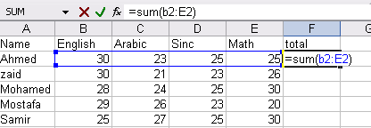

Average Function
TO find the average
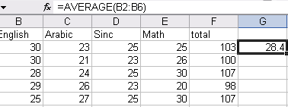

Max Function
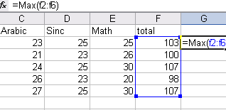
To Find the "maximum value"

Min Function
To find the "minimum value"
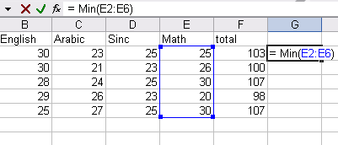

CountA Function
To find number of cells not empty.
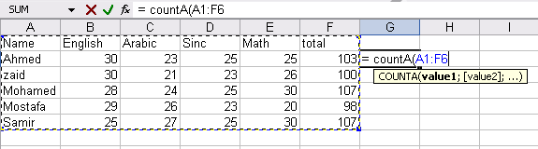

To copy the "formula "
- use the "copy"and "paste" buttons form the "Toolbar" or the "Autofill"
- Move the cursor to lower right corner of the cell until change the shaoe of the cursor to +
- Click the left-hand button of the mouse while dragging downwards to the last cell in which the "formula"is to be copied.
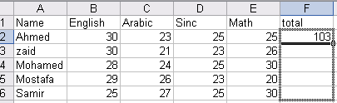

Chapter 13 Excel Chart

A chart is a graphic representation of worksheet data that can offer visual analysis of information.
Some chart types are set with a two dimensional (2D) or three – dimensional(3D)
A chart may be created on an existing worksheet, or in a new sheet.
Using the Chart wizard
Helps to create a chart by several steps:
- select the range of cells for which a chart needs to be designed.
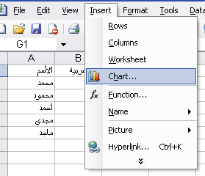

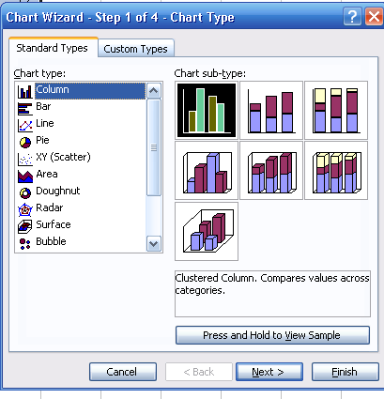
- From the "insert" menu, select "Chart"or click the on the standard bar
- A window appears

- Choose a "Chart type"and
Chart sub type.
- To view the chart, click"Press and Hold to view Sample"
-Click "Next"
This window is used to select the range of data.

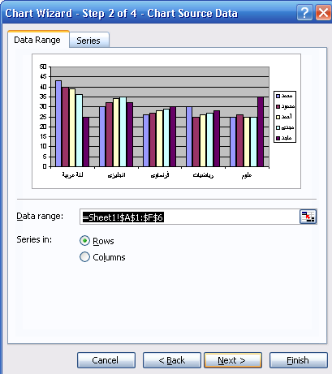

Which is to be presented in a chart.
- Click "Next"
- type the Title of the chart.
- type the category of the "X-axis" and the value of the "Y-axis "
- Click"Next"
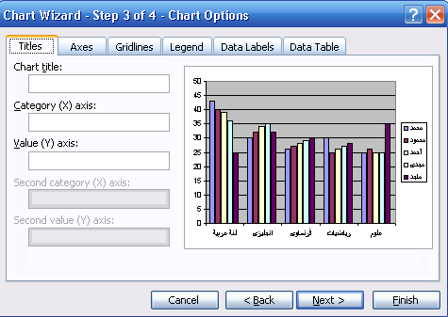

To put the Chart on a new worksheet, Choose "As new sheet"

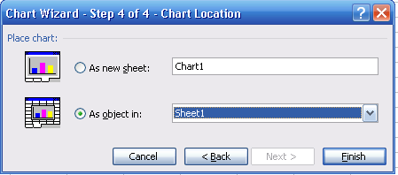

To put the chart from the current worksheet, select "As object in"
-It is possible to modify the chart by using the "Chart Toolbar" that display wgen activating the chart.
To delete the chart,select it and click the key delete"on the keyboard.

Chapter 14: Excel printing

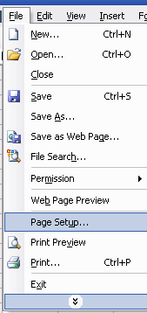

- To setup a page:

Choose "page setup" from file menu -
- Choose "Page"tab
- Choose from "Orientation"either:
"Portrait"to align the page horizontally
or "Landscape"to align the page vertically.

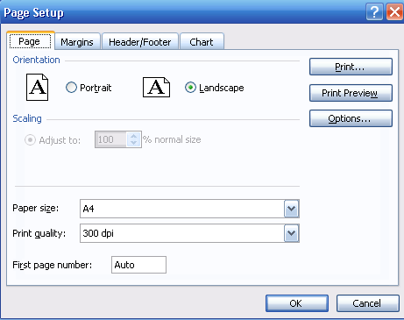

- To define the size of a document as a percentage:

Select " percentage" from "Scaling"
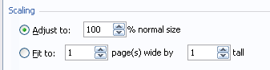

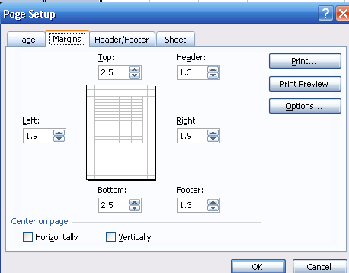
To select the four page margins:
Choose "Margins"tab
To center the print on the page
vertically or horizontally
To put the page header and footer:
Choose "Header/Footer"tab
To set up a Custom header:
press "Custom Header"
To set up a Custom footer:
Press"Custom footer"
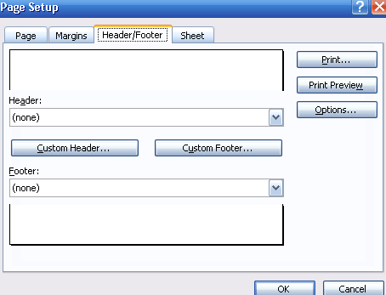

To View the document before printing
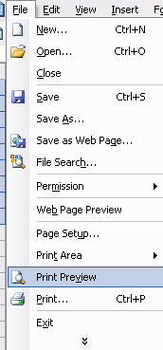

Choose" print Preview" from the "File" menu
The preview screen is displayed including a toolbar
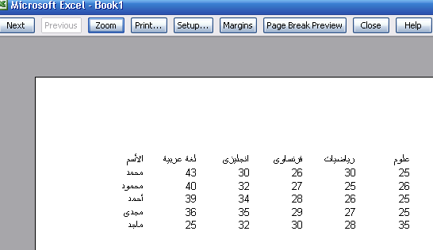
with the following commands:

1- "Next" to show the next page in case there are multiple pages
2- "Previous" to show the previous page in case there are multiple pages
3-"Zoom" to magnify or Minimize the page width
4- "Print" go to the print dialogue box.
5-"Page setup" go to setup dialogue box.
6- "Margin" go to setup dialogue box.
7- "Close" to close the "Preview"screen before printing.
To print the existing worksheet:
1- Click 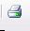 on the standard bar
2- Or Choose "print"from the "File"menu

Model Exam 1

Q.1:Complete:
1- To insert a new worksheet choose ………….from………menu
2- To format numbers and align text and make borders to the cell choose…………from the shortcut menu.
3- To show all hidden column choose ………then……….and from the submenu choose………..
4- 5*6+3=………..but 5*(6+3)=……………
Q.2:Write the steps of putting a Header and footer on all the to be printed pages:

Q.3:Match from column (A) with th sutible from (B)
(A) (B)
Sum find arithmetic arrange
MAX find the least sum
MIN find the total sum
CountA Number of non empty cells

Average find largest value

Q.4:How can you highlight the following things:
1- Highlight arrange or arrange of cells beside each other.

2- Highlight a row

Highlight a column 3-

Model Exam 2

Question No1: Choose the right answer from between brackets:
1- When opening "Excel" a default workbook called (book1-worksheet-books) appears.
2- To insert a new column, sheet (Hide-Delete- Cell) from the shortcut menu
3- To format cells, select ("Row"-"Column"-"Cell") from the "format" menu
4- To show all hidden rows,select("Sheet"&"Row"&"column") from the format menu then choose(Unhide-Hide- Delete)
q.2 : Compare
1- The alignment tab with the font tab in the Format cells window
2- Hide with Unhide
3- The sum functions with the Average functions
Q.3: Complete:
1-…………….is one of the Spreadsheet programs.
2- A worksheet contains………….rows and…………..columns.
3- To copy data from a worksheet, select it, then choose…………
From Edit menu then on a worksheet you want to copy data into choose…………from the Edit menu
- To format a cell and to add a border, select it and choose……….from the Shortcut menu.
Q.4: Match column (A) with column(B)
A) (B) )
"Shift cells right's used to close the "print preview" window
"CountA " is used to hide the items
"Close" is used to shifting cells to the right in the same row
"Unhide"is used to count the cells are not empty

Model Exam 3

