Want Healthy Habits? 21 Ways to Get There

By Holly Lebowitz Rossi
What does "healthy" mean to you? Perhaps it means freedom from illness, or the best possible performance of your body. Or health might be a state of mind, something that fits into the category of "I know it when I see it." Regardless of your health goals, these tips can help you feel better—starting right now.
Holly Lebowitz Rossi is Beliefnet's Health editor and the co-author of the holistic health blog Fresh Living.

Eat
Eat well, eat often--4-6 small meals a day to optimize your metabolism and keep your body energized and in balance. Don't deny yourself treats, but make sure that the majority of your food choices are high in nutrients, fiber, "good fats," and lean protein. Local, in-season, and organic when possible? All the better

Sleep

A recent scientific study showed that people who slept fewer than 7 hours each night were three times as likely to catch colds as those who slept 8 hours nightly. So tuck in and get your zzs

Love
Falling in love feels great, we all know that. Love triggers the release of all manner of feel-good brain chemicals that bathe our bodies in happiness and well-being... even protection from illness. But that's not the only reason love—be it romantic or platonic--is a health-giving thing. When you choose to love, you experience what pianist Arthur Rubinstein famously said "Love life, and life will love you back."

Talk
Sometimes you feel bad because something's on your mind, skulking around and sabotaging your well-being, inside and out. Talking to a trusted friend or therapist can help you sort out what's really going on inside—and map out steps to make it better.

Laugh

Did you ever think of laughter as an ab-toning exercise? Well, it is! Plus, it's a blood-oxygenator, endorphin-releaser, and general body relaxer. Ha HA

Move

So many of us spend most of our time sitting—on the couch, at our desks, in the car. But the human body was meant to move, stretch, expand, and engage. So take a walk, jump in a pool, skip rope, or just lift your arms toward the sky and see how high you can reach.

Breathe

Drawing breath is the most fundamental thing we do to stay alive. But it can be so much more than a survival technique. Try taking ten long, mindful breaths, feeling clean oxygen come smoothly into your body, CO2 and toxicity gently flowing out. Don't you feel better already?

Give
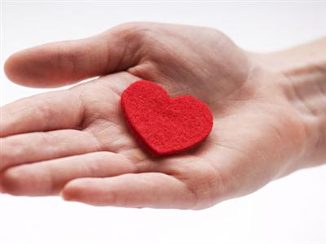
Studies have shown that volunteering can help alleviate depression and may even contribute to longevity. So help clean up a local park or volunteer at a nursing home, and know that you can feel great about what you've given, but also what you've received

Learn
Take the time to educate yourself about health challenges that you face in your life. Seek out trustworthy resources, hit the library and the Internet, and above all, don't be afraid to ask your doctor to be your educator.

Change
The principle of "cross-training" is embraced by athletes who know that changing things up keeps our bodies primed, flexible, and in top form. Try cross-training your life by bringing healthy variety into your diet, fitness, work, and social habits.

Plan

Is there any more comforting feeling than waking up with a cold and realizing you don't have to drag yourself to the store for tea, lozenges, and decongestants? Set your home up for healing by planning ahead, keeping supplies fresh... and doctors' numbers easily accessible.

Drink
Water, that is. Imbibe 8-12 glasses (8 ounces each, please!) of clear, hydrating fluid to keep your system functioning at its best—and toxins moving toward the exits.

Play

Remember when you were a kid and your mom called you in to dinner? You were so engrossed in playing, you couldn't believe it was already dark outside! Play takes many forms, from a romp around the yard with the dog to doing a jigsaw puzzle to (gulp!) attempting a cartwheel. Play today to feel healthy and alive—make the word of the day "fun!"

Create
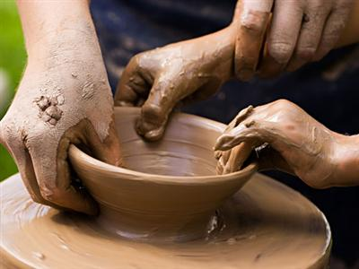
Do you want to feel better? Make something. Maybe it's a knit scarf, maybe it's a beaded mosaic. Maybe it's a sandcastle or a container garden. Doing creative activities not only engages your brain on an above-the-everyday plane, it is believed to contribute to better heart health and even longevity.

Walk

"Me thinks the moment my legs begin to move, my thoughts begin to flow," said Henry David Thoreau. So put one foot in front of the other and take a walk through a park, in the woods, on the beach, or around the block, and see what flows.

Sing

Singing requires deep breathing, and deep breathing oxygenates your blood and makes your body happy. So tra-la-la yourself to good health!

Rest

A rest is not the same as a nap or a night's sleep, but it is a crucial aspect of good overall health. Schedule "time-out" time each day—make an appointment in your calendar if necessary!—to unplug and vege out with a magazine, a meditation CD, or just the blessed sounds of silence.

Think

When health challenges present themselves, think before you act. Research your treatment options, talk to trusted professionals and friends, and take a step back to assess a situation in the larger context of your life and health

Dance

"Stifling an urge to dance is bad for your health," said Adabella Radici, "It rusts the spirit and the hips!" So whether you're in a club, in your bedroom, or even in the bathroom at work, put on an iPod or radio and move, sway, bounce—in other words, dance and feel your body open up.

Cry

"Let it out," we whisper to ourselves or loved ones when tears start to flow. And we mean that both emotionally and physically—tears have antiviral and antibacterial properties, as well as health-giving lubricating effect on our eyes.

Connect

Simple human connection, whether online, over the phone, or even in the doctor's office waiting room, can be a restorative tonic, not to mention protection against the isolation and anxiety that can come when we struggle with health conditions.

