#20 Winter Chickedee
by JMitaStudios
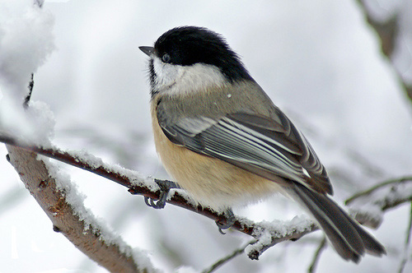
A Winter Bokeh
by Kuddlyteddybear2004
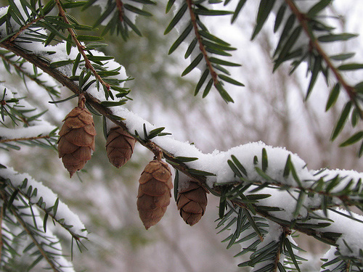
A Winter Tale..
by Nilgunkara
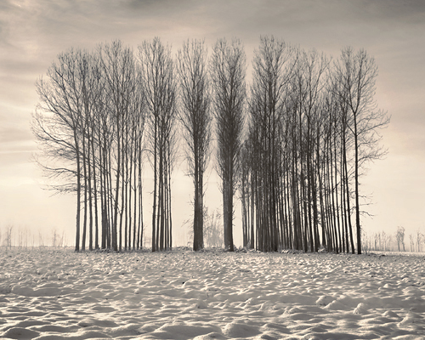
Barn in Winter
by James Jordan
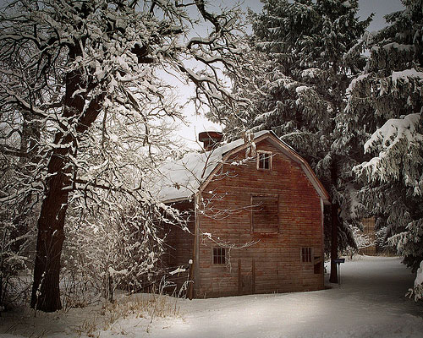
Blue Winter ….
by Alf07
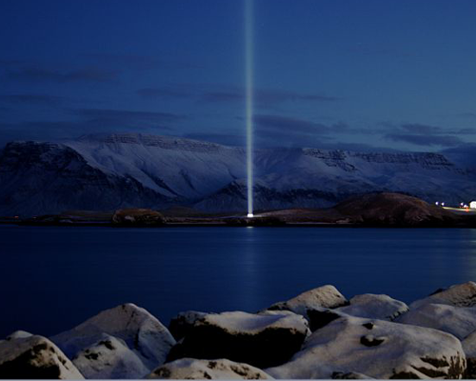
Cardinal in Winter
by LittleREDelf

Chase Winter Deer
by Johnmuk
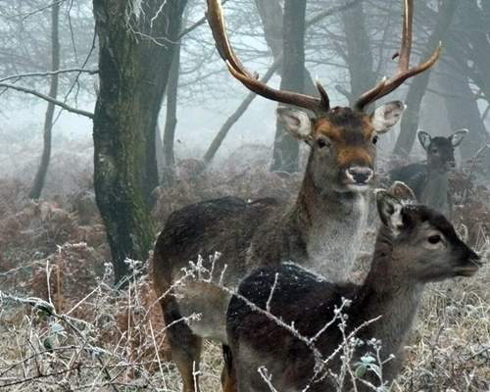
Crater Lake, Winter
by MarcAdamus
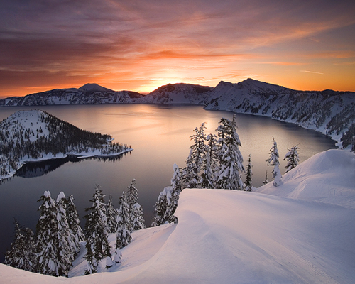
Classical Russian Winter
by Doberman4ik
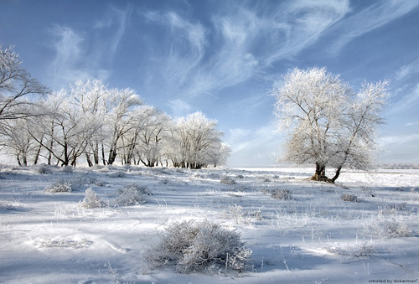
Field Mint in Winter
by Yksin
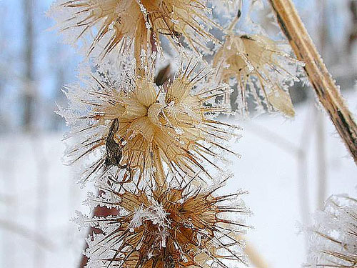
Farmstand in Winter
by Muffet
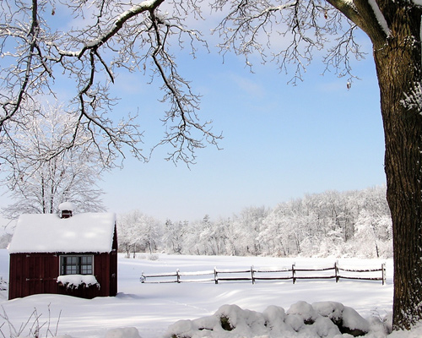
Grand Canyon in Winter
by Creativity+ Timothy K Hamilton
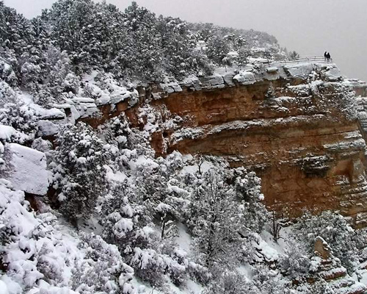
Happy Winter Solstice Day
by Kuddlyteddybear2004
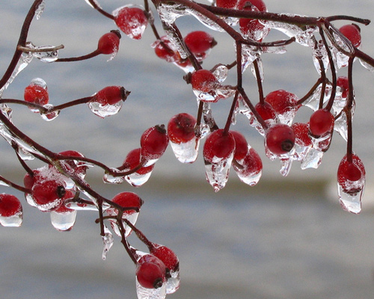
Horse In Winter Field
by Darwin70
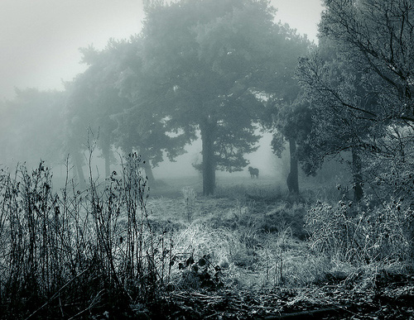
Holga Winter
by Rakastajatar
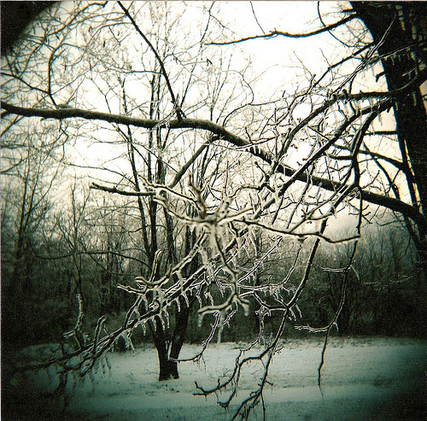
Law Library (Winter)
by Dgermony
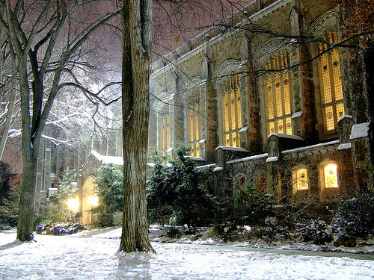
The Lone Boatman in Japan’s Winter Light
by Okinawa Soba
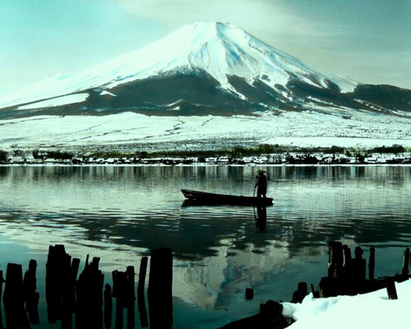
On Winter…
by Matt McGee
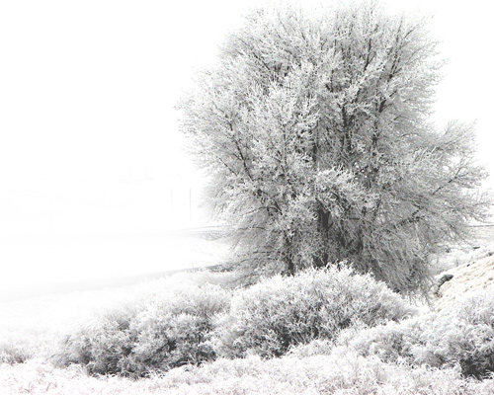
Onset of Winter
by Ssilence
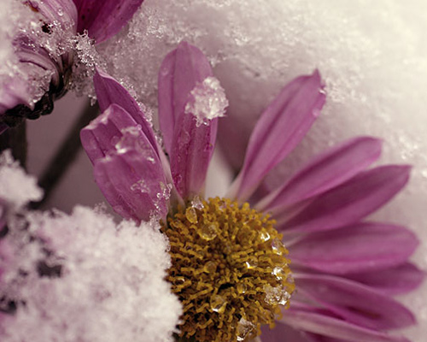
Winter Textures
by Grant MacDonald
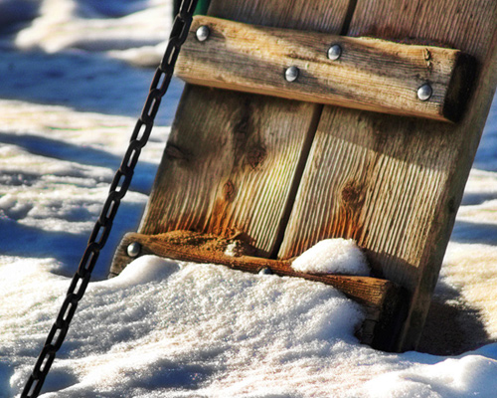
Struma River in Winter
by Klearchos Kapoutsis
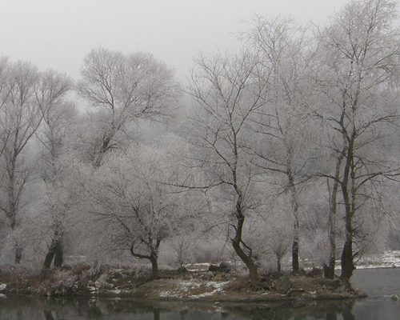
Tail End of Winter
by Melissa Maples
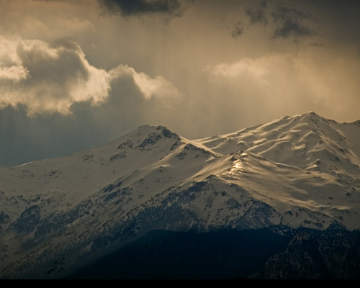
The Tree That Refused to Believe It Was Winter
by EJP Photo
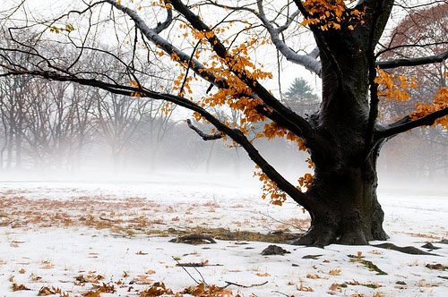
Winter
by 6Artificial6
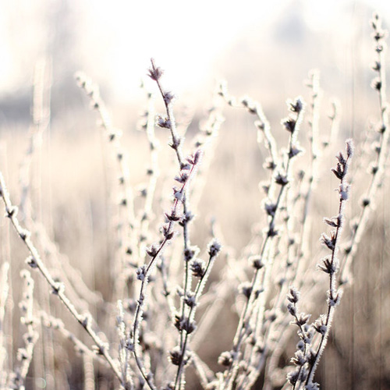
Winter
by Valyeszter
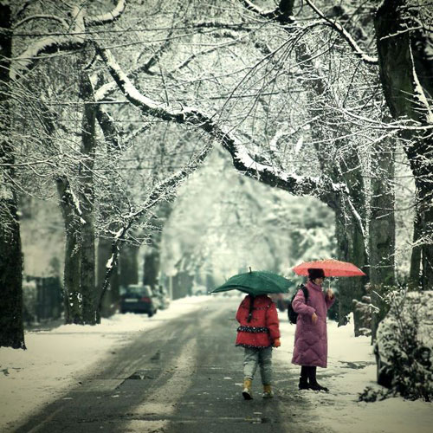
Winter 8
by Aniabeata
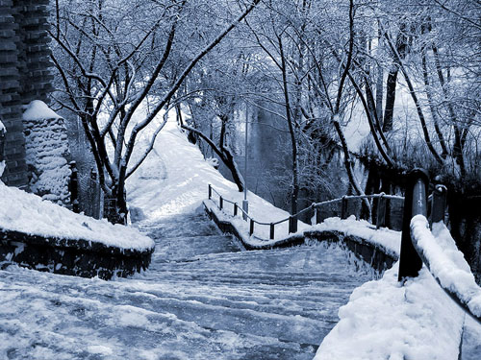
Winter Apple
by Rabasz
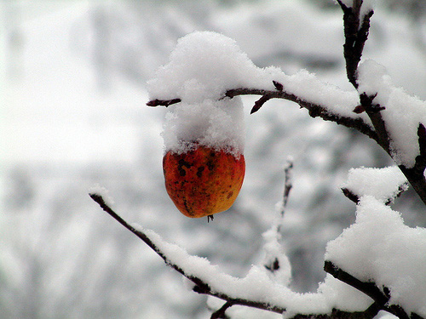
Winter
by Behindmyblueeyes

Winter
by Dinarakey
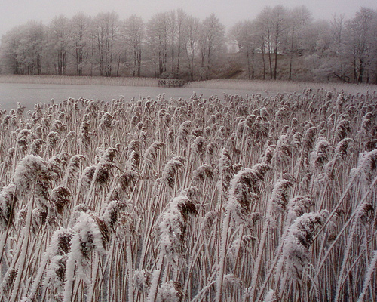
Winter
by Fragoline
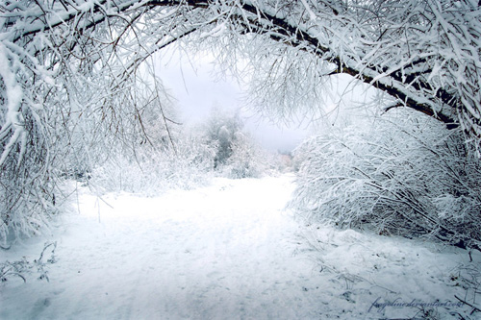
Winter
by Voorikvergeet
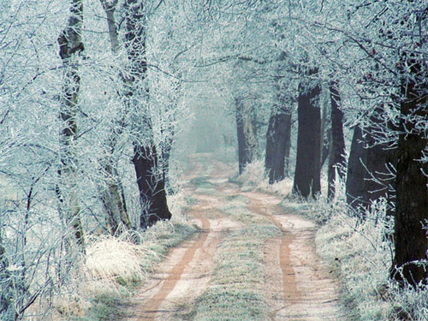
Winter Flight
by IgorLaptev
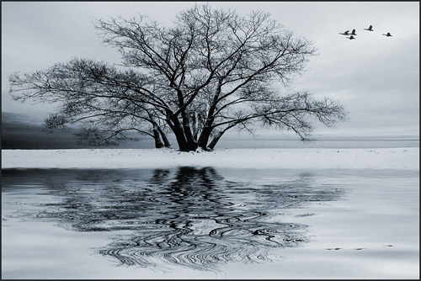
Winter Freight on Salt Creek Trestle
by Ahockley

Winter Fur
by Orvaratli
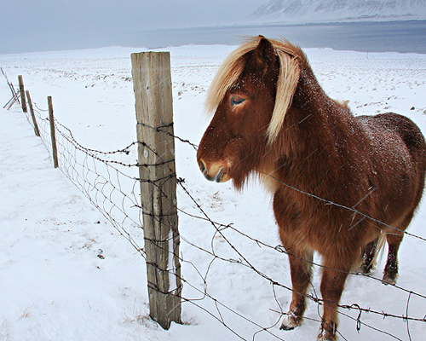
Winter Field
by James Jordan
