السلام عليكم ورحمة الله وبركاته
Click this bar to view the full image.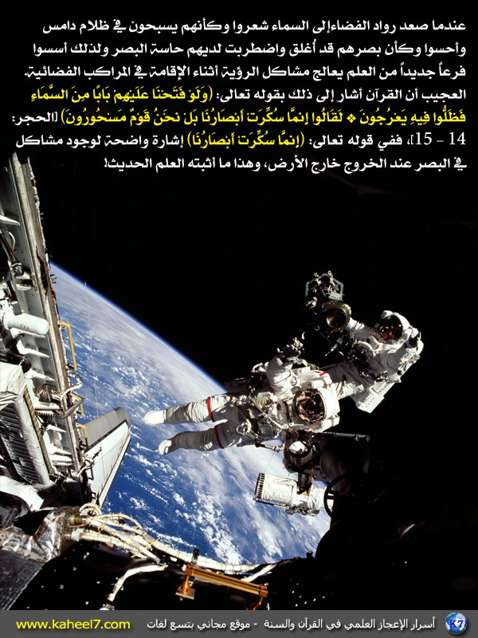
Click this bar to view the full image.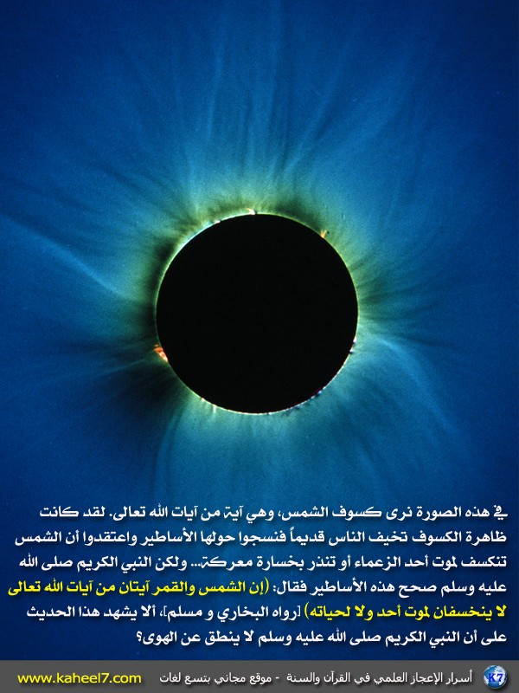
Click this bar to view the full image.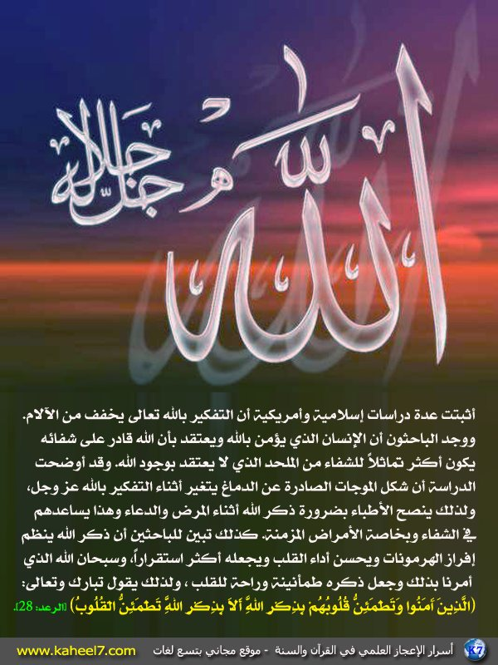
Click this bar to view the full image.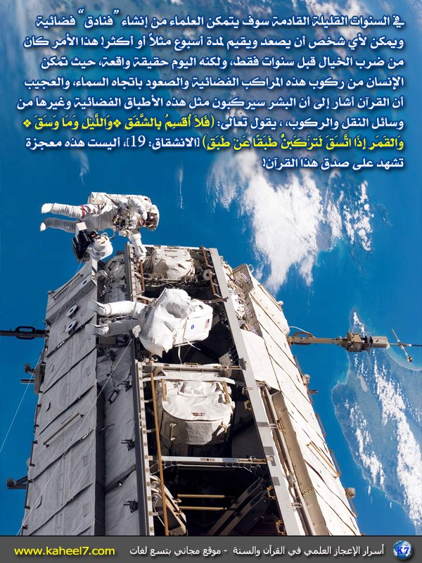
Click this bar to view the full image.
Click this bar to view the full image.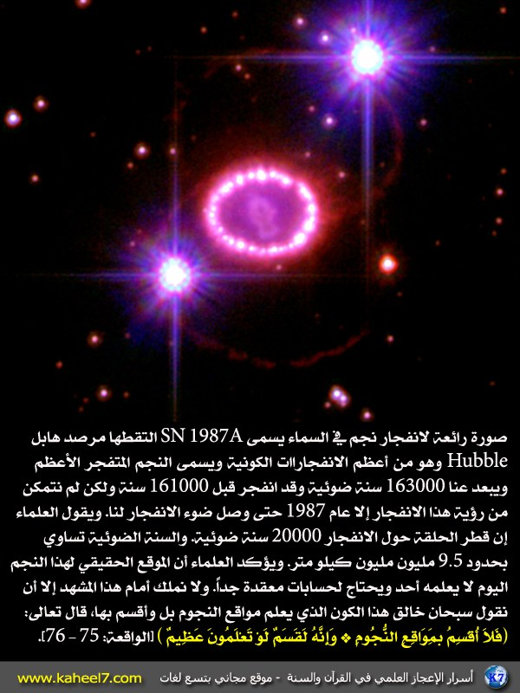
Click this bar to view the full image.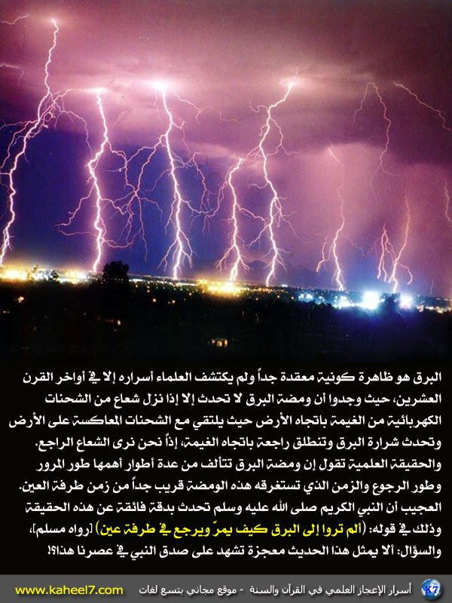
Click this bar to view the full image.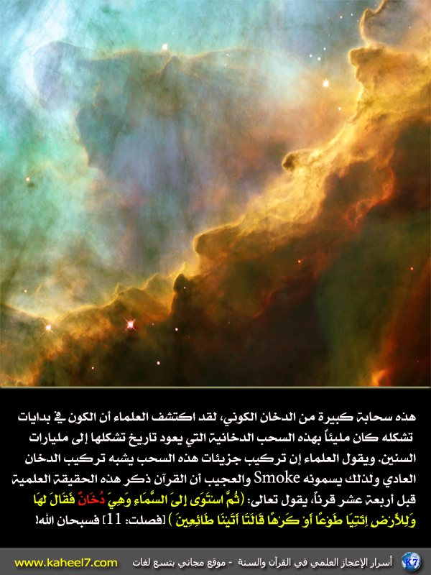
Click this bar to view the full image.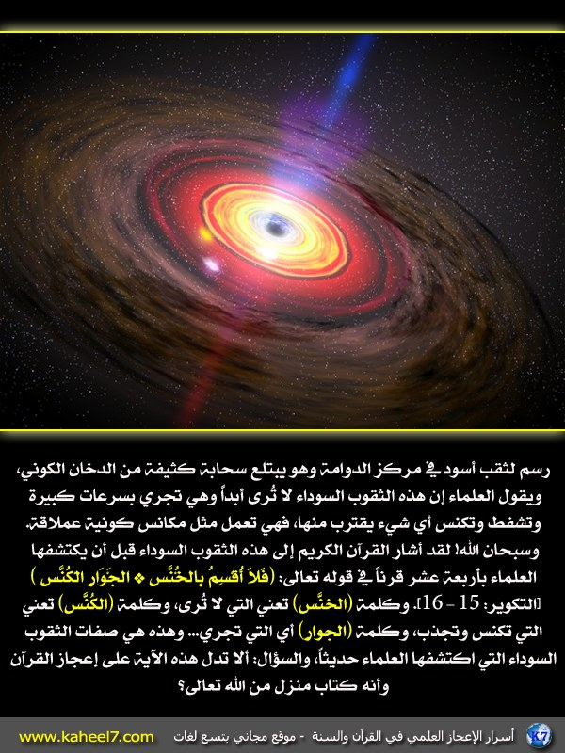
Click this bar to view the full image.