بسم الله الرحمن الرحيم
1
وقـل ربـــي زدنـــــي علمــا 
صدق الله العظيم
Unit
13
سلسلةYara
الفصـــل الـــــــدراســـي الثانى 13 - 25
What should I buy?

lazyكسؤل | pondبركة | joke نكتة | mobile موبيل
tired متعب | together سويا | ticket تذكرة | CDاسطوانة
footprintsاثار اقدام | syllables مقاطع | boring ممل | problemمشكلة
safeامن | stress تشتيد | until حتى | suggestيقترح
wetمبلل | comfortableمريح | pronounceينطق | present هدية
الاقتراح والرد
1-Why don’t we……………….? 2-What about (How about +v + ing…?
3-Could you + المصدر.......................? 4 -Let's + المصدر
اما طلب الاقتراح فنقول :
…. ? 2- What should I do for Ahmed’s birthday? ….? المصدر What should I+- 1
وللرد على الاقتراح نقولYeas, good idea - 1-No, I don't really like …….? 2
ياتى( v+ ing )بعد الأفعال الآتية :-
enjoy يتمتع بـ | suggest يقترح | miss يفقد | remember يتذكر
finish ينتهي | fancy يتخيل | postpone يؤجل | need يحتاج
feel likeيشعر برغبة | deserve يستحق | practice يمارس | mind يمانع
deny ينكر | complete يكمل | regret يندم | avoid يتجنب
admit يعترف | give up يقلع عن | escape يهرب | stop يوقف
advise ينصح | quit يهجر \ يترك | confess يؤكد | understand يفهم
ِ1-Ahmed likes playing football 2-Idon,t mind going with you to visit her.
3-Ahmed stopped wasting his time. 4- You must avoid cheating.
5-We enjoy watching People Channel 6-I feel like drinking tea.
7-I suggest going by train. 8-She regretted going with them to the party
9-I don’t complete watching the film 10-Yara doesn’t finish revising unit two.
11-They will never confess cheating. 12-Fancy, not cheating in the exam.
❶Choose the correct answer.
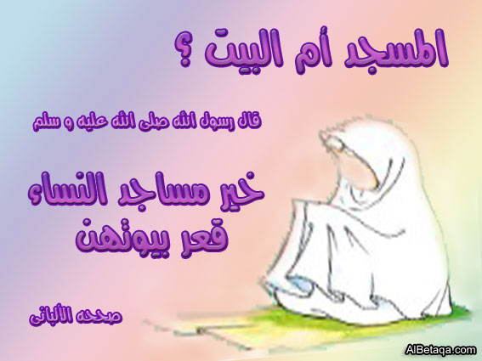
1-Why don’t you (get-getting- get) him a mobile?
2-It was a (funny- boring- bad) .I laughed a lot.
3-Yara enjoys (watching- watch- watched) T.V?
4-Ahmed doesn’t likes (eating- eats-eat) fisha and kersha.
5-How about (going-goes –went) by train.
6-Heba bought me a (present- past- film) on my birthday.
7- She is very (lazy-helpful- crazy) as he helped me.
8-Amina could (buy-bought-buying) these books.
9-(Its-It's- It) a funny story.10- (Its-It's- It) colour is black
11-(It-Its –It's) eaten the bons13-(It-its –It's) is expensive.
❷Read and correct the following sentences.
2
Corrections | Mistakes
...........................  ...........................  ...........................  ...........................  ...........................  ...........................  ............................  ...........................  ...........................  ...........................  ............................ | 1-Ahmed is capable in solving this problem.  2-She could buy a couple of football boots.  3-Cairo is the capital of France.  4-Ahmed enjoys ate fish and rice.  5-I mind going with you to the cinema.  6-How about watched this match.  7-It,s fun book with lots of jokes.  8-Yara could cheated in the exam.  9-Ahmed always put her hands in his head.  10-Ahmed couldn’t leaf the rice with the hen  11-Ahmed always read English.
عندما نحكي قصة نستخدم الكلمات الآتية في بداية الجمل لبيان تسلسل الأحداث :-
1 –First أولا / First of all أولا وقبل كل شئ 2 – Then ثم
3 –After that وبعد ذلك 4 – Finally / at the end في النهاية
The story of Goha in the correct order:
First, Goha’s son rode the donkey Then, Goha rode the donkey.
After that, both Goha and his son rode the donkey.
Finally, Goha and his son carried the donkey.
Complete the missing parts in the following dialogue between:-
Ali and his neighbour who wants to borrow money from him:
Neighbour: May I you a favour?

Ali : ………………..…1………………………
Neighbour: Can you lend me ten pounds?
Ali : …………………..2……………….…….
Neighbour: Next month.
Ali : I can lend you five pounds ……….3……………..
Neighbour: Thank you. This will help
me to some extent.
❶Read the following and answer the questions:-
3
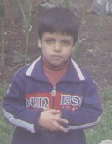
My name is Mohamed. I am twelve years old. I live in Cairo.
I am at Mahallet Bisher prep school. I like school. I am good at
English and science. I am not good at social studies.
My father is a teacher and my mother is housewife.
My sister is at primary school she likes reading stories but
I like playing computer games school .She likes reading
stories but I like playing computer games . My uncle is a
taxi driver . He lives in Alexandria with his wife.
A) Answer the following questions:-
1-What school does Mohamed go to?…………………………………………..
2-What is the father’s job? ……………………………………………………..
B) Choose the correct answer:-
3-Mohamed is not good at (social studies – playing games – English and science
4-Mohamed’s uncle is a (businessman – doctor – bus driver – taxi driver).
❷Make question to these answers.
1 – The bus stopped in the square………………………………………..………
2 – The pupils played in the playground. …………………………………….…
3 – I slept in a hotel last night. ………………………………………………..…
4 – Naglaa put the books on the desk. ……………………………………………
5 – They went to the cinema yesterday. …………………………….……………
6 – The doctor finished his work an hour ago. ……………………………..……
7 – Osama's father bought a house in 1975. ……………………………..………
8 – I wrote the lesson at ten o’clock. ……………………………………………
9 – They went to Alexandria week. ………………………………………..……
10 – Marwa washed the clothes yesterday. ………………………………………
لاحظ ان (too)تعنى اكثر من اللازم ويترتب عليها نتجية منفية. He is too ill to go his work وتستخدم( too ) بمعنى ايضا فى الجملة المنفيةِAhmed goes to institute ,too. 
Punctuate the following sentences:- ❸
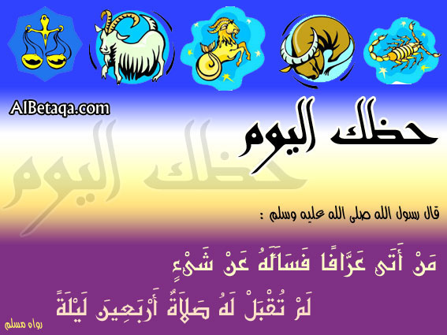
1-yesterday asmaa bought an english book. …………………………….…………….
2 -funny fred goes to bed late on thursday . . …………………………….……………
3 –can ali meet his friend hassan at school . . …………………………….…………….
4 -where are ahmed and samir going next friday .
…………………………….……………
5-mr khaled doesnt teach us arabic or history
…………………………….……………
6-ahmed goes to cairo with mohamed on monday
…………………………….……………
سلسة Yaraابداع دائم
❶Read and match.
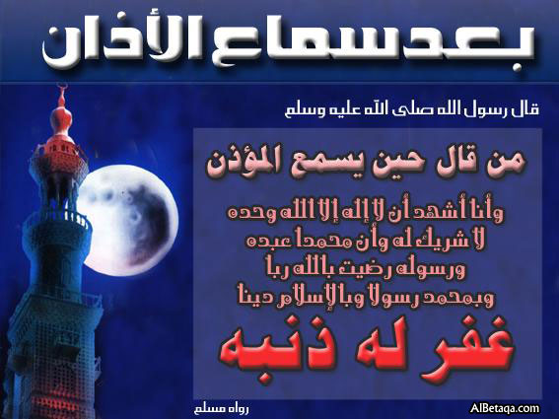
1-Ahmed is too tired. a-dangerous animals
4
2- Yara can't watch T.V. b-makes you fat
3-We should be careful of c- is my favourite subject.
4-Too much food. d-because she is busy.
5- English e-to do his work.
❷Finish the following dialogue with these words.
Walk- tired- straight- way- long).)
Yara :Can I help you?
Amina :Yes, Could tell me the………….1………..to Khan-al-Khalili.
Yara : Khan-al-Khalili! Go……………2……..and then turn left.
Amina :How………………………..3……doe it take to reach it?
Yara :A few minutes walk.
Amina :But I am too…………………4……..to walk.
Yara :You can take a taxi.
❸Write question using words in brackets.
1-Yara gets up at six o'clock. (What)…………………………………………..….?
2-The lion was too tired to hunt. (How)……………………………………..…….?
3-Yara doesn’t like cheating. (What) …………………………..………..…….?
4-It is a good idea not to cheat (How about)…………...………......……………..?
5-Yara goes to the doctor when she is ill(When)……..……………….…………..?
6-She doesn't cheat as it is a shame.(Why)…………………………..……………?
7-Ahmed read a story.(What)………………….………………………………….?
8-She shouldn’t cheat in the exam.(What) …………….………………………….?
9-She is used to cheating in the exam.(What) …………….…………………..….?
10-She behaves badly as her parents didn’t bring up her well (Why)
…………….………………………………………………………….………..….?
لاحظ مايلى جيدا:
اعل -1 +invite+مفعول+to+ اسم او مصدر Ahmed invited me to the party.
فاعل -2+help +مفعول+with + اسم او مصدر I helped me with the housework
3- فاعل +help +مفعول+to do + شى I helped me with the housework
فاعل-4+thank +مفعول+for + ( ( اسم v+ ing Thank you for coming with me.
I thanked him for helping me.  Thank you for helping me.
+فاعل -5Would like to + مصدر  I would like to come to the party.
Can-must + مصدر افعال ناقصة وياتى دائما المصدر بعدهااثبات او نفى
1-I must study .I must not cheat. 2-I can answer son I can't cheat.
3-I couldn’t see him. 4-I could answer as I studied.
5-I help Ahmed to answer the test 6-I thanked Ahmed for helping me
7-Mr.Khaled invited Ahmed to his party 8-Ihelped you to understand .
سلسة Yaraابداع دائم
❶ Supply the following parts .
5
Ahmed:……………………………...? Yara : It’s a good idea. -1
ًWafaa:………………………………? Saida :Iam Egpyption.-2
❷Punctuate the following.
1-why dont you buy ahmed a new mobile……………………………………….
2-how a bout going to cairo on monday………………………………………….
3-ahmed enjoys reading english. …………………………………………………
4-first ahmed went to the zoo ……………………………………………………
5-we arent going to alex on friday………………………………………………..
❸ Read and match the following.
1-Marwa eats so much sweet a- for her birthday.
2-Ahmed likes riding bikes, so b- to read English books.
3-I should buy Yara amoblie c- football boots to play football.
4-Ahmed goes to the library d-so, she will be fat.
5-Ahmed bought anew pair of e- his father is oing to bbuy him one.
❹Choose the correct answer.
1-He put the hen in the boat and (left- leaves- take- ) the dogwith the bag of rrice.
2-A\an (elephant- hen- camel) lays egge3-He lives by the (canal- sea- River) Nile.
4-A(car- boat- taxi) carries people across the river.
5-He (likes- would like- like) studing with friends.
6-First , Ahmed (take- takes- taken)a bath.7- Then,he (pray-prays-prayed).
8-After that ,he (is wearing- wears- wear) his uniform.
9-Finally, he (leave- leaving- leaves)for instiute.
10-The first lesson (starts- star- strating)at ight o,clock.
❺Fill in the spaces using the following questions words :-
How – What – Which – Where
1 - ……..subjects are you good at? - Algebra and English.
2 - ……..good is Hani at English? - He is very good.
3 - ………is your name? - My name is Khaled.
4 - ……primary school did you go to last year? I went to Giza Primary school.
5 - ………are you going? - I am going to my new school.
6 - ………old are you? - I am eleven years old.
7 - ………animals do you like to read about? - The lion and the giraffe.
8 - ………….is your favourite sport? - My favourite sport is football.
❻Make questions for these answers:-
1 –Yara goes to school on foot.…………………………………………………?
2 –Ahmed lives in Mahallet Bisher………………………………………….…?
3 – Mohamed is younger than Ahmed. …………………………………………?
4 –Amal bought twenty eggs. ……………………………………………..……?
5 –Aya visits Cairo twice a week. …………………………………………...…?
6 –Mr. Khaled teachers English. ………
………………………………………?
❶Read the following passage and then answer the questions:-
6
Science has told us many things about the moon. It is not a friendly
. Place. There is no air or water there so there, so there can be no life of any kind. There are plains of dust with mountains around them. Above the sun and stars shine in a black sky. They moon is also a very silent world because sound can only travel through air. You can see the earth from there. It looks like an immense ball. Coloured blue, green and brown.
A Questions:-
1 – Why is the moon a silent world?…………………………………………….
2 – Can you live on the moon? Why? …………………….…………………….
B Choose the correct answers:-
3 – The word “immense “means [small – very small – not big – huge] .
4 – The underlined word there refers to [the earth – the moon – the sky – the sun]
5 – The moon is a [noisy – friendly – quite – small] place.
Must be – may be – can’t be
و هـــــــي الكلمــــات التي تدل علي الاستنتاج deduction .
1 – must be ( وتعني لابد أن يكون ) و تستخدم عندما يكون الشخص قريب من التأكد .
2 – may be ( و تعني ربما ) و تستخدم عندما يكون الشخص غير متأكد .
3 can’t be- ( و تعني لا يمكن أن يكون ) و تستخدم عندما يكون الشخص متأكد من عدم حدوث الشيء
Examples:-
1 – Ahmed has got very good marks. He must be clever.
2 – Mohamed has got very had marks. He can’t be clever.
3 – This man is taking photographs. He may be a tourist.
❷Choose the correct answer:-
1 – Mohamed has got an expensive car; he [can’t – must – will – may] be rich.
2 – The picture is the pyramids, it [can’t – must – will – May] be from England.
3 – Mohamed is too young, he [can’t – must – will] be in a secondary school.
4 – I’m not sure, he [must – may – will – would] be a teacher.
5 – Ahmed [must – can’t – won’t – May] be poor; his clothes are torn.
6 – I think Magdy is at home. I am not [sure – afraid – frightened] .
7 – That boy [can’t – may – must] be very hungry. He’s eating a lot of food.
8 – That [can’t be – must be – may be] a plane. It’s flying over the road.
9 – I’m not sure of my answer. It [may be – must be – can’t be] right.
10 – Adel [must be – may be – can’t be] a doctor. He is controlling the traffic.
❸Complete the missing parts in the following dialogue between
Ahmed and his teacher :-
Teacher : ……………………………….?Ahmed : My name is Ahmed Khaled .
Teacher: …………………………………………….?
Ahmed : I was at Mahallet Bisher primary school .
Teacher: What subjects are you good at?
Ahmed : ……………………
……………………..
Unit
14
سلسلةYARA
7
Comparing things.

Iguanodon حيوان | pearsكمثرى | subjects مواد | rhyme سجع
Tyrannousطغيان | classmate زميل | hobbyهواية | leavesاوراق
Sharpحاد | scientists علماء | vehicle مركبة | Meterمتر
commonشائع | tortoiseسلحفاء | museumمتحف | Probablyمحتمل
mountainجبل | cheetahالفهد | together معا | The same نفس الشى
Numbers in words
zero صفر | a thousand ألف
ten عشرة | a hundred thousand مائة ألف
a hundred مائة | a million مليون
Read the following numbers:-
200 = two hundred 5.000 = five thousand 200.000 = two hundred thousand
4000.000 = four million .
نلاحـــــــــظ أن كلمـــــــات : ( million – thousand - hundred ) لا تجمع مهما كان الرقم الموجود قبلها فهي تستخدم كصفات , و الصفة لا تجمع في الإنجليزية .
❶Write in figures:-
1-five million. (5.000.000) 2-Three hundred thousand. ( …………)
3-a million. ( …………) 4-a zero . ( …………)
5-eight hundred (…………)
❷❷Write in letters:-
1 – 500 (five hundred) 2 – 4.000 (………….………..)
3 – 2.000.000 (…………………….….) 4 – 15.000.000 (……….………….)
5 – 100.000 (……………………….)
❸Do the following sums:-
Example: What is ten multiplied by ten? Answer : It is one hundred.
1 – What is a hundred multiplied by ten? …………………..
2 – What is a thousand multiplied by ten? …………………..
3 – What is ten thousand multiplied by ten? …………………
4 – What is a hundred thousand multiplied by ten? ………….
كلمة ( hundred - مائة ) و كلمة ( thousand - ألف ) لا تستخدم فىصيغةالجمع إذا كانت مسبوقة برقم . Three thousand ثلاثة آلاف four hundred
ولكن اذا استخدمنها بمفردها نضع لها(s) مثل Hundreds-Thousands
❶Choose the correct word:-
8
1 –Two (minus – plus – multiplied – by) three equals five.
2 –Nine (plus – multiplied by – divided by – minus) three equals six.
3 –Twenty – five divided (on – to – by – for) five equals five.
4 –Four multiplied by twenty (plus – minus – equals – divided by) eighty.
5 –Two thousand divided by four equals (five thousand – five hundred – four hundred four thousand).
❷Do the sums write the answers in letters:-
a) 120 + 80 = ……………… c) 1000 X 3 = ………………….
B) 350 – 50 = ……………… d) 400 ÷ 2 = …………………..
❸Finish the sentences using:-
first – second – third – fourth – fifth – sixth – seventh
1-Sunday is the ……………...day of the week
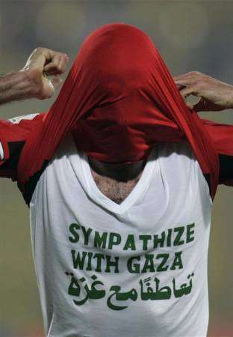
2 –May is the …………......month of the year.
3-A is the ………..letter of the English alphabet.
4-Monday is the ………….…day of the week.
5-F is the ….…….letter of the English alphabet.
6-Friday is the …….…..…..day of the week
❹Choose the correct answers:-
1-B” is the (third – second – first – fourth) letter in the English alphabet.
2-A dog is (a thing – a bird – a place – an animal).
3-The sack is full of (water – rice – milk – ice cream).
4-I (taste – smell – touch – hear) with my nose.
5-My father bought me a red (train – plane – bike – wolf) last year. I can ride it.
6-March “is the (fifth – first – second – third) month of the year.
❺Read the following and answer the questions: - The biggest dinosaurs were as big as ten elephants . The smallest ones were as small tiny chickens .Scientists found bones of a bird dinosaur in Jordan and
America. Those huge birds could probably fly from Africa to America. Answer the questions:-
1 – What is the passage about?
2 – Now dinosaurs are big or small animals?
3 – Now scientists are sure that there [were – weren’t – probably were – probably
weren’t ] dinosaurs in East .
4 – Did dinosaurs fly [great – weak – short – high] distances.
❻Fill in the spaces with words from the list: - fed – died – ate – fly – big – earth
The dinosaurs ……out a bout 65 million years ago. Some dinosaurs were very ……….. and some were small . The huge bird dinosaurs could probably………. from Africa to America . Most dinosaurs ……….on plants. Other dinosaurs ……..…….animals
ADJECTES الصفــــــــــــــــــات
9
Comparatives and superlatives المقـــــارنـــة و التفضيـــــــــل
أولا :- ما هـــــــي الصفــــــــة ؟ هـــــــي كلمـــة تصـــــف الاســـــــــم
1 - في حالة تساوي أثنين في صفة طويلة أم قصيرة توضع بين as .........................as
Yara is as tall as Ahmed Yara’s watch is as expensive as Ahmed’s watch
2 – في حالة المقارنة بين أثنين في صفة قصيرة نضع للصفة er و بعدها than مثل :-
Yara is taller than Ahmed.  Ahmed is shorter than Yara.
3 – في حالة المقارنة بين أكثر من أثنين في صفة قصيرة نضع للصفة est و قبلها the
Abdou is the tallest boy in the class.
مــــــلاحظــــــــات علي الصفات القصيرة :-
1 – إذا انتهت الصفة بـ e تحذف عند إضافة er أو es مثل :-
Arabic is nicer than English.
2 – إذا انتهت الصفة بحرف قبل الأخير حرف واحد فقط متحرك و كان التشديد يقطع علي الحرفالأخير تكرر
الحرف الأخير عند المقارنة بين أثنين أو أكثر من أثنين مثل :-
August is hotter than April.  He sham is the thinnest boy in the class.
3 – إذا انتهت الصفة بحرف y و سبقه حرف ساكن يحذف و تضع ier أو ies
English is easier than Arabic.
الصفـــات الطــــويلة

1 – عند المقارنة بين أثنين في صفة طويلة نضع more قبل الصفة و بعدها than
Yara is Mohamed’s more beautiful than Ahmed’s suit.
2 – عند المقارنة بين أكثر من أثنين في صفة طويلة نضع the most قبل الصفة .
Boxing is the most dangerous game.
- هذه صفات شـــــاذة . تحفــــظ كمـــا هــــي :-
Adjective الصفة | للمقارنة بين اثنين | للمقارنة بين أكثر من اثنين
Far بعيد | Farther than | The farthest
Good حسن | Better than | The best
Bad رديء | Worse than | The worst
Ill مريض | Worse than | The worst
Little قليل | Less than | The least
Much كثير ( للكمية | More than | The most
Many كثير ( للعدد ) | More than | The most
①Choose the correct answers:-
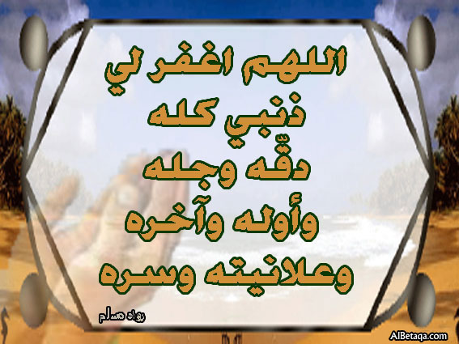
1 –A hippo is as (big – bigger – bigger – biggest) as a buffalo.
2 –A camel is (tall – taller – tallest) than a horse.
3 –The horse is the (fast – faster – fastest) animal.
4 –An elephant is (heavy – heavier – heaviest) than a buffalo.
5 –The giraffe is the (tall – taller – tallest) animal.
6 –A buffalo is as (strong – stronger – strongest)
as a cow.
①Choose the correct answers:-
10
1 Yara is [young – a young – younger – youngest] than Ahmed.
2 – My school is [large – larger – largest – the largest] that Ahmed’s school.
3 – Lesson two is [an – easy – easy – easier – easiest] than lesson one.
4 – Mona is [the beautiful – more beautiful – most beautiful] than Faten.
5 – Ahmed is [good – better – best – the best] than Mohamed.
6 – Yara is the [short – a short – shorter – shortest].
7 – This is the [nice – nice – nicest – a nice] toy in the toyshop.
8 – My school is the [a big – big – bigger – biggest].
9 – Science is the [more difficult – much difficult – most difficult] subject
10 – Ahmed is the [good – better – well – best] pupil in the school.
②Finish the sentences using ( as – than – the ) :-
1 – The black dinosaur is …………big as the hippos.
2 – The brown dinosaur is as tall ………….a giraffe.
3 – A cow is bigger ………………a goat.
4 – Yara is thinner ……………Ahmed. 5 – A goat is heavier …………a rabbit
③Choose the correct answers:-
1 – Ahmed is [strong – as strong – the strongest – stronger] than Yara.
2 – Science is [difficult – as difficult –the most difficult] as social studies.
3 – Heba is [happy – as happy – happier – the happiest] than Manal.
4 –Cairo is [noisier – noisy – the noisiest – as noisy] than Tanta.
5 –A wolf is a [dangerous –more dangerous than – most dangerous] animal.
6 –A buffalo and a donkey are all plant [eating – feeding – working] animals.
7 –There is thousand [tens – hundreds – thousands – millions] in one million.
8 –In Greek, dinosaur means [tiny – nice – terrible – small] lizard.
9 –Dinosaurs died [in – since – a bout – out] millions of years ago.
10 -A giraffe is [tall – taller – tallest – the tallest] than a horse.
11 –A donkey isn’t as [strong – stronger – strongest – the strongest] as a buffalo
12 –A dinosaur was as big as three [hippo – a hippo – hippos – the hippos] .
13 –But the rabbit is [small – smaller – smallest – the smallest] of those animals
14- [Someone – No one – Not every one] knows why the dinosaurs died out.
15 –An elephant is [heavy – heavier – the heaviest – heaviest] than a camel.
16 –Ahmed is [short – a short – shorter – the shortest] pupil in class.
17 –It is [cold – coldest – the coldest – cold] in January than in December.
18 – Cairo is [big – bigger – the biggest – bigger than] city in Egypt.
19- London is [cold – a cold – colder – coldest] than Cairo.
20 –The River Nile is [long – longer than – the longest] river
21-English is (easy – easier – as easy – easiest) as Algebra.
22-Algebra is (the most difficult – more difficult – as difficult) than English.
23-Science is the (easy – as easy – easier – easiest) school subject.
24-Weight lifting is (dangerous – more dangerous– as dangerous) than football.
25-Pin pong is the (safer – safe – as safe – safest) game.
①Read the following passage and answer the questions:-
11
The first dinosaurs lived 225 million years ago. The biggest dinosaurs
were as big as ten elephants . The smallest ones were as tiny as small chickens. Most dinosaurs ate plants. Others fed on animals. Scientists found bones of a bird dinosaur in Jordan and America. Those huge birds could probably fly from Africa to America. No, more dinosaurs are found now. They died out sixty – five million years ago.
A) Answer the following questions :-
1 – What is the passage about? 2 – What did dinosaurs eat?
B ) Choose the correct answers :-
3 – Dinosaurs died out [225 – 65 – 160 – 56] million years ago.
4 – Dinosaurs could fly [great – weak – strong – tall] distances
②Choose the correct word:-
1 – Dinosaurs died [away – out – down – off] 65 million years ago.
2 – There are no dinosaurs on the earth [that day – yesterday – today – one day].
3 – The biggest dinosaur was as big [than – more – most – as] a small plane.
4 – The bird dinosaur was as big [than – more – most – as a small plane.
5 – When the dinosaurs died out, other smaller animals had a better chance to
[die – die out – live – leave ].
③Read the following and answer the questions:-
No, dinosaurs live on earth today. They died out about 65 million years ago. Some dinosaurs were very big and some were very small. The huge dinosaur could probably fly from Africa to America. Most dinosaurs ate plants.
Questions :-
1 – Are there dinosaurs on earth today? 2 – Were all dinosaurs very big?
3 – What did they feed on? 4 – When did they die out?
④Choose the correct answer:-
1 – The dinosaurs is [the most – as - more – than] frightening animal.
2 – The lion is [more – most – as – the most] dinosaurs than a wolf.
3 – The cat is [more – most – as – the – more] dinosaurs than a mouse.
4 – A buffalo is [most – as – more – the most] useful than a cat.
5 – A cow is [as – more – the most – most] big as a buffalo.
⑤Supply the missing parts in the following dialogue between:-
Yara and grocer. Yara wants to buy five eggs, a kilo of sugar and a packet of tea:
Grocer : ………………………………. ?
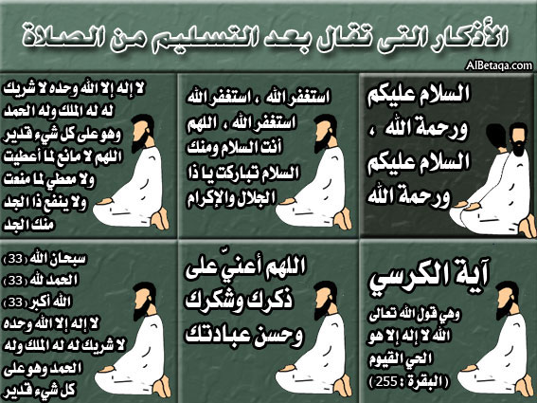
Yara : Yes, I want five eggs, please.
Grocer : Here you are . Anything else?
Yara : ………………………………?
Grocer : Here you are Anything else .
Yara : No, thank you…………………?
Grocer : Four pounds .
Yara : Here you are. Thank. Goodbye.
Relative clauses pronouns ( ضمائـر الـوصول)
127
This is Mr. Khaled who teachers us English.
تعمل ضمائر الوصل عمل الصفة فهي تصف شيئا ما أو شخصا ما
who – that – which – whose – where – when و تبدأ بإحدى ضمائر الوصل
❶Who – that – which (as subjects) .
 تستخدم هذه الضمائر كفاعل و في هذه الحالة لا يمكن حذف ضمير الوصل
Yara who studies hard gets high marks Yara ate tan apple that was in the fridge
❷Who – that – which (as objects)
و تستخدم كمفعول و في هذه الحالة يمكن حذف ضمير الوصل و الخاصة في المحادثات .
Ahmed likes the shirt which I wear Ahmed likes the shirt I wear.
 لا حـــظ الأداة whose تحل محل ضمائر الملكية [ his – her – their – its ]
This is the car whose driver is foolish.
تستخدم where للمكان و when للزمان .
We have a nice garden [where – that – which] we can play.
September is the month [who – when – that] school begins.
①Choose the correct answer:-
1-Cotton is a material (that – who – where) is used for making clothes.
2-August is the month (where – which – when – why) we go to Axel.
3-I don’t know (why was Ahmed – why Ahmed was late – why is Ahmed late)
4-The teacher is the man (where – who –whose) explains the lessons to us.
5-Ahmed was the captain of the ship (who – which – where) came near the coast.
6-Here is Ahmed (who – whose – which – where) hand was slightly burnt.
7-That is the rope (which – whose – who – whose) he pulled the air
8-Yara will tell you about the film (who – whose – which – when) I saw last right
9-Yara likes the kite (which – where – whose – who) Ahmed has made.
10-Do you know the player (which – when – who) has just scored a goal?
11-That is the farmer (who – whose – where) wish is to see his son a doctor.
12-Yara gave you the book (who – whose – when – which) her father wrote
13-I’ll (write – wrote – writing – writes) a letter to my pen friend soon.
14-This is the house (which – who – whose – where) he lives.
15-A car (which – whose – who – where) is new, is expensive.
16-An engineer is a person (when – what – which – who) has studied engineering
17-Ahmed (who – where – whose) you meet on your way to school is my friend
18-A dictionary is a book (who – where – which) gives the meanings of words
②Finish the sentences with words from the list:-
(When – whose – where – who – that)
1-A friend is the person …………… I can talk to when I have problems.
2-This is a book …………………… I keep in my school bag.
3-Alexandria is a place ……….…… lots of people spend their summer holiday
4-My birthday is the day …………. I was born.
4-My father is the person ……….…wife is my mother.
①Put who or that following sentences:-
1 –A secretary is person ………..types letters.
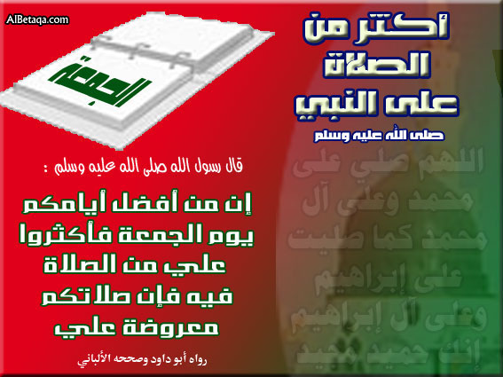
2 –The farmer killed the dog ………chased his son.
3 –The car …………..Khaled bought is very new.
4 -Yara ate some dates …………..were in her.
5 –Mr.Khaled ……….lives in Mahallet Bisher teachers us.
6 –A baker is a person ………..bakes bread.
7 –A fruit seller is a person …………sells fruit.
8 –A bookseller is a person ………… sells books.
9 –A photographer is a person ………….takes photographs.
10-A footballer is a person …………..plays football.
11 –A butcher is a person ………..sells meat.
②Read the passage and answer the questions:-
Once upon a time, two brothers lived on a farm. They grew fruit and vegetables in their fields. They had a donkey, a cow, five goats and some chickens. They looked after the cow and it gave them milk. The chickens gave them eggs every day.
13
A- Answer the following questions:-
1 – Where did the two brothers live? 2 – What do cows give us?
B – Choose the correct answer:-
3-The two brothers got eggs from (the market – their farm – their chickens)
4-The two brother had ( two – seven – five – four ) animals .
Language Functions
Excuse me : لو سمحت – عفوا – معذرة
( تستخدم عندما نريد أن نبدأ حديثا مع شخص لجذب انتباهه بأسلوب مؤدب )
Offering help عرض - تقدم المساعدة
Would you like me to + فعل ?  Do you want me to + فعل ?
Shall I + فعل ?  Can I + فعل ?
Would you like me to clean the blackboard?
Do you want me to draw a cat ?
Shall I carry those books for you? Can I carry this bag for you?
a) Accepting help: قبول المساعدة Yes, please. * Oh, thank you very much.
b) Refusing help: رفض المساعدة No, thanks.
③Make questions for these answers:-
1-Yara’s shirt is twenty pounds. ……………………………………………..…?
2-Ahmed is one meter tall. …………………………………………………...…?
3-Ahmed’s brother is called Mohamed. …………………………………...……?
4-Alaa, Yara and Amal stayed in Alex for a week. ………….………….………?
5-They went to the museum last week. ………….………….……………..……?
6-Sara bought a new car last year. ………….………….…………………….…?
7-We invited them for lunch three days ago. ………….…………….….………?
8-No, Mr.Khaled teaches us English. ………….…………………….….………?
①Read and correct the following sentences.
14
Corrections | Mistakes
...........................  ...........................  ...........................  ...........................  ...........................  ...........................  ............................  ...........................  ...........................  ...........................  ............................ | 1-Lions are the stronger animals on land.  2- A mouse is the smaller a camel.  3-This film is the more interesting one.  4- Tafeed is the cleverest than Tafeeda.  5-Lions are the biggest animals on land.  6-A tyrannosaurus ate other birds.  7-An iguanodon walked on its front legs with the help of a big tail.  8-A brontosaurus ate plants and sandwiches all day.  9-A clown makes people cry.  10-Heba is as fatter as Amany.  11-Reading is my very bad hobby.
لاحظ مايلى جيدا:للسؤال بمعنى اى v to be +………………..? +الفاعل+Which
Which building is more ancient?  Which boy is clever?
How + الصفة + ………………………………..? How easy is English?
للمقارنة بين اثنين غيرمتساوين فى صفة واحدة as………….. +(الصفة ) not so\ as+
Ahmed is not so (as) short as Mohamed = Mohamed is shorter than Ahmed
Ahmed is taller than Mohamed  =they are not the same.
1-Wafaa is not so (as) fat as Saida  =………………………………....
 = ……………………………………  =…………………………………
للتعبير عن عدم امكانية شخص لتحقيق شى معين نتيجة لسبب ما نستخدم الاتى:
(الجملة الدالة على النتيجة)
+فعل+ فاعل-1So(صفة او حال )that+ فاعل+فعل
1-Ahmed is very clever .He can answer the question.(so……….that)
Ahmed is so clever that he can answer the question.
+فعل+ فاعل-2too+ (صفة او حال ) to+ فعل فى المصدر(اذا كان الفاعل واحد)
1-Ahmed is so ill that he can't go to his institute.
Ahmed is too ill to go to his institute.
+فعل+ فاعل-3too+ (صفة او حال )+for++الاسم to+ فعل فى المصدر (اذا كان الفاعل مختلف)
1-The question is so difficult that Ahmed can't answer it.
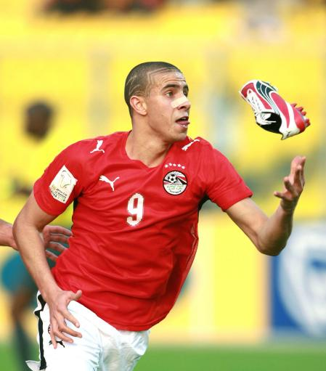
 The question is too difficult for Ahmed to answer it.
②Choose the correct answer.
1-Ahmed is too ill (two-too-to) go to institute.
2-The question is too difficult (to- to-too-for) Ahmed to answer.
3-Ahmed is clever (too-enough-to-for) to succeed.
4- He is (as-so-too-enough) clever that he can answer the exam.
5-He is too short (too-enough-to-for) touch the ceiling.
6-Manar is happy (too-enough-to-for)to sing.

Unit
15
سلسلةYARA
15
Stories and famous people

probable محتمل | statueتمثال | Religionدين | magic سحر
such asمثل | retire معاش | prayيصلى | get intoيركب
personشخص | without بدون | solider جندى | engineمحرك
anyone اى فرد | scientists علماء | B C قبل الميلاد | bootيركل بقوة
leader قائد | temple معبد | A D بعد الميلاد | primaryابتدائى
Study the following))
حروف الجر ( By – at – on – in )
1–b- تستخدم مع وسائل المواصلات المنوعة ( car – bus – plane )
2- و تستخدم on مع وسائل المواصلات الطبيعية on – horse back – on foot .
3 -at تستخدم مع الساعات at six o’clock وكذلك مع at night – at noon .
4-in تستخدم مع فترات اليوم الزمنية مثل in the morning – in the evening -afternoon .
لاحظ أن حرف الجر on يستخدم مع أيام الأسبوع on Monday و مع الشهر إذا جاء معه تاريخ .
Choose the correct word:-
1–The tourist will arrive (on – at –to) Cairo – Airport (on – at– to) eleven night.
2–It rains (on – at– to) winter and we don’t go to school (on – at –to) Friday.
3–We get up (at – in – on) six o’clock (in – on – at) morning.
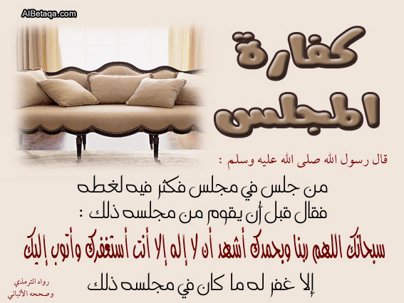
4–Salma will arrive (in – at – to – on) school at seven o’clock.
5–I go to school (on – by – to) taxi or (on – at – by – to) foot.
6 –I get (at – up – to – down) at seven o’clock.
7 –My sister goes (at – from – to up) bed at nine thirty.
8 –Nadia will arrive (on – up – at – to) school at seven thirty.
9 –After school, we (go – play – do – have) home.
10-Marwa will have lunch (in – on – at – up) one o’clock.
11 –Ahmed will (use – do – have – go) supper at eight thirty.
لاحظ مايلى جيدا:-
) v + ing ) ياتى بعدها ( because ) اما )ياتى بعدها الفاعل ثم الفعل because)- 1
1-Ahmed succeeded because he studied very hard.
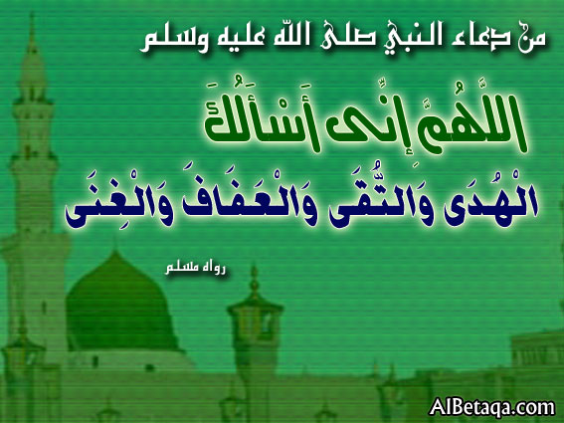
2-Ahmed succeeded because of studying very hard.
 فاعل +see+شخص+v + ing( (تعنى اننا شاهدنا الحدث من منتصفة
1-I saw Ahmed playing football. 2-We saw him running.
 فاعل +see+شخص+to + مصدر(يعنى اننا شاهدنا الحدث كاملا (.
1-We saw Ahmed to play football. 2-I saw you to write.
 Ahmed should respect the elders تستخدم للنصيحة بمعنى يجب should -1
Shouldn't -2 تستخدم للنصيحة بمعنى لايجب Ahmed shouldn’t waste his time.

Question tag
16
التكــوين :- يتكون السؤال المذيل من الفعل المساعد أو الناقص وضمير الفاعل .
1-Does he ? ?Is he ? Won’t you ?
إذا كان الفعل الرئيسي مثبت يكون السؤال المذيل منفي والإجابة المتوقعة هي " Yes "
ضمير الفاعل + فعل مساعد أو ناقص منفي ===== جملة مثبتة
1-The manager arrived late, didn’t he? “Yes “, he did.
2-It’s hot today, isn’t it? “Yes “it is “ .
إذا كان الفعل الرئيسي منفي ويكون السؤال المذيل مثبت والإجابة المتوقعة هي " no " :-
ضمير الفاعل + فعل مساعد أو ناقص مثبت ==== جملة منفية :-
1-Ragab won’t come to the party, will he? 2-Salah hasn’t bought a car, has he?
3-You don’t speak English, do you? 13-We shall save him, shan’t we?
Look and study
1-This (that) is your book, isn’t it? 2-These (those) are yours, aren’t they?
3-There is a meeting today, isn’t there? 4-Everything is all right, isn’t it?
5-Everyone took the test, didn’t they? 6-I am surprised to be here, aren’t I?
7-Don’t, make any noise, will you? 8-Let’s sit in the garden, shall we?
9-I’m coming with you, aren’t I? 10-Let’s leave, shan’t we?
11-Let us leave, won’t you? 12-Ahmed’s sold his flat, hasn’t he?
❶Choose the correct answer:-
1-This car is very expensive,[ isn’t it –isn’t this car – doesn’t it – is it ] ?
2-Yara can’t read, [isn’t she – doesn’t she – can she – can’t she]?
3-They arrived late, [don’t they – didn’t they – weren’t they – weren’t them]?
4-Amgad will visit us tomorrow, [will he – won’t he – wasn’t he – doesn’t he]?
5-Ahmed won’t come to the party, [will he – doesn’t he – isn’t he – can’t he]?
6-Yara didn’t tell me anything, [did you – did she– were you –was I]?
7-Maher doesn’t like teacher, [is he – does he – does Maher – likes he]?
8-I don’t know French [am I – do I – do you – are you]?
9-You’d better meet him, [hadn’t you – wouldn’t you – hadn’t I – wouldn’t I ] ?
10-Let us go, [shall we – won’t we – won’t you – do you]?
11-I haven’t done it yet, [have you – have I – do I – do you]?
12-You were late this morning , [didn’t you – didn’t I – weren’t I - weren’t you ] ?
13-I’d rather have some coffee, [hadn’t I–wouldn’t you –wouldn’t I ] ?
❷Add question tags to the following :-
1-They want to come, ………………..? 2-Mon and Nadia won’t be here ,…….…
3-You’ve never been to Pairs,………? 4-Mona ‘ll help us later ……………….…
5-Nobody cheated in the exam,………? 6-Ever thing is wrong today ,…………….
7-I am invited , ………………….… .? 8-Yara is there ,…………………………
9-Yara went to the cinema,…………? 10-We must obey our parent,……………..
11-We are happy,……… ………… ?
12-Books are very useful,…………..……

Read the following
17
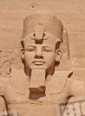
( King Ramses)
Ramses lived 3300years ago.He was a king of Egyptfor 66
years. He was called Ramses the Great .We don’t know
when and where he was born.He became king in1279B C .
He married Queen Nefertari and had lots of children .He
built many temples .Abou simble is the most important
temple,which he built.He died in 1213 B C .There are
many enormous statues of Ramses in Egypt.
Queen Nefertari
Queen Nefertiti is one of the most famous ancient
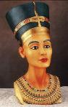
Egyptions .she lined 3400 years ago.Her father was
probably a solider but we don’t know her date ob birth or
where she was born Nefertiti husband was called Akhenaton
He became king of Egypt for seventeen years until he died in
1336BC..They had six daughters but no sons.Queen Nefertiti
lived at atime of change .She is important because she helped
Akhenaton with a new religon in Egypt .in 1349Bc, they
changed their names because of their new religon. Nefertiti is ofetn called the most beautiful wamon in the world.Somepeople think Nefertari died in Akhenaton’s fourteen years as a king , one year after the death of her daughter.
①Read the following then answer the questions.
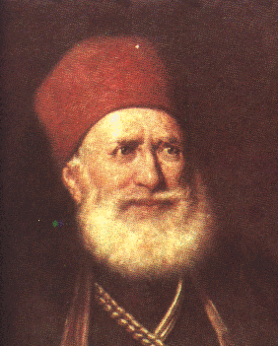
Mohamed Ali is a very important leader in the history
of Egypt .He was leader of Egypt from 1805 to 18048.He
was born in Albania in 1769 his father died when he was
a boy and he become a soldier for Turkey .He arrived in
Egypt with Turkish soldiers in 1798.Mohamed Ali built
lots of new buildings such as Alsun School and the
Mosque of Mohamed Ali.
Answer the following questions.
1-When did Mohamed Ali arrive in Egypt?……………………………………..
2-Where was Mohamed Ali born? ……………………………………..………..
Choose the correct answer.
3-Mohamed Ali became a leader of Egypt in (1789- 1769- 1848-1805).
4-Before he came to Egypt, Mohamed Ali was a (teacher- soldier- doctor).
5-Mohammed Ali's (father– wife- son) died when he was a boy.
②Read and match.
1- Mohammed Ali arrived in Egypt a- Egypt in 1805.
2-Ramas became king of b- a famous mosque.
3-Mohamed Ali became king of Egypt c- with Turkish soldiers in 1798.
4-Mohamed Ali built. d- Egypt in 1279B C.
5-Ramses was king off Egypt e- for sixty –six years.
①Choose the correct answer.
18
1-Akhenaton became a (king-queen- prince) in1353 BC.
2- Because of her beauty , Nefrtiri is often called one of the most
(beautiful- rich- tall) woman in the world.
3-Nefertirti ,s father was probably a ( doctor- teacher- solider)..
4-Nefertari helped Akhenaton with a new (job- science-religon) in Egypt .
5- Mohammed Ali was leader (on-in –for-of) Egypt from 1805 to 18048.
②Read and correct the following sentences
Corrections | Mistakes
...........................  ...........................  ...........................  ...........................  ...........................  ...........................  ............................  ...........................  ...........................  ...........................  ............................ | 1-Ramses lived 3300years for.  2-Where is Mohamed Ali born?  3-Mohamed Ali arrive in Egypt at 1789.  4-Mohamed Ali built a famous museum of Mohamed Ali.  5- Moh.Ali is a very important leader in the geography of Egypt.  6-Mohamed Ali was a good teacher.  7-Ahmed went to Alex, doesn’t he?  8-Ahmed goes to institute, does he?  9-Ahmed will go on foot, didn’t Ahmed?  10-Ahmed visited Cairo, isn’t he?  11-Ahmed visited Cairo, hasn't he?
④Make question to these answers.
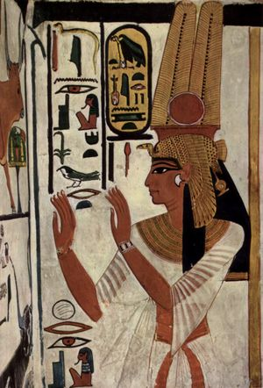
1-Mohamed Ali built a famous mosque in Egypt.(What).
……………………………………………………………………………
2-Ahmed and Mohamed was born in Mahallet Bisher.(Where).
……………………………………………………………………………
3-Akhnetaton ruled Egypt for 17years.(How long).
……………………………………………………………………………
4-Mohamed Ali became a leader of Egypt in 1805.(When)
……………………………………………………………………………
5-Mohamed Ali was born in Albania. . (Where).
……………………………………………………………………………
6-I am going to play football on Monday (When).
7- She was born in July.(In which). ……………………………………………………………………………
8-He succeeded in the exam because he studied hard(Why)
……………………………………………………………………………
9-Nefertiri and Akhenaton changed their name because of their new religion.(Why
……………………………………………………………………………
10-Our lesson started at 10 o, clock. (When)
……………………………………………………………………………

①Finish the following dialogue with words from the list.
19
(Soldiers – die – lived – Albania - famous).
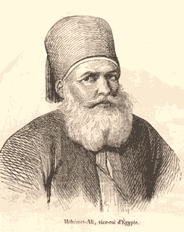
Ahmed :Where was Mohamed Ali born?
Mohamed :………… …1……………….
Ahmed : Who did he come to Egypt with?
Mohamed :With Turkish ………………….
Ahmed :What did he build in Egypt?
Mohamed :He built a………………mosque.
Ahmed :When did he……………………?
Mohamed :in 1849.
②Choose the correct answer.
1-(Ramses- Nefertiti- Akhenaton) became king of Egypt in1279 BC.
2-Teachers (retire- resign- think) at the age of sixty.
3-We should be (angry- pleased- helpful) to our neighbours.
4-The (ancient- modern- new) built the pyramids.
5-She can fry fish, (can-can not-can't) she?
6-He lived at a time of great (change- idea- history).
7-In about 1353BC, Akhenaton (became-becomes- become).
8-Ahmed (didn’t –is- was not) late for the chemist, was he?
9-Yara thought, she was late for her institute, (doesn’t-wasn’t – didn’t) she?
10-Mohamed (doesn’t didn’t did) have time for tea, didn’t he?
③Look at the picture and write more sentences.
Soldier- built- died.
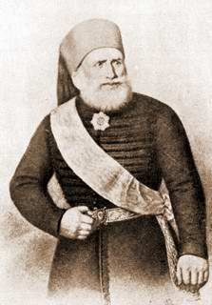
...................................................................................
...................................................................................
...................................................................................
...................................................................................
...................................................................................
④Punctuate the following.
1-where was mohamed ali born 2-mohamed ali arrived in Egypt with Turkish
………………………………… …………………………………………
3-nefertiri helped akhenaton. 4-akhenaton died in 1336bc
………………………………… ………………………………………
⑤Supply the missing parts in the following dialogue.
A-What was the name of Nefertiti's husband? B-………………………………….
A-…………………………………………...? B-He was born in Albania.
A- They haven’t listened to music, have they? B-………………………………….
A- …………………………………………? B-I leave for school at half past ten.
A-………………………………………....? B- He ruled Egypt for 17 years.
A-When did Akhenaton become a king? B-………………………………….
A-………………………………………?
B-No, he hasn’t
Unit
16
سلسلةYARA
20
Changes

check يتاكد | abroad خارج | preparatory اعدادى | list قائمة
writing كتابة | decideيقرر | difference اختلاف | toysلعب
grow up يكبر | cover يغطى | environment البيئة | club نادى
fly to يطير الى | menu قائمة | paragraph موضوع | blind اعمى
healthy صحى | Both...andكلا من | put away يضع فى مكاتة | great عظيم
لاعطاء التعليمات
(Go out- Be careful )1- نستخدم المصدر لاعطاء التعليمات المثبتة
2- نستخدم المصدر المنفى لاعطاء التعليمات المنفية ( المصدر + Don’t )
1-Don’t waste you time .2-Don’t be childish 3-Keep quite 4- Open the door.
①Choose the correct answer.
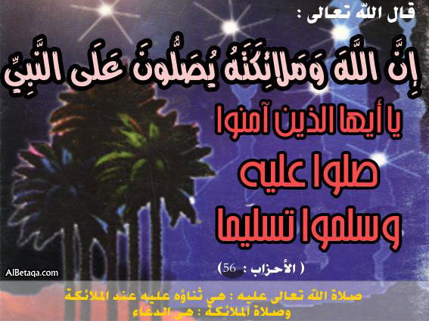
1-The teacher told Zeyad (not to-to that if) waste his time.
2-The teacher told Zeyad (not to-to that if) study hard.
3-If I (was-were-is-are) you, I would study hard.
4-You had better (getting-get gets) up early.
5-You (had- shouldn’t should- better) be back late Come early.
6-My mother told me (to –not to-Don’t didn’t) touch the hot pan.
7-She had (better- rather- together) tell me the truth.
8-Ahmedwas upstairs (drinking- moving- eating- preparing) a room for the guest.
9-We have to (concentrate- study- need- receive) on the job we are doing now.
10-The opposite of rude is (careful-tolerant –active –polite).
②Finish the following dialogue with these words:-
(Museum- nationality- important- cooking- photograph.)
Ahmed : Have you met an………………person this year?
Mohamed: Yes, I have.
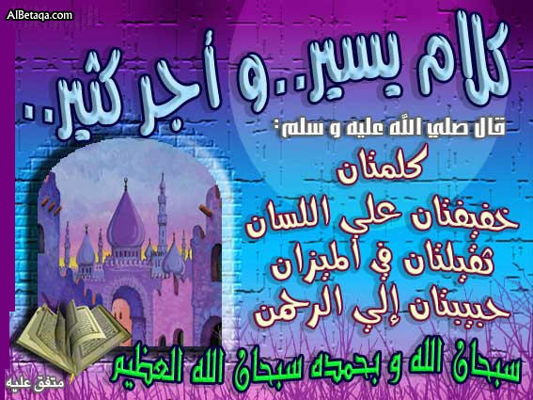
Ahmed : Where did you meet him?
Mohamed: Near the Egyptian museum
Ahmed : What is his………………………?
Mohamed: Japanese.
Ahmed : What was he doing?
Mohamed: He was taking some………………
.
لاحظ ان (v. to. have) يمكن استخدمة كفعل اساسى بمعنى يملك اذا جاء بمفردة.
Ahmed has a car.2- We have another computer.3- I have a nice mobile.-1
اما اذا جاء بعدها (تصريف ثالث) فايكون فعل مساعد1- Ahmed has bought a new computer
THE PRESNT PERFECT SIMPLE TENSE المضــارع التــــام
21
1-يعــبر:- عن حدث وقع منذ قليل :- أو حدث بدأ في الماضي ولا زالت آثاره حتى الآن .
2-يتكون من :- have + P P 1 – وضمائر و أسماء الجمع .
has ضمائر المفرد وكذلك أسماء المفرد الغائب .
3 – كلماته :- حديثا - حتى الآن –لمدة- منذ - إبدأ - دوما - توا - فعلا
already -just -every- never - since - for - yet – recently

لاحـــــــظ / أن المضارع التام يؤكد علي حدوث الفعل و لا يهتم أو يحد متى حدث هذا الفعل .
Yara has eaten her food.  Yara and Noha have visited Alexandria.
لاحــــــظ أيضا أننا نستخدم / never أو ever لكي نسأل أو نتكلم عن خبرة سابقة .
Has Yara ever seen the pyramids?  No, she has never seen the pyramids.
لاحـظ أيضا أنه إذا جاء معsince زمن واحد يكون مضارع تام Yara has slept since six o'clock اما إذا جاء معها زمن يكون الذي يأتي بعدها مباشرة ماضي بسيط والأخر مضارع تام .
(ماضي بسيط since X مضارع تام) -2 ( مضارع تام - ماضي بسيط since) -1
We have studied since Mr. Khaled hit us.
Mr. Khaled has explained since he arrived
لاحــظ أيضا أن الكلمات تأتي بين الفعل المساعد و التصريف الثالث Just - already – ever never
Yara and Rana have just arrived. Wafaa and Saida have never eaten frogs.
لا حــظ أيضا جيدا / إذا جاءت ever في السؤال تحول عن الإجابة بكلمة No إلي كلمة never .

أما إذا كانت الإجابة بكلمة Yes تبقي كما هي مثل :- ①Has Mr. Khaled even hit you?

 No , Mr. Khaled had never hit us . Yes, Mr. Khaled has ever hit us .
لاحــظ أيضا أن الماضي البسيط يعطي التأكيد علي حدوث الفعل في الماضي و عادة يحدد الزمن الذي حدث فيه :-
Yara and Asmaa quarreled yesterday.
كيــــــف تختـــار ( since – for – yet – ago )
انتبــه جيــدا: أننا لا نستخدم كلمة (ago) مسبوقة بفترة زمنية إلا في زمن الماضي البسيط منفي أومثبت
 Amal didn’t eat any thing two days ago .Mr. Khaled hit Yara the days ago .
 | Since بالنسبة لـ |  | For أما بالنسبة
Since | 1998 – May – Monday  then  yesterday  last + فترة زمنية  o’clock وأجزائها |  | Day – month –year  The last + فترة زمنية  A week  hour وأجزائها  along time فترة زمنية + اوعدد
أمـــا بالنسبة لكلمة yet فقط تستخدم في الجملة المنفية مثل :-
Yara hasn’t known English yet.Has Soha asked Mr. Khaled yet? أو في السؤال
Choose the correct answer:-①
1 –Yara [haven’t – hasn’t] seen you since last week.
2 –Eman [was – bas been – is] in Cairo [for – since] two years.
3 –Sara has [since – never – yet] played in the street.
4 –Abeer has studied hard [since – for – never]
last year.
①Put (since - for - yet-ago ) :-
22
1-Yara hasn’t seen Wafaa …………. 2 –Yara has been ill ……….year.
3-Ahmed didn’t play three days ………….. 4 – I haven’t eaten ……….two days
5-Yousif hasn’t eaten ………….. 6 – I have studied English ………..1991.
7-Huda wants to study here ………….an other week.
8-This school was built ten years ………….
9-Amany hasn’t bent arm’s Salma ………..Mr. Khaled beat him.
10-Mohamed didn’t write his lesson two days …………
11-Mona hasn’t slept ………….Marwa burnt her books.
12-Ahmed has played football …………..8 o’clock.
13-Amina has wept …………...she lost her pens.
14-Eman has eaten …………....hours. 15 –I have been sad ……..I stole her shoes
②Choose the correct words:-
1 –The farmer is [feeding – picking – collecting – ploughing] the filed.
2 –The woman is [planting – mending – feeding – watering] the cow.
3 –The mechanic is [mending – cutting – breaking – ploughing] the car.
4 –Asmaa is [feeding – ploughing – picking – mending] the fruit.
5 –The man is [mending – watering – feeding – eating] the flowers.
6 –The girl [didn’t finish – don’t finish – hasn’t finished] her homework yet.
7 –The students have [write – wrote – written – writing] the new lesson.
8 –The mechanic hasn’t mended the car [too – yet – ago – already].
9 –Marwa [have – has – is – was] mended the roof of his house.
10 - Chosen ‘is the past participle of [change – chase – choose – check].
11 –I’ve [write – written – wrote – writes] two lessons.
12 –Where did you [find – found – finds – finding] my bag?
13 –Shymaa [draw – drown – drawn – drew] a picture yesterday.
14 –Have you ever [ridden – rode – ride – rides] a camel?
15 –[Did – Have – Will – Do] you ever drawn a picture? – Yes, I have.
16--What [have – are – haven’t – did] you draw?
17 –[What – Where – When – who] did you draw it? – Last week.
18 –[Where – Who – When – What] did you draw it? – At school.
19 –Have you ever [be – being – been – to be] to Paris?
20 –Have you [write – wrote – written – writing] anything today?
21 –[Where – What – When – Why] did you write the letter? – Yesterday.
22 –I’ve [lend – lending – lends – lent] Wafaa a pen.
23 –What did Amira [draw – drew – drawing – drawn] – a picture of a cat.
24 –Adel [have – hasn’t – has – doesn’t] mended his bike yet.
③Punctuation: -
1-i havent met mohamed yet 2-i have been learning english since 1990.
………………………………… ……………………………
3-yara has been helping asar at home 4-have you been helping football .
………………………………… ……………………………………
①Read the following passage and then answer the questions:-
23
Goha’s neighbour wanted to know what Goha was doing. Every day
he watched Goha from the window . In the morning and in the evening,
Goha went into the street outside the house. He walked backwards and forwards, moving his arm from side to side. So the neighbour decided to find out what Goha was doing. He put his head out of the window. Again, Goha was walking backwards and forwards in the street. “What are you doing?” He asked. “I’m watering the flowers “said Goha. “ But I can’t see any water. “Said the neighbour.” Well, can you see any flowers? “Said Goha.
Questions:-
1-What did Goha do every day? ……………………………….………………
2-What did the neighbour decide to do? …………………….…………………
Choose the correct answer:-
3-A neighbour is a person who lives [next door – far away– on a farm].
4-Goha said he was [watering flowers– moving his arm from side to side]
5-In fact, Goha was watering [some plants – nothing – flowers – a new crop].
②Rearrange the following sentences:-
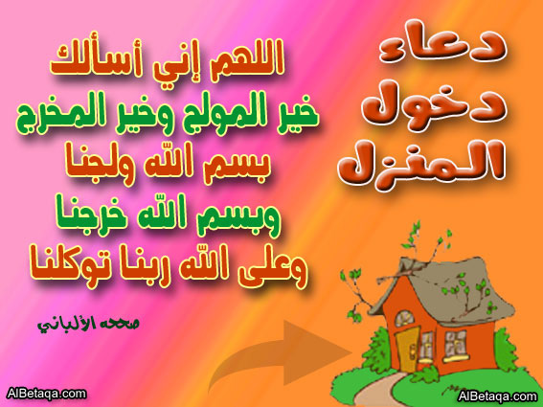
1 – has – living – in – He – for – been – town – this – years – six .
……………………………………………………………….
2 – 1995 – since – His – has – travelling – brother – been .
…………………………………………………………………
3 – three – They - - Playing – been – have – football – hours – for .
…………………………………………………………………..
1 – read – the – book – new – Let’s .
………………………………….………………………….
2 – eggs – a lot of – hens – The – laid .
……………………………………………………………...
3 – My – greedy – rich – became – neighbour – but – he – is .
………………………………………………………………
③Read and match.
1-Students have written menus a- her blind neighbour.
2-We have decided to b-walked to school for a month.
3-I've used the internet to learn c- try new sports.
4-Wafaa has decided to help d- more a bout healthy food.
5-Students in menu class have e- for healthy lunches.
g- about the environment around the world
④Supply the missing parts in the following dialogue.
A-Have you tried any American food? B-…………………………………………
A-Yes, I have read the story B-………………………………………..?
A-…………………………………..? B-It costs L.E320 pounds.
A-No, She hasn’t moved to a new flat. B-……………………………………..…?
A-……………………………………? B-Yes, he has ever been to London.
لآحظ جيدا مايلى
24
Ahmed has been to Cairo and came back (( ذهب وعاد
 Ahmed has gone to Alex and still there.(ذهب ولم يعد اى مازاال هناك)
①Read and then correct the mistakes.
Corrections | Mistakes
...........................  ...........................  ...........................  ...........................  ...........................  ...........................  ............................  ...........................  ...........................  ...........................  ............................ | 1-Ahmed have been to Cairo for last week.  2-She already has tried a new sport.  3-Studied your lesson , Ahmed.  4-have he tried anew sports?  5-we have see an accident  6-ahmed ,s been to cairo and still there.  7-have you hear me?no, I hasn’t .  8-they haven’t never eaten in a big restaurant.  9-ahmed aleady has bought a new cd.  10-the stusents take to their teacher.  11-i decided at learn about healthy food.
② Read the story of the wolf’s Supremes, then choose the correct:-
One day a wolf fell into a hole in the woods. Just then, a monkey came along. The wolf promised not to eat the monkey if he helped him out of the hole. So, the monkey helped the wolf to get out of the hole .But when he was safe, the wolf said he would eat the monkey. Just then a tortoise came along. The tortoise said, “Show me what you were doing when the monkey helped you. “ So the wolf got back into the hole. The clever tortoise and the monkey went away, leaving the wolf in the hole.
Questions :-
1 –The wolf was [clever – dangerous – kind – right].
2 –The wolf asked for help because it [went to- fell into – got out of] a big hole.
3 –The monkey [ate – didn’t help – promised – helped] the wolf.
4 –The [tortoise – wolf – monkey – donkey] didn’t keep its promise.
5 –The tortoise [ate – promised – helped – left] the monkey.
③Write questions to these answers.
1-Ahmed does his homework at four o'clock. ( When)
…………………………………………………
2-Ahmed can't drink tea as it is very hot. (Why).
…………………………………………………
3- It is twenty pounds. (How much)
…………………………………………………
4-Ahmed has written a letter (How many)
…………………………………………………

Unit
17
سلسلةYARA
25
We've been very busy

rememberيتذكر | nationalityجنسية | exit خروج | busy مشغول
compass بوصلة | Olympicالاولمبية | vowelsمتحرك | during خلال
passport جواز سفر | mosque مسجد | consonant ساكنة | capitalعاصمة
stay يقيم | temple معبد | language لغة | entry دخول
double يتضاعف | continent قارة | example مثال | map خريطة
Study the following
(Famous)مشهور ولاياتى بعدها حرف الجر اذا لم يذكر الشى المشهور بة
 I read a famous book about Abou TreikaِAlexandria is a famous city
(Famous for)مشهور واياتى بعدها حرف الجر اذا ذكر الشى المشهور بة
1-Giza is famous for its Pyramids 2-Alexandria is famous for its old building
1-What is the capital of………………………?للسؤال عن العاصمة نقول 
2-What is the nationality of people from\of…? للسؤال عن الجنسية نقول 
3-What language do they speak in………..…? للسؤال عن اللغة نقول
Direction الاتجاهات الاصلية

شمال North
Northeast
Northwest
شمال شرق شمال شرق

شرق East غرب West
Southeast
Southwest
جنوب شرق جنوب شرق

South جنوب
لتحديد موقع مدينة من مدينة اخرى او دولة من دولة اخرى على الخريطة نستخدم:- 
مدينة)+is+اتجاة +of+مدينة اخرى)
1-Benha is north of Cairo. 2-Libya is west of Egypt.
3-Italy is northwest of Greece. 4-Siwa is west of Cairo
ولتحديد موقع مدينة داخل دولة: 
مدينة)+ is + in the+اتجاة +of+دولة )
1- Alexandria is in the north of Egypt. 2-Aswan is in the south of Egypt.
للتعبير عن التوريخ نستخدم الصيغة التالية:-( العام-الشهر+of +اليوم (on+
(17-10-1980.) On the seventh of October ,nineteen eighty -one
①Fill in each space with [since or for] :-
26
1 –I have written letters ……………..two o’clock.
2 –I have written letters ……………..two hours.
3 -Yara has not been to Tanta ……....1985.
4 –Ahmed has not been to Tanta ……ten years.
5 –We have studied English ………...about three years.
6 –We have studied English ………..1993.
②Compete the missing parts in the following dialogue:-
Teacher : Ahmed …………….1…….…………
Ahmed :I play chess, sir .
Teacher : Oh, really ? That’s interesting. Who taught you to play chess?
Ahmed : …………….………2…………….……
Teacher : ……………………..3…………………?
Ahmed : Since I was ten.
③Read the following and answer the questions:-
Ahmed’s institute is very big. It has a wide playground. It has many classrooms. There is a room for the headmaster and two rooms for the teacher. There is also a school shop that sells sandwiches, notebooks, sweets, pens and pencils,. Don’t go to school on Friday .The school has three big doors, one for the boys and girls, and the others for the headmaster and the teachers. Last Saturday Yara was late for school because he works up late.
Questions:-
1 –What can pupils buy at the school shop?…………………………………….
2 –What happened last Saturday? …………………………………………..….
3 –Yara doesn’t go to school on [Sunday – Saturday – Friday – Tuesday].
4 –There are [three – two – four – six] doors for teachers in Ahmed’s institute
④ Punctuate the following:-
1-what would you like to eat . 2 - id like to eat rice and vegetables ………………………………….… ………………………………….…
3-would you like to drink lemon juice 4 - no thank you .
………………………………….… ………………………………….…
5-he ll be in alexandria next week. 7-she said i want a kilo of macaroni
………………………………….… ………………………………….…
⑤Finish the following dialogue with these words.
Capital- English- have- London- nationality.
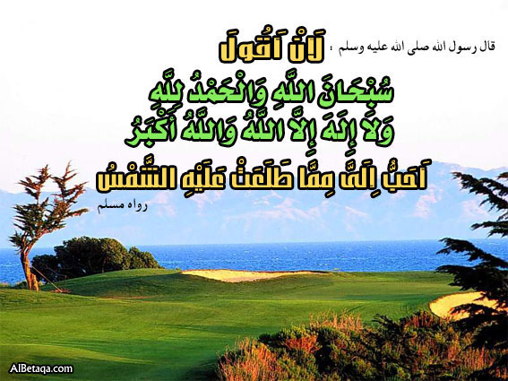
Ahmed :Have you ever been to Britain?
Mohamed :Yes, I……………………..….
Ahmed : What's the ………………of Britain?
Mohamed :…………….is the capital of Britain
Ahmed :What Language do they speak in Britain?
Mohamed :They speak………………………..

تكوين السؤال فى المضارع التام
27
( اولا اسؤال بدون اداة) (ثانيا السؤال باداة مناسبة)

1-( اولا اسؤال بدون اداة) (بهل) هو السءال الذى يبداء بفعل مساعد (Has- Have ) .وتكون الاجابة علبة ب((Yesأو( No )وفى السؤال نحذفهما ونقدم الفعل المساعدعلى الفاعل.
1-Yes,I have ever seen him or No, I have never seen him.
 Have you ever seen him?
لاحظ عند وجود ever فى السؤال عند الاجابة ب No تحول الىever اما عند الاجابة ب Yes تبقى كما هى دون تغير.
2-(ثانيا السؤال باداة مناسبة)و يكون شكل السؤال كالتا لى:-
1-Ahmed has changed his mobile What has Ahmed changed?
2-We have bought a new house.  What have you bought?
①Write question to these answers.
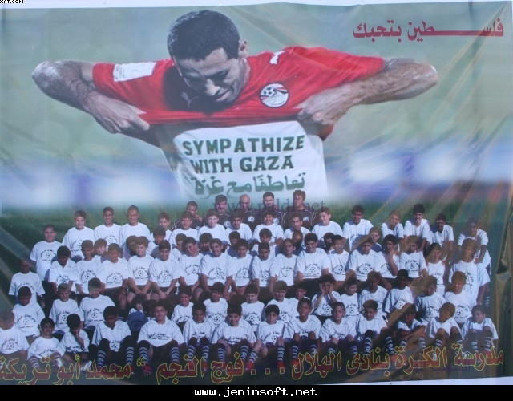
1-Athens is the capital of Greece.(What).
…………………………………………..
2-Egypt is in the north east of Africa.(Where).
…………………………………………..
3-Ahmed has one brother (How many).
…………………………………………..
4-English is written from left to right.(How).
…………………………………………..
5-Ahmed went to Cairo to buy books.(Why)
…………………………………………..
6-Yes, Ahmed has been to Italy.(Has)
…………………………………………..
7-No, We have never eaten frogs.(Have)
…………………………………………..
8-Abou Treaka is Egyptian.(What)
…………………………………………..
9- He was born in Egypt.(Where)
…………………………………………..
10-I have stayed in Gaza for two days (How long).
…………………………………………..
②Read and match.
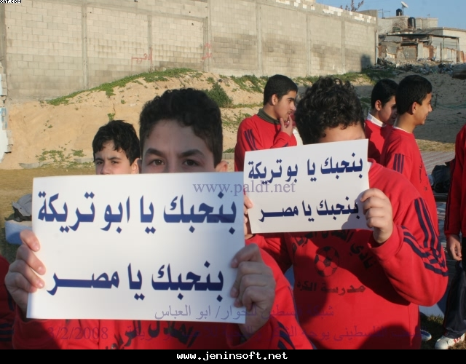
1-The Sudanese people a- called The Umayyad Mosque.
2- The capital of Sudan b-are Turkish
3-Rome has a famous old building c-is Khartoum.
4- The people of turkey d- speak Arabic.
5- Damascus has a beautiful mosque f-called the Coliseum
6-Ahmed hasn’t brushed g-his homework yet.
7-Ahmed hasn’t written. h-his teeth yet.
①Read and answer the following, then answer he question.
28
Egypt is a beautiull country in the northeast of Africa.
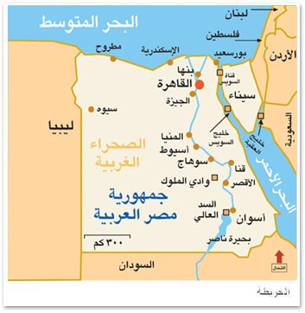
The first language in Egypt is Arabic .Egypt is famous
for its weather .The pyramids ,National Musuem,
Sphinx, Khan-El-Khalii and so on.The River Nile ,
The longest river in the word runs through It.Most of
the Egyptions live in the Nile Vally because its soil is
very rich,So the farmers are able o grow many crops.
Answer the following questions.
1-What is Egypt famous for?……………………………………………………
2-Why are the farmers in Egypt able to grow many crops?
………………………………………………………………………
Choose the correct answer.
3- Most of the Egyptian people live in the (desert- River Nile- Nile valley).
4-The under line pronouns it refers to (Africa- Egypt- the River Nile).
5-Egypt is an Arab country in the (northeast- northwest- southwest).
②Read and then correct the mistakes.
Corrections | Mistakes
...........................  ...........................  ...........................  ...........................  ...........................  ...........................  ............................  ...........................  ...........................  ...........................  ............................ | 1-Port Said is northwest of Cairo.  2-The capital of Italy is Greece.  3-Benha is east of Cairo.  4- Ankara is the capital of Greece.  5-Cairo is on Africa.  6- HS Ahmed be to Damanhur?  7-She haven’t cleaned the room.  8-She went to Cairo in the 21st of April ,2007.  9-When did she went there?  10-Ahmed has visited much countries.  11-How high did he spend in London?
③Punctuate the following.
1-magedy left for Ismailia on Monday 2-is samascus the capital of aswan
…………………………………… ……………………………………
3- the capital of Egypt is cairo 4-berlin is northwest of Greece
…………………………………… ……………………………………
5-londan is in the north of europ 6-have you visited cairo
…………………………………… ……………………………………
④Supply the following dialogue.
A-What is the capital of Saudi Arabia? B-…………………………………
A-………………….……………….? B-Damascus is an Arab city in Syria.
A-No, I have never been to London. B-…………………………………..?
A-What have you done today? B-……………………………………
①Choose the correct answer.
29
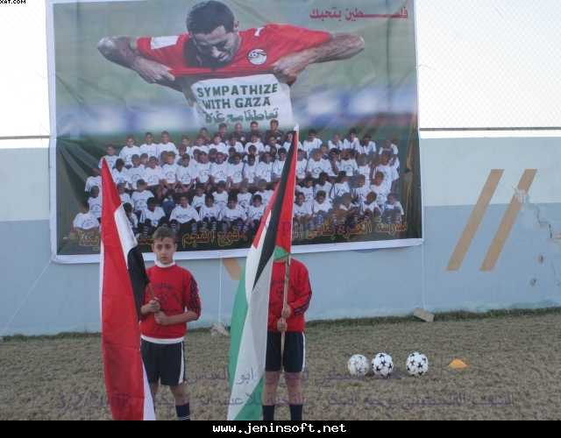
1-Yara hasn't phoned Amina (just-ever –never –yet)
2-Yara had (girl- grill-grilled-grills) the fish.
3-They (have-has-had) studied since they arrived.
4-W'eve decided (to-for-too) win the match.
5-The farmers didn’t (run-ran-running).
6-Ahmed has (already- yet-since) seen the film.
7-Libya is (north- south- west east) of Egypt.
8-How (much-many- long) was he in Egypt?
9-How (much-many- long) countries has he visited?
10-I have (ever0 never- just) been to France.
11-May I (ask-asked- asking) you some questions.
12-Ahmed went to the market and [buy – buys – bought – buying] some eggs.
13-I’m going to [sell – sells - sold – selling] my old car.
14-The farmer and [he - him – his – its] wife were happy.
15-I [am not – didn’t – haven’t – hasn’t] know where Samy lives.
16–The past tense of draw is [draws – drew – drawing – drawn].
17-The farmer was very [exciting – excites – excited – excite].
18-Have you [write – wrote – writing – written] today?
It’s been smiles on the field all along 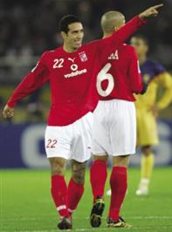
19-The boy has [feed - fed- feeds – feeding] the buffalo.
②Read then answer the question.
Children dream of growing up to be like him,
Mohammed Abu Treika His sporting journey began at
the age of 12, when a friend told him that the Tersana
Club was holding tryouts ago and asked to Even at age
12, Abu Treika knew that he wanted to be a soccer
player . He thought he would become a civil engineer,”
Abu Treaka's role model is his dad. Despite his rise to
stardom, he still remains close to his friends. If there is one thing most fans don’t know about the superstar player, it is perhaps his deep faith and commitment to God. It is this faith, and an associated humility, he believes, that have brought him this far. “God gave me this blessing and I want to use it as best [as] I can to benefit everyone in order for God to bless me and grant me more.
A-Answer the following question.
1-Wha did Treaka think he would be?...................................................................
2-Who is Abu Treaka’s role model in life ?...................................................................
3-When was he playing before?...............................................................................
4-What do children dream of?................................................................................
B-Choose the best answer.
5- ou need to stay humble and not become conceited and
He always remember to thank (people-parents-God-teachers) for everything.
6-Treaka still remains (away- far-close) to his friends.
Look at the picture and answer the questions. ①
30
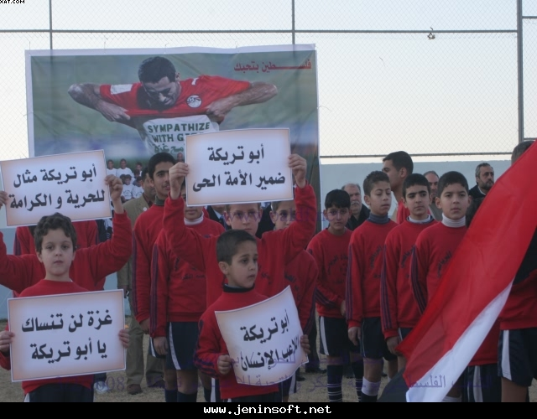
1-Who is the player in the picture?
……………………………………………
2- Have you watched him playing?
……………………………………………
3-Why has he done that?
……………………………………………
4-Did you agree for what he did?
……………………………………………
5-Why did he do that?
……………………………………………
6-Is he a good man? Why?
……………………………………………
7-How many Arabic word scan you see?
……………………………………………
8-Do you want to be like him?
……………………………………………
②Choose the correct answer:-
1 – Ahmed has been buys [since – when – ago – for] a very long time.
2 – [What – Who – Where – How] has been learning carpentry? – Nabil.
3 –Yara’s been studying French [for - since – ago – when] last September.
4 – The boys have been playing football for [two hours – two o’clock)
5 –Ahmed has been playing [at – for – from – by] the team since 1994.
6 – Welcome [for – to – from – by] our party.
7 – I hope Somiaa will [do – make – take – find] well this year.
8 – It has been [rain – rains – rained – raining] for three hours.
9 –Somiaa has been writing letters [since – for – when – from] 9 o’clock.
10 – I’ve been living in Giza [from – when – for – since] nine years.
11 –Wafaa is very good at Maths. She can do sums [easy – easily – lazy – angry
12 – [What– How – Who] did she sing in the party? – She sang beautifully.
13 – Who would you like to be your [pen – pan – pin – pens] friend?
14 – [He has – Has he – We have – Have you] written the letter? Yes, he has.
15 – Have they been eating? No, they [has – hasn’t – haven’t – have].
16 – Has Mona been [read – reads – reading] book?
17 – [Who – Whose – Who’s – Where’s] address is it? – It’s Rana’s.
18 – I’m [glad – sad – unhappy – tired] that you want to be my friend.
19 – You can’t swim in the sea now. It is [calm – quiet – nice – rough].
20 – I [will – must – can – would] like to be your pen friend
21 –Marwa has been learning how to [make – play – use] computers at school.
22 – I [thanked – thought – caught – bought] my friend for his letter.
23– Amal is interested [on – at – in – of] playing the piano.
24– How old [is he – he is – he has – has he]?
– He’s twelve years old
Unit18
سلسلةYARA
31
Have you done your homework yet?

trick يخدع | voiceصوت | Mathsرياضيات | revise يرجع
run up يرتفع | chaseيطارد | enormous هائل | trousers بنطلون
science علوم | furious غاضب | deliciousلذيذ | naughty شقى
truthصدق | sound صوت | save ينقذ | experimentتجربة
plateطبق | clamهادى | internetانترنت | website موقع
Study the following.

already)-1 بالفعل) توضع بين الفعل المساعد والتصريف الثالث .Ahmed has already eaten
2-( just توا) =Yara has just arrived. a few time ago- a short time ago
3-Yetتستخدم فى نهاية الجملة المنفية والسؤال Ahmed hasn’t written his homework yet. 
Punctuation علامات الترقيم
1-Capital letters:
تبدأ الجمل و أسماء الأشخاص و أسماء الأماكن الشهيرة بحروف كبيرة (Capital )
2-The full stop: نقطة نهاية الجملة
 This is my uncle.  His name is Ali.  He is a cook.  He lives in Tanta.
علامات التنصيص ( Quotation marks )3-
هي قوسين صغيرين يوصفان حول الكلام المباشر الذي قاله صاحبه ولابد أن تبدأ الجملة بداخلهم بحرف
كبير وتنتهي بـ بنقطة ولابد أن تضع فاصلة( Comma ) بعد نقل القول ( Say ) .
 Mr. Khaled says, “Look at the whiteboard.”
4-Questionn mark: علامة الاستفهام
How old are you? Did you watch Treaka's deed? Why does Ahmed cry?
①Punctuate the following:-
1 –Sherhan is manal and farouk s aunt . 2 –she lives in minia
………………………………… ………………………
3 –this is my grandmother / her name is houda / she lives in suez
……………………………………………………………………
4 –yara s uncle isnt adriver / he is a tourist guide.5– ahmed says i like english .
………………………………… …………………………
6–mohameds brother is colled ahmed. 7– yara says sitdown .
………………………………… ……………………
8– mr kahed says to faten don’t makle noise . 9– good morning can i help you .
………………………………… ……………………
10-yaras home is near. 11-I ve seen ahmed
“Wh “questions كلمات الاستفهام
32
What ماذا  Who من للعاقل How manyكم العدد  How tall كم للطول | When متي  Whose ضمير من  How old كم للعمر  How deep كم للعمق | How high ما ارتفاع  How often كم عدد المرات  How far كم للبعد  How much كم للكمية | How fast ما  Why لماذا How long كم  Which أي
How to make a question? كيفية تكوين السؤال
1 | 2 | 3 | 4 | 5 | 6
كلمة استفهام | فعل مساعد | الفاعل | الفعل | تكملة | علامة الاستفهام
How long - who -what | do-does  did | He – she  Your | go – write  drink – play | ……… | ?
When | do | You | go | to school | ?
لاحــظ لآننــا لا نستخــدم did – does – do إلا إذا كانت الجملة خالية من الأفعال المساعدة التالية :-
am - is - are - was - were - has - had – have - do - does - did - will - would - shall - should - can - could - may might must
لاحــــظ أن كل أدوات الاستفهام السابقة يمكن أن ينطبق عليها القاعدة السابقة ماعدا الأدوات الأتية :-
How long - who - what - how much - how many – whose - which.
①Make questions for these answers:-
1-Yara goes to school on foot 2-Ahmed lives in Mahallet Bisher.
……………………………………… ………………………………
3-Mohamed is younger than Ahmed 4-Amal bought twenty eggs.
……………………………………… …………………………………
5-Alaa visits Cairo twice a week. 6-Mr. Khaled teachers English.
……………………………………… ……………………………
7-Yara’s shirt is twenty pounds. 8-Ahmed is one meter tall.
……………………………………… …………………………………
9-Ahmed’s brother is called Mohamed. 10-Amal stayed in Alex for a week.
……………………………………… …………………………………
11-I have seen the match. 12-We like Abou Treaka.
……………………………………… …………………………………
13-She has bought ten pens 14-She has drunk a lot of water.
……………………………………… …………………………………
15-Yes, I have seen the match. 16-No, I have never visited the film.
……………………………………… …………………………………
17-No, we have travelled by train. 18-Yes,I have helped Ahmed
……………………………………… …………………………………
19-I come from Egypt. 20-My name is Ahmed Khaled.
……………………………………… …………………………………
①Read then answer the question.
331
I’m a very simple man and I don’t like to complicate things that don’t need complication. I wake up after the call to prayer for (dawn)(morning prayer) and call it a night fairly early. After praying, I start to get ready for our morning practice at the club which starts around 9:30am and lasts for about an hour and a half. I’ll usually go to the club at least an hour and a half before practice starts to work out at the gym and do other exercises to put me in shape. I enjoy reading a lot, especially religious and cultural books, but my favorite books are ones by the late Sheikh Mohammed El Shaarawy. After practice, I’ll wait until the noon prayers so that I can pray before leaving the club. He does everything himself, including organizing his schedule for any visits, guest appearances or commercial advertising deals.
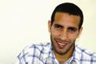
A-Answer the following question.
1-What is Abou Treaka favourite hobby?…………………………………..
2-When does he get up?..............................................................................................
3-What does he do before leaving his club?..............................................................
4-What has he received?................................................................................
B-Choose the best answer.
5- Abu Treaka's life revolves around (sleeping- watching T V-soccer).
6- Abu Treaka's doesn’t believe in personal (trainer- player- managers).
7- Abu Treaka’ll usually go to the club at least an hour and a half before (play- read-practice).
②Match the questions and answers :-
1 – Where do we buy bread? a) Some sugar and rice.
2 – What did mother buy at the grocer’s? b) Some stamps.
3 – What did you buy at the post office? c) Because it was too expensive.
4 – Where do we get meat? d) At the baker’s.
5 – Why didn’t you buy the shirt? e) At the butcher’s.
③Finish the following with these words.
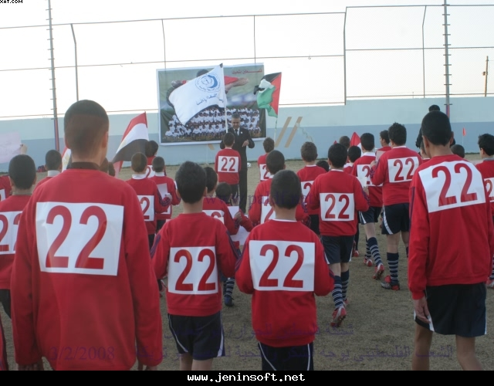
Most- had- must- haven’t –jobs.
Father : Have you................a nice day, Ahmed?
Ahmed :Yes, dad.
Father :Have you done all your...................yet?
Ahmed :Yes, I have finished.............of them
Father :What about the homework.
Ahmed :I've started. But I.................Finished yet.
Father : When you finish ,we will go for a walk.
سلسلة Yara ابداع يفوق الخيال
①Punctuate the following:-
341
1-what would you like to eat……………………………………….…...
2-i d like to eat rice and vegetables……………………………………..….
3-would you like to drink lemon juice ……………………………………..
4-no thank you…………………………………………………..………..
5-can i have an ice cream dad ……………………………………………..
6-yes adel visited alexandria and aswan. ……………………………..….…
7-no we dont go to school on friday ………………………………..….…..
②Choose the correct word:-
1–May I have a [bar – cup – piece – tube] of tea, please?
2–Yara bought a [tube – bag – bar – bottle] of orange juice.
3–Yara gave me a [piece – bar – cup – tube] of cake.
4 –I haven’t got lemonade what about a [jar – tube – bag – bottle] of fruit juice?
5–Ahmed bought half a [bag – kilo – packet – bottle] of cheese.
6–Don’t forget to buy a tube of [tea – chocolate – toothpaste – cake].
7–What [for – to – on – about] a bottle of Pepsi?
8–Mohamed has got a big shop. He is a good [shop – shopper – shopkeeper].
9–You eat out in a [restaurant – shop – grocer’s – street].
10- This is a [bottle – loaf – bar – sack] of chocolate for my young sister.
11 –This [shopkeeper – policeman – nurse – shopper] never gives you the change
12–Things [sell – buy – take – cost] a lot these days.
13–A bad onion? Well, choose another [one – list – piece – else].
14–Yara goes [shop – shops – shopping – to shop] every Friday.
15–Go to the [butcher – butchers – butcher’s – butchers ‘] and buy a kilo of meat
16 –Remember to get [a – an – some – much] bones for the soup.
17–Do you want anything [else – other – anther – others]?
18–Mr. Khaled went [buy – to buy – bought – buying] some pears.
③ Read the following and answer the questions
Yesterday my brother Ahmed went to bed early in the evening. It was
nine o’clock. This is because he wanted to get up very early in the morning. He had to catch the first train to Aswan. He wanted to go there to see Aswan. It was the first time for him to go to Aswan. His father works there as an engineer. He will see some of the interesting places. He heard about these places from his father. He thinks that he will enjoy his time in Aswan.
A) Answer the following questions :-
1 – Why did Ahmed go to bed early yesterday? …………………………………
2 – Why did he want to go to Aswan? ………………………………………….
B) Choose the correct answers:-
3 – Ahmed went to bed at [seven – eight – nine – ten] o’clock.
4 – Ahmed’s father is [a doctor – an engineer – a teacher – a farmer] .
5 – It was his [first – second – third – fourth] time to go to Aswan.

①Supply the following dialogue:-
351
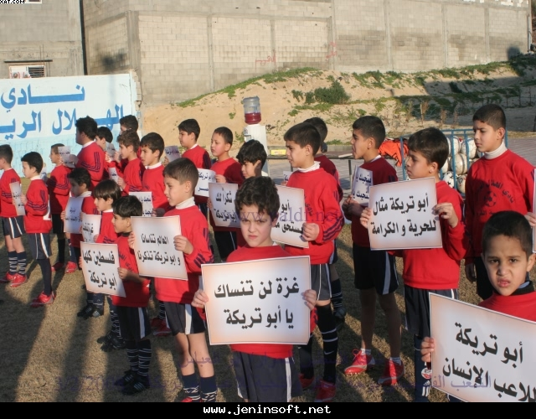
Kamal : Has your uncle bought a new car?
Fawzi : ………………”1” ………………
Kanal : ……………...”2” ………………
Fawiz : He bought it last month.
②Read the following passage and then answer the questions:-
A dog once stole a big bone from a butcher’s shop. It away very fast. The butcher shouted, “Stop, thief!” but no one could stop it. Outside the village there was a small river. The dog stopped there and started to eat the bone. When it looked down into the water, it saw another dog with a bone in its mouth. The dog wanted to take the bone from the other dog. It opened its mouth to get it, but the bone it was carrying fell off into the water and sank deep down the river.
Questions :-
1-What did the butcher do when the dog stole the bone…………………………
2-What did the dog see in the river? ……………………………………...…
Choose the correct answer:-
3-This story tells us not to [be greedy – be happy – run away – at bones].
4-The dog got [the second bone – the first bone – the two bones – nothing]
5-The underlined word it refers to [the real dog– the other dog – the river]
③Supply the missing parts in the following mini- dialogue:-
Mother : Nabil , you haven’t finished your homework yet ! ………since 3 o’clock ?
Nabil : I’ve been looking for the book.
Mother : Have you found it ?
Nabil : …………………yet.
④Finish the sentences with words from the list
planted – laid – controlled – measured – translated – replied – wrote
1 – Angles are ………with a protractor.
2 – I ……………..one paragraph from Arabic into English yesterday.
3 – The teacher asked her a question and she ………correctly.
4 – The fat hen ……………….an egg yesterday.
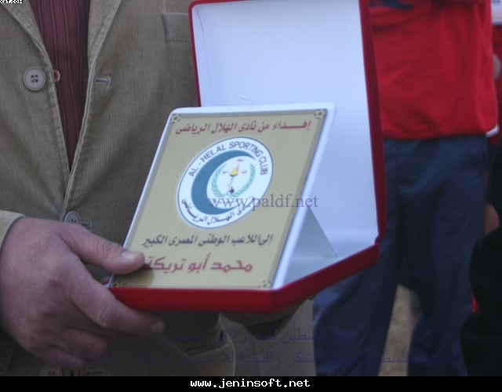
5 – The farmers haven’t ………………all the rice yet.
⑤Read and match.
1-Cry means shout a- tell lies.
2- I've finished but b- goes quickly.
3-She’ s already ironed c- my sister hasn't.
4-Hurry means d- a hot drink, please.
5- Can I have e-in a loud voice
6-A wolf f- seen a wolf.
7- Have you ever g-can eat the sheep.
8-Don’t h-looked after the sheep.
9-He’s i-tell lies
الأسئلة بهل في صيغة المضارع البسيط
36

أولا :- إذا كان الفعل الأساسي في الجملة به S يكون السؤال بـ المصدر + Does بمعني هل و بعد المصدر بدون " S"
Wafaa speaks English well . Does Wafaa speak ………………….…….……….?
Wafaa studies Arabic hard . Does Wafaa study ………………………..……….?
و في الإجابة علي السؤال تكون إما بالإثبات مثل Yes, Wafaa studies .
أما في حالة النفي فتكون الإجابة مثل No, Wafaa doesn’t study …………
ثانيا : - إذا كان الفعل الأساسي بدون S يكون السؤال بـ المصدر Do بمعني هل
They go to school every day . * Do they go to school …………?
Animals eat plants . * Do animals eat plants ………..?
و في الإجابة علي السؤال إما بالإثبات مثل Yes, they go to school …………
أما في حالة علي السؤال بالنفي مثل No, they don’t go to school ………… ①Make questions to these answers :-
1-Yes, Mohamed studies English with Yara ……………………………………..
2-Yes, Wafaa and Faten visit Dina ……………………………………………...
3-No, I don’t like social studies ………………………………………….……...
4-No, Sammer doesn’t hit Sara…………………………………………………..
5-Yes, Sara likes English. ……………………………………………………..
و تستخدم arrive at مع أسماء الأماكن الصغيرة . He arrived at school
و تستخدم arrive in مع أسماء الأماكن الكبيرة . He arrived in Cairo …….
Why …………………………………?Because…………………………………
تستخدم ( Why ? ) بمعني ( لماذا ؟ ) للسؤال عن السبب .
تستخدم ( Because ) بمعني ( لآن ) في الإجابة لبيان السبب .
1 – Why is Mather running? Because he is late.
2 – Why is Wafaa drinking lots of water? Because she is thirsty.
②Supply the missing parts:-
1 – Why is she sleeping? Because ……………………….…………………( tired )
2 - ……………………….? (he – carrying – umbrella ) Because it is going to rain
3 - …………………………………..? (That man – shouting) Because he is angry.
4 – Why are you wearing a coat? Because …………………………………..(cold
5 - ………………………………………....? (Boy – smiling) Because he is happy.
6 - …………………………………...? (Babies – crying) Because they are hungry
نستخدم حروف الجر الآتية عند إجابة السؤال الذي يبدأ بــ ( Where ? أين ؟ ) لبيان المكان .
 Wafaa works on building sites.  Mohamed woks on a farm.
Salma works at home.  Ahmed works in a bakery.
Sara works in a bakery.  Rania works in an office.
③Punctuate the following.
1- mr Khaled met mona and wafaa in alex on monday. 2-how are you heba
……………………………………………………. ……………………
3-stanly bridge is in alex. 4-ahmed has got a nice dictionary
………………………………. ……………………..……………..
①Write question using the words in brackets.
37
1-I used to go to institute on foot.(What)
………………………………………………………….…………….…?
2-Ahmed met Mohammed at the institute gate.(Where)
………………………………………………………….…………….…?
3-We travel to Alex by bus.( How).
………………………………………………………….…………….…?
4-Ahmed used to play with Mohamed.(Who).
………………………………………………………….…………….…?
4-Ahmed went to Alex in Summer.( Where)
………………………………………………………….…………….…?
5-Ahmed goes with Mohamed to the institute.(Who…With)
………………………………………………………….…………….…?
………………………………………………………….…………….…?
6-This dress costs 100 pounds.( How much- What ………………………………………………………….…………….…?
………………………………………………………….…………….…?
7-Yara lives in Mahallet Bisher.(Where-Who)
………………………………………………………….…………….…?
………………………………………………………….…………….…?
8-I’ll have to buy a dictionary to learn English.(Why-What)
………………………………………………………….…………….…?
………………………………………………………….…………….…?
9-Ahmd goes to institute on food.( How -Who-Where)
………………………………………………………….…………….…?
………………………………………………………….…………….…?
10- Mr.Khaled teaches us English (Who-What-Who-What)
………………………………………………………….…………….…?
………………………………………………………….…………….…?
………………………………………………………….…………….…?
………………………………………………………….…………….…?
11-Ahmed went to Cairo yesterday with Mohamed by bus(Who- What-Where-How- When)
………………………………………………………….…………….…?
………………………………………………………….…………….…?
………………………………………………………….…………….…?
……………………………………………………
…….…………...…?
①Write question using the words in brackets.
38
1-Ahmed spent two weeks in Alex.(How long-Where)
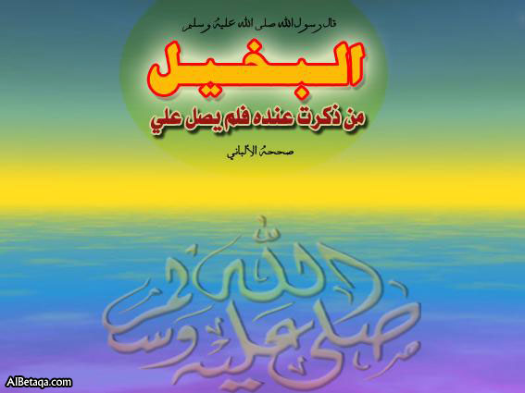
……………………………………………………………………..
……………………………………………………………………...
2-People can't eat rats (Who-What- What)
……………………………………………………………………..
……………………………………………………………………...
3-Ahmed is going to play football (Who-What)
……………………………………………………………………..
……………………………………………………………………...
4-Ahmed goes to his institute on foot.(Who-How-Where)
……………………………………………………………………..
……………………………………………………………………...
……………………………………………………………………..
5- Ahmed's father teaches us English (Whose-What-Who-Who)
……………………………………………………………………..
……………………………………………………………………...
6-Ahmed visited Cairo three days ago.(When-Who-where-How long) …………………………………………………………………………
…………………………………………………………………………
…………………………………………………………………………
7-Ahmed got high marks because he had studied hard.(Why-Who-What)
…………………………………………………………………………
…………………………………………………………………………
…………………………………………………………………………
8-Ahmed is eating his breakfast.(What- Who-What).
…………………………………………………………………..……?
………………………………………………………..………………?
……………………………………………………………..…………?
9-Mr.Khaled is explaining unit three now.(Who- What-Which-When)
……………………………………………………………..…………?
………………………………………………………….….…………?
…………………………………………………………..……………?
…………………………………………………………………..……?
10-Mr.Khaled goes to his institute on food.(Who-How-Where)
……………………………………………………………..…………?
……………………………………
…………………….….…………?
①Read and answer the questions Egypt beats Cameroon 1-0 in final. Egypt won its sixth
39
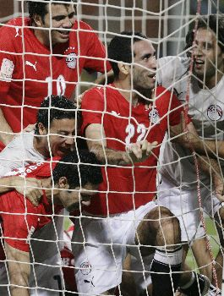
African Cup of Nations title, and second in a row, by
beating Cameroon 1-0 Sunday in the final .Mohamed
Abou Treika scored the only goal in the 77th minute,
converting Mohamed Zidan's cross for his fourth goal
of the tournament . Kameni burst into tears at the final
whistle and had to be comforted by Eto'o. Defender
Augustin dropped to his knees and gazed into
the distance as Egypt's players rolled on the floor and
Egypt's Mohamed Abou Treika (22) celebrates with team mates after he scored against Cameroon.

hugged in celebration.
A-Answer the questions.
1-How many goals did Treaka score in the champion?
………………………………………………………………………….
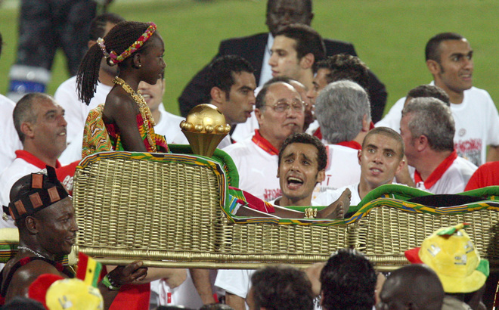
2-Who burst into tears at the final whistle? ……………………………………………………………….
B-Choose the correct answer.
3- (Augustin- Eto'o- Kameni ) dropped to his knees.
4- (Treika- Zidan –Meteb) scored the only goal in the 77th minute.
5- (Egypt- Cameroon-Ghana) won its sixth African Cup of Nations title, and second in a row.
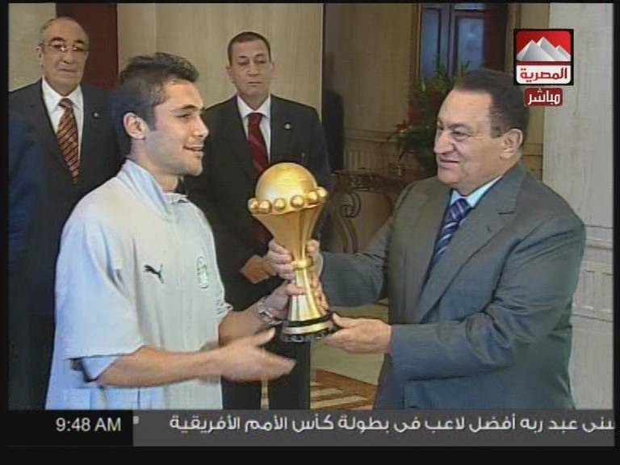
②Punctuate the following sentences.
1- egypt beats cameroon 1-0 in final
…………………………………………
2- mohamed abou treika scored the only goal
…………………………………………
3-mobark received the team at cairo airport
…………………………………………
4-egypt won its sixth african cup of nations
…………………………………………………………….…
Copy the following.
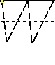 |  |  | 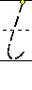 |  |  |  |  | 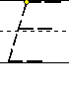 | 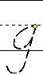 | 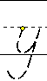 | 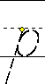 | 
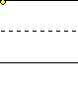 | 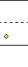 |  | 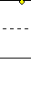 | 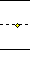 | 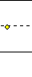 |  |  | 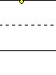 | 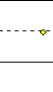 | 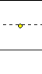 | 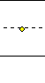 | 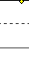
We love our country so much.

5-Egypt: essam el hadary shady Mohamed hani said ahmed fathi hosni abd

………………………………………………………………………………………………………………
rabou emad motaeb (mohamed zidan, 59) sayed moawad ahmed hassan amr zaky
…………………………………………………………………………………………………………………
(mohamed shawky, 89) wael Gomaa mohamed abou treika (said ahmed, 88)are
……………………………………………………………………………………………………………
egypt's heroes. …………………………………………

①Read then answer the questions.
403940

Ahmed played a trick on the farmersthree times .Every time the
farmers ran to save the sheep because Ahmed cried for help as the wolf wanted to eat the sheep .But one morning, Ahmed really saw a wolf .He hurried to the village and shouted for help this time the farmers didn’t run up the mountain to help Ahmed because they didn’t believe him because the tricked them The wolf ate lots of sheep .Ahmed was sad and promised not to tell lies again.
A-Answer the following.
1- Why did Ahmed cry?………………………………………………………….
2-What does the word "He" refer to? …………………………………………
Choose the correct answer.لB-
3-Ahmed tricked the farmers (one-two-three) times.
4-The wolf was able to eat (meet- eat-teach) lots of sheep.
5-Ahmed promised to tell (lies- truth-story).
②Read and correct the following sentences.
Corrections | Mistakes
...........................  ...........................  ...........................  ...........................  ...........................  ...........................  ............................  ...........................  ...........................  ...........................  ............................ | 1-yara has just write the letter.  2-Ahmed forget to do her homework tomorrow.  3-Furious means very hungry.  4-Ahmed enjoys plays football.  5-My father find a new job lat week.  6-Ahmed reads a lot of books yesterday.  7-people should tell lies.  8-They made a trick on the thief.  9-Ididnt failed in the exam.  10-I lost mine book and found hers book.  11-me father works in Mahallet Bisher.
③Choose the correct answer.
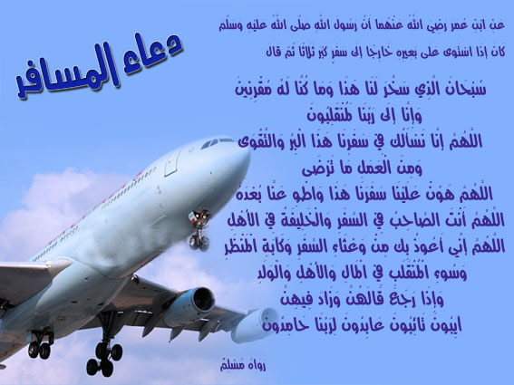
1-Yara has just drawn a picture by (herself-myself-itself).
2- Ahmed has just (revise-revised-revises) his lesson.
3- (Bad-Good-Naughty) pupils don’t make noise.
4-Ahmed ate a (delicious-salty- bad)meal It's tasty.
5- I have just (brush- brushed- brushed) my teeth.
6-Don’t (tell-say-tells- says) lies.
7-I decided (to-on- by) study my lesson carefully.
8-Ahmed won't (tell-told-tells) lies again.
9-The wolf (eat- ate – eaten) a lot of sheep.
10-Have you (ever-never-just) eaten frogs?
11-(Bad-Good-Naughty) pupils shouldn't make noise.
12-We don’t like (clever- naughty- good) puiples.
13-Yara hasn’t swept- revised- ironed) the floor yet.

Unit
19
سلسلةYARA
41
Under the sea.

Neck رقبة | Fins زعانف | Sharp حاد | Problem مشكلة
Mobileموبيل | Tusks انياب | Unusual ريد | Monitor الشاشة
Club نادى | Sea world عالم البحار | Dugong لاطوم | Octopus اخطبوط
Electronicالكترونى | Address عنوان | Flipper زعنفة | Look like يشبة
kangarooكنججارو | Bottom قاع | Music موسيقى | Crocodileتمساح

Structure
1 – Used to تستخدم لكي 2 – used for تستخدم لأجل
1- used to تأتي بعدها الفعل في المصدر 2 – used for يأتي بعدها الفعل + ing
The microscope is used for examining very small things.
The microscope is used to examine very small things.
A watch is used to show the time A watch is used for carrying things.
①Use the pattern “be used to “in the following sentences :-
1 – A chair is used for sitting. 2 – A fork is used for eating.
................................................ .....................................................
3-A camera is used for taking photographs 4-Money used for buying things
................................................ .....................................................
②Use “ for” instead of “to ‘ and make any necessary changes :-
1-A microscope is used to examine very small things. .......................................................................................
2-A cassette is used to play music. 3-A keyboard is used to type words.
................................................ .....................................................
اود ان ..........................
1-I would like to be a doctor. 2- I would like to listen to the Holy Quran.
3- I would like to have a computer.
 What would like to be? للسؤال عن ماذا تحب ان تكون. 
للتعبير عن الاماكن التى تعيش فيها الحيوانات:
.المكانplace+يعيش فىlive in +اسم الحيوان name of animals
1-Sharks live in warm water near the land.
The elephant is grey animals with a big body, short legs and long nose.لوصف حيوان
يستخدم حرف الجرwith لوصف الناس والحيونات.Ahmed is tall with black eyes
للسؤال عن بيانات شخص ما What's his\her name\address\mobile number?
1-What is Mr.Khaled’s mobile number? 2-What’s her name?
①Finish the sentences with words from the list:-
46
landed – blinked – took – took off – translated – computed – gave
1 – Mohamed ……….all these sums to get the result he wanted.
2 – They ………..their eyes when the strong light fell on them.
3 – It ………….him two hours to reach the village.
4 – The plane ………….and rose high in the sky.
5 – Ahmed ………….her speech into Arabic as they don’t know Italian.
②Complete the missing parts in the following dialogue between :-
Ahmed and his father about computers:-
Father : I’ve bought you a computer .
Ahmed: Thank you , father but I …………..1…………
Father : You should learn how to use it .
Ahmed: ……………2………………..
Father : Yes, you can start with doing sums . Then you ……………3………….
Ahmed: That’s OK . It’ll be a great help when I do experiments .
③Rearrange the words to make correct sentences :-
1 . use – to tell – computers – brains – We – what – our – to do .
……………………………………………………………………………………..
2-translate – one language – Computers – from – be able – will – another – to – to
……………………………………………………………………………………..
3 . of – are – important – Computers – invention – modern – the most .
……………………………………………………………………………………...
1 – computers – are – than – People – more important .
………………………………………………………
2 – difficult – Computers – quickly – sums – can do .
……………………………………………………….
④Finish the sentences with word from the list :-
action – active – pronounce – plough – shadoof – museum – world
1 –Yara visited the Egyptian ………….to see Tot An khamon .
2 –His quick ………….saved her life.
3 –The Nile is the longest river in the ……………….
4 –The farmer uses a ………..to turn over the earth.
5 –How do you ………………...your name?
⑤Read and finish the paragraph :-
factories – patients – invention – information – take off – money – difficult – problems
The computer is a very modern..………… A computer can do very ………sums quickly and accurately. It can store huge amounts of ………….computers are used in banks to store information about people’s ………..they are used to work out difficult scientific ……………..computers in robots can do difficult work in ……………computers help planes to ………….and land . Doctors use computers to look inside the bodies of some …………..
①Choose the correct answers:-
453
1 – We will be [can – able – can’t – could] to visit the moon.
2 – A protractor can [measure – help – do – read] angles.
3 – Computers were not [invent – invents – invented – inventing] a long time ago
4 – My brother can [translate – translates – translated] from English into Arabic.
②Read the following and answer the questions
Computers are very useful in modern times. Without computers, life would be difficult. Computers can do very difficult sums quickly and accurately. They can store huge amounts of information. So, computers are important everywhere. They can help planes to take off and land. They are used by doctors to look inside the patients bodies. Computers will be able to translate from one language to another.
Answer the following questions:-
1 – Why are computers very useful?……………………………………………
2 – How can computers help planes? …………………………………………
Choose the correct answers:-
3 – Computers can do [ideas – sums – amounts – life] quickly and accurately.
4 – Computers can store [little – small – huge – big] amounts of information.
5 – [Teachers –English – Doctors] use computers to inside the patients bodies.
لاحـظ أننــا : - عندما نريد أن نسأل عن الزمن نستخدم الأداة " When " عندما متي .
When does Yara go to institute?
و تستخدم When أيضا كأداة ربط تربط بين جمليتن بمعني عندما و إذا كان الفعل الذي يأتي بعدها مضارع فيكون الفعل الثاني مضارعا أيضا . When water boils . it turns into steam .
③Finish the words :-
1 – Computers are proba_ ly the m_st importa t invent_on of m_dern tmes .
2 – Computers can do dif_icult sums qui_kly and ac_urately .
3 – Computers can st_re huge amo_nts of info_mation .
4 – We can work w_th w_rds, n_mbers and p_ctures on computers .
5 – Most bo_ks, newspa_pers and magaz_nes are n_w made with the h_lp of it .
④Rearrange the words to make correct sentences :-
1 – banks – used – computers – in – are – Today .
………………………………………………………………………………
2 – translate – language – one – another – to – can – from – I .
……………………………………………………………………………….
3 – neighbour – nice – Our – next – door is – very .
……………………………………………………………………………….
⑤Choose the correct answers:-
1 – Computers were [invent – invented – invents – inventing] a long time ago.
2 – Most books are made [by – with – about – on] the help of computers.
3 – Shall we be able to live and work [in – on – at - with] space?
4 - We use clocks to [measure – measuring – measures – measured] time.
5 – A camera is used for [take – took – taking – taking – takes] photographs.
① Read the following and answer the questions:-
44
A few days ago my daughter Yara succeeded in the examination and got
high marks. I decided to give a party. Yara invited her relatives and friends. She telephoned some and sent letters to others. The party will be next Thursday evening. They guests will arrive at 6 o’clock. Yara will receive her guests with smiles on her face. She will be in her new white dress. Everyone will enjoy the party.
Choose the correct answer :-
1-Yara’s father decided to give a party because his daughter [passed the examination -travelled – sent letters – telephoned her friends].
2 – Guests will be received with [presents – a new dress – smiles – letters].
3 – Yara’s father was [happy – beautiful – sad – angry].
Answer in complete sentences:-
4 – Why will Yara be in a new dress?
5 – When will visitors go to Yara house?
②finish the sentences with words from the list :-
took – checked – revised – practised – perfect – rang – measured
1 – His reading is ………….; we all liked it.
2 – I ………….up my friend to tell him the news.
3 – Mother ……………the child to see which size suits him .
4 – Ahmed ………….the car before starting his journey.
5 – Mohamed ……………..a lot to perfect his English.
③Write these sentences with the correct punctuation :-
1 – my name is saber 2 – my favourite sport is football
…………………………………. ………………………………….
3 – this is my friend adel 4 – he goes to ramses prep school
…………………………………. ………………………………….
5 – they went to tanta 6 – my uncle lives in port said
…………………………………. ………………………………….
7 – miss magda is a secretary . 8 – cairo is the capital of Egypt
…………………………………. ………………………………….
④Answer the questions:-
1 –Does a secretary work in an office? ………………..……………………….
2 –Do carpenters make tables, beds and chairs? ………………………………
3 –Does a salesgirl work in a workshop? ……………………………….…..….
4 –Do housewives work outside homes? ……………………………………….
5 –Does a builder build flats, offices, and factories? ……………………….….
6 –Do bakers bake and sell bread? ……………………………………..….……
7 –Does a farmer work in a hospital? ………………………………….……….
8 –Do doctors look after the people who are ill? ……………………………….
9 –Does a mechanic work in a workshop? ………………………………….….
10–Do shopkeepers teach the pupils? ………………………………………….

①Read and match the folowing.
43
1- A computer is used for a- go fromplace to another.
2- A keyboard is used b-to open with
3-A pencil is used to c-to cut with.
4-Akey is used for d-typing with.
5-A bicycle is used to e- to write with.
②Read and correct the following sentences.
Corrections | Mistakes
...........................  ...........................  ...........................  ...........................  ...........................  ...........................  ............................  ...........................  ...........................  ...........................  ............................ | 1-amouse is used to type words.  2-Flippers help a dugong to eat.  45  3-Sharks live in cold water.  4-This part called the mouse.  6- I’d like know more about sea life.  7-Oil is used for make fuels.  8-Ahmed is used to studying hard.  9-An octopus has got dark brown skin.  10-Octoups eat vegetables.  11-White sharks live in frozen water.  12-I’d like to has a new computer.
③Write questions to these answers.
1-Sharks can weigh 3000kg.(How heavy)………………………………………
2-Ahmed is twelve years old.(How).……………………………………………..
3-A knife is used to cut with (What). …………………….……………………..
4-Sharks have big mouths with sharp teeth (What).……………...……………...
5-Ahmed will stay in Alex for a week. (How long).…………………………..…
6- Yes, I like sea animals (Do….?)……………………………….……………...
7- Fish and octopus live under the sea.(Where).………….……………………..
8-an octopus eats small octopus.(What).………………………………………..
9-Yara uses computer to store information.(What) ……………………………
10-I would like to be a doctor (What). ……………………………..……………
11-We use pen to write with (What). ……………………………………………
-Ahmed can speaks Italian and Arabic.(How many) …………………………12
13-White sharks and dugongs live in warm water.(Where). ……………………
14-A printer is used to put words from the computer on paper (What)
…………………………………………………………………..……….
④Finish the dialogue with these words.
(dangerous-Who-cousin-did-were.)
A-Why didn’t you come to the club? B- Because I went to the zoo.
A- .................did you go with? B- with my.......................Ahmed.
A- How ..................you go there? B- By bus

parts of the computer.ٌ①Read and match the
42
1-A keyboard is used to control electronic information.
2-A computer is used to send commands to the computer.
3-A mouse is used to show pictures, words and information.
4 -A monitor is used send e-mail from one computer to another
5-A modem is used to put words from the computer to the paper.
6-A printer is used to type words and send them to the computer.
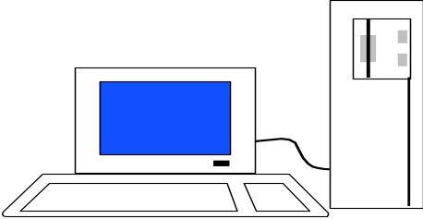
Screen
Microprocessor
Mouse

CD-ROM



Printer
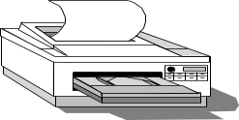
Keyboard

②Choose the correct answer.
1-The printer is used to (write-make put) words from the computer on paper
2-Ahmed is interested in (study-studying-studied) English.
3-A (Printer- mouse- monitor) is used to send commands to the computer.
4-A train is used for (carrying-carried- carry) people from place to place.
5-(Dugongs-Elephants-Lions) are great white sharks live in warm water.
-The mouse sends (commands- letters- pictures) to the computer.6
-Birds eat the meat (between- of- about) the crocodile's teeth7
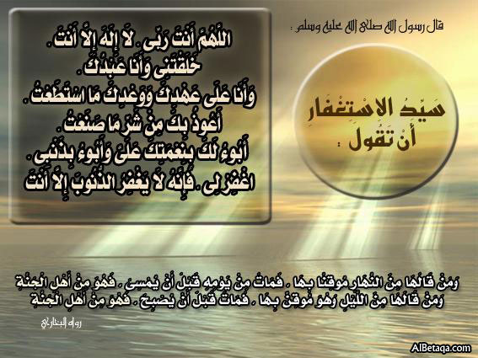
-A compass is used to(-knows- know- knows)the direction.8
-The (monitor – keyboard- mouse)is used for typing words.9
- A bicycle is used to go from place to (other-another- else)10
11-We should turn (on- off- to) the computer after using.
2-A (jug-freezer- kettle) is used to heat water.1
3- (Flippers- Skin-Eyes) help dugong to swim.1
14-We use the (printer- keyboard- mouse) for typing.
5-A computer is too (light- expensive- small) to buy.1
16-Great white sharks have (weak- sharp- thin) teeth.
17-There are too much website (at-in-on) the internet.
-The modem is used (to- for- on) sending e- mails.18
19-A (mobile- key- pencil)is used to open doors.
20-You should (start- shut- switch) on the monitor before use
③Supply the missing parts in the following mini-d dialogue :
Yara : What do we use the internet for ?Ahmed…………1……………………
Yara : …………………2 …………………..
Ahmed : This system is called “ electronic mail “ .Yara : ………3…………...
Ahmed : There are a lot of violent computer games .
Yara : I think many children spend too much time playing computer games
Ahmed : …………………”4” ………………………

Unit
20
سلسلةYARA
47
How long have you been here?

engine محرك | crash اصطدام | marry يتزوج | excuse me معذرة
fantasticرائع | injure يصيب | life حياة | companyشركة
fieldحقل | robbery سرقة | puzzleلغز | certainly بالتاكيد
valley وادى | mistakes اخطا | report تقرير | finally فى النهاية
steal يسرق | arrestقبض على | accidentحادثة | scientist عالم
For –since
Since تعبر عن بد ية حدوث الفعل حيث ياتى بعدها بداية الفترة الزمنية:-
Since(last-Sunday-20th Oct. –yesterday- 2007-9o,clock.)
1-Mr.Khaled has been in Alex since last week.
2-We have learned English since 2000.3-I have visited him since20th May.
1-Since.مضارع تام +فاعل - ماضى بسبط+فاعل+
1-Since we came ,he has studied. 2-Since She cooked ,we haven’t eaten well
مضارع تام +فاعل -2 since ماضى بسبط+فاعل
1-They have watched TV since the finished studying.
2-Mr Khaled has explained since we arrived.
Forياتى بعدها فترة زمنية محددة المدةمحسوبة وتشير الى المدة التى استغرقها الحدث.
For (5hours- 2days-weeks-months- along time- the last week)
1-Ahmed has played football for two hours.
2-They have visited us for the last month.
و تستعمل for فى زمن المضارع التام لتشير الى استمرار الحدث حتى الوقت الحاضر.
1-We have lived in Mahallet Bisher for ten years. Bu t we still live there.
وعندما تاتى for مع الماضى البسط فانها تدل على فترة زمنية منتهية.
1-We lived in Mahallet Bisher for ten years=but we don’t live there now.
(How long) تستخدم لطول المدة وللاجابة عليها نستخدم ( (for-since
1-Ahmed has been in Alex since last week. =How long has Ahmed been in Alex?
2-Ahmed has slept for two hours. =How long has Ahmed slept?
لاحظ ان المضارع التام يستخدم للتعبير عن فعل بداء فى الماضى وانتهى او مازال مسبمر لكن بدون تحديد وقت حدوث الفعل.
اما الماضى البسيط يعبر عن فعل حدث فى الماضى وانتهى مع تحديد وقت حدوث الفعل.
الفرق بين ((steal و (rob) اسم الشى المسروق او (الشخص) +steal+ فاعل-1
اسم المكان المسروق+rob+ فاعل-2
1-The boy stole my watch. 2-They robbed the bank last week.
①Read and match.
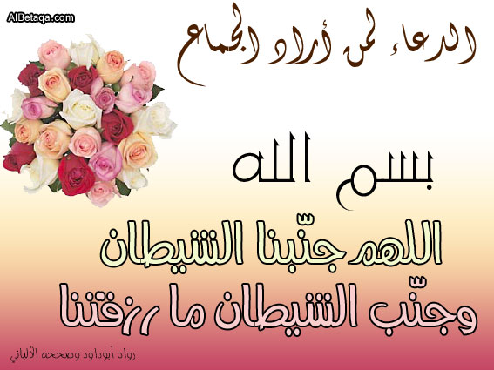
1-This man robbed a-my watch.
2-They stole b-my house.
48
3-I have been in London c-you been in London?.
4-How long have d-for two years.
②Finish the following dialogue with these words.
For-How long- Since-ago-job.
Ahmed : What's your……….……., please?
Mohamed :I'm a doctor.
Ahmed :…………..have you been in Egypt?
Mohamed :I've been here……………two weeks.
Ahmed :How long have you been in Cairo?
Mohamed :……………..Saturday. I arrived two days ago.
للتعبيرعن التخطيط لعمل شى فى المستقبل. المصدر Am-is-are +going to+ 
1-Iam going to study English.2-We are going to buy a car.
3-Scientists are going to use the engine in cars next year.
The police اسم جمع Policeman رجل الشرطة(مفرد)
1-The police have arrested the thieves. 2- This policeman is very brave.
③Read and correct the following sentences.
Corrections | Mistakes
...........................  ...........................  ...........................  ...........................  ...........................  ...........................  ............................  ...........................  ...........................  ...........................  ............................ | 1-Khartoum is the capital of Egypt.  2-The farmer got money for his field from a canal.  3-Ahmed has had a computer of Egypt.  4-The police has arrested a thief.  5-They have stayed in the hotel for Sunday.  6-How long are you going to reading this story?  7-I've learn English for five years.  8-They have been married for 2000.  9-Yaara stayed in a hotel in a week.  10-The robbery happen at seven o'clock last Monday.  11-They have been in Alex since an hour.
④Punctuate the following.
1-what is your job 2-how long has mr khaled been teaching english
………………………….. ……………………………..………………..
3-i was at giza last week 4-ahmed shouldn t eat too much cake said yara
………………………….. ……………………………..………………..
5-ahmed is from Egypt 6-I cant go with you on Friday as I am busy
………………………….. ……………………………..………………..
7-does ahmed study well 8-ahmed and Mohamed went to aswan on monday
………………………….. ……………………………..………………..
①Choose the correct answer.
49
1- I like my friend because she is (ungratful- unfierndly-helpful).
2-I live in Mahallet Bisher all my (alive-life-live).

3-Ahmed loves (visiting-visit-visits) the Egyptian Museum.
4-He (stole-robbed-took) me of my many.
5-I have been in Egypt (ago-for-since) last week.
6-Egypt won Cameroun (with-by-at) four goals to two.
7-Our team (lost-got- won) the match and got the cup.
8-We love her because she is (selfish-childish-clever).
9-The police (have-has- having) reported a bad fire.
10-There has been a bad (factory- accident-match) on the main road.
11-The result of the match was three (to-too-in) two.
12-Thives (robbed- stole-took) the bank yesterday.
13-A lorry (robbed- crashed- changed) into a bus this morning.
14-The farmer gets water for his field (from-by-in)a canal.
15-The plane (robbed- crashed- took off) and all the travellers died.
16-Some thieves (robbed- stole- took) our house last Tuesday.
17-We can't drive here: the road (is closed- closed- closes).
18-Our team won the football match (with-by-for) two goals to Zero.
19-The Egyptian people are very (stupid-friendly-bad).
20-How (many-long- much) are you going to stay in Egypt?
21-Mr.Khaled (learned- taught- told) us English last year.
22-A (doctor-teacher-farmer) works in a clinic.
23-The (sun-moon-weather) in Egypt isn’t too hot or too cold.
24-Ahmed's stayed in Ghaza (for- since-lately) the year 2002.
②Write question using the words in brackets.
1-I come from Mahallet Bisher.(Where). 2-I am from Mahallet Bisher(Where)
……………………………….…….. …………………..………………..
3-I,m going to stay for three weeks(How long). 4-My name is Mr.Khaled.(What)
……………………………………... …………………..………………..
5-I am teacher.(What) 6-There was a robbery at the bank(Where)
…………………………………… …………………..………………..
7-Ahmed has had a new computer since 2000(How long)
………………………………………………………..………………..
8-Ahmed thanked me for helping him(Why).
………………………………………………………..………………..
9-Damascusus is the capital of Syria.(What)
………………………………………………………..………………..
10-A lorry crashed into a bus yesterday (When)
………………………………………………………..………………..
11-Iam eating a lot of sandwiches.(How many)
………………………………………………………..
………………..
①Complete the following dialogue between Fatma and Amira :-
50
Fatma : Did you go out yesterday?
Amira : ……………”1” …………..why?
Fatma : I called you twice but you didn’t answer the telephone ……..”2”…………?
Amira : I was doing my homework.
Fatma : ……………”3” …………….. ?
Amira : English. you know it’s the subject I like best .
②Punctuate the following sentences:-
1 – does – ahmed khaled study english . 2 – do ahmed and Mohamed visit tanta . ……………………………………. ……………………………
3 – where does sara sabry work . 4 – when did amal and nadia go to alexandria
………………………………………..………………………………………..
5 – when you fill a balloon with hot air it rises .
……………………………………………………...
③ Read the following and answer the questions:-
When Yara reads a story or a passage in English, she tries to understand the most important ideas. When she finds a word that she doesn’t understand, she doesn’t stop reading. Reads the paragraph. Then, thinks of the meaning of the whole paragraph to guess the meaning of the word. If she can’t know the meaning she can look it up in the dictionary. In this way, you can easily know it .
Answer the following questions:-
1 – When Yara reads passage, what must she understand first?
………………………………………………………………………….
2 – How can Yara guess the meaning of a new word?
………………………………………………………………………….
Choose the correct answer :-
3-Yara [must – mustn’t – are – do] understand every word when she reads a story
4-Yara can look up the difficult words in the [book – class – dictionary]
5-Yara mustn’t stop [reading – read – reads – to read] the passage.
6-Learning a language is like learning [swim – to swim – swims – swam] .
7-Yara can [look up– looks in – looks over] a new word in the dictionary.
④Rewrite the following sentences using the words in brackets :-
1 –Ibrahim is sending a letter to his pen friend next week. (Every month)
……………………………………………………………………………………
2 –The tourist travels to Luxor and Aswan. (next week )
……………………………………………………………………………………..
3 –We watch the football match on TV. (at the moment
…………………………………………………………………………………….
4 –Adel is playing football now. (every Friday )
……………………………………………………………………………………..
①Read the following and answer the questions:-
51
It was two o’clock and lunch was ready. Everyone was in his place at the
table ready to eat. Mohamed had his plate full of rice. His father told him not eat it all because there were other things he should eat. He must eat a variety of food to keep healthy. It was half past two. They all left the table.
Choose the correct answer:-
1 – Mohamed’s plate was full of [rice – meat – things – food].
2 – It was half past two, time for [dinner – breakfast – lunch – leaving the table].
3 – To keep healthy, Mohamed must eat [rice – a variety of food – meat – food].
Answer the following questions:-
4-Why was everybody at the table?……………………………………………
5-How long did their lunch take? ……………………………………………
②Choose the correct answer:-
1 –In the future, we [are will be – will – can] able to use robots.
2 –We [may be – will – must be – are] able to visit the moon.
3 -Yara [travel – travels – travelled – will travel].
4 –Tomorrow, she read – reads – will read – reading].
5 –Next week, they [build – will build – building – built] a new house.
6 –The farmers [will irrigate – irrigated – irrigates] the land tomorrow.
7 -Yara [leaving – leaves – left – will leave] for Alexandria next week.
8 –They [go – will go – going – went] to Tanta next week.
9 –We [have watched – will watch– watched] a football match tomorrow
10 –I [buy – will buy – have bought – is buying] a new watch next month.
③Rearrange the words to make correct sentences:-
1 – was – school – He – he – saw – walking – an accident – to – when .
…………………………………………………………………….
2 – freeze – turns – it When – water – you – ice – into .
………………………………………………………………………
3 – he – the lights – While – reading – went – was – out .
……………………………………………………………………….
4 – liquids – and – are – Water – milk .
……………………………………………………………………….
5 – football – They – the afternoon – in – were – playing .
……………………………………………………………………….
6 – rise – the – in Does – the east – sun ?
……………………………………………………………………….
7 – in – We – trees – plant – the soil .
………………………………………………………………………..
8 – in – divers – the sea – The – went down .
…………………………………………………………………………
9– Egyptian – clever – people – The – are – hard – working – and
………………………………………………………
…………
52
سلسلةYara ابداع مابعدة ابداع

①Choose the correct answers:-
75
1 –Ahmed [drink –drinks – drinking – drunk] a lot of milk every day.
2 –Cats always [catching – catches – catch – to catch] mice.
3 –Mohamed sometimes [goes – go – going – gone] to the river.
4–Yara usually [gets up – to get up – get up] at six o’clock.
5 –We often [play – plays – playing – has played] games at school.
6 -Yara [buy – buys – bought – will buy] a blanket yesterday.
7 –The tourists [visit – visits – visiting – visited] the zoo last week.
8–We [fight – fought – fighting – will fight] the enemy twenty – three years ago
9– Hany Shaker [has sung – will sing – sang – sings] a new song tomorrow.
10–Asmaa [have bought – is buying – will buy – buying] a car next week.
11 –We are going to [watch – watches –watched] the game tomorrow.
12 –I am [write – writes – writing – written] English.
13 -Amal is [read – to read – reads – reading] the Arabic lesson.
14 –They are [listening – listen – listens – listened] to the radio.
15 –Look .The actors are [made – make – makes – making] a film.
16–Have you ever [travelled – travel – travelling – travels] abroad?
17–I have never [see – seen – saw – seeing] a giant.
18 –We have [study – studying – studies – studied] English since 1994.
19–We have [study – studying – studies – studied] English for two years.
20–I [will eat – hasn’t eaten – haven’t eaten – would eat] breakfast yet.
21–It has been [rain – rains – rained – raining] for two days and it is still raining
22 -I have [learn – learns – learned] Arabic for six years
23–We travel [east – west – north – south] to go to Aswan.
24 –If you look at a mirror, you can see [yourself – myself –himself – herself].
25–The wind [grows – blows – runs - - throws] in spring.
26-We need [flour – tomatoes – lemon – tea] to make bread.
27–When a volcano explodes; [cold air – smoke – river] comes out of its hole.
28–When a train leaves, it [go – goes – went – going] out of the station.
29–A factory is a building [what – who – which – where] people make things.
30–Some students don’t go to school [on – in – at – by] Sundays.
31–Samira is [mine – me – my – I] sister.
32–They [have – heaves – left – are going to leave] Alexandria.
33–It [will rain – raining – was raining – rains] all day yesterday.
34-They [to play– were playing – will play] in the garden yesterday afternoon.
35–He was [climb – climbs – to climb – climbing] the tree when he fell down.
36–We were playing football when I [score – scores – scored] two goals.
37–While I [go – goes– was going] to school, I [meet – will meet – met] my uncle
38–It [rain – to rain rained] while we were [playing – played – plays] basketball
39–A [farmer – driver – pilot – mechanic] flies a plane.
40–It is a good [meal – idea – clock – habit] to get up early.
41–The earth is very [hot – cold – famous – young] deep down.
42- He climbed the [ ladder – ground – plane – sea ] to the roof of the house .
①Choose the correct answers:-
765
1 – I am Mohamed Khaled I go to a [girl’s – boys’ – babies’] schools.
2 – My [sister – sister’s – sisters] name is Yara.
3 – My [brother’s – brothers – sisters] name is Ahmed.
4 – Ahmed and Yara are going to [they – their – them – him] new school.
5 – [Today – Last week – Yesterday] we are going to our new school.
6- Try to speak more English in class and read more [– at home– on the road]
7 – Which [forms – names – school – subjects] are you good at?
8 – Wafaa is very good [in – on – at – to] English.
9 – Dina is not good at listening [at – on – to – in] .
10 – Doaa form shows [which – and – that – but] I am a clever pupil.
11 – Last year Yara [have – having – had – has] three English lessons a week.
12 – This year Yara [had – has – laving – have] five English lessons a week.
13 – Yara visits her uncle three times [in – an – by – a ] year .
14 – Yara play football four times [ a – in – by – the ] month .
15 – Last year,Yara [ go– went – goes – going ] to Mahallet Bisher primary school
16-Three ships were [walking – sailing – driving – giving] on the sea.
17– He switched on the radio [and – but – so – because] he listened to the match
18–He has been to London [and – but – so – because] he’s never been to Rome.
19– I’m not sure. He [must – may – will – would] be a doctor.
20– He is clever [but – and – so – yet] he answers all the questions.
21– He is out. He [must – may – will – would] be in the office.
22– You can look [of – up – on – at] the meaning of the word in the dictionary.
23– He looked [of – up – on – for] his lost pen but didn’t find it.
24– I usually get [of – up – on – at] early in the morning.
25– He couldn’t work [up – of – on – out] the sum correctly.
26– He walked [into – out – onto – in] of the school and went home.
27– Please be quite, I [do – am doing – did – does] my homework now.
28– Where are you [go – goes – went – going]? To the shops.
29– [Does – Did – Do – Doing] you clean your teeth every day? Yes, I do.
30-[When – What – Who – Where] were you born? In Cairo.
31– I [see – sees – seeing – saw] an accident yesterday.
②Write the sentences in their correct group:-
baker – brother – hall – shorts – orange – uncle – chicken –koshari – teacher doctor – grandmother – classroom – headmaster’s office – trousers – farmer – aunt – toilet – playground – cousin – mechanic – galabiya- dress – fish – meal .
1-Food: …………. …………… ………… ……………. …………..
2-Clothes: ……….. ………… ………… ………… ……… ……….
3-Jobs: ………….. ………… ………… ……….. ……..
4-People in the family : ………. ………. ………… ……….. ………
5-Places in a school : ………… ……….. …………. ………… ………..
سلسلةYara ابداع مابعدة ابداع
❶Make question to these answers..
775
1-Yes, I am reciting the Holy Qur'an…….……………………….….........….…?
2-No, they aren’t playing football.…….………………......….....…………....…?
3-Yes, Mohamed is playing with Ahmed. …………...………………….........…?
4-No, girls are clever than boys. …………...……………..….........................…?
5-No, We are eating sandwiches.………..……...…….…………………..…..…?
6- I've been waiting here for three hours now. ……………………..…………..?
9-I can't drink it because it is too hot. ………………………………..……..…..?
7-I drank three glasses of tea. ………………………………………...……...…?
8-Mr-Khaled is a teacher. ……………………………………..……………..…?
9-No, no one is injured in this accident………………………………….………?
10-I have one brother. …………………………….……..…………..…….……?
11-Yes, My name is Mohamed Khaled……………..……………..……………?
12-No, I don’t go to my institute by bus. ……………………..……………..…?
13-Yes, my brother likes to watch football. …………………..……………..…?
14-Yes, Ahmed likes English. …………………………..…………...............…?
15-No, Ahmed doesn’t like rats. …………………………………..………....…?
16-Yes, El-Ahly always beats Zamalek. ………………………...…..…….……?
17-Yes, my father told me not to do that……………………………………..….?
18-No,I bought this CD last week………………………………...………….....…?
19-No, I am a teacher of English…………………………………………….….…?
20-No, he is English teacher………………………………………………….……?
21-No, Ahmed has bought this car since last month……………………………....?
22- Abou Treaka is a good player………………………………………...…….….?
23-The boys are playing football now. .…………………...………………….....?
24-Yes, Ahmed studies English hard.…………………………...…………...….?
25-No, We don't eat at our class. ……………………………...………….…..…?
26-Yes, Wafaa writes it ……………………..…………………...……..…...….?
27-Ahmed goes to institute on foot. ...………………………………...……..….?
28-They play with us. ……………………………………………………….…..?
29-Walaa drinks tea. ………………………………………..…..………………?
30-I carry my bag. ………………………………………....………….….….…?
31-Mr.Khaled teaches us English. …….…………………………………….….?
32-Mahmoud has his dinner at home…….………………………………...……?
33-On foot…….……………………..……………………………………....….…?
34-My uncle…….………………………………………………………….....……?
35-I like tea…….…………………………………………….....................…….…?
36-she is tall…….……………………………………………………….…....……?
78
37-Yes, it's mine. .................................................................................................?
38-Ahmed carries some books. ............................................................................?
39-Iusually gets up at six o clock. ........................................................................?
40-My room is three meters wide. .......................................................................?
❶Make question to these answers..
1-Mr.Khaled is a teacher. ……………………………………………………….?
2-Mr.Khaled teaches us English…………………………………………..……..?
3-He works in Mahallet Bisher institute………………………………....…...…?
4-He lives in a small village. ……………………………………….…..….……?
5-Ahmed wants to eat something. …………………………………..……….…?
6-Ahmed visited a lot of countries. …………...……………....…………..……?
7-Ahmed sent me some letters. …………………………………………………?
8-Ahmed likes watching T.V. ………………………………………………..…?
9-We need some tea. ……………………………….…………………...………?
10-Ahmed eats a lot of meat. ……………………..…………………...………?
11-There will be a holiday on Monday. ………………………………..……..?
12-Yara lost a lot of many. ………………..………………………..…………?
13-I can't see the bird. ……………………...………………………..…….……?
14-Tea grows in Iraq. ………………………………….…………..……...……?
12-Ahmed had to go by train. ………………………...………………..…….…?
15-Yara went to the zoo. …………………………..…….…………………...…?
16-I know where Ahmed lives. ………………….....…………………...………?
17-Ahmed asked Yara to make tea. …………………..…………………..….…?
18-We saw a lot of birds in the cage. ………………….....…………….…….…?
19Ahmed bought CD from Damanhur. …………….………………..…………?
20-There are plenty of orange in the basket. …….…….………………………..?
21-Ahmed wants to eat something. …………………………………....….…….?
22-Ahmed visited a lot of countries. ………………………………........………?
23-Ahmed sent me some letters. ……………………………………...……...…?
24- My favourite subject is English……………….….……………..…………?
25-My father is a teacher. …………………………..………………..……..…?
26- He works in Mahallet Bisher institute. …………..…………....……..……?
27-I go to my institute on food. ……………………………………...…...……?
28-Mr.Khaled teaches us English.………………..……………………….……?
29-My name is Ahmed Khaled. …………………….…………………..……..?
30-My favourite subject is English………….….………..………….……..……?
31-My father is a teacher. …………………………….……………….………?
32-He works in Mahallet Bisher. …………………………..…..………...……?
33I go to my institute on food. ……………………….………..….………….…?
34-I have got one brother. ……………….……………..…………….…..……?
35-Yes, My name is Mohamed ……………………………………………..…?
36-No, I don’t go by bus. …………………………………………...…...……?
37-Yes, I like to watch football. …………………………………..……….……?
38- Mr. .Khaled teaches us English.………………………..………………..…?
39-My name is Ahmed Khaled. ………………………………..….…….…..…?
40-The hole is eleven meters deep. ......................................................................?
❶Make question to these answers..
79
1-The building is thirty meters high. ....................................................................?
2-Ahmed played football. .....................................................................................?
3-No, Mr.Khaled teaches me English. .................................................................?
4-Yes, Mr. Gomaa is the best teacher. .................................................................?
5-Yes, Ahmed is my old friend……………………………...….....………....…?
6-No, my teacher's name is Mr. Khalid. …………………...………….………..?
7-No, I don't see Ahmed ………………………………….……………..……...?
8-Yes Yara helps Ahmed……………………………...…...……………………?
9-Do you study English? …………..........……………..……………..….…...…?
10-Does Ahmed like playing football? ............................................................…?
11-Did you teach your young sister? ...............................................................…?
12-Can you write a letter?.................................................................................…?
13-What did you do yesterday? .......................................................................…?
14-What were you doing when I arrived?.............................................................?
15-Are you clever at English? ..............................................................................?
16-How long have you been studying English?....................................................?
17-How much does this suit cost?.....................................................................…?
18-Where do you come from? ?........................................................................…?
19-Where are you from? ?.....................................................................................?
20-Ahmed eats a lot of meat. ……………………………………………...……?
21-There will be a holiday on Monday. …………………………………...……?
22-Yara lost a lot of many. ……………………………………………….…..…?
23-Yes, I don't like to travel by bus……………………………………………..?
24-No. I don’t see, Ahmed…………………………………….……………..…?.
25-Yes, Elham supports Zamalek…………………………………...…….…….?
26-No, Ahmed went by bus…………………………………….…………….….?
27-No, she doesn’t goes by bus…………………………………………………?.
28-No, I didn’t see him yesterday……………………………….……..….…….?
29-No, they studied Arabic…………………………………………………..….?
30-It was cold yesterday. .……………..……………………………………..….?
31-My sister washed the dishes. ……….……………………….………..…..…?.
32-It is raining heavily now. ……………….……………………..……....…….?
33-Nurses take care of sick people. …………………..…..…………………..…?
34-I brush my teeth before going to bed. ………………...........................…..…?
35-These boys come to institute on foot………..………….......................…..…?
36-An engineer works in a factory. …………………….………….……..…..…?
37-Yara gets up early. ……………………………..…………………….…..….?
38-Ahmed Speaks English well. ……………….………………...…………..…?
40-I found this bag. …………………….…………………..…….…..…..…..…?
41-Yara told me the story. ……………….……………………..………...…..…?
42-Ahmed made this mistake. …………….………..….…………………..……?
❶Make question to these answers..
80
3-I am his brother. …………….…………….…………………....…….
4-Bakers sell bread. ……………….……….……………..……..
5-She thinks it is cheap. ……………….……….……………..……
6-yara has two brothers. …………….……………………..……
7-Ahmed may come in time for dinner. ……………….……
8-My uncle sold his old his car. ……………….………….……………
9-This bus goes to Om Hakim. ……………….…………..….....
10-Ahmed has a lot of balls. ………….………….………...……
1-Ahmed lives in Mahallet Bisher. ……………….…………......……..
2-We go school on foot………….......……………......…...
3-I visit Alex once a year…………………....………………..…...
4-He watched Abou –Trika…………….………....………………..…...
5-They played yesterday………….……..………………..…......
6-I write a letter…………….………...…………………..…..…...
7-I like English……….……..……..…...................……….….
8-Ahmed has bought two pens…………………..…...……..…...
9-Ahmed is one mater tall……………………….……….....…...
10-This road is 10 K.M. long………………….…..……..……....
11-I like fata. ………………...……..…………..........……..….
12-Ekram goes to school with Nehal. ……………....….……….
13-Amira eats fish and rice ……………..……………….……...
14-He is my friend ,Ahmed. ………………….……………………...
15-They go there twice a week. ……………………………..…...
16-She always studies early. ………………………………...…....
17-I went there yesterday…………..…………………..…..…
17-How many months are there in the week? ..............................
18-when do people wear thin clothes? ...........................................
19-What does Egypt export? .............................................................
20-What would you like to be in the future? ...........................................
21-Is Egypt in Asia or in Africa? ............................................................
22-Which is taller Ahmed or Mohamed? …………………….…
23- How often do you go to Mr.Khaled? ………….…………….
24-What is your father doing now? ………………………………….…
25-Does your father work in Kuwait? …………….…………..…
26-Whom did you go to institute with? …………….……..……..……
27-How long will you stay in Cairo? ………….…………..……

❶Answer the following questions.
80
1- What's your name?…… …………………………………………….………...
2-Where do you come from? ……………………………………….…..………..
3-What is your nationality? …………………………………………...…….…...
4-Where do you live? …………………….……………………………………...
5-Are you a boy or a girl? ……………………………………….…….…………
6-How old are you? ……………………………………….……………………...
7- How do you go to your institute? …………………………………...……...…
8-What's your father? ………………………………………………….….……...
9-Has May thirty or thirty one? ………………….…………..….……
10-How tall are you? …………………………….……………………….………...
11-Have you ever visited London before? …………...………………………….
12-How many brothers have you got? ……………………………..………….…
13-How many sisters have you got? …………………..…………………...……
14-What is your favourite subject? ………………………………….…………...
15- When do you get up?............................................................................................
16-Do you perform your prayer at their time?...........................................................
17-Can you recite the Holy Qur'an?...........................................................................
18-How many prayer should Muslim do at day?.......................................................
19-What is the second pillar of Islam?.......................................................................
20-What is the third pillar of Islam?...........................................................................
21-What is the link between Muslims and Allah?......................................................
22-How many Sours are there in the Holy Quean?....................................................
23-How much cheese is there on the table. ............................................................
24-What makes street wet in winter? .....................................................................
25-What does a driver do? .....................................................................................
26-Whose watch is this,? .......................................................................................
27-Where so you meet Mr.Khaled? ......................................................................
28-What does butcher sell? ....................................................................................
29-Who brings the letter to your house? ...............................................................
30-What are tables and chairs usually made of? ...................................................
29What does a butcher buy? …………….………………………………....……
30-Who do you want to see? ……………..….…………………………....…..…
31-Whom did you go to institute with? …………………………………..…...…
32-How long will you stay in Cairo? ……………………………………………
33-Which is taller Ahmed or Mohamed? ………….……………….…….………
34-How often do you go to Mr.Khaled? …….………………..…..….....……
35-What is your father doing now? …………………………………..…….……
و بذلـك نكـون انتهيا من الفصـل
و إلـي اللقـاء
أن شـــاء الله

محافظة البحر الأحمر
مديرية التربية والتعليم
الإدارة التعليمية بالقصير
مدرسة جمال عبد الناصر الإعدادية المشتركة
مادة اللغة الإنجليزية – الفصل الدراسي الثاني

الاسم :- مصطفي محمد جاد الرب علي خليل
الفصل :- 1 / 1

