Biography 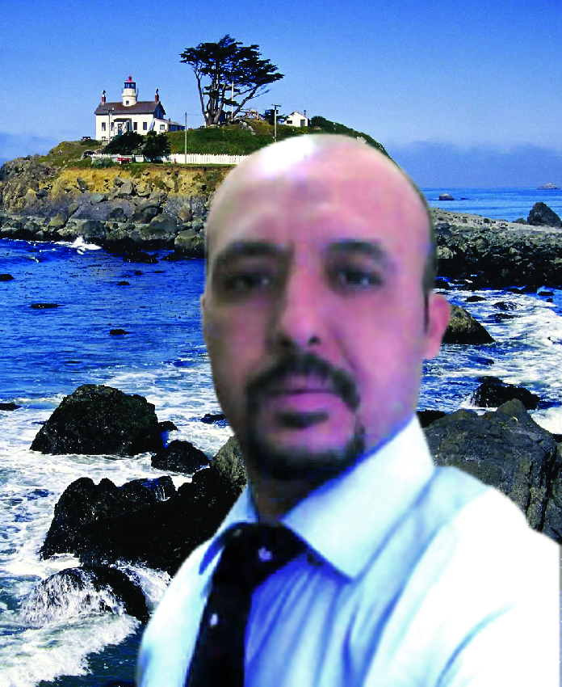
Name: Ahmad Abd El Naby Mohamed Moawad Hathout
Address: 30 Street clean - our facility grate - Cairo
Phone home: / 0565054582 - 002 02 /23412521
E-mail: ah_hathout@hotmail.com
hathoutahmed2@gmail.com
ah_hathout@yahoo.com
Qualifications: Bachelor of Art Education
Specialization: Sculpture Mural
Graduation Year: 1999
Date of Birth: 01/12/1976
Marital Status: Married
Occupation: 1 - Teacher of Art Education
2 - Graphic Designer: 3ds max-photoshop- sony vegas -after effect
Languages:
1 - Arabic (mother tongue)
2 - English (proficiency in reading and writing)
Experiences related to the field of work:
1 - work in the field of advertising (design and implementation)
2 - Working in the field of metalworking (drilling and vaccination)
3 - Working in the field of puppets (Mariont - Mask - brides Jawnty)
4 - Working in the field of sculpture Aljdreatt (gummy and Paz) by using different materials
5 - Working in the field of woodwork (the design and implementation)
6 - Work in the field Almoszek
7 - Working in the field of stained glass
Local posts:
1 - organizing an exhibition in the National Institutes Egyptian Opera House in 2001 - 2002
2 - exhibits a private school, but Ngelezip of the year (2001 AD) until (2005)
Posts of Foreign Affairs:
1 - Gulf Traffic Week 18 (2006)
2 - Tree Week
3 - Educational oversight mechanism in the field of metal mesh under the supervision of Al Safa Center in Jeddah (2006)
4 - gallery of art education in schools of the Two Holy civil (1427 -1428 e)

- اعمال علي اليوتيوبhttp://www.youtube.com/watch?v=yuRyRVH4rFA
http://www.youtube.com/watch?v=OkP2FdSLVtA

موقع
http://kenanaonline.com/ahmedhathout

