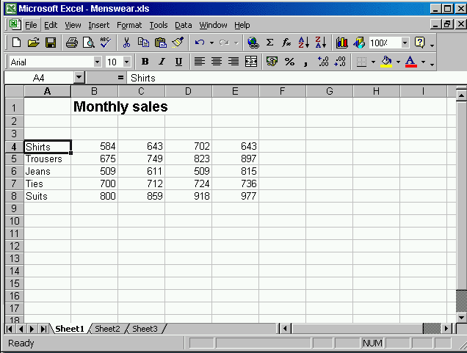


File→ open→ select the samples.xls → open

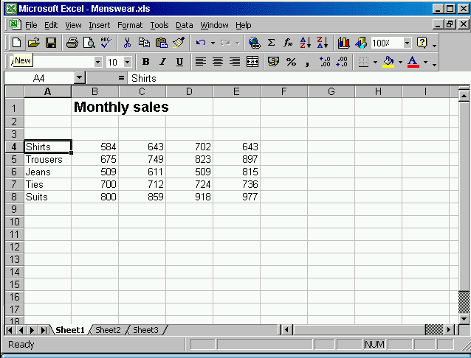
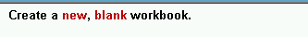

Click new tool from the standard tool bar

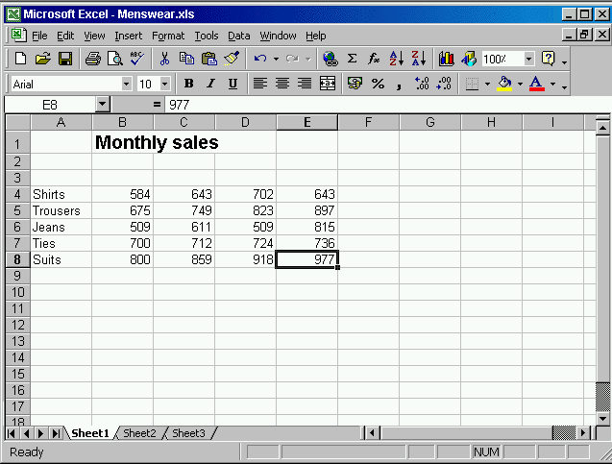
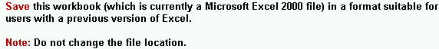

File → save as → select Microsoft excel 5.0/95 work book from save as type → click save

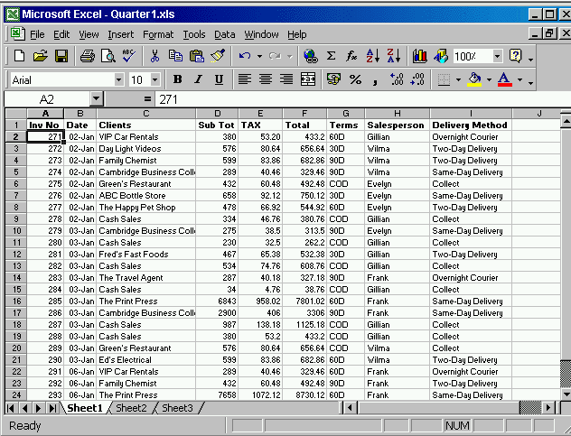

Help → Microsoft excel help → type advanced filters → click search

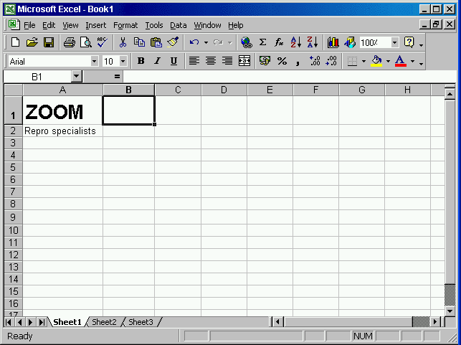

Tool → options → select General tab → in user name type Carla Banks

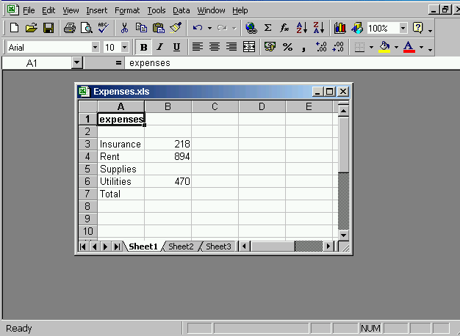
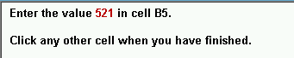

Select B5 cell → type 521→ click any other cell

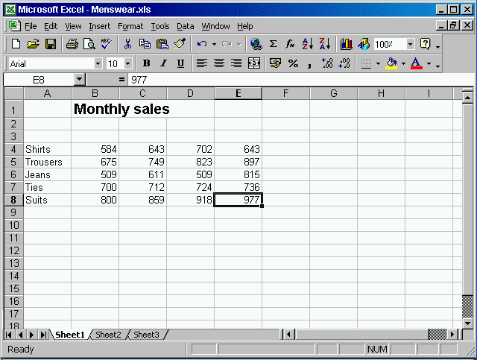
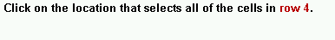

Click on the gray area of the row 4

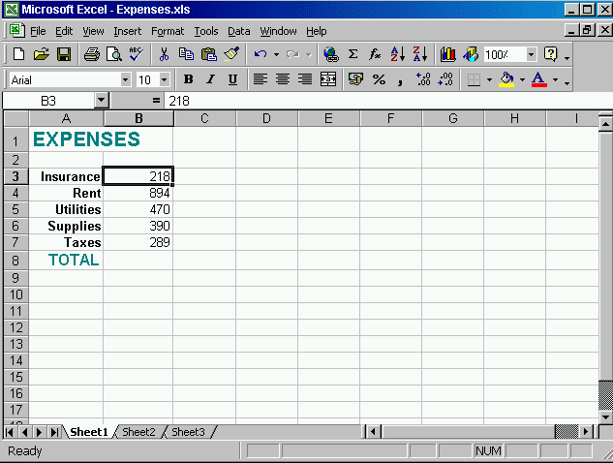


Click on the undo tool from the standard tool bar
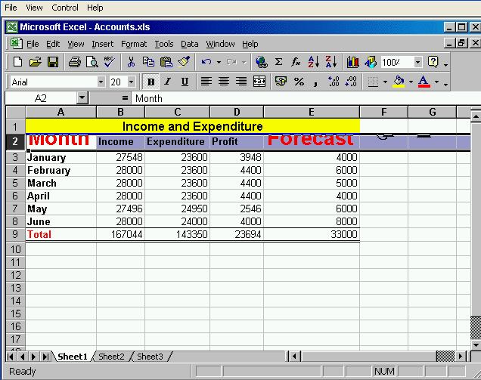

Double click on the gray area between Row 2 and Row 3

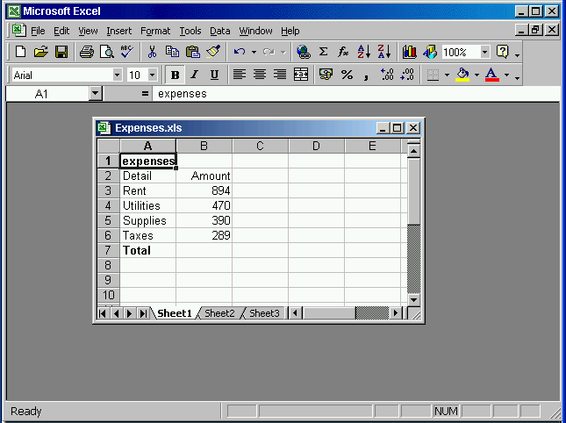
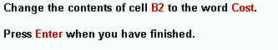

Select cell B2 → type Cost→ press Enter

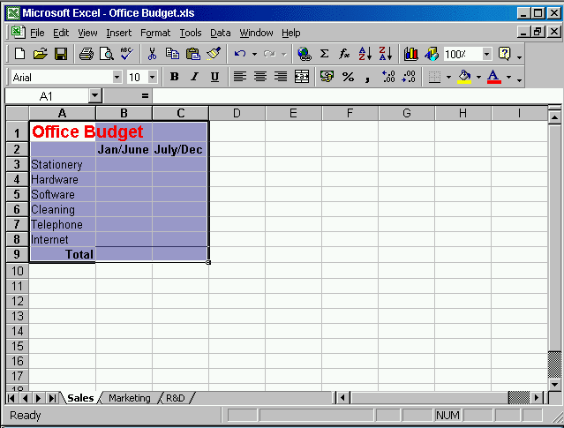

Click copy from the standard tool bar → select the Marketing worksheet → click paste from the standard tool bar

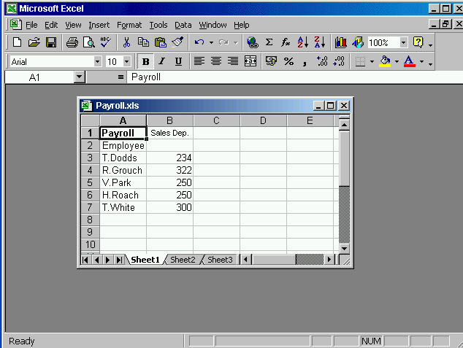

Select the cell B3 →press the delete key from the keyboard

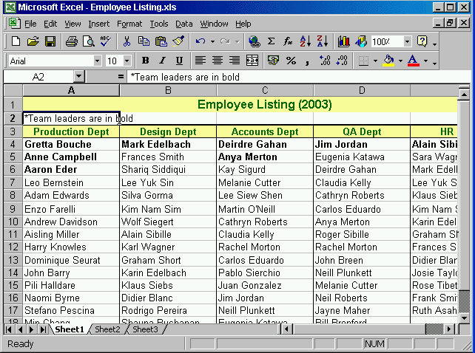

Edit → select replace → type Jane Harris in the find what → type Tom Snow in replace with → click replace all
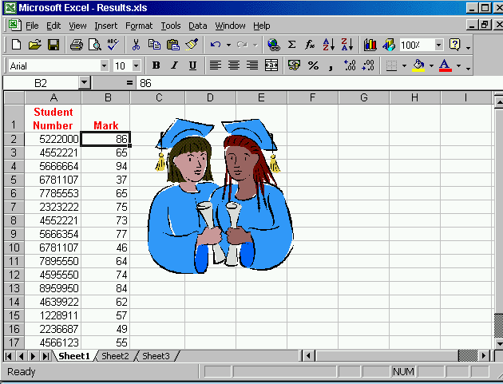

Click the sort descending tool from the standard tool bar
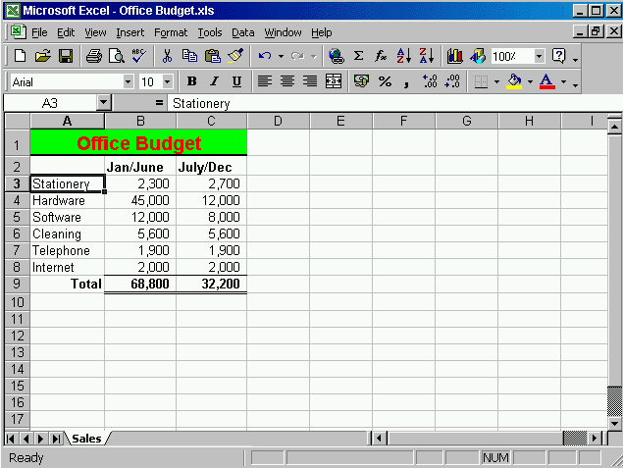

Right click on the sales worksheet → select insert → ok

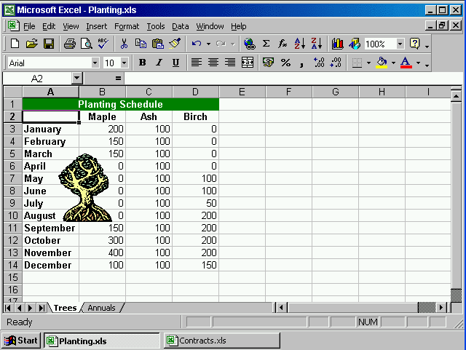

Right click on the Annuals worksheet → select move or copy → select Contracts from to book → select move to end from before sheet → ok

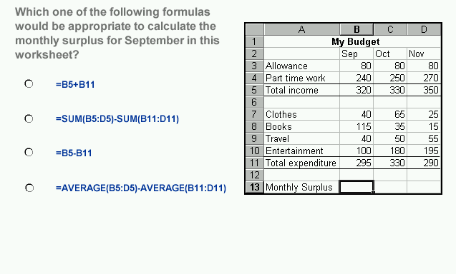
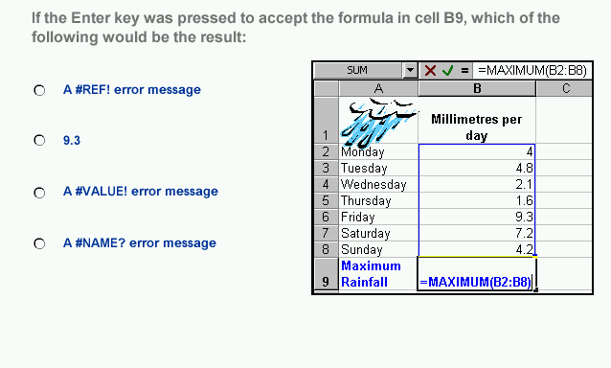

القائض

= B5-B11

- A#NAME? Error message

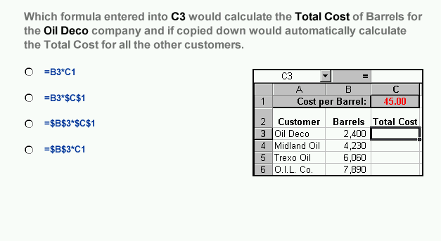
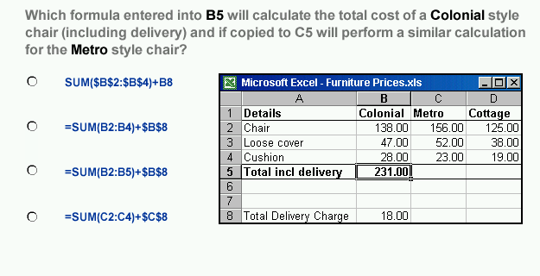

- =B3*$C$1

- =sum(B2:B4)+$B$8

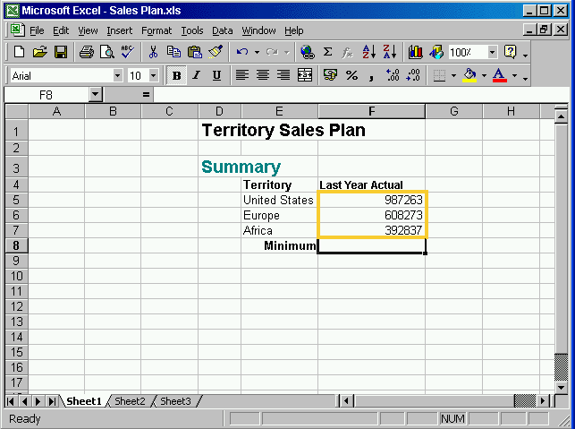

Type = min (F5:F7) → press Enter

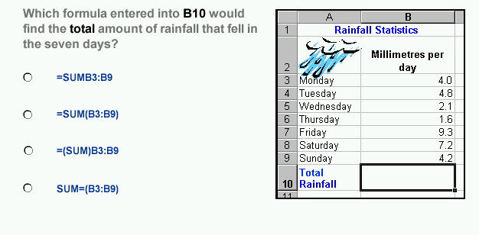
- =sum(B3:B9)

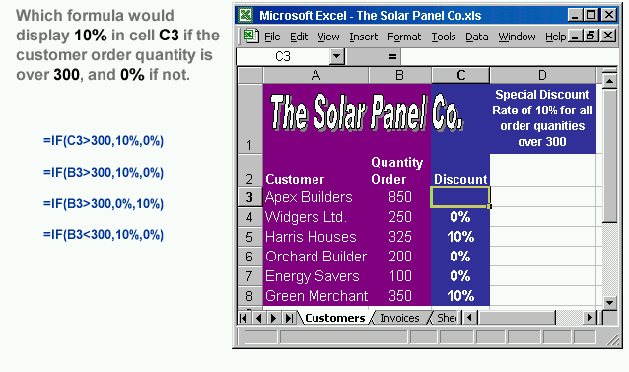

- =IF (B3>300, 10%, 0%)

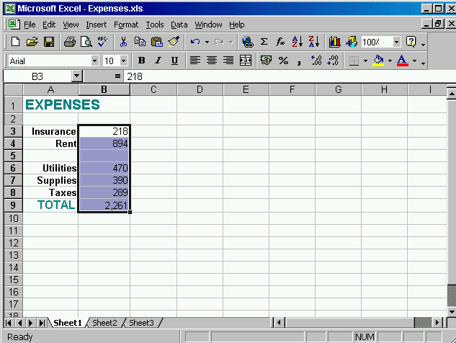

Click on increase decimal tool from the formatting tool bar

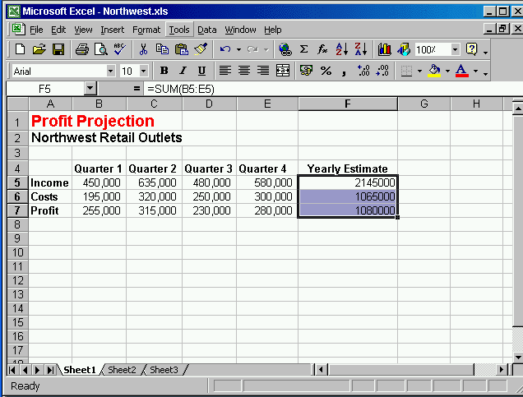

Format → select cells → select currency from the category → select £ English (United Kingdom) → ok

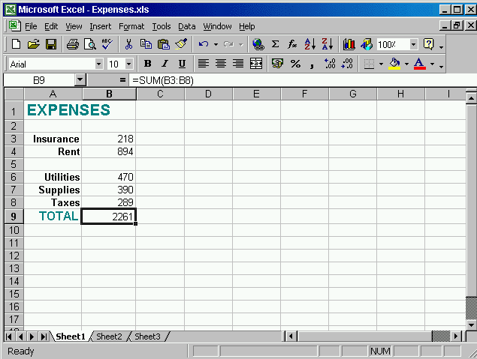


Click on the bold tool from the formatting tool bar

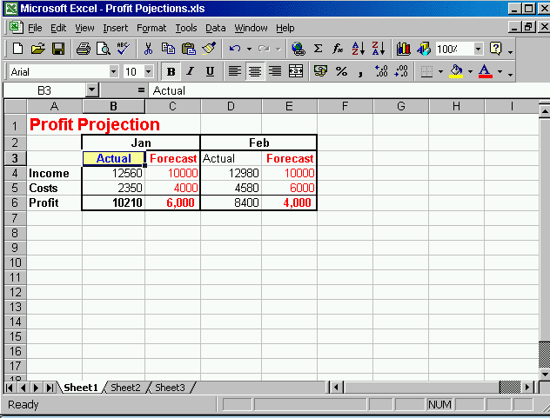

Click the format painter tool from the standard tool bar → click on cell D3

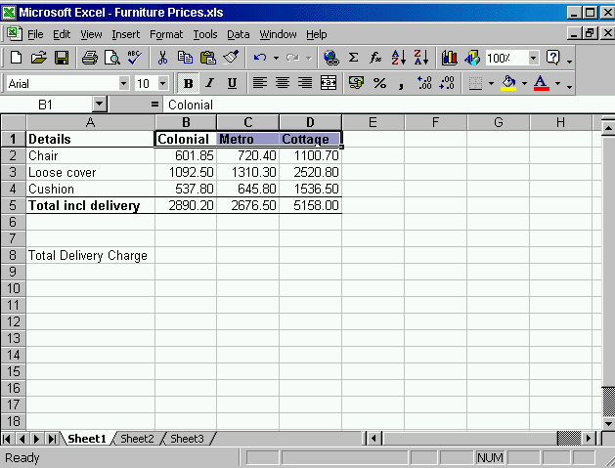

Format → select cells → select Alignment tab → in the orientation area move the red point up to the first point

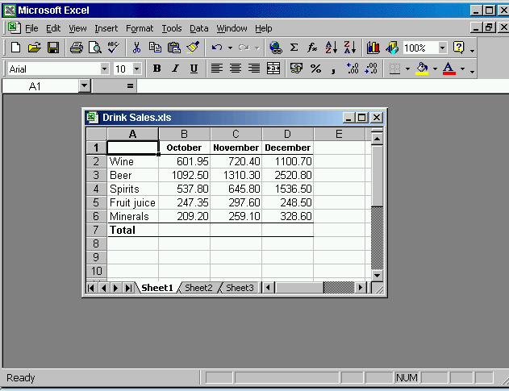


Select the range → insert → select chart → select pie in the chart type → click finish

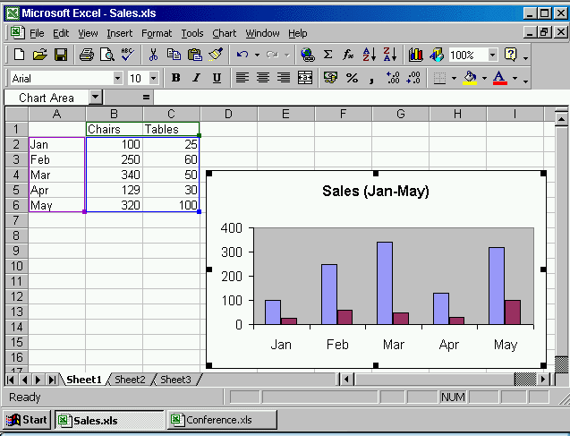

Click copy from standard tool bar → select the Conference workbook → click paste from the standard tool bar

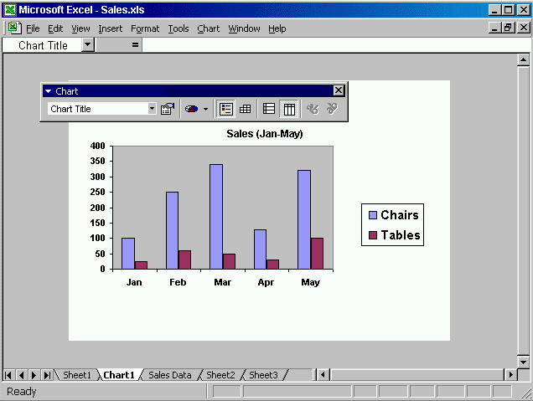

Click on the arrow in the chart type tool in the chart tool bar → select bar chart

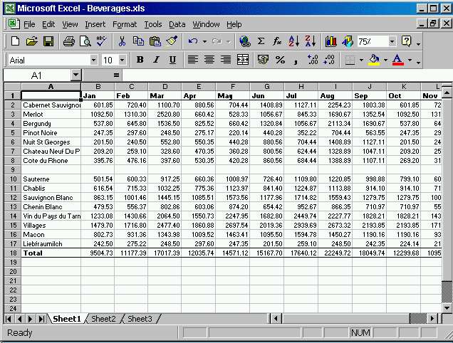

File → select page setup → select margins tab → type 2 in top box → ok

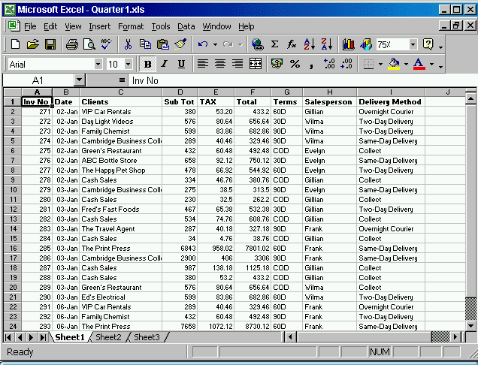

File → select page setup→ delete number 4 and type 3→ ok

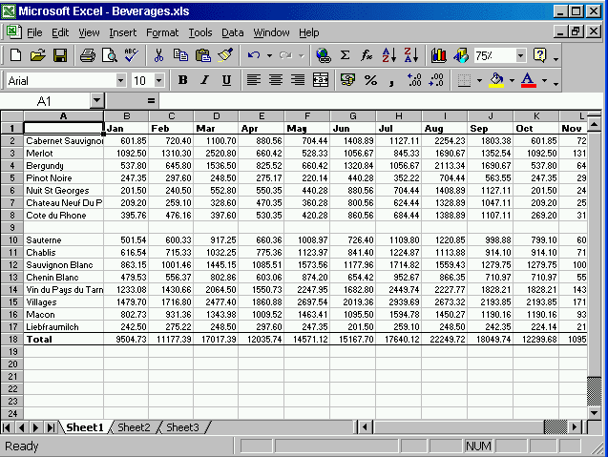

View → select Header and Footer → click custom Header → click in the center section→ click on → ok → ok

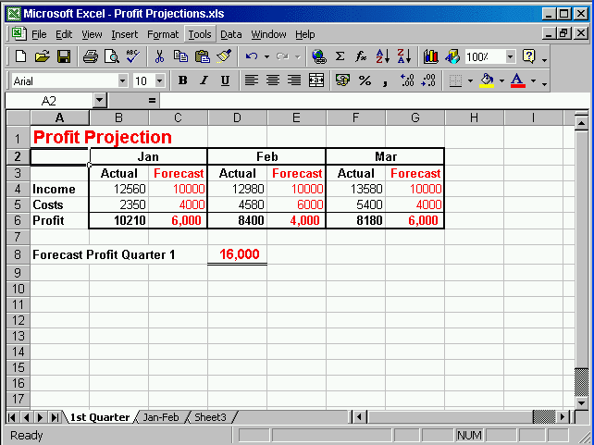

File → select page setup → select sheet tab → check the gridlines in the print section
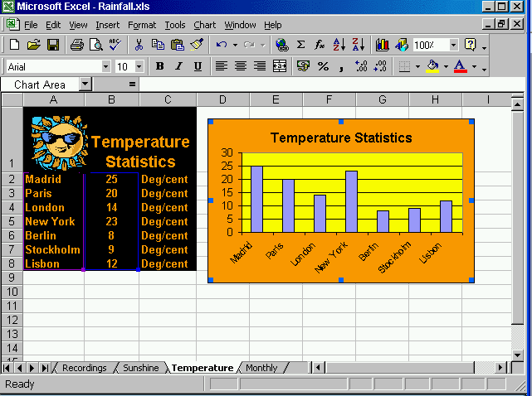

File → select print → ok

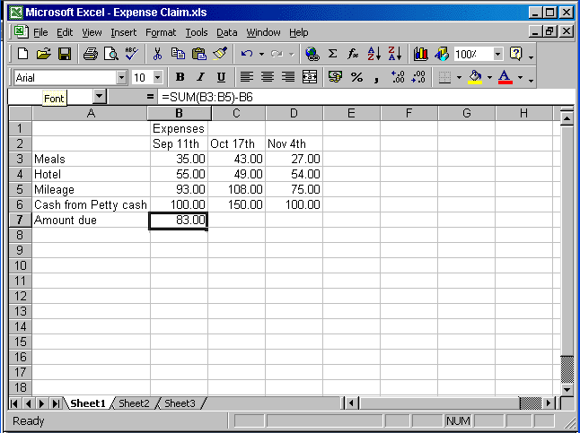
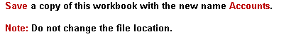

File→ save as →change the name Expense Claim into Accounts→ok

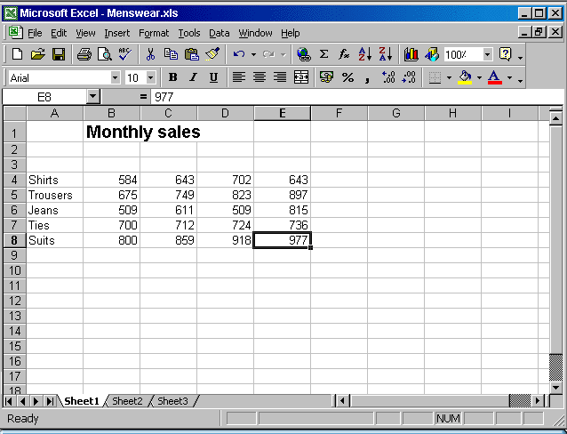

Click on the gray area of the column c

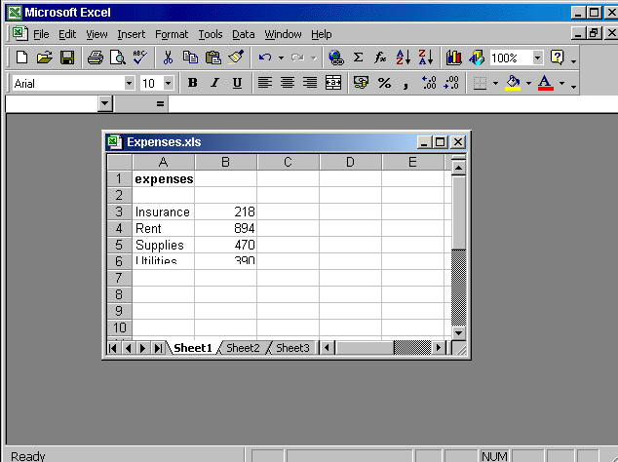

Right click on the gray area → select delete

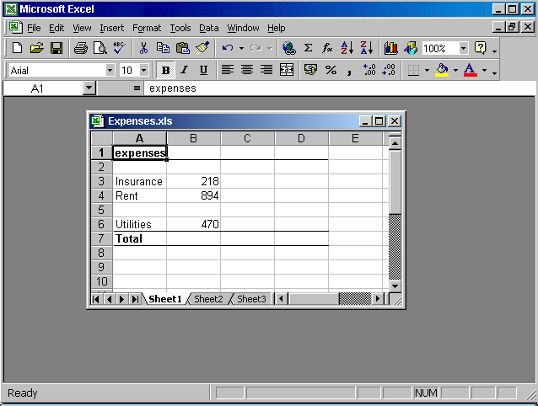

Select cell B3→ press delete from the keyboard

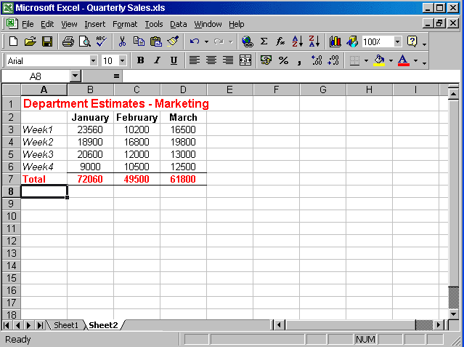

Right click on the sheet2 tab → select rename → type Costs

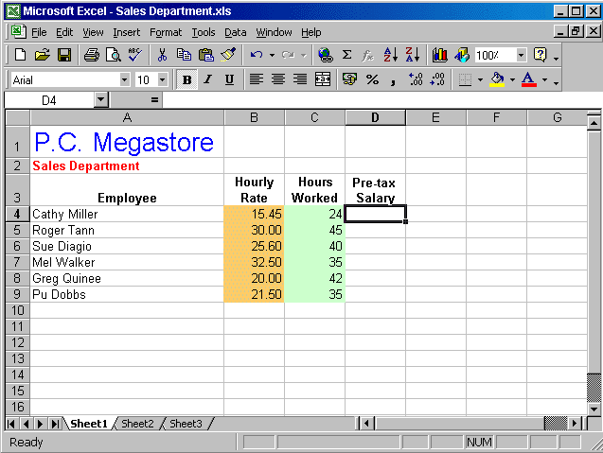
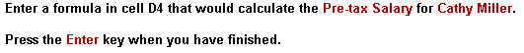

Type = B4*C4 → press Enter

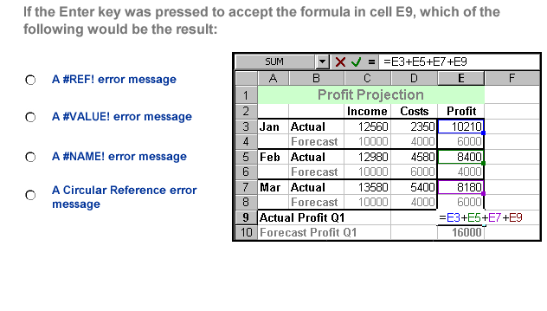
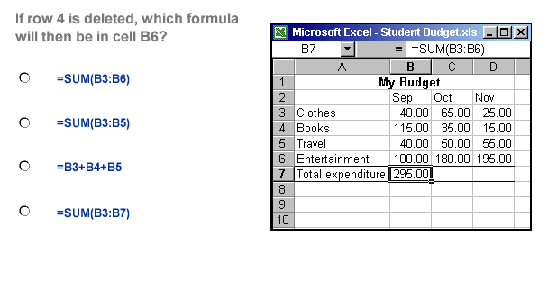

- A Circular Reference error message

- =sum(B3:B5)

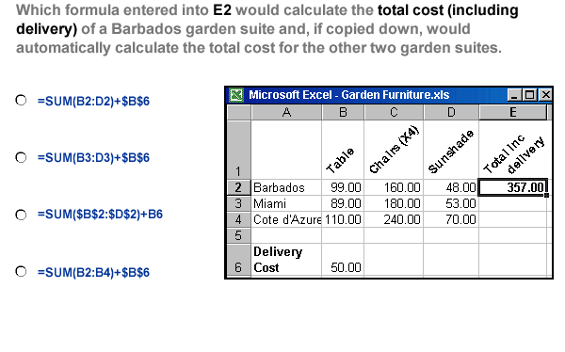
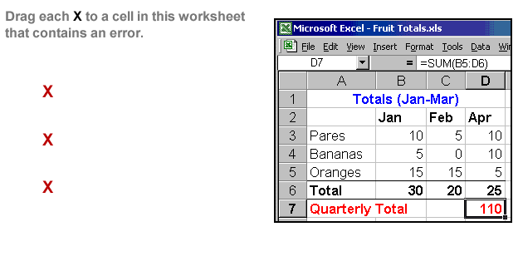

- =sum(B2:D2)+$B$6

The first put it on 110
The second put it on Apr

The second put it on pares

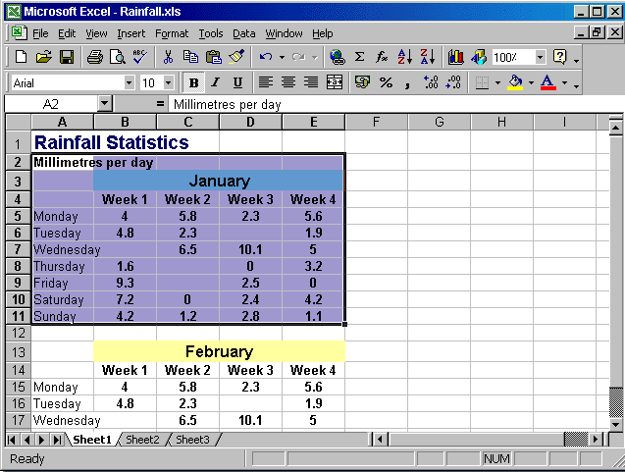
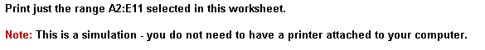

File → print → in print what section → select Selection

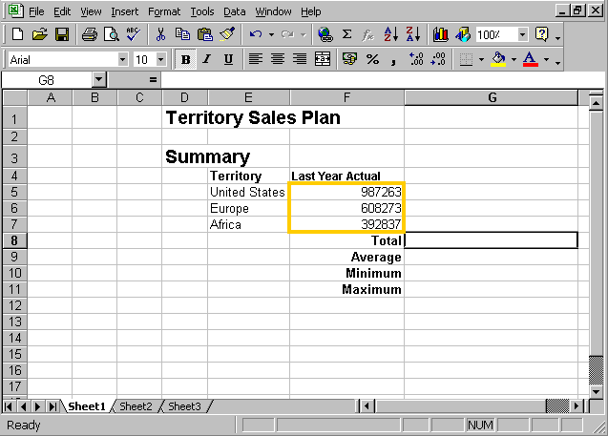

Type =sum (f5:f7) →press enter from the keyboard

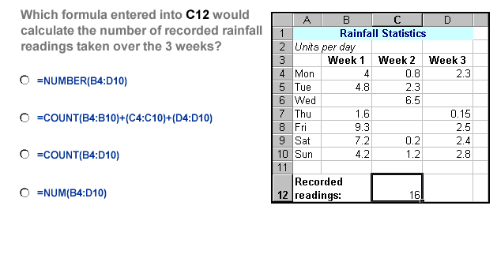
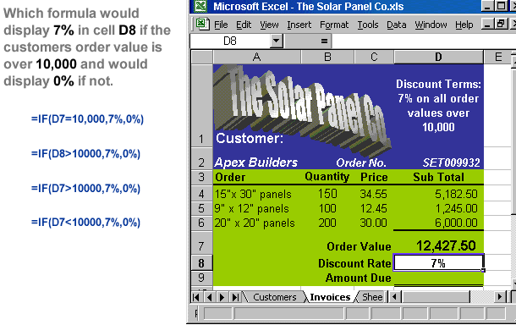

- =count (B4:D10)

- =if (D7>10000, 7%, 0%)

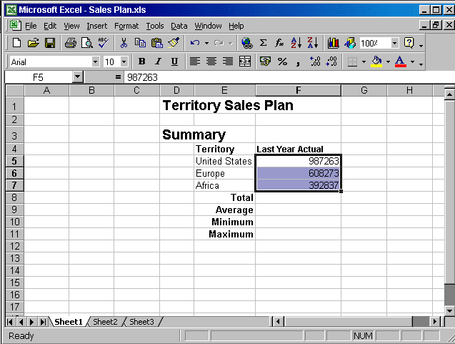

Click the comma style from the formatting tool bar

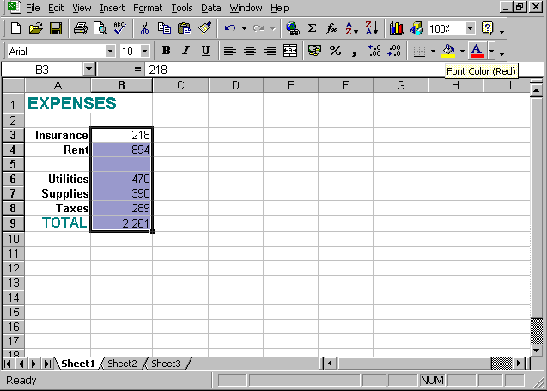


Click the arrow in the borders tool from formatting tool bar → select out side borders

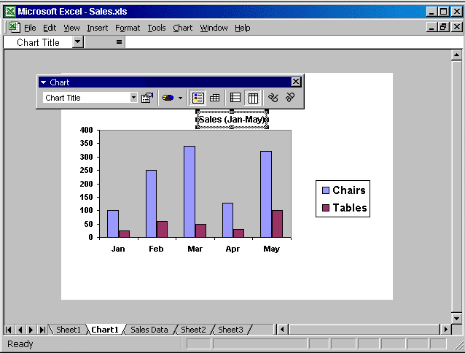

Click the arrow in the chart tool bar → select the chart area → click on the format

Chart area tool → select the yellow color → ok

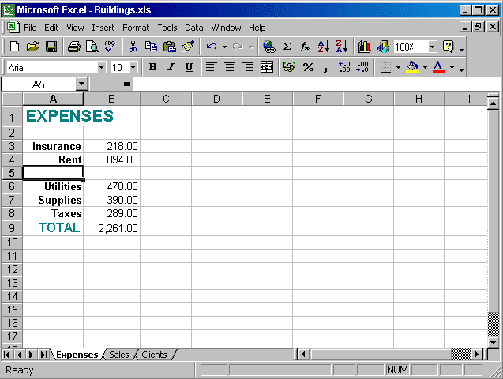

View → Header and footer → click on the custom footer → type Confidential
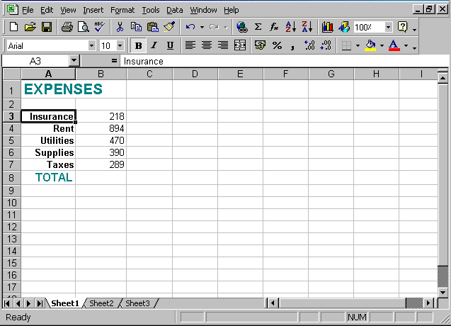

File→ print → ok
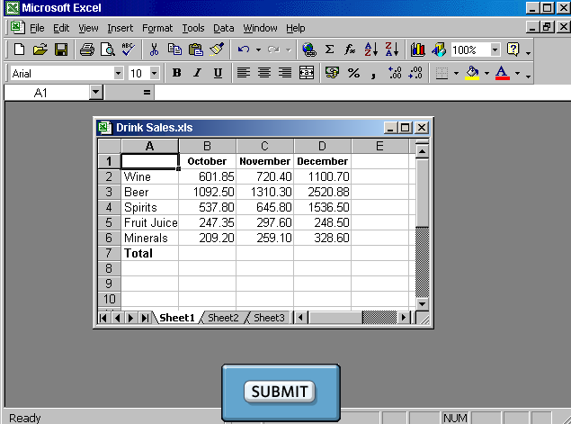

Select cell A4 and drag to cell C6

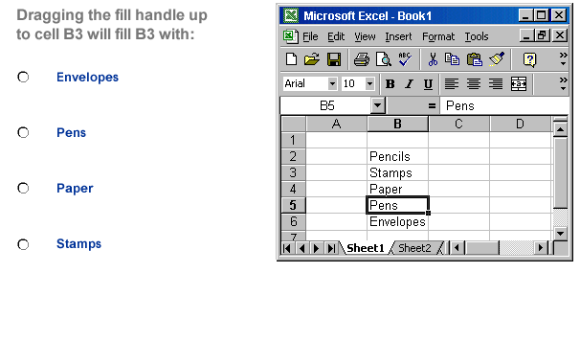
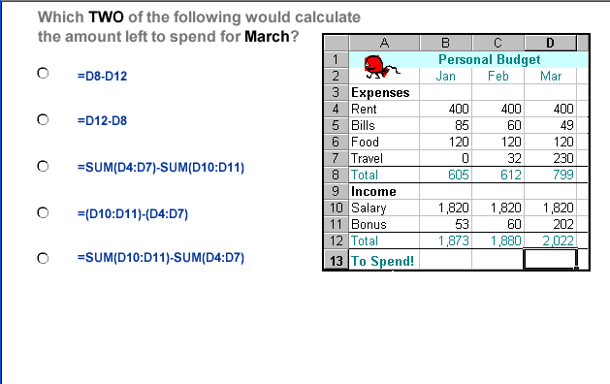

- pens

- =D12-D8
- =sum(D10:D11)-sum(D4:D7)

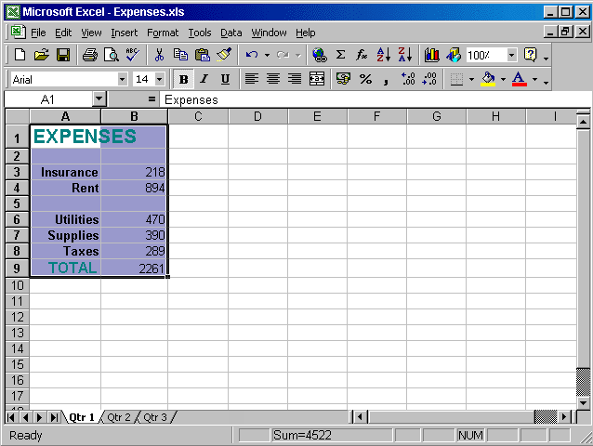

Click on the cut tool from the standard tool bar → select the Qtr3 sheet → select cell A1→ click on the paste tool from the standard tool bar

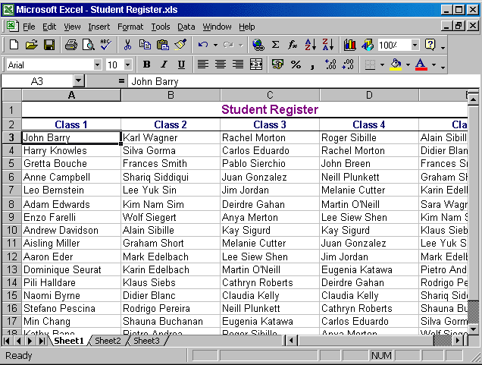

Edit → find → type Kim Brown → click on the find next button

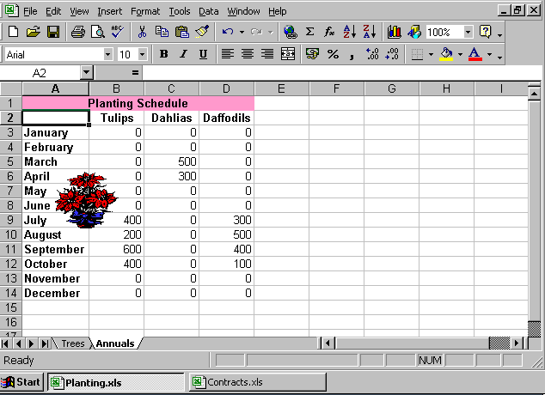

Right click on the Trees worksheet tab → select move or copy → check the create a copy → from the to book drop down list select the Contracts workbook → select (move to end) → ok

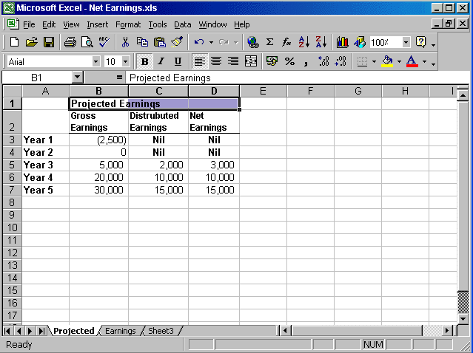

Format → cells → Alignment → from the drop down list of the Horizontal → select center Across Selection

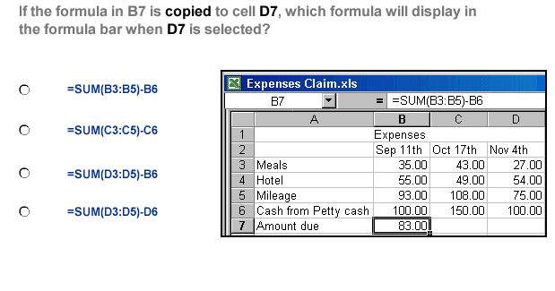
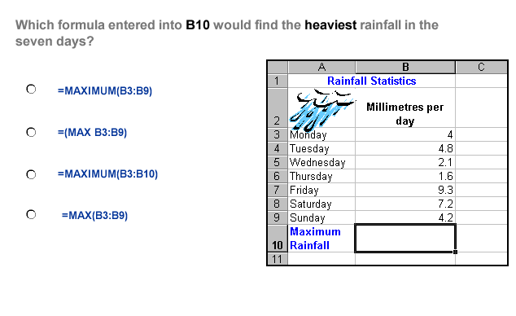

- =sum(D3:D5)-D6

- =max(B3:B9)

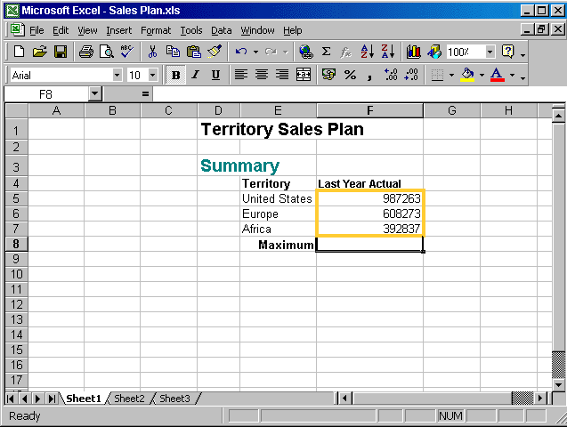
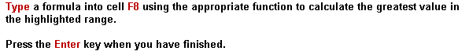

Type = max (F5:F7) → press enter from the keyboard

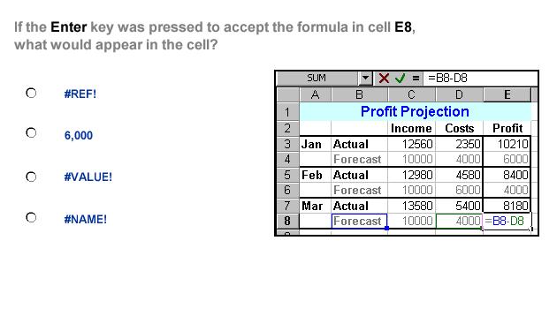

- #VALUE!
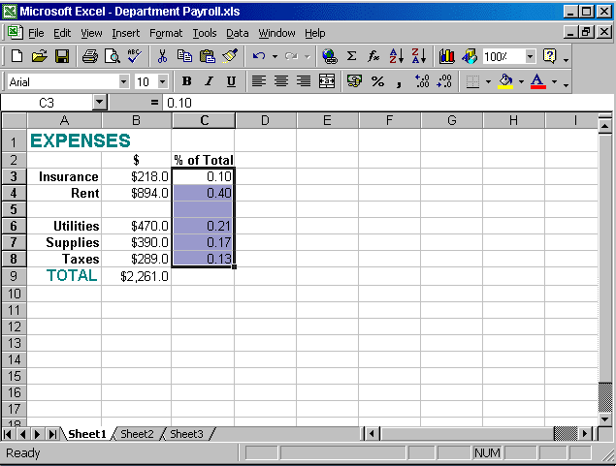


Click on the percent style tool from the formatting tool bar

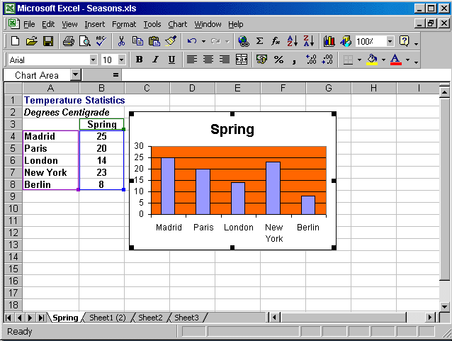


Press Delete from the keyboard

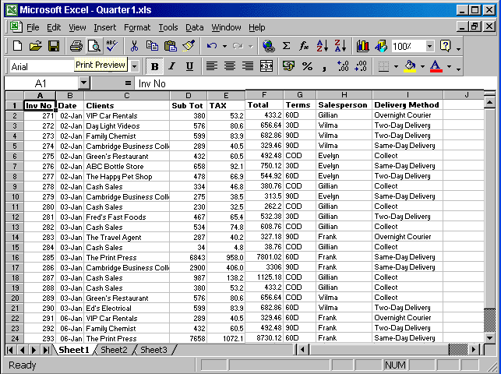

File → select print preview

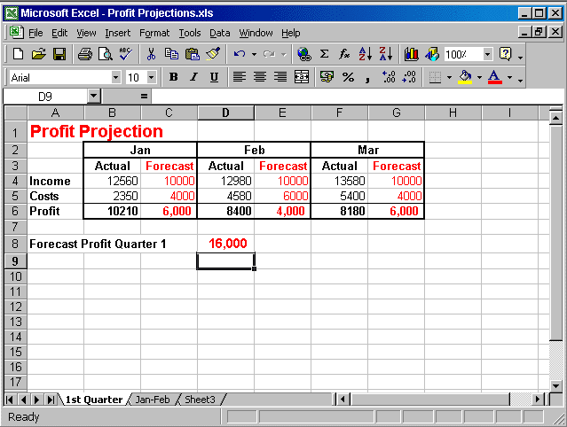

File → select print → in the number of copies use the arrow to make it 3 → ok

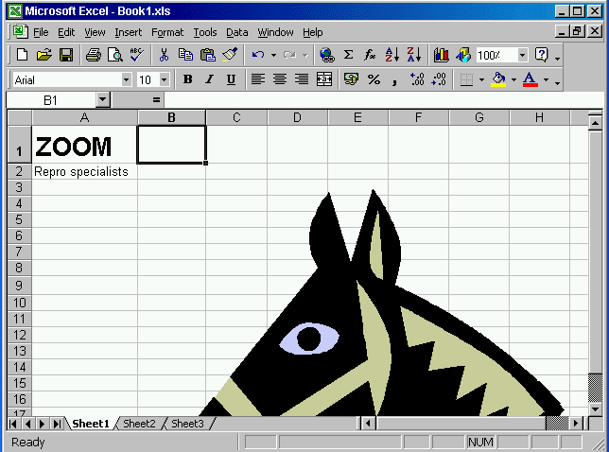

From the zoom tool in the standard toolbar use the drop down list and select 75%

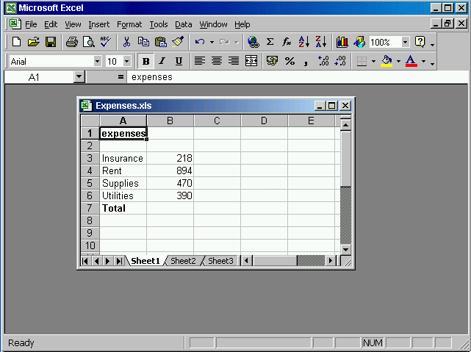


Select row 5 from the gray area → Insert Rows

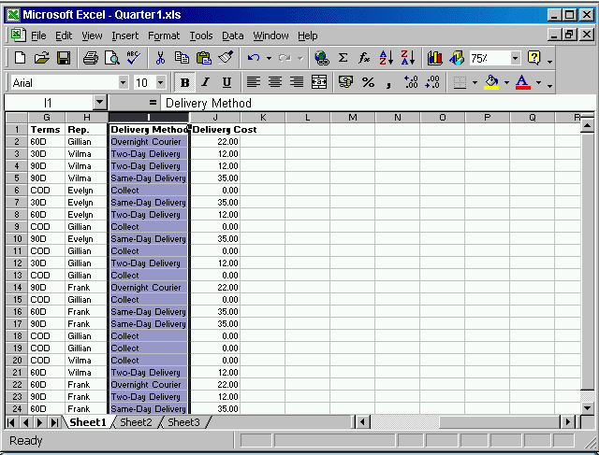

Format → column → Auto fit selection

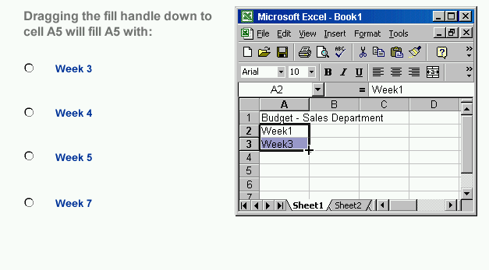
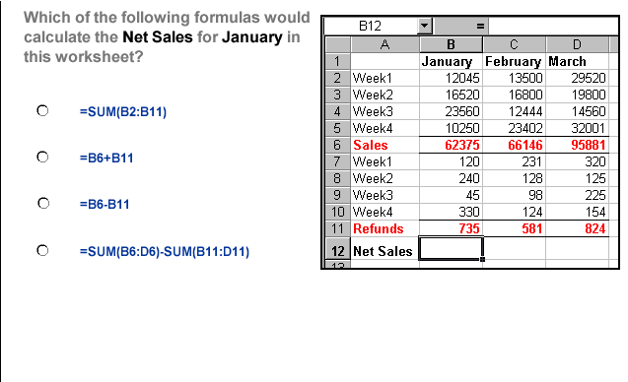

- Week 7

- =B6 – B11

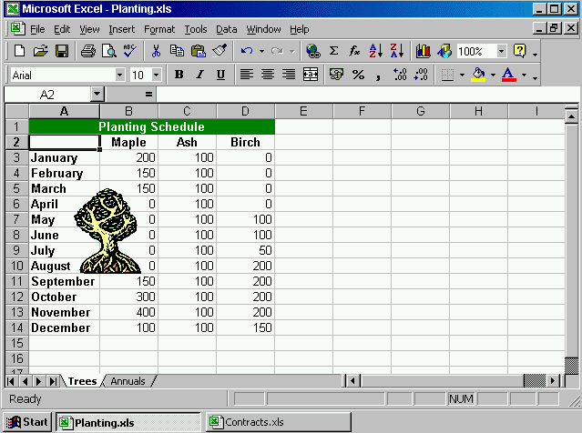

Right click on the trees worksheet → select move or copy → select Contracts workbook → ok

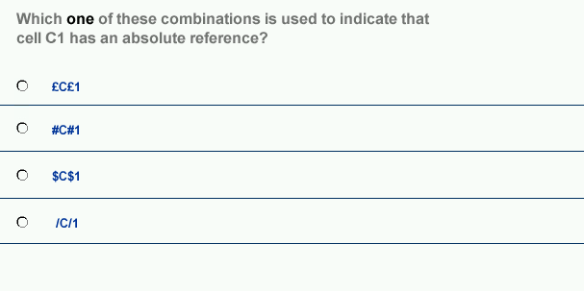

- $c$1

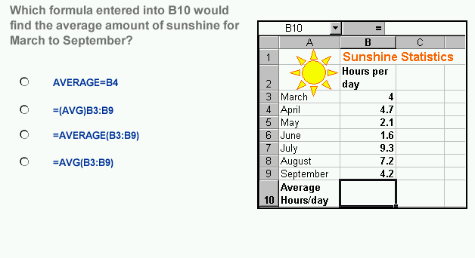

- =average(B3:B9)
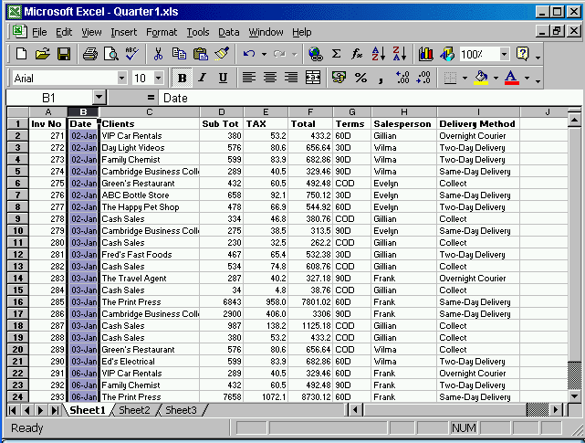

Format → cells → select date → select 04-Mar-02 → ok

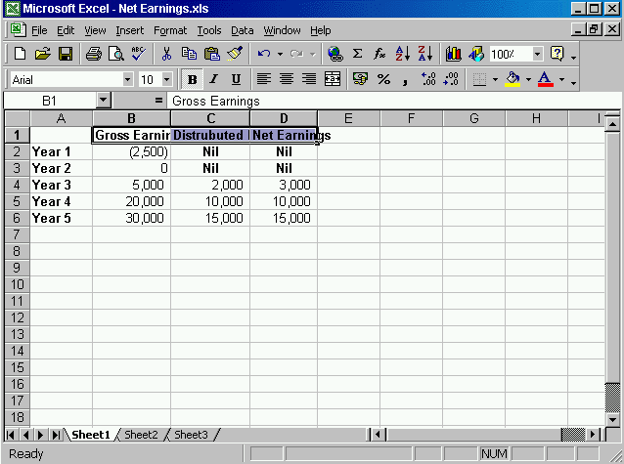

Format → cells → select Alignment tab → check the wrap text → ok

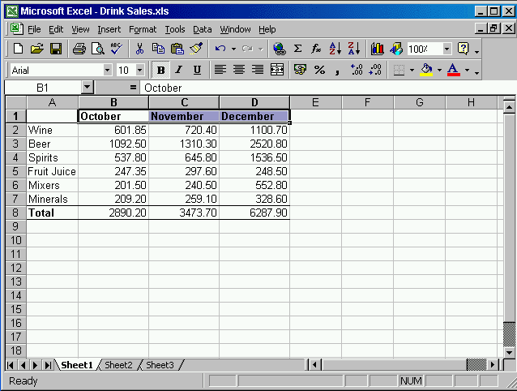

Click the center tool from the formatting toolbar

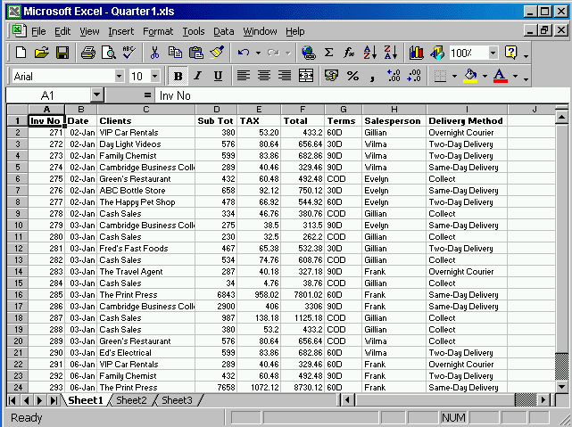

File → page setup → select landscape → ok

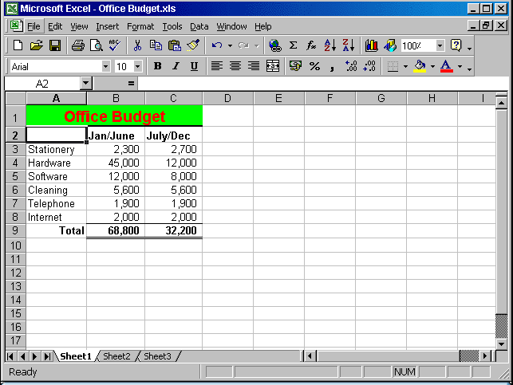


File → save as → in the save as type → from the drop down list → choose text (Tab delimited) → save

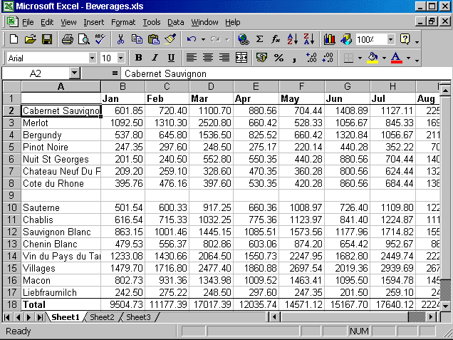

Select the cell B2 → window → select freeze pane

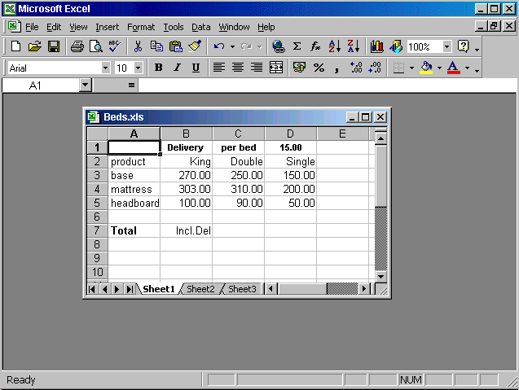

Select the column B → insert → columns

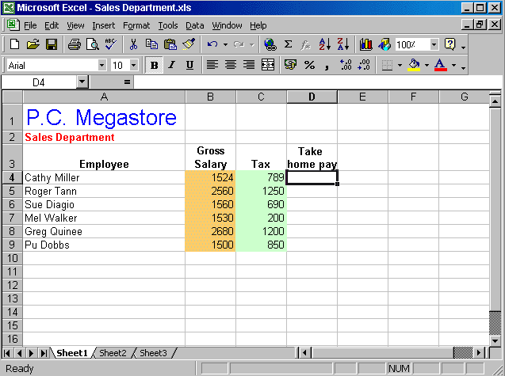

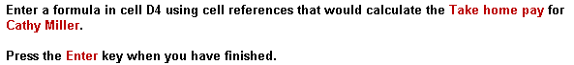

Type = B4-C4

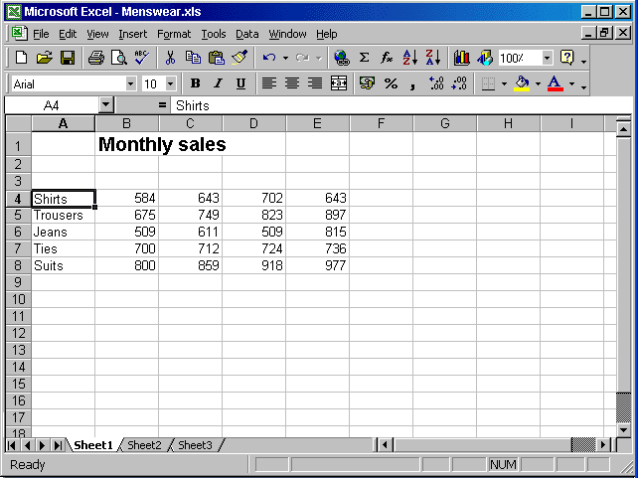

File → close

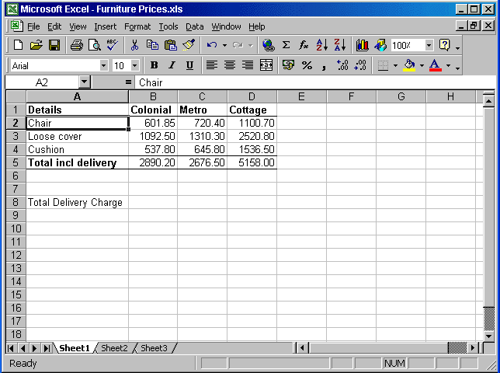

View → Toolbars → Drawing

