Unit 3

 Complete the following sentences:
a. The soil contains gravels produced from breaking down of ……………
b. The main soil components are ……………, ……………., ………….
c. Water and ………….. break down rocks into small pieces.
d. Humus add nutrients to ……………………
a. The main types of soil are ……….., …………….. and …………….
b. The color of ………….. soil is dark, while that of ………….. soil is yellow.
c. Soil is highly fertile because it contains large amount of …………..
d. Clay soil holds ……………. Water and ……………… soil holds less water.
e. The compactness of ……………. Soil is very weak, while that of ……………… soil is highly compact.
a. The most important soil pollutants are …………. , ………… and …………………..
b. The soil types are ……………, ………………. and …………………..
c. Silt soil aeration is ……………., clay soil compactness is …………….and the silt soil fertility is ………………….
d. The ……………….. region in Egypt is considered as the best region for rice cultivation.
e. The origin of the agricultural soil in Egypt is the rocks from the ……………. plateau.
--------------------------------------------------------------------------------------------------------------
 Write the scientific term which expresses each of the following :
a. A thin non-compacted layer covers the Earth's crust.
b. A soil is mainly composed of clay and silt particles.
c. A soil is rarely contains humus.
a. A thin loose layer covering the Earth's crust.
b. The remains of the decayed organisms.
c. A highly fertile soil because it contains suitable dissolved salts and humus.
a. The cells which carry oxygen.
b. The artery that carries oxygenated blood to all parts of the body.
c. A set of small balls of smooth surfaces are put together between the internal surfaces of the moving objects of machine.
d. A friction force between air and the moving object through.
e. The soil type rich with humus.
f. The most a rated soil.
--------------------------------------------------------------------------------------------------------------
- Give reason:
a. The soil is the main component of the environment?
b. Roots are important for the soil.
a. The sand soil has good aeration.
b. The water level in the clay soil is higher than the water level in both the sand and silt soils.
c. The silt soil fertility is the highest.
d. The clay soil has poor aeration.
e. Soils differ in compactness depending on their types.
f. The microorganisms that live inside the soil have a great importance.

- Choose the correct answer:
a. The particles size of clay soil is ………………..
(large – small – medium)
b. The aeration of sand soil is ………………….
(good – bad – medium)
c. The most suitable soil for cultivation is …………….. soil.
(sand – clay – silt)
d. The sand soil …………… water more than the other two types of soil
(drains – holds – retains)
a. The silt soil compactness is ……………….
( strong - weak - medium)
b. The origin of the agricultural soil in Egypt is from ……………… plateau.
(Tibet - Golan - Ethiopia)
c. The particles of the clay soil is ………………
(tiny - medium - large)
d. The water drains easily in the …………….. soil.
( silt - sand - clay)
e. Rice grows efficiently in …………. Soil.
(clay - silt - sand)
a. Carbon dioxide and water vapor are released by the …………….
( kidneys. - lungs. - heart.
b. Urea is expelled by the …………….
( heart. - kidneys - lungs.
c. The heart is a muscular pump in a size of your ………………….
( fingers - foot - fist)
d. Blood vessels which carry blood from the heart are the ………………
( arteries – veins - blood capillaries)
e. Blood components which are responsible for attacking the microbes causing diseases to man are the ………………
( red blood corpuscles - white blood corpuscles - blood platelets)
f. The silt soil compactness is…………………..
( strong – weak - medium)
g. The origin of the agricultural soil in Egypt is from ………….. plateau.
( Tibet – Golan - Ethiopia)
h. The particles of the clay soil is……………
( tiny – medium - large)
i. The water drains easily in the ………… soil.
( silt – sand - clay)
j. Rice grows efficiently in …………….. soil.
( clay – silt - sand)
------------------------------------------------------------------------------------------------------------
- Put () or () in front of each of the following sentences and correct the underlined words in the wrong sentences:
a. Wheat plant grows in sand soil.
b. The spaces between the particles of clay soil are large.
c. Cactus plants are seen in sand soil.
d. Silt soil contains gravel, clay, sand, silt and humus.
e. Sand soil is more compacted than silt one.
a. Environmental balance is the tendency of the environmental system to stability.
b. The sand soil is strongly compact, has poor ventilation and fertile.
c. The clay soil has poor ventilation.
d. Humus is the remains of fragmented small rocks and was deposited on the Earth's surface.
e. Cactus plant grows in clay soil.
-------------------------------------------------------------------------------------------------------------
- Put ( ) or ():
a. Adding natural fertilizers leads to soil pollution.
b. Using insecticides to control agricultural pests protects the soil from pollution.
c. Soil pollution causes the disappearance of plant and animal groups.
d. Spacing periods of irrigation leads to increase the validity of the soil.
e. The pollution is any change in the environment that disturbs its natural balance.
-------------------------------------------------------------------------------------------------------------
- What are the soil different components?
……………………………………………..
- How was Egypt's agricultural soil formed?
……………………………………………..
- How do plants and animals affect in soil composition?
……………………………………………..
- What is the importance of soil as a main component of the environment?
……………………………………………..
- How can soil be protected from pollution?
……………………………………………..
- What are the harms resulted from the polluted soil?
……………………………………………..
……………………………………………..
----------------------------------------------------------------------------------------------------------
- Put a circle around the letter that does not match with the following statement:
From the sources of pollution of agricultural soil is : من مصادر تلوث التربة الزراعية
a. Chemical pesticides.
b. Salts.
c. Natural fertilizers.
d. Asphalt.
----------------------------------------------------------------------------------------------------------
- Mention three examples of plants that grow in the following types of soil.
Clay : ………………………………….
silt :…………………………………….
sand: ….……………….………………
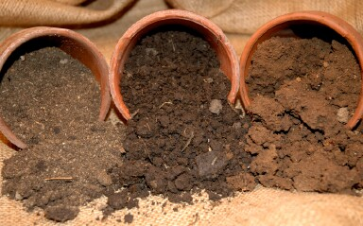  - What do you see in the picture?  ……………………………………………..  - Which of the soil types is the best for cultivating plants?  ……………………………………………..  - Which of the three is the most in absorbing water?  ……………………………………………..  - Which of the three types is the most fertile?  …………………………………………….. | 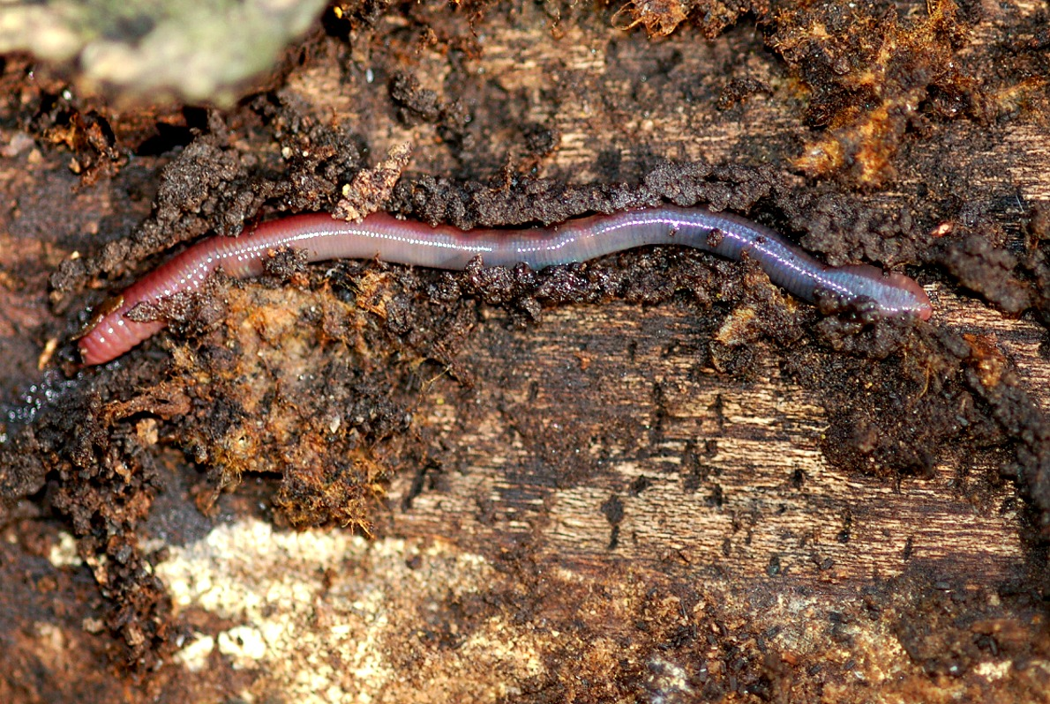  - What do you see in the picture?  ……………………………………………..  - Is the organism shown in the picture useful or harmful?  ……………………………………………..  - If it is useful, what are the benefits?  ……………………………………………..  - If it is harmful, what are the harms?  ……………………………………………..

- What do you see in the picture?
……………………………………………..
- Why is this process done in fields?
……………………………………………..
- What are the advantages and disadvantages of this process?
……………………………………………..
- Do the benefits from this process exceeds the harms?
……………………………………………..

- Describe an experiment that you have performed to compare water absorption امتصاص in different types of soil.
- Describe an experiment that you have performed describing water draining in different types of soil.

- Write a brief account about each of the following:
a. Friction.
b. Plasma.
c. Sand soil.
d. Aorta.
e. Sweat.
f. Water resistan

