@
Unit 1
Welcome back

New words
pizza | بيتزا | watermelons | بطيخ |  | cucumbers |  | خيار
grapes | عنب | strawberries |  | فراولة | subject | مادة
sports | ألعاب | favourite |  | مفضل | birthday | يوم ميلاد
green | أخضر | volleyball |  | كرة طائرة | colours | الوان
purple | بنفسجى | football |  | كرة قدم | teach | يعلم
pink | وردى | tennis |  | تنس | Hello! | أهلا
name | اسم | aunt |  | عمة | bear | دب
friend | صديق | Arabic |  | عربى | English | انجليزى
Who? | من ..؟ | science |  | علوم | maths | رياضيات
thirty | 30 | giraffe |  | زرافة | like | يحب
wheel | عجلة

☻Learn the following☻
☻What's your name? ما أسمك؟
► My name's Sohila. أسمى سهيلة.
☻What's your favourite subject? ما هى مادتك المفضلة ؟
► English is my favourite subject. مادتى المفضلة هى الانجليزية.
►My favourite subject is English.
☻Sing your favourite song. غنى أغنيتك المفضلة.
☻Sing with your class. غنى مع فصلك .
like & likes
معناه ( يحب ) و يستخدم كما يلى: ( like) تذكر أن الفعل☻
I / We / You / They | like | strawberries.  football.  Arabic.
He / She / It | likes | strawberries.  football.  Arabic.
للسؤال عن الشخص الذى يحب شيئا ما نستخدم: ☻
Who likes……………..? من الذى يحب .......؟

ونضع اسم الشخص الذى يحب هذا الشىء ( who ) وعند الاجابة نحذف
☻Who likes basketball?
►Ahmed likes basketball.
من الفعل: ( - s) مع مراعاة أن الاجابة اذا كانت باسم جمع تحذف الــــ
►Mona and Sara like basketball.
/////Exercise/////
Exercise on lesson 1 & 2
- Read and circle the odd one out :
- we – you – milk – they.
- volleyball – English – maths – music.
- Rasha – Lamia – Dalia – Ali.
- bananas – strawberries – milk – Arabic.
- Match the questions with the answers :
A | B
- What's your favourite subject?  - Do you like strawberries?  - Who likes Arabic?  - Does Ahmed like English? | - Yes, I do.  - Mona likes English.  - My favourite subject is art.  - Yes, he does.  - Ahmed likes Arabic. | ( )  ( )  ( )  ( )  ( )

- Rearrange the words to make meaningful sentence :
  - Arabic – We – like.
……………………………………….………………………. .
  - My – is – name – Heba – Miss.
……………………………………….………………………. .
  - likes – English – Rana – Arabic – and.
……………………………………….………………………. .
  - your – What – name – is?
……………………………………….………………………. .
  - maths – My – subject – is – favourite.
……………………………………….………………………. .
- Punctuate the following sentences :
mona and dina like arabic
……………………………………………………………… .
- Copy the following sentence:
Don't waste your time.
………………………………………………………………. .
Exercise on lesson 3 &The whole unit.
- Read and circle the odd one out :
- pink – purple – car – green.
- tennis – aunt – volleyball – basketball.
- aunt – bear – giraffe – lion.
- father – mother – brother – black.
- watermelon – banana – strawberry – pizza.
- listen – name – like – sing.
- football – thirty – twenty – ten.
- Rearrange the words to make meaningful sentence :
- is – my – English – subject – favourite.
……………………………………….………………………. .
- thirty – is – Ten – twenty – and.
……………………………………….………………………. .
- with – sing – I – friends – my.
……………………………………….………………………. .
- favourite – My – is – tennis – sport.
……………………………………….………………………. .
- Read and choose the correct answer:
My name's Yasmeen. I'm twenty three years old. I teach English in a primary school. Heba is my sister. She is twenty four years old. She likes Arabic. I like strawberries, but she likes grapes. We like football.
- Heba and Yasmeen like ( basketball – volleyball – football)
- Heba is ( twenty - twenty four - twenty three) years old.
- Yasmeen likes ( grapes – strawberries – cucumbers )
- Heba likes ( Arabic – English – maths)

- Finish the sentences with words from the list:
[ these – animal – likes – colours – like - subject ]
- Salma and Heba …………..…….art.
- ………………..are basketballs.
- My favourite …………………are red and yellow.
- Ahmed ………………. Arabic .
- My favourite ……………..is the cat.
- Punctuate the following sentences :
lamia likes arabic and english
………………………………………………………..
Unit 1 Welcome back. Revision exercises.
- Circle the odd one out :
- Rasha – Tamer – Dina – Yasmeen.
- ice cream – cake – art – pizza.
- tennis – science – English – Arabic.
- bananas – music – watermelon – ice cream.
- volleyball – football – tennis – maths.
- father – brother – teacher – mother.
- read – black – pink – green.
- giraffe – pear – lion – tiger.
- pizza – milk – sandwich – cake.
10. strawberries – cucumbers – grapes – bananas.

- Match the questions with the answers :
A | B
- What's your favourite sport?  - Do you like English?  - Who likes science?  - Who likes grapes? | - Mona and Heba.  - Tennis is my favourite sport.  - Manal likes science.  - Yes. he does.  - Yes, I do. | ( )  ( )  ( )  ( )  ( )

- Rearrange the words to make meaningful sentences:
- favourite – is – your – What – sport?
……………………………………………………………. .
- Sohila – Arabic – Tasneem – and – like.
……………………………………………………………. .
- and –My – like – mother – father – football.
……………………………………………………………. .
- Ahmed – is – My – Mr – name.
……………………………………………………………. .
- thirty – is – Twenty – fifty – and.
……………………………………………………………. .
- your – song – Sing – favourite.
……………………………………………………………. .
- with – Sing – friends – your.
……………………………………………………………. .
- your – is – What – name?
……………………………………………………………. .
- subject – is – English – favourite – my.
……………………………………………………………. .
10.Who – maths – likes – science – and?
……………………………………………………………. .

- Read and choose the correct answer:
Ahmed and Ramy are friends. They play football in the sports lessons. Ahmed's favourite subject is Arabic. He likes grapes. Ramy's favourite subject is science. He likes bananas. Mr Ebrahim teaches them English. Ahmed and Ramy like English.

- Ahmed likes ( bananas – strawberries – grapes )
- Mr Ebrahim teaches ( Arabic – science – English )
- Ramy's favourite subject is ( Arabic – science – English )
- Who likes Arabic? ( Ahmed – Ramy – Mr. Ebrahim )
- Ramy is Ahmed's ( friend – brother – teacher )
- They play football in the ( club –school – house )

- Finish the sentences with words from the list :
[ name's – Sing – food – sport – favourite –
that – they – He – like –likes – What – Who ]
- My …………….. subject is English.
- ……………….likes art? Khalid.
- Mona and Heba ………………. bananas.
- My ………………Yasser.
- This is a car and …………….is a bus.
- Dalia …………….football.
- …………………your favourite song.
- ………………….likes milk.
- My favourite …………………is pizza.

- Punctuate the following sentence :
- my names fatma
……………………………………………………………. .
- sara and mariam like english
……………………………………………………………. .
- here s a cd
……………………………………………………………. .
- sing your favourite song alaa
……………………………………………………………. .
If you sow , you will reap.
من جد وجد ومن زرع حصد

Unit 2
Healthy food
New Words
Let's play | هيا نلعب |  | very much | كثير جداًًًً
ready | جاهز |  | o'clock | تماما
great | رائع |  | nice | لطيف
market | سوق |  | work | يعمل
do homework | يعمل الواجب |  | go home | يعود للمنزل
have / has | يملك \ لديه |  | foot | قدم
on a tractor | على الجرار |  | on the farm | فى المزرعة
have breakfast الافطار يتناول |  |  | مع الأكل معناها يتناول ( have)
foodالطعام
healthyصحى |  | foodالطعام | unhealthyغير صحى
grapes | عنب | foodالطعام | fried potatoes |  | بطاطس محمرة
cucumbers | خيار | foodالطعام | burger |  | هامبورجر
bananas | موز | foodالطعام | crisps |  | مقرمشات
strawberries | فراولة | foodالطعام | soft drinks |  | مشروبات غير غازية
carrots | جزر | foodالطعام | biscuits |  | بسكويت

☻Learn the following☻
Let's …….. هيا ..... , دعونا.........
للاقتراح نستخدم الصيغة التالية :☻
☻Let's play football at four o'clock.
☻Let's go home.
► That's a good idea. تلك فكرة جيدة.
تستخدم للموافقة على الاقتراح.
☻This is……………… تستخدم عند تقديم شخص لاّخر .
► This is my brother Hesham.
► Hi, Hesham. وعند الرد نستخدم:
☻ It's good to have a friend. من الجيد أن يكون لك صديقا.
قبل الفاعل : “ Do أو Does “في حالة السؤال بمعني "هل ...؟ "في المضارع البسيط نضع ^^
► Do + you / they + الفعل في المصدر ……… ?
► Does + he / she / it + "s" الفعل في المصدر بدون …… ?
** Do the boys like football? → Yes, they do .
** Does Huda like geography? → No, she doesn’t.
☻ What's the time? ما الوقت ؟ ( كم الوقت ) الان
► It's three o'clock.
للسؤال عن الوقت الذى يقوم فيه شخص بفعل شىء ما نستخدم:
☻What time does Hany go to school ?
►He goes to school at seven o'clock.
/////Exercise/////
Exercise on lesson 1 & 2
- Read and circle the odd one out :
- sing – good – like – play.
- idea – six – four – five.
- football – bus – basketball – football.
- Tamer – Youssef – Hesham – tennis.
- Match the questions with the answers :
A | B
- Does Rasha like burger?  - Does Tamer like grapes?  - Who likes bananas?  - Do you like ice cream? | - Yes. I do.  - Mona likes bananas.  - Yes, they do.  - Yes, he does.  - No, she doesn't. | ( )  ( )  ( )  ( )  ( )

- Rearrange the words to make meaningful sentence :
- she – football – like – Does?
……………………………………………………………. .
- a – idea – 's – good – That.
……………………………………………………………. .
- Let's – seven – football – at – play.
……………………………………………………………. .
- ready – Are – you?
……………………………………………………………. .
- seven – It – o'clock – is.
……………………………………………………………. .
- don't – unhealthy – I – like – food.
……………………………………………………………. .

- Finish the sentences with words from the list:
[ much – unhealthy – o'clock – plays – do - play ]
- We play tennis at five ……………………. .
- …………..………..you like football? – Yes , I do.
- I like English very ………………. .
- Let's …………..……….volleyball.
- I don't like ………….………..food.
- Punctuate the following sentence :
yes i like fruit
………………………………………………………………... .
- Copy the following sentence :
A drowning man will clutch a straw. ………………………………………………………………...

Exercise on lesson 3 &The whole unit.
- Read and circle the odd one out :
- breakfast – lunch – dinner – homework.
- class – friend – school – home.
- father – sister – brother – foot.
- school – three – six – five.
- play – crisps – fried potatoes – tomatoes.
- Rearrange the words to make meaningful sentence :
- like – I – food – healthy.
……………………………………………………………. .
- basketball – Let's – at – play – 7 o'clock.
……………………………………………………………. .
- brothers – nice – My – are.
……………………………………………………………. .
- plays – football – He – at – 2 o'clock.
……………………………………………………………. .

- Read and put a ( √ ) or ( X ) :
Yasmeen and her sister Alaa have dinner at six o'clock. Alaa likes healthy food. She likes bananas, strawberries, cucumbers and carrots. But Yasmeen likes unhealthy food. She likes soft drinks, biscuits, burgers, fried potatoes and crisps.
- Biscuits are unhealthy food.
- Yasmeen likes carrots.
- Alaa likes healthy food.
- They have dinner at seven o'clock.

- Finish the sentences with words from the list:
[ friend – healthy – plays – likes – market – play ]
- She …………………..strawberries.
- Does Amira ……………..…..tennis at four o'clock?
- It's good to have a ………..…………… .
- She goes to the ……….………..at ten o'clock.
- Carrots are ……………..………..food.
- Punctuate the following sentence :
do sara and huda like grapes
………………………………………………………. .

Unit 2 Healthy food. Revision exercises.
- Circle the odd one out :
- home – homework – school – market.
- basketball – lunch – volleyball – football.
- milk – crisps – pizza – burger.
- sister – farmer – father – brother.
- good – ready – soft drink – unhealthy.
- biscuits – burger – fried potatoes – carrots.
- grapes – bananas – pizza – cucumbers.

- Match the questions with the answers :
A | B
- Does Nada like grapes?  - What time does he go to school?  - Do you like biscuits?  - What's the time? | - It's three o'clock.  - Yes, he does.  - Yes, I do.  - No, she doesn't.  - At seven o'clock. | ( )  ( )  ( )  ( )  ( )

- Rearrange the words to make meaningful sentence :
- at six – homework – She – o'clock – her – does.
……………………………………………………..…………………. .
- don't – food – I – unhealthy – like.
……………………………………………………..…………………. .
- football – o'clock – at – let's – six – play.
……………………………………………………..…………………. .
- Youmna – potatoes – Does – fried – like?
……………………………………………………..…………………. .
- Hany – home – time – does – What – go?
……………………………………………………..…………………. .

- football –o'clock – He – six – plays – at.
……………………………………………………..…………………. .
- has – seven – She – at – dinner – o'clock.
……………………………………………………..…………………. .
- like – drinks – Does – Ahmed – soft?
……………………………………………………..…………………. .
- is – Hesham – This – brother, – my.
……………………………………………………..…………………. .
- very – I – football – much – like.
……………………………………………………..…………………. .
- That – good – is – idea – a.
……………………………………………………..…………………. .
- good – have – It's – to – friend – a.
……………………………………………………..…………………. .

- Read and put a ( √ ) or ( X ) :
My name's Mahmoud. I like to play football. My friend Sameh likes to play football but his favourite sport is volleyball. I like grapes but he likes strawberries. I don't like volleyball.
- Mahmoud likes volleyball.
( )
( )
( )
( )
( )
- Mahmoud and Sameh like football.
- Sameh's favourite sport is football.
- Mahmoud likes strawberries.
- Sameh and Mahmoud are brothers.

- Read and put a ( √ ) or ( X ) :

My name's Yara. I'm in the kitchen helping
my mother. I like healthy food. Carrots, bananas, strawberries, cucumbers, grapes and milk are healthy food. Biscuits, burger, fried potatoes, pizza , crisps and soft drinks are unhealthy food.
- Yara doesn't like unhealthy food.
- Yara is at school now.
- Yara doesn't like burger.
- Yara likes healthy food.
- Yara is a good girl.
- Yara is helping her father.

- Finish the sentences with words from the list :
[ do – does – ready – healthy – unhealthy
– have – has – go – goes – much – o'clock]
- He ………………..lunch at four o'clock.
- Crisps and burger are ……………………food.
- …………….Menna like football?
- It's three …………………….. .
- What time does she ………………….home?
- I …………..….my homework at six o'clock.
- Let's ………….…….dinner.
- I like football very ……….………… .
- Good. Let's play. Are you ………..……..?

- Punctuate the following sentence :
- dalia and samy don t like pizza
……………………………………………………..…………………. .
- does hoda have lunch at four o clock
……………………………………………………..…………………. .
- no she doesn t
……………………………………………………..…………………. .
- it s seven o clock
……………………………………………………..…………………. .

عن أبي بكر الصديق رضي الله عنه أنه قال لرسول الله صلى الله عليه وسلم علمني دعاء أدعو به في صلاتي قال قل
اللهم إني ظلمت نفسي ظلما كثيرا ولا يغفر الذنوب إلا أنت فاغفر لي مغفرة من عندك وارحمني إنك أنت الغفور الرحيم

New Words
yesterday | الأمس | was | كان | buffalo | جاموسة
tractor | جرار | animals | حيوانات | Sheep | خروف
cart | عربة كارو | cow | بقرة | goat | معزة
palm tree | نخلة | horse | حصان | bird | طائر
farm | مزرعة | donkey | حمار | egret | أبو قردان
farmer | مزارع | the sky | السماء | grass | حشائش
Sharkia | الشرقية | goodbye | وداعا | fields | حقول
went | ذهب | tomatoes | طماطم | camel | جمل
saw | رأى | many things | أشياء كثيرة | happened | حدث

The past simple tense زمن الماضى البسيط
تذكر أننا نستخدم الماضى البسيط للحديث عن شىء بدأ وأنتهى تماما فى الماضى.
► Yesterday, I visited my uncle in Sharkia.
► I saw lots of animals.
وتذكر أن الماضى البسيط يتكون من:
1- الفعل فى المصدر + ed → visited .
2- ( التصريف الثانى للافعال غير المنتظمة)→ saw.
regular verbs  أفعال منتظمة | irregular verbs  أفعال غير منتظمة
يزور visit → visited | يرى see → saw
يساعد help → helped | يطير fly → flew
يعيش live → lived | يأكل eat → ate
يحب like → liked | يقود drive → drove
يلوح wave → waved | يذهب go → went
يعمل work → worked | يكون is → was
للسؤال بمعنى هل فى زمن الماضى البسيط نستخدم:
☻ Did + الفاعل + الفعل فى المصدر ………………?
► Did you go to the zoo yesterday?

للسؤال بكلمة أستفهام فى زمن الماضى البسيط نستخدم:
☻ كلمة الأستفهام + did + الفاعل + الفعل فى المصدر ………………?
► What did you see on the farm?
► I saw buffaloes, cows and donkeys.
/////Exercise/////
Exercise on lesson 1 & 2
- Read and circle the odd one out :
- yesterday – bus – tractor – cart.
- tiger – lion – donkey – market.
- zoo – farm – field – sheep.
- tomatoes –cows – donkeys –goats.
- visit – drove – went – saw.
- farmer – giraffe – elephant – donkey.
- look – listen – uncle – play.

- Match the questions with the answers :
A | B
- Did they see animals at the market?  - What did you see at the zoo?  - Did you see a horse and a cart?  - What did they see on the farm? | - I saw a tiger and a lion.  - They saw cows and goats.  - Yes, I did.  - No, they didn't.  - I saw pupils at school. | ( )  ( )  ( )  ( )  ( )

- Rearrange the words to make meaningful sentence :
  - did – you – see – What?
……………………………………………………..…………………. .
  - Did – a – you – see – cart?
……………………………………………………..…………………. .
  - tractor – on – a – I'm.
……………………………………………………..…………………. .
  - went – Sharkia – We – to – a farm – in.
……………………………………………………..…………………. .
  - the farm – happened – Many – things – on.
……………………………………………………..…………………. .
  - happened – the farm – yesterday – What – on?
……………………………………………………..…………………. .
  - at five – Ahmed – o'clock – goodbye – waved.
……………………………………………………..…………………. .
  - worked – He – fields – the – in.
……………………………………………………..…………………. .

- Finish the sentences with words from the list:
[ helped – saw - tractor – waved – see - did ]
- What did you ………………..on the farm yesterday?
- The farmer drove a……..…………..last Friday.
- Heba …………………her uncle on the farm.
- What ………….……you do yesterday?
- He …………….……goodbye.
- Punctuate the following sentences :
what did ahmed and heba do yesterday
……………………………………………………………….. .
- Copy the following sentence :
At two o'clock, I watched television.
…………………………………………………………………. .

Exercise on lesson 3 &The whole unit
- Read and circle the odd one out :
- camel – cow – bird – sheep.
- sky – waved – helped – visited.
- doctor – farmer – teacher – help.
- farm – donkey – horse – sheep.
- grass – farmer – tree – palm tree.
- Rearrange the words to make meaningful sentence :
- see – What – the market – did – they – at?
……………………………………………………..…………………. .
- cows – helped – Nada – the – with.
……………………………………………………..…………………. .
- worked – The farmer – in – the – fields.
……………………………………………………..…………………. .
- the – sky – flew – A bird – in.
……………………………………………………..…………………. .
- Read and put a ( √ ) or ( X ) :
Hagar lived with her family in a town. She wanted to have some animals in the garden, but the garden wasn't big. She didn't have a field for animals , so she was sad.
( )
( )
( )
( )
- Hagar was sad.
- She liked animals.
- The garden was small.
- Hagar lived in a field
- Finish the sentences with words from the list:
[ on – at – fly – flew – grass – saw – did ]
- Did you see a horse on the farm? – Yes, I ……………. .
- Yesterday, a plane ……………in the sky.
- I ……………….lots of animals yesterday.
- Cows eat……………. .
- What did Ali do …………. five o'clock ………..the farm?
- Punctuate the following sentences :
where did heba go last friday
……………………………………………………………………… .

Unit 3 A visit to a farm. Revision exercises.
- Circle the odd one out :
  - went – saw – visited – ate.
  - sheep – cucumbers – carrots – tomatoes.
  - camel – cart – horse – donkey.
  - field – teacher – doctor – farmer.
  - worked – helped – drove – waved.
  - farmer – village – field – farm.
  - Sunday – Yesterday –Monday – Friday.
  - van – bus – tractor – cart.
  - tomatoes – sheep – horse – buffalo.
  - yesterday – now – last – ago.
  - goat – egret – tiger – buffalo.
  - grass – plant – farmer – palm tree.
- Match the questions with the answers :
A | B
- Where did you go yesterday?  - Who helped with the cows?  - What did you see?  - Did the cow eat grass?  - What's your favourite bird? | - Sameh helped with the cows.  - I saw buffaloes.  - Yes, it did.  - The egret.  - English.  - I went to a farm in Sharkia. | ( )  ( )  ( )  ( )  ( )  ( )
- Rearrange the words to make meaningful sentences :-
- did – do –one o’clock – What – he – at ?
……………………………………………………………………… .
- yesterday – happened – the – What – on – farm?
……………………………………………………………………… .
- went – a farm – Tanta – I – in – to.
……………………………………………………………………… .
- lots of – We – animals – on – saw – the farm.
……………………………………………………………………… .
- ate – yesterday – my – I – sandwiches.
……………………………………………………………………… .
- uncle – goodbye – o’clock – My – at – waved- seven.
……………………………………………………………………… .
- farm – Magdy – my – Yesterday, –visited.
……………………………………………………………………… .
- my – Alexandria – drove to – week, – father – Last.
……………………………………………………………………… .
- of – saw – lots – We – animals.
……………………………………………………………………… .
- egret – My – is – bird – favourite – the.
……………………………………………………………………… .
- grandfater – Mariam – yesterday – her –visited.
……………………………………………………………………… .
- saw – the – buffaloes – I – farm – on .
……………………………………………………………………… .
- farmer – to – Ahmed – goodbye – The – waved.
……………………………………………………………………… .
- in – bird – the – A – sky – flew.
……………………………………………………………………… .
- things – the farm – happened – on – yesterday – Many.
……………………………………………………………………… .
- see – did – yesterday – What – you?
……………………………………………………………………… .
- has – animals – The farmer – lots – got – of.
……………………………………………………………………… .
- lots of – a cart – saw – tomatoes – I – with.
……………………………………………………………………… .

- Read and put a ( √ ) or ( X ) :
Magdy went to the zoo yesterday. He went with his friends . They saw lots of animals there. They saw lots of giraffes. They ate grass and carrots. They saw lions. They ate meat. They were very happy. Magdy waved goodbye to his friends at five o’clock.
( )
( )
( )
( )
( )
( )
- Magdy went home at four o’clock.
- The lions ate meat.
- The giraffes didn’t like carrots.
- They went to the zoo yesterday.
- The children weren’t happy.
- The children ate grass.

- Read and choose the correct answer:
My name’s Youmna. I visited my uncle in Sharkia. He has a big farm . I saw lots of animals. I saw cows and buffaloes. I saw donkeys and camels. I saw lots of birds. My favourite bird is the egret. My uncle drove a tractor and waved to me.
- I visited my uncle in ……….…( Sharkia – Cairo – Fayoum )
- My favourite bird is the ………( camel – donkey – egret )
- My uncle has a big ……………( farm – egret – buffalo )
- My uncle drove a ………………( camel – tractor – donkey )
- The farm isn’t …………………..( big – small – tall )
- Youmna didn’t see ……………( buffaloes – goats – camels )

- Read and put a ( √ ) or ( X ) :
Many things happened on the farm yesterday. The farmer drove a tractor. A cow ate grass. A bird flew in the sky. At ten o’clock, the farmers worked in the fields. At twelve o’clock, they ate lunch. At five o’clock, they waved goodbye and went home.
- The cow flew in the sky.
( )
( )
( )
( )
( )
( )
- The farmers waved goodbye at five o’clock.
- The farmers worked in the fields at ten o’clock.
- The bird ate grass.
- The farmer drove a car.
- At ten o’clock, the farmers worked in the zoo.
- Finish :
[ on – flew – ate – saw – see – waved
– farmer – bird – animal – visited - helped ]
- The ………..…….……drove the tractor.
- What did she ……….…….….at the market yesterday?
- Mazen ………….………his grandfather yestreday.
- My favourite……….……..…… is the horse.
- At two o’clock, the farmer…….……….…….goodbye.
- A plane ………….……….in the sky.
- Salwa …………….……..her uncle with the cows.
- A cow ………..…….……grass.
- I saw a buffalo ………..……..….the farm.
- Punctuate:
- at one o clock heba waved goodbye
……………………………………………………………………… .
- yesterday wasn t Friday
……………………………………………………………………… .
- what did ahmed do at nine o clock
……………………………………………………………………… .
- my name s mohamed
………………………………………………………………………

Revision A
New words
flag | علم | uniform | زى موحد
date | تاريخ | crocodile | تمساح
How many? | كم عدد..؟ | sports | رياضات
What sports? | ما الرياضات؟ | wear | يرتدى
Where? | أين..؟ | between | بين
science book | كتاب العلوم | tractor | جرار
geography | جغرافيا | desk | مكتب

Learn the following
- The boys are playing football.
- The flag is between the tractor and the crocodile.
- The football is red and white.
- She's wearing a blue and white uniform.
- What colour is the uniform?
- How many boys and girls can you see?
- What sport do they play?
- Listen to the words and circle the right picture :
1- Apples. 2 – Cucumbers. 3 – A cart.
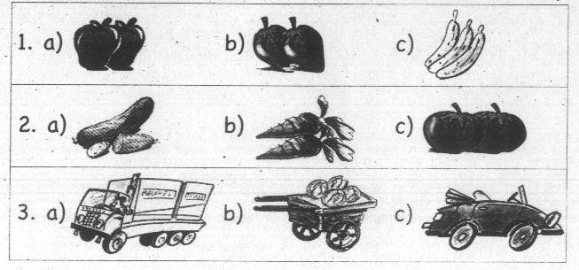

- Listen to the sentences and circle the right picture :
1- I saw a tiger in the zoo. 2 – I like pizza very much.
3- She's watching T V.
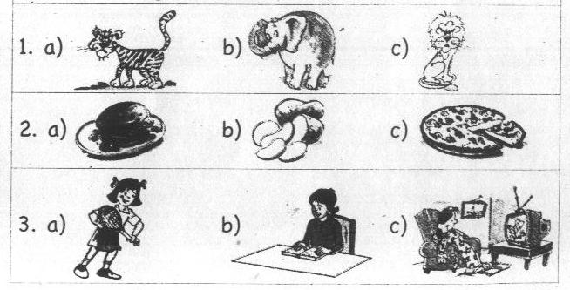
B) Reading Comprehension:
- Read and circle the odd one out :
- oranges – apples – tomatoes – grapes.
- buffalo – basketball – volleyball – football.
- cow – elephant – burger – horse.
- cat – van – tractor – cart.
- November – September – December – Remember.
- Friday – Yesterday – Sunday – Tuesday.
- tomatoes – carrots – grapes – cucumbers.
- crocodile – goat – donkey – sheep.
- geography – farm – Arabic – maths.
- desk – book – farm – uniform.
- burger – school – field - farm.
- Match the questions with the answers :
A | B
- Where is the computer?  - Did Ali see a cow yesterday?  - What did you see at the zoo?  - What's your favourite sport? | - It’s one o'clock.  - A tiger and a lion.  - Football.  - Yes, he did.  - It is on the table. | ( )  ( )  ( )  ( )  ( )
- Where did your mother go yesterday?  - What did you do last Friday?  - Do you like burger?  - What did Ahmed do at 4 o'clock? | - I'm ten years old.  - He played football.  - Yes, I do.  - She went to the market.  - I visited my uncle. | ( )  ( )  ( )  ( )  ( )

C)Writing :
- Read and put a ( √ ) or ( X ) :
Sohila is a pupil. She does her homework in the evening. Her teachers like her. Her favourite school subjects are maths and English. Her favourite sport is tennis. She eats healthy food. She doesn't like soft drinks. She doesn't eat burger or crisps.
( )
( )
( )
( )
( )
( )
- Sohila doesn't like unhealthy food.
- Burger is Sohila's favourite food.
- The English teacher likes Sohila.
- Sohila doesn't like maths.
- Sohila is a good pupil.
- Crisps are unhealthy food.

- Read and put a ( √ ) or ( X ) :
Yesterday was Friday. Ahmed visited a farm in Tanta. He saw lots of animals. He saw a donkey and a cart. He didn't see a cow. He saw buffaloes and sheep. He saw potatoes, tomatoes, carrots and cucumbers. He helped the farmers in the fields.
( )
( )
( )
( )
( )
( )
- There were a donkey and a car.
- Ahmed helped the farmers in the fields.
- He didn't see a goat.
- He visited a farm in Sharkia.
- He saw four vegetables.
- Today is Saturday.

- Finish the sentences with words from the list :
[ drove – next to – on – cart – between - many ]
- I saw many animals ……………..……the farm
- How ……………….…….girls can you see?
- The farmer ………..…………….a tractor yesterday.
- I saw apples in the ……….……………. .
- The flag is …………..…………the tractor and the crocodile.

- Finish the sentences with words from the list :
[ idea – visited – saw – sport – colour - bird ]
- My favourite ………….……….is the egret.
- I ………………..….camels and buffaloes on the farm.
- That's a good …………..……….. .
- What …………………….is your jacket? It's blue.
- She ……………..…….a farm yesterday.

- Rearrange the words to make meaningful sentences :
- football – are – The – playing – boys.
………………………………………………………………………… .
- is – favourite – your – What – subject?
………………………………………………………………………… .
- tennis – Let's – seven – at – play – o'clock.
………………………………………………………………………… .
- see – yesterday – Yara – a goat – Did?
………………………………………………………………………… .
- sport – is – My – tennis – favourite.
………………………………………………………………………… .
- next – The – is – the flag – to – crocodile.
………………………………………………………………………… .
- were – of – There – potatoes – lots.
………………………………………………………………………… .
- likes – Who – and – maths – English?
………………………………………………………………………… .
- white – is – The – red – football – and.
………………………………………………………………………… .
- the desk – an English – There – on – book – is.
………………………………………………………………………… .
- girls – can – I – two – see.
………………………………………………………………………… .
- goes – four – She – at – home – o'clock.
………………………………………………………………………… .
- likes – He – ice cream – much – very.
………………………………………………………………………… .
- Punctuate the following sentences :
- let s visit the farm on friday
………………………………………………………………………… .
- there s an english book on the table
………………………………………………………………………… .
- does mona like arabic
………………………………………………………………………… .
- it s seven o clock
………………………………………………………………………… .
- Copy the following sentence :
No gains without pains.
………………………………………………………………………… .

عن أبي هريرة أن رسول الله صلى الله عليه وسلم قال الملائكة تصلي على أحدكم ما دام في مصلاه الذي صلى فيه ما لم يحدث تقول اللهم اغفر له اللهم ارحمه

 | اختبار شهر أكتوبر | 1
A ) listening:
- Listen to the words and circle the right picture :
1- Basketball. 2 – A skirt. 3 – A tractor.
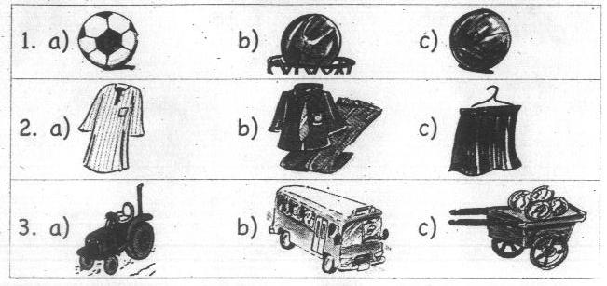
- Listen to the sentences and circle the right picture :
1- It's six o'clock. 2- My favourite subject is maths.
3- I visited a farm yesterday.
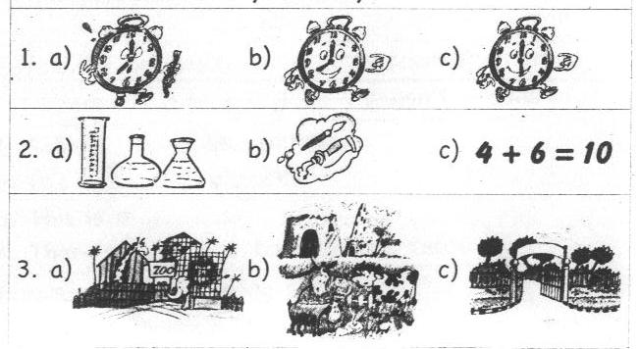
B) Reading Comprehension:
- Read and circle the odd one out :
- tiger – green – red – yellow.
- potatoes – bear – monkey – lion.
- bus – tractor – car – palm tree.
- black – father – mother – uncle.
- Match the questions with the answers :
A | B
- Do you like pizza?  - What did Dalia do at six o'clock?  - Did Ali go to a farm yesterday?  - Where is the flag? | - She played at six o'clock.  - He played at six o'clock.  - Yes, he did.  - It's in the box.  - Yes, I do. | ( )  ( )  ( )  ( )  ( )

C)Writing :
- Read and put a ( √ ) or ( X ) :
Yesterday was Friday. Ali visited a farm in Mahalla. He saw lots of animals and birds. He saw donkeys and egrets. He saw a horse and a cart. There were lots of cucumbers in the cart. He likes cucumbers very much.
( )
( )
( )
( )

  - Ali likes cucumbers.
  - There were lots of cucumbers in the cart.
  - Ali saw lots of birds and animals.
  - Ali visited a farm in Sharkia.
- Finish the sentences with words from the list :
[ is – Who – field – subjects – was ]
- Yesterday ……….………………Friday.
- ……………….…...likes art?
- My favourite …………..………….are English and Arabic.
- A farmer works in the ……….…………………. .

- Rearrange the following words to make meaningful sentences :
- favourite – my – egret – The – bird – is .
…………………………………………………………………… .
- is – ,Hany – This – brother – my.
…………………………………………………………………… .
- red – is – The football – white – and.
…………………………………………………………………… .
- saw – goats – We – and – cows.
…………………………………………………………………… .
- Punctuate the following sentence :
today s tuesday
…………………………………………………………………… .
- Copy the following sentence : ( / )
Let's play football at five o'clock.
…………………………………………………………………… .

عن رَسُول اللَّهِ صَلَّى اللَّهُ عَلَيهِ وَسَلَّم قال: من سبح اللَّه في دبر كل صلاة ثلاثاً وثلاثين، وحمد اللَّه ثلاثاً وثلاثين، وكبر اللَّه ثلاثاً وثلاثين قال تمام المائة: لا إله إلا اللَّه وحده لا شريك له، له الملك وله الحمد وهو على كل شيء قدير، غفرت خطاياه وإن كانت مثل زبد البحر رواه مُسلِمٌ.

Unit 4
The months of the year

New words
hear | يسمع | birthday | يوم ميلاد
month | شهر | year | عام
stand up | يقف | present | هدية
before | قبل | after | بعد
start | يبدأ | end | ينتهى
school starts | المدرسة تبدأ | school ends | المدرسة تنتهى
turn | يصبح عمره | Sham El Nesem | شم الفسيخ
first term | الترم ألاول | Mother's Day | يوم الام
mid-year | نصف العام | holiday | اجازة
exams | أمتحانات | Who..? | من؟
when | عندما | When..? | متى؟
get → got | يحصل على | all | كل - جميع
eat → ate | يأكل | these | هؤلاء
come → came | يأتى | then | ثم

☻ Learn the following ☻
☻Let's play a game.هيا بنا نلعب لعبة .
☻ When is your birthday? متى يكون يوم ميلادك؟
►My birthday is in May.
☻ Stand up when you hear your birthday month.
☻ His birthday comes after June.
☻ his, her and your ☻
يستخدم للاشارة الى شىء يمتلكه مفرد مذكر. ( his )ضمير الملكية
► his pencil → قلمه his birthday يوم ميلاده
يستخدم للاشارة الى شىء يمتلكه مفرد مؤنث. ( her ) و ضمير الملكية
► her pencil → قلمها her birthday يوم ميلادها
يستخدم للاشارة الى شىء يمتلكه المخاطب. ( your ) و ضمير الملكية
► your pencil → قلمك your birthday يوم ميلادك
Is ……….? هل .......؟
"Is …?" لتكوين سؤال بمعنى " هل ...؟"نبدأ الكلام بأحد الأفعال المساعدة مثل
☻ Is your birthday in March?
► Yes, it is >>> Or >>> Yes, my birthday is in March.
► No, it isn't. >>> Or >>> No, my birthday isn't in March.
( Yes, it is – No, it isn't ) ويفضل استخدام الإجابات المختصرة
/////Exercise/////
Exercise on lesson 1 & 2
- Read and circle the odd one out :
- month – week – one – day.
- write – listen – look – birthday.
- Friday – March – February – January.
- Ali – Magdi – Salma - Ahmed.
- Match the questions with the answers :
A | B
- Who watched television with you?  - Did you play computer games?  - What did you do yesterday?  - When is your birthday? | - Yes, I did.  - In June.  - I played football.  - My name's Heba.  - Omar. | ( ) ( )  ( )  ( )  ( )
- Rearrange the words to make meaningful sentence :
- months – are – May – August – and.
………………………………………………………..
- play – Let's – game – a .
……………………………………………………….. .
- is – When – your – birthday?
……………………………………………………….. .
- birthday –Her – in – is – August.
……………………………………………………….. .
- before – May – comes – June.
……………………………………………………….. .
- my – Yesterday – birthday – was.
……………………………………………………….. .
- turned – She – nine – old – years.
……………………………………………………….. .
- Cairo – in – April – I – to – went.
……………………………………………………….. .
- Punctuate the following sentences :
ahmed s birthday is in june
………………………………………………………. .

Exercise on lesson 3 &The whole unit.
- Read and circle the odd one out :
- Lamia – Hossam – Heba – Noha.
- present – March – May – April.
- Aswan – Luxor – Cairo – computer.
- five – Thursday – four – ten.
- father – mother – day – brother.
- one – two – three – school.
- was – turned – watched – played.
- came – flew – ate – wave.
- Rearrange the words to make meaningful sentence :
- got – Yasser – presents – many.
……………………………………………………….. .
- Cairo – I – to – went – May – in.
……………………………………………………….. .
- Day – is – March – in – Mother's.
……………………………………………………….. .
- ends – School – May – in.
……………………………………………………….. .
- Read and put a ( √ ) or ( X ) :
Yesterday, it was Rania's birthday. She turned nine years old. Five friends came to her birthday. They ate cake and played volleyball in the garden. Then, they watched television. She got many presents. Rania was very happy.
( )
( )
( )
( )
( )
( )
- Rania turned nine years old.
- Rania got many presents.
- Rania wasn't very happy.
- They played football in the garden.
- 15 friends visited Rania yesterday.
- Rania was eight last year.
- Finish the sentences with words from the list:
[ before – his – her – computer – starts – was – after ]
- School ………………..in September.
- February comes……………… January.
- I …………….at school yesterday.
- Heba played …………………games yesterday.
- This is Mona. ………………….birthday was yesterday.
- Punctuate the following sentences :
is alaa's birthday in april
…………………………………………………………. .

Unit 4 The months of the year. Revision exercises.
- Circle the odd one out :
- September- July – Many – March.
- ten – four – man – five.
- Monday – Sunday – Mother's Day – Tuesday.
- farm – Alexandria – Luxor – Cairo.
- Yara – Suzy – July – Sam.
- blue – orange – white – read.
- Friday – birthday – Monday – Sunday.
- birthday – maths – present – cake.
- ate – played – came – got.
- my – his – you – her.
- Match the questions with the answers :
A | B
- What comes before July?  - When is your birthday?  - Is your birthday in January?  - What did you eat?  - When does school end? | - Yes, it is .  - In May.  - I ate lots of cakes.  - My birthday is in May.  - Yes, I am.  - June comes before July. | ( )  ( )  ( )  ( )  ( )  ( )

- Rearrange the words to make meaningful sentences :
- birthday – in – His – August – is .
……………………………………………………………… .
- your – When – birthday – is ?
……………………………………………………………… .
- there – How – are – months – many?
……………………………………………………………… .
- brother's – is – birthday – your – When?
……………………………………………………………… .
- are – The – the year – twelve – of – months.
……………………………………………………………… .
- week, – presents – I – many – got – Last.
……………………………………………………………… .
- December- comes – Her – before – birthday.
……………………………………………………………… .
- are – of – the months – These – the year.
……………………………………………………………… .

- your – in – Is – August – birthday ?
……………………………………………………………… .
- old – years – ten – turned – Heba.
……………………………………………………………… .
- comes – June – before – May.
……………………………………………………………… .
- February – The – is – holiday – in – mid year.
……………………………………………………………… .

- Read and put a ( √ ) or ( X ) :
Yesterday, it was Thursday. It was Heba's birthday. She turned eleven years old. Seven friends came to her house. They ate cakes and played computer games. Then, they watched television. Heba got many presents.
( )
( )
( )
( )
( )
( )
- Heba's friends didn't get her presents.
- Heba was ten last year.
- Heba turned ten.
- There were eight friends at the birthday.
- Heba's birthday was on Wednesday.
- They ate pizza.

- Finish the sentences with words from the list :
[ her – his – present – May – days – months
– in – When – starts – turned – before – after ]
- January comes …………………February.
- ………………..…..is your birthday?
- Ahmed is twelve years old. …….………..birthday is in May.
- There are twelve………………….in a year.
- School …………………..in September.
- This is your birthday ……………..….. .
- I …………,,,,….ten years old last year.
- My birthday is ................. November.
- June comes after ………………….. .
- Punctuate:
- when is magda s birthday
……………………………………………………………… .
- ali s birthday is in june
……………………………………………………………… .
- is mona s birthday in may
……………………………………………………………… .

Unit 5
Animal facts

New words
look at | ينظر الى |  | animals |  | حيوانات | fly |  | يطير
dance | يرقص |  | hippo |  | سيد قشطه | can |  | يستطيع
jump | يقفز |  | crocodile |  | تمساح | wear |  | يرتدى
sing | يغنى |  | parrot |  | ببغاء | neck |  | رقبة
swim | يسبح |  | goldfish |  | سمك زينة | nose |  | أنف
run | يجرى |  | rabbit |  | أرنب | uniform |  | زى موحد
hop | يقفز بسرعة |  | teeth |  | أسنان
adjectives and opposite الصفات و عكسها
long |  | طويل ( للاشياء) |  | xxxx opposites xxxx | short |  | قصير
big |  | كبير |  | xxxx opposites xxxx | small |  | صغير
tall |  | طويل ( للانسان) |  | xxxx opposites xxxx | short |  | قصير
fat |  | تخين |  | xxxx opposites xxxx | thin |  | رفيع
dark |  | غامق |  | xxxx opposites xxxx | light |  | فاتح
happy |  | سعيد |  | xxxx opposites xxxx | sad |  | حزين
clean |  | نظيف |  | xxxx opposites xxxx | dirty |  | قذر
good |  | جيد |  | xxxx opposites xxxx | bad |  | سىء

☻ Learn the following ☻
Can & can't
للتعبير عن القدرة على عمل شيء ويأتي بعده المصدر:( can ) يستخدم الفعل
☻ Hippos can swim . ( إثبات )
☻ Can you swim? ( استفهام )
► Yes, I can. ► No, I can't.للإجابة المختصرة.
have got
ويتكون من : ( معناه( يملك \ لديه ( have got ) الفعل
I / We / You / They + الجمع |  | have got ( 've got ) | …..  ……
He / She / It + المفرد |  | has got ( 's got ) | …..  ……
Adjectives الصفات
الصفة فى اللغة الإنجليزية توضع قبل الاسم :
► long hair ► big ears ► short legs
لاحظ نضع "،" بين الصفتين المتتاليتين المتبوعتين باسم :
Ahmed's got short , brown hair.
/////Exercise/////
Exercise on lesson 1 & 2
- Read and circle the odd one out :
- mother –giraffe – father – brother.
- day – table – desk –chair.
- tiger – cat – book – dog.
- door – Tuesday – Monday – Sunday.
- dark –clean - ball – thin.

- Match the questions with the answers :
A | B
- Can crocodiles fly?  - Has a giraffe got a long neck?  - Can a hippo swim?  - What's the opposite of tall? | - Yes, he has.  - Short.  - Yes, it can.  - No, they can't.  - Yes, it has. | ( )  ( )  ( )  ( )  ( )

- Rearrange the words to make meaningful sentence :
  - opposite – is – The –of – dark – light.
……………………………………………………….. .
  - a long – A giraffe – got – neck – has.
……………………………………………………….. .
  - parrots – fly – Can?
……………………………………………………….. .
  - animals – What – you – see – can?
……………………………………………………….. .
  - legs – They – got – short – 've.
……………………………………………………….. .

- Punctuate the following sentences :
no it can t
……………………………………………….. .

Exercise on lesson 3 &The whole unit.
- Read and circle the odd one out :
- Sunday – Monday – book – Tuesday.
- elephant – Tuesday – tiger – giraffe.
- door – table – desk – brother.
- fish – jump – swim – dance.
- cup – cat – cow – camel.
- fat – dirty – short – hippo.
- play – clock – fly – run.
- she – it – uniform – he.
- Rearrange the words to make meaningful sentence :
- Crocodiles – dance – can't.
……………………………………………………….. .
- jump – A cat – run – and – can.
……………………………………………………….. .
- has – A monkey – got – tail – a long.
……………………………………………………….. .
- opposite – bad – The – of – good – is.
……………………………………………………….. .
- hippos – Have – necks – long – got?
……………………………………………………….. .
- Read and put a ( √ ) or ( X ) :
We like to go to the zoo to see animals and birds. We like to play with monkeys because they are funny. The monkeys can jump , but they can't swim. We like to ride elephants, but they can't fly. We like animals.
( )
( )
( )
( )
- We ride elephants.
- We don't like animals.
- Monkeys can swim.
- We see animals and birds at the zoo.
- Finish the sentences with words from the list:
[ have – swim – can't – has – thin – can ]
- Mona is fat but Sara is ……………..…….. .
- Goldfish can ………………….
- A hippo …………………..got small ears.
- Can a crocodile dance? – No, it …………..…… .
- Giraffes ………………… got long necks.
- Punctuate the following sentences :
have mariam and sohila got brothers
…………………………………………………………… .

Unit 5 Animal Facts. Revision exercises.
- Circle the odd one out :
- cat – book – tiger- dog.
- Monkey – Friday –Tuesday – Sunday.
- table – door – chair – hippo.
- father – brother – giraffe – cousin.
- lion – giraffe – fish – tiger.
- ears – teeth – legs – shoes.
- read – grey – black – brown.
- short – jump – clean – sad.
- dark – light – long – fall.
- dance – hop – dark – fly.
- mother – cousin – teacher – father.
- Match the questions with the answers :
A | B
- Has a hippo got long legs?  - Can a horse jump?  - Has a lion got big teeth?  - Can you swim?  - What is the opposite of dark? | - Yes, I can.  - Yes, it has.  - The opposite of dark is light.  - Yes, it can.  - No, it hasn't.  - Yes, I can, | ( )  ( )  ( )  ( )  ( )  ( )

- Rearrange the words to make meaningful sentences :
- neck – a very – A giraffe – got – long – has.
……………………………………………………………..….. .
- a light – green – is – wearing – uniform – Sama.
……………………………………………………………..….. .
- of – is – The – short – long – opposite.
……………………………………………………………..….. .
- tail – got – A tiger – a long – has.
……………………………………………………………..….. .
- run – A horse – and – jump – can.
……………………………………………………………..….. .
- a big – We – got – clock – have.
……………………………………………………………..….. .
- walk – jump – can – can't – A crocodile – ,but it.
……………………………………………………………..….. .
- a hippo – a big – got – mouth – Has?
……………………………………………………………..….. .

- tall – brown – light – It's – and.
……………………………………………………………..….. .
- black – She's – long – got – hair.
……………………………………………………………..….. .
- can't – but it – can – The fish – swim – sing.
……………………………………………………………..….. .

- Read and put a ( √ ) or ( X ) :
Hagar is my friend. She's tall. She's got short, brown hair. She's wearing a green and white uniform. She has got a white cat. It's got small ears and long tail. It's got long hair. It drinks milk and eats fish. She likes her cat very much.
( )
( )
( )
( )
( )
( )
- Hagar has got a white car.
- Hagar isn't short.
- Hagar drinks milk and eats fish.
- Hagar has got short, white hair.
- Hagar is wearing a green and white skirt.
- Hagar likes her cat.

- Read and put a ( √ ) or ( X ) :
Crocodiles live in water. They eat animals. They have got short legs. They can walk, but they can't jump. They've got long tails and small ears. They can run. They can't sing. They can't fly.
- Crocodiles can jump.
( )
( )
( )
( )
( )
( )
- They've got long tails and small ears.
- They can swim.
- They've got short tails.
- They don't walk.
- They eat grass.
- Finish the sentences with words from the list :
[ has – hasn't – have - Can – dirty – dark – it –
they – horses – crocodiles - nose – neck ]
- ……,,,,,,………crocodiles fly? No, they can't.
- Elephants …………,,,,……got a very long nose.
- The opposite of clean is …,,,,……………. .
- …………………..can't jump.
- A giraffe has got a long …….,,,,,,,…... .
- A lion …………,,,,,,,..got sharp teeth.
- Has Sara got brown eyes? No, she ………,,,,…… .
- Can hippos dance? No, ………,,,,..….can't.
- ……………….is the opposite of light.

- Punctuate the following sentence :
- ahmed and heba can t swim
…………………………………………………………… .
- she s got long black hair
…………………………………………………………… .
- no they can t
…………………………………………………………… .

****عن أبي هريرة رضي الله عنه قال كان رسول الله صلى الله عليه وسلم يدعو ويقول
اللهم إني أعوذ بك من عذاب القبر ومن عذاب النار ومن فتنة المحيا والممات ومن فتنة المسيح الدجال
1460 - وعن أبي هريرة رَضِيَ اللَّهُ عَنهُ قال، قال رَسُول اللَّهِ صَلَّى اللَّهُ عَلَيهِ وَسَلَّم: إذا أوى أحدكم إلى فراشه فلينفض فراشه بداخلة إزاره فإنه لا يدري ما خلفه عليه، ثم يقول:
باسمك ربي وضعت جنبي وبك أرفعه؛ إن أمسكت نفسي فارحمها، وإن أرسلتها فاحفظها بما تحفظ به عبادك الصالحين متفق عَلَيهِ.
*** لفظ الجلالة "الله" جل وعلا، ورد في القرآن الكريم "2707" مرات، "980" في حالة الرفع و"592" في حالة النصب و"1135" في حالة الجر

Unit 6
What can you hear?

New words
hear | يسمع | Here's | ها هو
see | يرى | eye | عين
bus | أوتوبيس | bridge | كوبرى
plane | طائرة | secretary | سكرتيرة
lorry | عربة نقل | nurse | ممرضة
train | قطار | factory | مصنع
bicycle | دراجة | manager | مدير
dress | فستان | worker | عامل
butterfly | فراشة | market | سوق
buy | يشترى | sheet | ملاءة
make | يصنع | cotton | قطن
live | يعيش | daughter | ابنة
key | مفتاح | son | ابن
in front of | أمام | behind | خلف
between | بين | balloon | بالونة

☻Learn the following☻
can hear & can see
فى ( see ) أو ( hear ) وبعده الفعل( can ) للتعبير عما يسمعه شخص أو يراه الأن نستخدم الفعل☻
صيغة المصدر ( أى: بدون اضافات ).
► I can see a butterfly. ►I can hear a car.
و للسؤال عما يستطيع أن يراه أو يسمعه، نقول: ☻
► What can you see? ماذا تستطيع أن ترى.
► What can you hear? ماذا تستطيع أن تسمع.
plurals………>>>>>>……… صيغ الجمع
، مثل: ( - s) عند تحويل الأسماء لصيغة الجمع نضيف لها حرف☻
a car >>>>>> cars. |  | a bridge >>>>>>> bridges.
a plane >>>>>> planes. |  | a train >>>>>>> trains.
a farmer >>>>>> farmers. |  | a banana >>>>>>> bananas.
و لكن لاحظ : ☻
{ - o / -ch / -sh / -ss / -s / -x } اذا أنتهى الاسم بحرف ساكن من الحروف التالية
فقط عند تحويله للجمع، مثل: (-s ) وليس ( - es ) يضاف لنهايته
a potato >>>> potatoes. | a watch >>>> watches.
a dish >>>> dishes. | a box >>>> boxes.
a bus >>>> buses. | a glass >>>> glasses.
، مثل: (- ies)، تقلب الى يسبقها حرف ساكن( y ) و الاسماء التى تنتهىبـــ☻
► a lorry >>>> lorries. ► a secretary >>>> secretaries.

/////Exercise/////
Exercise on lesson 1 & 2
- Read and circle the odd one out :
- six – eyes – eight – nine.
- television – umbrella – clock – monkey.
- read – see- fish – hear.
- two – car – tractor – bus.
- blouse – jacket – butterfly – dress.
- lorry – bridge – bus – plane.
- strawberries – grapes – cucumbers – lorries.
- bananas – secretary – nurse – farmer.
- Match the questions with the answers :
A | B
- What can you hear?  - Can you see a bus?  - What can you see?  - Can Sama hear a plane? | - Yes, she can.  - No, I can't.  - I can see a train.  - No, it can't.  - I can hear a bus. | ( )  ( )  ( )  ( )  ( )
- Rearrange the words to make meaningful sentence :
- hear – Can – a clock – you?
……………………………………………………… .
- are – two – There – cars.
……………………………………………………… .
- can – He – see – car – a.
……………………………………………………… .
- is – butterfly – That – a.
……………………………………………………… .
- Punctuate the following sentences :
that s my father s t-shirt
……………………………………………………… .

Exercise on lesson 3 &The whole unit
- Read and circle the odd one out :
- Mahalla – Cairo – Aswan – bridge.
- Secretary – farmer – sheet – house.
- market – hospital – worker – farm.
- car – bus – train – cotton.
- Rearrange the words to make meaningful sentence :
- father – My – worker – is – a.
……………………………………………………… .
- lives – Mahalla – Ahmed – in.
……………………………………………………… .
- works – a – Toka – in – school.
……………………………………………………… .
- visit – Let's – factory – cotton – a .
……………………………………………………… .
- goes – Sara – to – market – the.
……………………………………………………… .
- see – you – What - ,Rana – can?
……………………………………………………… .
- Read and choose from a, b or c:
My name's Fahmy. I am the manager of a cotton factory in Mahalla. The workers make sheets. Ahmed is my son. He likes to visit me in the factory. He wants to be a manager of a cotton factory when he grows up.
( )
( )
( )
( )
- Ahmed is a manager of a cotton factory.
- Ahmed is Fahmy's brother.
- The workers make sheets.
- Fahmy works in Sharkia.
- Finish the sentences with words from the list:
[ see – are – make – buy – is – manager ]
- The workers …………….…….sheets and shirts.
- My father is a ………….…………of a factory.
- There ………………a bus next to the car.
- I can ……………..…..a train.
- You can ………….…………at the market.
- Punctuate the following sentences :
mayada and i went to mahalla
……………………………………………………… .

Unit 6 What can you hear? Revision exercises.
- Circle the odd one out :
- skirt – bus – dress – sheet.
- monkeys – potatoes – tomatoes – mangoes.
- bridge – car – tractor – lorry.
- farmer – secretary – manager – key.
- skirts – buses – dresses – shirts.
- house – school – factory – butterfly.
- daughter – teacher – manager – worker.
- giraffes – secretaries – monkeys – donkeys.
- trains – lorries – planes – bridges.
- here – see – eat – read.
- Match the questions with the answers :
A | B
- What is it?  - Can you see a plane?  - Where do you live?  - Can you hear a fish?  - How many monkeys can you see? | - I live in Tanta.  - No, I can't.  - Two.  - It's a butterfly.  - Yes, I can.  - She lives in Mahalla. | ( )  ( )  ( )  ( )  ( )  ( )
- Rearrange the words to make meaningful sentences :
- see – lorries – I – two – can.
…………………………………………………………………. .
- you – what – hear – can ?
…………………………………………………………………. .
- father – a factory – the manager – My – of – is.
…………………………………………………………………. .
- behind – cars – the – The tractor – two – is.
…………………………………………………………………. .
- cotton – Mahalla – The – in – is – factory.
…………………………………………………………………. .
- flower – a butterfly – on – is – the – There.
…………………………………………………………………. .
- the market – buy – You – the shirts – can – at.
…………………………………………………………………. .
- shirts – dresses – The – and – make – workers.
…………………………………………………………………. .
- see – trains – Can – two – you?
…………………………………………………………………. .
- see – What – you - ,Heba – can?
…………………………………………………………………. .
- Read and put a ( √ ) or ( X ) :
My name's Abdul Rahman. I'm a pupil at Tanta Primary school for boys. We visited a cotton factory in Mahalla last week. The workers there are very good. They make sheets, dresses and shirts. We saw nice dresses, but no one can buy dresses at the factory. You can buy dresses at the market.
( )
( )
( )
( )
( )
( )
- They visited a cotton factory in Mahalla.
- The workers in the factory aren't very good.
- You can buy dresses at the factory.
- The workers make socks at the factory.
- Abdul Rahman lives in Tanta.
- He can see girls at the school.
- Read and put a ( √ ) or ( X ) :
My name's Nehal. My father is the manager of a cotton factory in Mahalla. In the factory, the workers make sheets, dresses and shirts. You can buy the shirts and the dresses at the market.
( )
( )
( )
( )
( )
( )
- The factory is in Cairo.
- You can buy the sheets at the market.
- The workers make sheets, dresses and shirts.
- Nehal works in a cotton factory.
- Nehal lives in Mahalla.
- Nehal's father is a teacher.
- Finish the sentences with words from the list:
[ in front of – between – manager – hear – see – market –
factory – planes – live – lives – butterfly- farmers ]
- She ……………………….in Sharkia.
- You can buy dresses at the…….………….…… .
- There is a bus ………………....…the lorry and the car.
- I can see a …………….…….on the flower.
- There is a cotton ………..….………in our town.
- My father is the ………..……….…..of a big factory.
- There are two ………….………...working in the fields.
- I can see two ………….…….…….in the sky.
- What can you ……………….……? I can see a train.
- Punctuate:
- what can you hear yasmeen
………………………………………………………… .
- khalid doesn t work in cairo
………………………………………………………… .
- my name s rahaf
………………………………………………………… .
- let s visit mahalla
………………………………………………………… .

Revision B
New words
melons | بطيخ | café | مقهى
fruit | فاكهة | vegetables | خضروات
head | رأس | each other | كل منهما الأخر
guavas | جوافة | greengrocer | خضرى
pull | يسحب | office | مكتب

☻ Learn the following ☻
- I can see two bridges.
- There are three buffaloes in that car.
- There are three secretaries in this office.
- The blue bus is between the green bus and the yellow bus.
- The tomatoes are between the guavas and the potatoes.
- I can see three donkeys pulling the cart.
- Hany is wearing orange trousers.
- There is a café in the market.

- Listen to the sentences and circle the right picture :
1- A tractor. 2- A donkey. 3- A bridge.
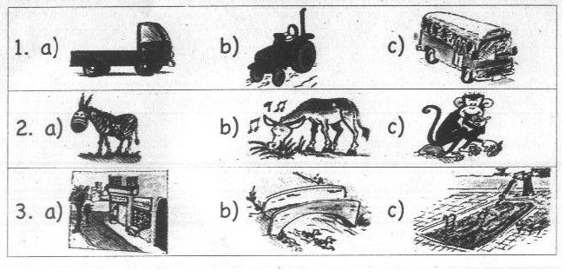
- Listen to the sentences and circle the right picture :
1- It's got a long neck. 2- It's got a big mouth.
3- My birthday is in August.
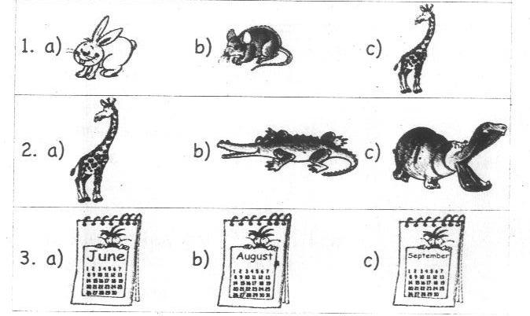
B) Reading Comprehension:
- Read and circle the odd one out :
- potatoes – tomatoes – oranges – yellow.
- bridge – crocodile – goat – hippo.
- t-shirt – blouse – skirt – bicycle.
- May – November – Thursday – September.
- bus – rabbit – tractor – lorry - train.
- yellow – brown – blue – read.
- small – long – swim – big.
- teeth – walk – run – swim.
- dark – mouse – giraffe – sheep - tiger.
- manager - potatoes – driver – secretary – clown.
- guavas – bananas – clowns – strawberries.
- neck – teeth – legs – clothes.
- book – door – desk – table.

- Match the questions with the answers :
A | B
- when is your birthday?  - What can you see?  - Have elephants got big ears?  - What's the opposite of dirty? | - Yes, they have.  - I can hear a bus.  - Clean.  - In July.  - I can see a plane. | ( )  ( )  ( )  ( )  ( )
- Which animal has a long nose?  - How many months are there in a year?  - What's the opposite of light?  - How many skirts can you see? | - Twelve.  - Dark.  - The elephant.  - Two.  - Fat. | ( )  ( )  ( )  ( )  ( )

C)Writing :
- Read and put a ( √ ) or ( X ) :
There are twelve months in a year. School starts in September and ends in May. It's very hot in July and August. Lots of people go to the beach to swim in the sea. It's cold in December and January. Lots of people go to Aswan.
- There are twelve weeks in a year.
( )
( )
( )
( )
( )
( )
- School starts in November.
- People go to the beach in August.
- December is cold.
- School ends in May.
- It’s hot in July.

- Read and put a ( √ ) or ( X ) :
Tasneem is my friend. She is in class five in a primary school. She's got black hair. She has got one brother. She goes to school with her mother. She is a teacher of art. Her name is Eman. Tasneem likes to watch T V and play volleyball.
  - Tasneem is in class ( four – five – six )
  - Tasneem's mother is a teacher of ( music – maths – art )
  - Tasneem has got ( four – five – six ) people in her family.
  - Tasneem has got black ( heart – eye – hair )
  - Tasneem has got one ( sister – uncle – brother )
  - Tasneem likes to play ( volleyball – football – tennis )

- Finish the sentences with words from the list :
[ market – office – have – rabbit – thin - has ]

- The opposite of …………….………is fat.
- Magda ……………….…..got long, black hair.
- You can buy the shirts at the ……………………… .
- It's small. It can't swim. It's a……………………… .
- There are three secretaries in that ……………………… .

- Finish the sentences with words from the list :
[ cart – giraffe – before – after – can't – it ]

- May comes ………………….. April.
- Can you see an elephant? Yes, I can see ……….……….. .
- I can see three donkeys pulling a ……………….…. .
- A crocodile ……………..…….jump.
- The ………………………has got a very long neck.

- Rearrange the words to make meaningful sentences :
- your – December – Is – in – birthday?
…………………………………………………………………. .
- a light – shirt – Selwan – green – wearing – is.
…………………………………………………………………. .
- tail – A rabbit – a very – got – short – has.
…………………………………………………………………. .
- sad – happy – opposite – is – The – of.
…………………………………………………………………. .
- a factory – My – the manager – is – of – father.
…………………………………………………………………. .
- got – teeth – It – big – has.
…………………………………………………………………. .
- see – bridges – Can – three – you?
…………………………………………………………………. .
- buses – the bridge – There – three – under – are.
…………………………………………………………………. .
- comes – His – after – birthday – June.
…………………………………………………………………. .
- hair – got – She – black – has.
…………………………………………………………………. .
- boys – see – can – you – How many?
…………………………………………………………………. .
- friends – came to – Ten – house – my.
…………………………………………………………………. .
- are – colour – What – umbrellas – the?
…………………………………………………………………. .
- the market – You – fruit – buy – can – at.
…………………………………………………………………. .

- Punctuate the following sentences :
- what s hany wearing
…………………………………………………………………. .
- ali s birthday is in march
…………………………………………………………………. .
- my name s salwa
…………………………………………………………………. .
- Copy the following sentence :
God helps them who help themselves.
………………………………………………………………………… .
Learn English by yourself
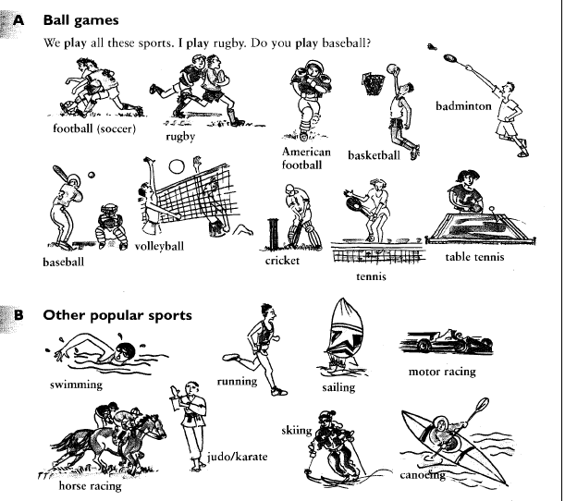
اعلم أنه ينبغي لكل مكلف أن يحفظ لسانه عن جميع الكلام إلا كلاماً ظهرت فيه المصلحة، ومتى استوى الكلام وتركه في المصلحة فالسنة الإمساك عنه؛ لأنه قد ينجر الكلام المباح إلى حرام أو مكروه وذلك كثير في العادة والسلامة لا يعدلها شيء.
1515 - وعنه رَضِيَ اللَّهُ عَنْهُ عن النبي صَلَّى اللَّهُ عَلَيْهِ وَسَلَّم قال: إن العبد ليتكلم بالكلمة من رضوان اللَّه تعالى ما يلقي لها بالاً يرفعه اللَّه بها درجات، وإن العبد ليتكلم بالكلمة من سخط اللَّه تعالى لا يلقي لها بالاً يهوي بها في جهنم رواه البُخَارِيُّ.

 | اختبارات شهر نوفمبر | 2
A ) listening
- Listen to the words and circle the right picture :
1- A rabbit. 2- A hippo. 3- A t-shirt.
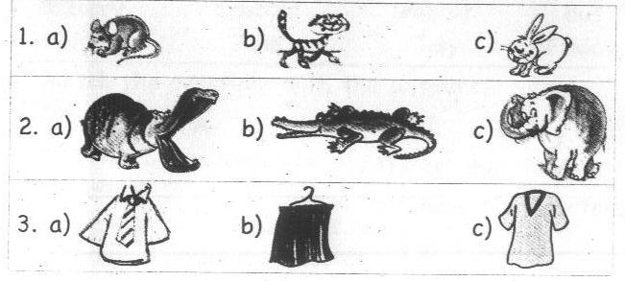
- Listen to the sentences and circle the right picture :
1- It's got a very long nose. 2- It can't swim.
3- My uncle is a greengrocer.
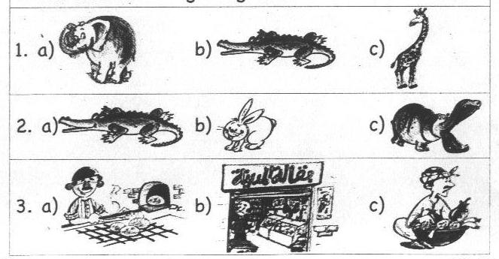
B) Reading Comprehension:
- Read and circle the odd one out : ( / )
  - car – lorry – bear – plane.
  - soft drinks – fried potatoes – grapes – burger.
  - football – volleyball – tennis – colours.
  - subject – guavas – cucumbers – melons.

- Match the questions with the answers :
A | B
- What's the time?  - Who likes pizza?  - Is your birthday in May?  - What can we make with cotton? | - Sheets.  - Yes, he is.  - It's seven o'clock.  - Rahaf likes pizza.  - Yes, it is. | ( )  ( )  ( )  ( )  ( )
C)Writing :
- Read and put a ( √ ) or ( X ) :
My name's Maha. I'm a pupil in primary five in Sharkia school. Yesterday was Friday. I went to the zoo with my father and mother. I like animals very much. My favourite animals are monkeys and giraffes. Monkeys can jump and run. Giraffes can run but they can't jump.
( )
( )
( )
( )
  - Giraffes can't run.
  - Maha's favourite animals are giraffes and donkeys.
  - Maha went to the zoo with her family.
  - Maha is a pupil in primary six in Sharkia school.
- Finish the sentences with words from the list : ( / )
[ it – clean – manager – has – they ]
- Can crocodiles run? Yes, ……………………can.
- Ahmed ……….………..…….got brown eyes.
- The opposite of dirty is ……………..…………….. .
- I'm a ………………………of a cotton factory.
- Rearrange the following sentence to make meaningful sentences :
- birthday – My – in – August – is.
………………………………………………………………………….. .
- factory – Ayman – in – works – a cotton.
………………………………………………………………………….. .
- after – May – comes – June.
………………………………………………………………………….. .
- black – got – eyes – Yasmeen – has.
………………………………………………………………………….. .
- Punctuate the following sentence : ( / )
no it hasn t
………………………………………………………………………….. .
- Copy the following sentence : ( / )
Eat to live, not live to eat.
………………………………………………………………………….. .
Unit 7
A family party

New words
trousers |  | بنطلون |  |  | t-shirt |  |  | تى شيرت
there | هناك |  |  | friend |  |  | صديق
here | هنا |  |  | wear |  |  | يرتدى
Who…? | من |  |  | shapes |  |  | أشكال
fireworks | ألعاب نارية |  |  | stars |  |  | نجوم
light | فاتح |  |  | dark |  |  | غامق
photo | صورة |  |  | stand |  |  | يقف
talk about | يتحدث عن
family
grandmother | جدة |  | العيلة المحترمة |  |  | grandfather |  |  | جد
daughter | ابنة |  |  |  |  | son |  |  | ابن
granddaughter | حفيدة |  |  |  |  | grandson |  |  | حفيد
wife | زوجة |  |  |  |  | husband |  |  | زوج
aunt | عمة |  |  |  |  | uncle |  |  | عم
cousin | ابن عم

Learn the following:
The present continuous tense زمن المضارع المستمر
يستخدم زمن المضارع المستمر للحديث عن أشياء تحدث أثناء الكلام عليها. ☻
ويتكون من:
I → | am | }+verb + ing(now)
He / She / I → | is | }+verb + ing(now)
We / You / They → | are | }+verb + ing(now)
► He is wearing a yellow shirt.
► They are playing football.
The apostrophe ('s )………الفصلة العلية
للتعبير عن الملكية ( آي أن ما بعدها يكون مملوكا لما قبلها)('s ) وبعدها نستخدمها◄
► He is my father's friend.
► This is my brother's bicycle.
:( is ) و ( has ) وأيضا اختصار للفعلان ◄
►He's Mr Ahmed. ( is )
►It's got short legs. ( has )
Exercise on lesson 1 & 2.
- Read and circle the odd one out :
- plane – car – bus – like.
- white – blue – son – green.
- October – May – April – skirt.
- Nesreen – wife – Sameera – Walid.
- talk – stand – photo – sit.
- married – grandfather – grandmother – aunt.
- Match the questions with the answers :
A | B
- What does Aliaa like?  - Is this your sister?  - Who's he?  - What colour is the blouse? | - Yes, she is.  - She is Heba.  - She likes grapes.  - It's dark red.  - He's Mr Ahmed. | ( )  ( )  ( )  ( )  ( )
- Rearrange the words to make meaningful sentence :
- grandfather's – name – His – Omar – is.
……………………………………………………………….. .
- have – I – sisters – two – got.
……………………………………………………………….. .
- is – Roshdy's – son – Ramy.
……………………………………………………………….. .
- wearing – dark – He's – the – shirt – blue.
……………………………………………………………….. .
- Punctuate the following sentences :
adel is ahmed s father
……………………………………………………………….. .

Exercise on lesson 3 &The whole unit.
- Read and circle the odd one out :
- book – ball – bag – wife.
- butterfly – dress – skirt – blouse.
- grandson – grandmother – jumper – grandfather.
- green – look – blue – orange.
- talk – look – wear – colour.
- Rearrange the words to make meaningful sentence :
- can – I – see – shapes – lots of.
……………………………………………………………….. .
- colour – your – What – is – jacket?
……………………………………………………………….. .
- sister – Noha – Ahmed's – is.
……………………………………………………………….. .
- your – Talk – father's – about – family.
……………………………………………………………….. .
- is – Youmna's – What – bag – colour?
……………………………………………………………….. .
- name – is – Her – Noora.
……………………………………………………………….. .
- Read Read and put a ( √ ) or ( X ) :
My name is Rahaf. I have one brother. My mother's name
is Huda and my father's name is Tharwat. My brother Ali is married. His wife's name is Dalia. They have got two daughters. I like my family.
( )
( )
( )
( )
( )
( )
- Rahaf likes her family.
- Huda is Rahaf's mother.
- Rahaf's father is Ali.
- Rahaf has got one brother.
- Ali has got two daughters.
- Huda is Tharwat's wife.

- Finish the sentences with words from the list:
[ cousin – who – got – uncle – wearing – aunt ]
- She's ………………….. a blue jumper.
- My grandfather's daughter is my…………………….. .
- He's ………………...…a red bag.
- My uncle's daughter is my ……………………… .
- ……………..…is he? – He is my father's friend.
- Punctuate the following sentences :
sohair and randa re wearing blue hats
…………………………………………………………………….. .

Unit 7 A family party. Revision exercises.
- Circle the odd one out :
- blue – orange – red – light.
- bag – trousers – t-shirt – skirt.
- September- October – Night – December.
- teacher – father – mother – brother.
- black – purple – right –pink.
- grandfather – grandmother – grandson – uncle.
- aunt –daughter – sister – son.
- husband – father – mother – daughter.
- brother – uncle – daughter – father.
- Match the questions with the answers :
A | B
- What is that shape?  - Who's your father's wife?  - What colour is Heba's bag?  - What's she wearing?  - How are you? | - She's wearing a dress.  - It's a triangle.  - Fine, and you?  - She's my mother.  - They are dark green.  - It's light blue. | ( )  ( )  ( )  ( )  ( )  ( )

- Rearrange the words to make meaningful sentences :
- is – pink – Rasha – trousers – wearing – a light.
…………………………………………………………………. .
- love –much – family – I – my – very.
…………………………………………………………………. .
- mother's – Alaa – My – is – name.
…………………………………………………………………. .
- the – Look – fireworks – at !
…………………………………………………………………. .
- is – My – my – friend – brother.
…………………………………………………………………. .
- is – shirt – What – your – colour?
…………………………………………………………………. .
- to – We – sing – love – play – and.
…………………………………………………………………. .
- to –Heba – standing – me – is – next.
…………………………………………………………………. .
- a photo – family – This – of – is – my.
…………………………………………………………………. .
- ۞ father – father's – grandfather- My – my -is.
…………………………………………………………………. .
- see – and – Can – my brother – you – my sister?
…………………………………………………………………. .
- me – is – Hossam – behind – standing.
…………………………………………………………………. .
- Sohair's – Roshdy – husband – is.
…………………………………………………………………. .
- soft drinks – unhealthy – and – are – Biscuits.
…………………………………………………………………. .
- light – trousers – Who's – green – wearing?
…………………………………………………………………. .
- my – friend – He's – father's.
…………………………………………………………………. .
- Tasneem – fine, - you, - thank – I'm.
…………………………………………………………………. .
- Read and choose the correct answer :
My name's Nada. My mother's name is Nawal. She is a doctor. My father's name is Mohmed Abo Treika. He is a footballer. I have one brother, Hossam and one sister, Sally. My grandfather's name is Abo Treika. My grandmother's name is Basant. I have one aunt, Elham, but no uncles.
- Mohamed has ( one – two – three ) children.
- Nawal works in a ( school – hospital – club )
- Abo Treika is my father's ( uncle – father – brother )
- I have ( one uncle – two uncles – no uncles )
- Nawal is Nada's ( sister – mother – wife )
- Sally is Abo Treika's ( mother – granddaughter – daughter )
- Mohamed plays for ( Al Ismaely – Al Ahly – Azamalek )

- Finish the sentences with words from the list :
[ husband – married – sister – fight – light – much –
Who's – granddaughter – grandson – are ]
- My grandfather's ………………………is my sister.
- We never ……………..… .
- My father is my mother's …….……………. .
- My t-shirt is ………………...blue.
- I love my teachers very …….…………….. .
- My aunt is ……………….……and has two sons.
- Hello! How ………….………you?
- " …………………. this?" – "He's my friend, Mona."
- My …………………….is my father's daughter.

- Punctuatec the following sentence :
- my sister s name is sara
…………………………………………………………………. .
- ahmed s noha s brother
…………………………………………………………………. .
- what colour is heba s bag
…………………………………………………………………. .
- mahdy is hany s father
…………………………………………………………………. .
- he s my father s friend
…………………………………………………………………. .

عن أنس بن مالك رضي الله عنه قال : قال رسول الله صلى الله عليه وسلم : ما من مسلم يغرس غرساً أو يزرع زرعاً فيأكل منه طير أو إنسان أو بهيمة إلا كان له به صدقة

Unit 8
My routine

New words
routine | عمل يومى متكرر | have | يملك
breakfast | الافطار | half past | ونصف
lunch | الغداء | go to bed | ينام
dinner | العشاء | do homework | يعمل الواجب
go | يذهب | go out | يخرج
get up | يستيقظ | day after day | يوم بعد يوم
after | بعد | It's a holiday | انها اجازة
late | متأخر | early | مبكر
morning | الصباح | afternoon | بعد الظهر
evening | المساء
go to bed = sleep |  | half past = thirty
☻Learn the following ☻
The present simple tense
زمن المضارع البسيط
يستخدم زمن المضارع البسيط للتعبير عن عادات متكررة أو حقائق ثابتة. ☻
ويتكون من: ◄
[ get up / do / play] 1- مصدر الفعل ، مثل :
أوأسم مفرد ( He / She / It ) اذا كان الفاعل( -es ) أو ( -s )2- مصدر الفعل مضاف له
غائب ( مثل اسم أى شخص).
اذا كان ينتهى بحرف من الحروف المتحركة الأتية:( -s ) أو( -es) لاحظ :يضاف للفعل
[ -o / -ch / -sh / -x / -ss ]
فى المضارع البسيط يتكون من : ( have ) الفعل
► I / We / You / They >> have . | ► He / She / It >> has.
فى المضارع البسيط يتكون من : ( be - يكون ) الفعل
►I >>>> am. ► He /She / It >>>> is.
► We / You / They >>>> are.
☻ For example:
► I have dinner at nine o'clock.
► She has lunch at two o'clock.
► I do my homework everyday.
► Nada does her homework everyday.
لتكوين السؤال فى هذا الزمن بأداة استفهام نستخدم التكوين التالى :
☻ When do you go to school?
↓ ↓ ↓ ↓ ↓
أداة أستفهام + do + فاعل + فعل فى المصدر + باقى الكلام ?
( I جمع أو )
ويبقى الفعل فى صيغة المصدر.( do) و فى الاجابات نحذف
► I go to school at eight o'clock.
يكون السؤال كما يلى: ( He / She / It )ومع المفرد الغائب
☻ When does Mariam go to school?
↓ ↓ ↓ ↓ ↓
أداة أستفهام + does + فاعل غائب + فعل فى المصدر + باقى الكلام ?
( He / She / It )
:( -s ) أو( -es) :يضاف للفعل.( does) و فى الاجابات نحذف
► She goes to school at ten o'clock.
What time …………. ? What's the time …………?
☻What time do you get up ?للسؤال عن وقت معين يقوم فيه شخص بشىء. ☻
► I get up at six o'clock. .( at ) و فى الاجابة نضيف◄
☻What's the time? للسؤال عن الوقت ( الان ) ☻
It's three o'clock. .( It's ………) وتبدأ الاجابة بـــــ◄
Exercise on lesson 1 & 2.
- Read and circle the odd one out :
- brother – mother – father – bed.
- bed – go – get up – have.
- dinner – breakfast – o'clock – lunch.
- nine – family – eight – seven.

- Match the questions with the answers :
A | B
- When does Tamer have lunch?  - What does Ali do at half past six?  - Does Dina do her homework?  - What time does she have breakfast? | - Yes, they do.  - At seven o'clock.  - Yes, she does.  - At half past two.  - He plays football. | ( )  ( )  ( )  ( )  ( )
- Rearrange the words to make meaningful sentence :
- does – his – homework – He.
…………………………………………………………………. .
- my – have – family – I – dinner – with.
…………………………………………………………………. .
- get – We – 6 o'clock – at – up.
…………………………………………………………………. .
- has – She – breakfast – o'clock – seven – at .
…………………………………………………………………. .
- half – It's – four – past.
…………………………………………………………………. .
- thirty – It's – twelve.
…………………………………………………………………. .
- goes – Ali – o'clock – bed – ten – to – at.
…………………………………………………………………. .
- Punctuate the following sentences :
nada and sara have breakfast at ten o clock
…………………………………………………………………. .

Exercise on lesson 3 &The whole unit.
- Read and circle the odd one out :
- swim – late – go out – get up.
- monday – Friday – three – Sunday.
- do – donkey – play – watch.
- day – market – school – park.
- lunch – family – breakfast – dinner.
- driver – teacher – doctor – zoo.
- seven – basketball – volleyball – football.

- Rearrange the words to make meaningful sentence :

- does – her – Mona – homework – o'clock – at seven.
…………………………………………………………………. .
- Friday,– we – On – late – up – get.
…………………………………………………………………. .
- go – We – on – Thursday – swimming.
…………………………………………………………………. .
- Manar – time – dinner – What – does – have?
…………………………………………………………………. .
- does – Alaa – At one – o'clock, – homework – her.
…………………………………………………………………. .

- Read and put a ( √ ) or ( X ) :
I'm Hagar. I get up at six o'clock everyday. I have breakfast with my father and mother at home. I go to school on foot. I go home at three o'clock. I do my homework at half past six. I go to bed at ten o'clock.
( )
( )
( )
( )
( )
( )
- Hagar does her homework at six o'clock.
- Hagar goes to school on foot.
- She has breakfast with her family.
- She gets up at 7 o'clock everyday.
- She sleeps 8 hours everyday.
- She is a good girl.

- Finish the sentences with words from the list:
[ get – have – morning – gets – has – at – late ]

- When does tamer ……………..…….. breakfast?
- Walaa …………….…….up at seven o'clock.
- On Friday, we get up …………….…………. .
- Dina …………………lunch ……………..twelve thirty.
- I have breakfast in the …………………. .

- Punctuate the following sentences :
manal s birthday is in february
……………………………………………………………… .

Unit 8 My routine. Revision Exercises.

- Circle the odd one out :
- breakfast – lunch – watch – dinner.
- seven – half – eight – ten.
- do – watch – goes – sing.
- watches – does – goes – play.
- people – farmer – teacher – doctor.
- lunch – sandwich – breakfast – dinner.
- zebra – horse – donkey – day.
- Friday – Day – Monday – Tuesday.

- Match the questions with the answers :
A | B
- What's the time?  - What time do you get up?  - Does she do her homework?  - What does Tamer do at seven o'clock?  - Where does Hany play? | - Yes, she does.  - He plays in the club.  - I get up at seven o'clock.  - She has breakfast.  - It's three o'clock.  - He does his homework. | ( )  ( )  ( )  ( )  ( )  ( )

- Rearrange the words to make meaningful sentences :
- play – at – o'clock – I – football – five.
…………………………………………………………………. .
- watch – do – When - television – you?
…………………………………………………………………. .
- half – breakfast – Shady – ten – has – past – at.
…………………………………………………………………. .
- up – Sohila – When – get – does?
…………………………………………………………………. .
- dinner – Nada – family – has – her – with.
…………………………………………………………………. .
- do – do – your – you – When – homework?
…………………………………………………………………. .
- before – have – school – I – breakfast.
…………………………………………………………………. .
- to – I – o'clock – go – at – bed – ten.
…………………………………………………………………. .
- past – seven – It's – half.
…………………………………………………………………. .
- go –night – We – out – at.
…………………………………………………………………. .

- Read and put a ( √ ) or ( X ) :
My name's Mariam. This is my routine. I get up at six o'clock. I have breakfast at half past six. I go to school at seven o'clock. I have lunch at half past two. I do my homework at half past three. I go to bed at ten o'clock. I go swimming on Fridays.
( )
( )

- Mariam goes swimming on holiday.
- She goes to school on Friday.
- She does her homework at three o'clock.
( )
( )
( )
( )
- She goes to school at seven o'clock.
- She has lunch at two thirty.
- She goes swimming at ten o'clock.

- Read and put a ( √ ) or ( X ) :
Ahmed Rafat is a good boy. He gets up at seven o'clock. He has breakfast at half past seven. He has lunch at four o'clock. He has dinner with his family at half past eight. He goes to bed at ten o'clock.
- Ahmed goes to bed at ten o'clock.
( )
( )
( )
( )
( )
( )

- He has dinner at eight thirty.
- He gets up at seven o'clock.
- He has breakfast with his family.
- He isn't a bad boy.
- At four o'clock, he has dinner.

- Finish :
[ past – do – at – go – goes – watches – have – has – early – late – lunch – does ]
- When does she …..……………..…lunch?
- I ……………..……..my homework before lunch.
- It's half ……………………..eight.
- On Friday, we get up ………….………………. .
- Walaa …………………...to school early.
- When ………………… Tamer go to bed?
- We have …………….…….at three o'clock.
- He ……………….... television at night.
- I get up ……………….seven o'clock.
- Punctuate:
- it s seven o clock
…………………………………………………………………. .
- what does sara do at eight o clock
…………………………………………………………………. .
- we don t go to school on friday
…………………………………………………………………. .
- i m tamer
…………………………………………………………………. .
1591 - وعن أنس رَضِيَ اللَّهُ عَنْهُ قال، قال رَسُول اللَّهِ صَلَّى اللَّهُ عَلَيْهِ وَسَلَّم: لا تقاطعوا ولا تدابروا ولا تباغضوا ولا تحاسدوا؛ وكونوا عباد اللَّه إخواناً، ولا يحل لمسلم أن يهجر أخاه فوق ثلاث متفق عَلَيْهِ.

Unit 9
My feelings.

New words
feelings | مشاعر | hot | حران
thirsty | عطشان | hungry | جائع
tired | متعب | food | طعام
drink | يشرب | eat | يأكل
glass | كوب زجاجى | cheese | جبنة
rice | أرز | sandwiches | سندوتشات
cake | كيك | sweets | حلويات
biscuits | بسكوت | water | ماء
crisps | مقرمشات | toothpaste | معجون أسنان
crane | رافعة | seagull | طائر النورس
port | ميناء | Port Said | مدينة بور سعيد
next to | بجوار | near | بالقرب من
Suez Canal | قناة السويس | building | مبنى
ship | سفينة | famous | مشهور
containers…………..الأوعية
a bunch of bananas | عنقود من العنب | a cup of tea | فنجان من الشاى
a plate of bananas | طبق من الموز | a bottle of water | زجاجة من الماء
a glass of milk | كوب من اللبن | a bag of sweets | كيس حلويات
a tube of toothpaste | أنبوبة معجون أسنان | a packet of biscuits | باكو بسكوت

☻Learn the following☻
►Here's a glass of water. ها هو كوب من الماء.
I'm + ( adj. ) ) ( صفة
قبل الصفة، و يتكون من: ( verb to be )غالبا ما يستخدم
I }→ am | }
He / She / It }→ is | } | ( الصفة + ) hungry.
We / You / They }→ are | }
►I'm hungry . ► He is tired. ► They are thirsty.
☻ Are you tired?
► Yes, I'm. ► No, I'm not.
☻ What has he ( the boy ) got? للسؤال عما لى شخص
☻ What has Heba got?
► She has got a bag of sweets.
☻There is يوجد ( للمفرد ) ☻ There are يوجد ( للجمع )
► There's a big building near the sea.
► There are lots of seagulls near the water.

Exercise on lesson 1 & 2.
- Read and circle the odd one out :
- oranges – hungry – bananas – apples.
- pizza – grandfather – sandwich – cake.
- cheese – tea – milk – water.
- thirsty – tired – hot – rice.
- Match the questions with the answers :
A | B
- Is Ayman hot?  - Do you like rice?  - What do you like to eat?  - Is Hadeer hungry? | - Cheese sandwiches.  - No, she isn't.  - Milk.  - Yes, I do.  - Yes, he is. | ( )  ( )  ( )  ( )  ( )

- Rearrange the words to make meaningful sentence :
  - a – It's – of – bottle – water.
……………………………………………………. .
  - has – Ali – What – got?
……………………………………………………. .
  - got – a bag – Lamia – crisps – of – has.
……………………………………………………. .
  - has – Who – a cup – tea – of – got?
……………………………………………………. .
  - boy – is – That – tired.
……………………………………………………. .
- Punctuate the following sentences :
yes hala's got a bag of crisps
……………………………………………………. .

اللهم ارزقني شهادة في سبيلك واجعل موتي في بلد رسولك صلى الله عليه وسلم
اللهم صلي وسلم و بارك على سيدنا محمد و على آله و صحبه أجمعين ومن تبعه بإحسان إلى يوم الدين
Exercise on lesson 3 &The whole unit.
- Read and circle the odd one out :
  - see – look – bridge – visit.
  - seagull – port – parrot – egret.
  - bus – car – lorry – city.
  - ship – Suez – Port Said – Egypt.
  - school – factory – city – bananas.
  - tired – bag – thirsty – hungry.
  - tea – water – crane – milk.
  - biscuits- tube – plate – bottle.
- Rearrange the words to make meaningful sentence :
- are – two – There – factories.
………………………………………….……………. .
- banana – got – Ali – Has – a?
………………………………………….……………. .
- glass – Here – of – a – water – is.
………………………………………….……………. .
- hot – and – I – tiered – am.
………………………………………….……………. .
- are – There – of – lots – seagulls.
………………………………………….……………. .
- famous – live – I – a – city – in.
………………………………………….……………. .
- is – near – Sameh – port – a.
………………………………………….……………. .
- Read and choose from a, b or c:
My name's Khalid. My family lives in Port Said. My town is very beautiful. My home is next to the port. I can see big ships. There are fishermen. They can catch fish. Seagulls are near the water.
( )
( )
( )
( )
( )
( )

- There are seagulls near the water.
- Fishermen catch seagulls.
- Khalid can see big cranes.
- Khalid's family lives in Port Said.
- Khalid lives near the port.
- Port Said is very beautiful.
- Finish the sentences with words from the list:
[ toothpaste – bottle – are – Canal – tired - is ]
- I'm hot and …………..……… .
- Has the boy got a tube of……..………….?
- I can see the Suez ………….…….. .
- There ………………..….a crane next to the ship.
- Who has got a ………….………..of water?

- Punctuate the following sentences :
tamer and hany aren t hungry
………………………………………….……………. .

Unit 9 My feelings. Revision Exercises.
- Circle the odd one out :
- thirsty – hungry – cake – tired.
- bananas – sandwiches – apples – grapes.
- at – are – is – am.
- cake – rice – cheese – milk.
- bottle – book – glass – cup.
- crisps – milk – water – tea.
- sweets – crisps – toothpaste – biscuits.
- bird – seagull – egret – bridge.
- lorry – tractor – bag – crane.
- hungry – thirsty – bicycle – tired.
- school – farm – hospital – building.
- tube –crane – packet – bag.
- Match the questions with the answers :

A | B
- Is the boy hungry?  - Has the boy got a bag of crisps?  - What has the boy got?  - Do you like tea?  - What can you see? | - He's got a bag of crisps.  - I can see lots of ships.  - Yes, he is.  - I can hear a plane.  - No, he hasn't.  - Yes, I do. | ( )  ( )  ( )  ( )  ( )  ( )

- Rearrange the words to make meaningful sentences:
- have – sandwiches – We – cheese – got.
………………………………….……………….……………. .
- Building – visit – the Suez – Let's – Canal.
………………………………….……………….……………. .
- the – you – Can – seagulls – see?
………………………………….……………….……………. .
- packets – are – of – There – biscuits – two.
………………………………….……………….……………. .
- port – at – He's – the – looking.
………………………………….……………….……………. .
- lots – There – seagulls – are – of.
………………………………….……………….……………. .

- ۞ is – big – What – building – this?
………………………………….……………….……………. .
- can – lorries – He – two – see.
………………………………….……………….……………. .
- sea – see – What – you – in the – can?
………………………………….……………….……………. .
- are – next to – two – There – the ships – cranes.
………………………………….……………….……………. .
- has – got – mother – What – the?
………………………………….……………….……………. .
- a bunch – She's – of – got – bananas.
………………………………….……………….……………. .
- Leila's – of – got – crisps – a bag.
………………………………….……………….……………. .
- the father – of – Has – tea – a cup – got?
………………………………….……………….……………. .
- you – cheese – like – sandwiches – Do?
………………………………….……………….……………. .
- hot – thirsty – Ahmed – and – is.
………………………………….……………….……………. .
- grandfather – Is – tired – your?
………………………………….……………….……………. .

Read and put a ( √ ) or ( X ) :
My name's Salma. I'm looking at the port. Look at the Suez Canal building. It's very big. I can see big ships. There are two cranes next to the ships. There are lots of seagulls near the water.
( )
( )
( )
( )
( )
( )

- Salma can see four big lorries.
- There is a big factory near the port.
- She can see a crane.
- She can see lots of birds.
- She is near the port.
- The Suez Canal Building isn't very big.

- Read and put a ( √ ) or ( X ) :
My name's Manar. My father is the manager of the Suez Canal Building. It's a very big building. I like to go there. I can see big ships. There are cranes next to ships. There are lots of seagulls near the water.
( )
( )
( )
( )
( )
( )

- Manar can’t see seagulls.
- There are cranes near the ships.
- Manar can see the port.
- Manar's father is a fisherman.
- The Suez Canal Building is very big.
- Manar likes the Suez Canal.

- Finish the sentences with words from the list :
[ bunch – city – toothpaste –do – are – crane –
lorries – got – have – has - seagulls ]
- …………….………you thirsty?
- …………………..….you like rice?
- He's got a …………….………..of bananas.
- There are lots of ……….………….near the water.
- There is a ……………..…….next to the ships.
- Port Said is a famous ………………….in Egypt.
- What ……………..…..the boy got?
- Have you …………….…..a cup of tea?
- I have got a tube of ………….…………….. .

- Punctuate the following sentence:
- there are lots of ships in the suez canal
………………………………………………………………. .
- this is the suez canal building
………………………………………………………………. .
- let s visit aswan
………………………………………………………………. .
- no i don t
………………………………………………………………. .
- are you hungry tamer
………………………………………………………………. .
☻ Learn English by yourself ☻
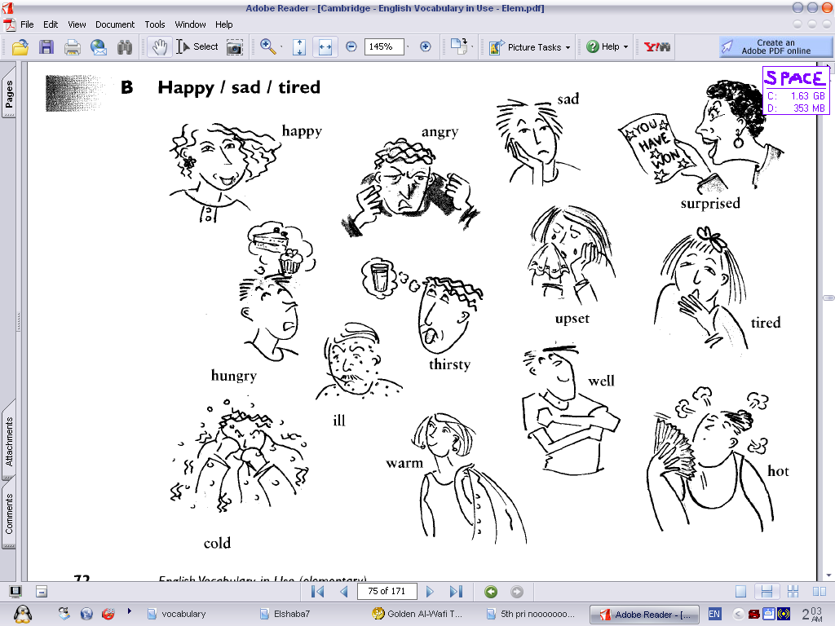
Revision C
New words
uncle | عم | aunt | عمة
cousin | ابن العم أو الخال | woman | سيدة
cafe | مقهى | coffee | قهوة
waiter | نادل (جرسون ) | carry | يحمل

A ) listening
- Listen to the sentences and circle the right picture :
1- A butterfly. 2- A farmer. 3- A zebra.
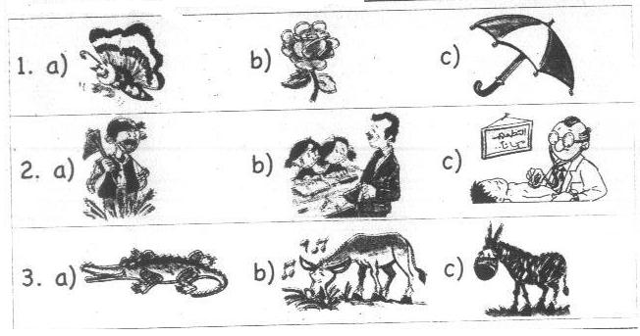
- Listen to the sentences and circle the right picture :
- I go to school at eight o'clock. 2- Cucumbers are healthy.
- I can see a ship.
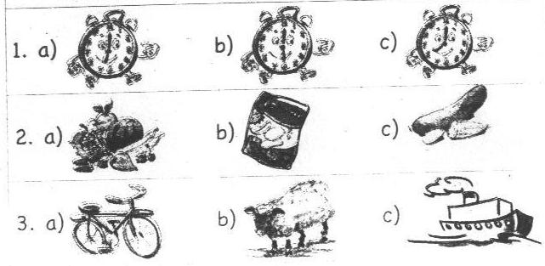

B) Reading Comprehension:
- Read and circle the odd one out :
- doctor – glass – greengrocer – teacher.
- donkey – monkey – bananas – hippo.
- hungry – cheese – rice – cake.
- lunch – breakfast – donkey – dinner.
- packet – car – bottle – plate.
- ball – bus – lorry – ship.
- biscuits – coffee – crisps – sweets.
- July – My – June – April.
- mother – father – farmer – grandfather.
- tea – dinner – breakfast – sandwich.
- water – juice – tea – sandwich,
- uncle – aunt – sister – grandmother.
- eat – have – twelve – watch.
- ship – lunch – plane – lorry.
- cup – tired – thirsty – hungry.
- factory – park – school – doctor.
- glass – city – cup – bottle.
- Match the questions with the answers :
A | B
- What time do you get up?  - Do you like cheese sandwiches?  - What does Hala do at half past six?  - Is this your uncle? | - She watches TV.  - He plays computer games.  - Yes, he is.  - I get up at six o'clock.  - No, I don't. | ( )  ( )  ( )  ( )  ( )
- Where's Dina's bag?  - Is the girl thirsty?  - What's the time, please?  - Who's wearing a light brown jacket? | - No, she isn't.  - Ali is wearing a light brown jacket.  - It's five o'clock.  - She's my mother.  - It's under the table. | ( )  ( )  ( )  ( )  ( )
C)Writing :
- Read and choose the corret answer :
My name's Omar. I live in Port Said. I'm looking at the port. I can see big ships. There are two cranes next to the ships. There are lots of seagulls near the water.
- There are lots of ( animals – cranes – seagulls ) near the water.
- Omar is looking at the ( port – school – fish )
- There are two ( seagulls – cranes – bridges ) next to the ships.
- Omar lives in ( the port – the sea – Port Said)
- The ships aren't ( big – small – short )

- Read and put a ( √ ) or ( X ) :
I'm Sara. I get up at 7 o'clock. I have breakfast at half past seven, I have lunch with my family. We eat healthy food like vegetables, meat and milk. My favourite sport is tennis.
( )
( )
( )
( )
( )
( )

- Sara's favourite sport is basketball.
- Sara's family eat good food.
- Sara has lunch with her friends.
- Sara gets up at seven o'clock.
- Meat is healthy food.
- Sara has breakfast at seven thirty.

- Finish the sentences with words from the list :
[ home – have – breakfast – glass – waiter - has ]
- The boy is drinking a ………………of water.
- We eat …………………..at eight o'clock.
- What time do you go ……………..?
- The …………….…..is carrying a plate of sandwiches.
- The woman ………………got a bunch of grapes.

- Finish the sentences with words from the list :
[ tube – get – homework – café – are – gets ]
- Are there two factories? Yes, there ………………….
- The waiter works in a ………………. .
- The boy has got a ……………….of toothpaste.
- She ……………..up at seven o'clock,
- I do my ……………………at six o'clock.

- Rearrange the words to make meaningful sentences :

- October – before – comes – September.
………………………………………………………………………… .
- hear – can – He – plane – a.
………………………………………………………………………… .
- is – Who – brother – Ali's?
………………………………………………………………………… .
- sandwich – Has – Sahar – a – got?
………………………………………………………………………… .
- dinner – with – I – have – family – my.
………………………………………………………………………… .
- toothpaste – have – I – got – a tube of.
………………………………………………………………………… .

- glass – Here – of – a – water – is.
………………………………………………………………………… .
- the – What – time – is – now?
………………………………………………………………………… .
- eat – o'clock – at – We – breakfast – eight.
………………………………………………………………………… .
- four – There – ships – big – are.
………………………………………………………………………… .
- see – can – He – factories – lots – of.
………………………………………………………………………… .
- Salma – lunch – What – eat – time – does?
………………………………………………………………………… .
- football – Ahmed – at – o'clock – plays – six.
………………………………………………………………………… .
- have – home – We – at – breakfast?
………………………………………………………………………… .
- does – do – Hesham – at six – What – o'clock?
………………………………………………………………………… .
- see – and – can – I – a bridge – a ship.
………………………………………………………………………… .
- up – past – at – gets – seven – Heba – half.
………………………………………………………………………… .
- is – father – Sohila's – Gamal.
………………………………………………………………………… .
- sister – father's – is – Your aunt – your.
………………………………………………………………………… .
- Punctuate the following sentences :
- nehal s birthday is in august
………………………………………………………………………… .
- ahmed is sohila s brother
………………………………………………………………………… .

- Copy the following sentence :
No news is good news.
………………………………………………………………………… .

 | 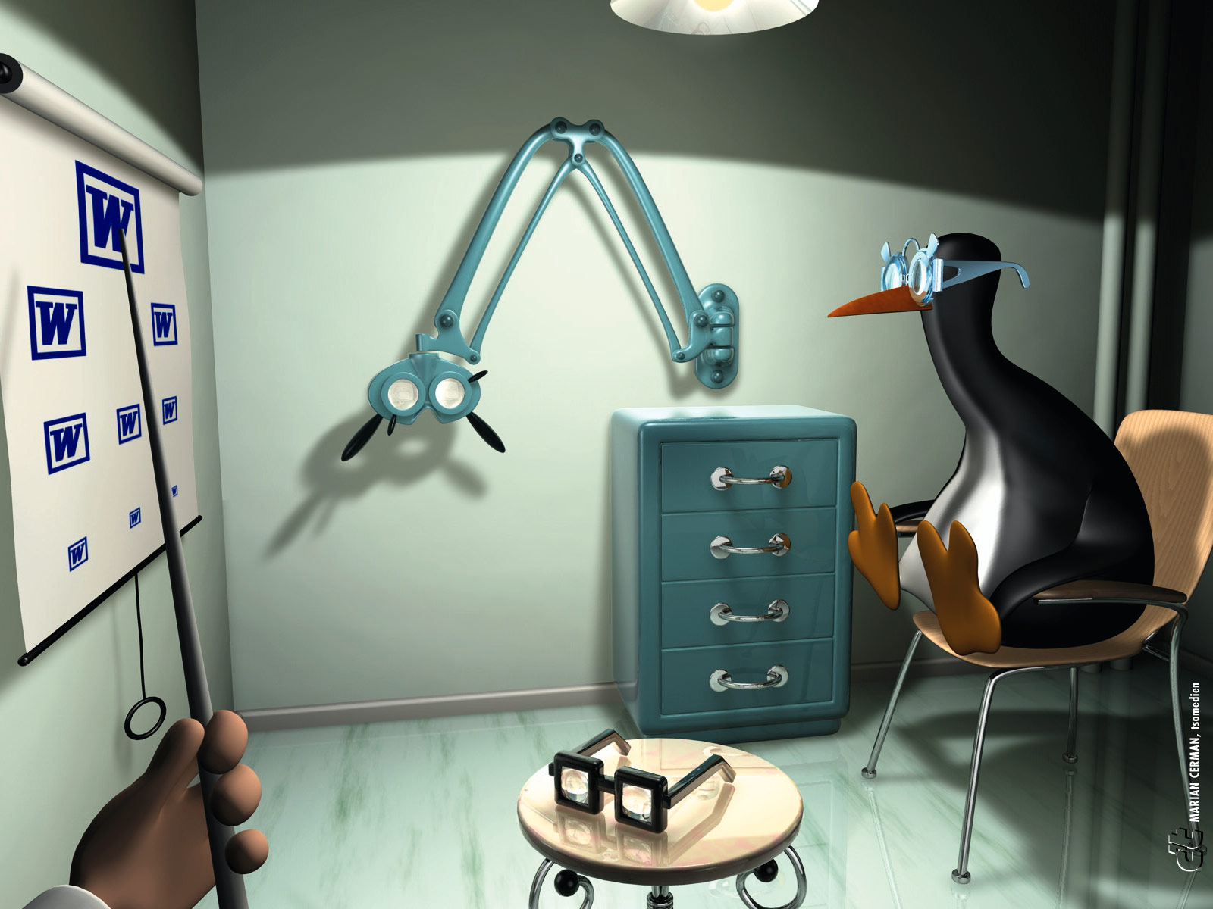 | 

 | اختبارات شهر ديسمبر | 2
A ) listening
- Listen to the words and circle the right picture :
1- A bag. 2 – A tiger. 3- A parrot.
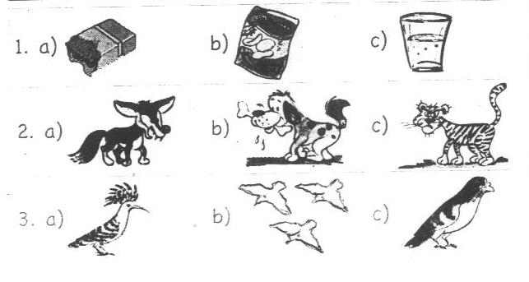

- Listen to the sentences and circle the right picture :
1- This is a bunch of bananas. 2- He is thirsty.
3- I go to bed at ten o'clock.
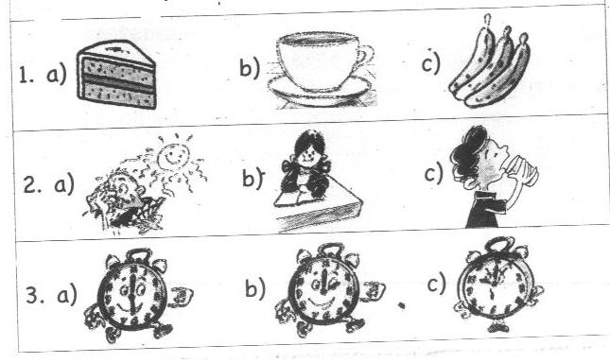
B) Reading Comprehension:
- Read and circle the odd one out :
- plate – port – cup – glass.
- parrot –crane – egret – seagull.
- tired – hot – hungry – food.
- son – never – wife – aunt.

- Match the questions with the answers :
A | B
1-Who has got a cup of tea?  2-Are there lots of seagulls near the water?  3-When do you go to bed?  4-Are they wearing trousers? | - Yes, they are.  - I get up at six o'clock.  - I sleep at nine o'clock.  - Salma.  - No, there aren't. | ( )  ( )  ( )  ( )  ( )
C)Writing :
- Read and put a ( √ ) or ( X ) :
Walaa is a pupil. She is ten years old. She has got two brothers and a sister. Walaa's father is a doctor. Her mother is a teacher. Every week, she visits her grandfather. She is a good girl.
- Walaa isn't a bad girl.
- She has got a brother and two sisters.
- Walaa is a teacher.
- Walaa's father works in a hospital.

- Finish the sentences with words from the list :
[ biscuits – is – have – what - ships ]
- ………………………Alaa hot? Yes, she is.
- Amira can see big ………………… .
- I ………………got a bag of tea.
- She's got a packet of ………………… .
- Rearrange the following words to make meaningful sentences :
- is – a glass – Here – water – of.
………………………………………………………………… .
- fight – We – never.
………………………………………………………………… .
- got – crisps – He's – a bag – of.
………………………………………………………………… .
- breakfast – Sameera – When – have – does?
………………………………………………………………… .

- Punctuate the following sentence :
hosam is rashdy s grandson
………………………………………………………………… .
- Copy the following sentence :
Deeds not words.
………………………………………………………………… .
مراجعة ليلة الامتحان
Activity و يفضل مراجعة أمتحانات كتاب الـــــــــــــــــــ
- Read and circle the odd one out
- play - visit – like – helped.
- blue - clown – purple – pink.
- cake – art – Arabic – maths.
- April – May – Sunday – July.
- ears – eyes – teeth – bus.
- hippo - buffalo – cart – crocodile.
- sheets – food – dress – shirt.
- bicycle - Mahalla – Mansoura – Aswan.
- farm - waiter - worker – manager.
- crane - rabbit – tractor – train.
- light – apple – dark – favourite.
- strawberries – cucumbers – juice – grapes.
- uncle – daughter - present – son.
- bottle - bunch – tube – seagull.
- field – factory – port – birthday.
- parrots – bang – egrets – seagulls.
- science – music – Thursday – Arabic.
- tired – thirty – hot – hungry.
- grass – flowers – three – plant.
- ate – drove – visited – flew.
- play – go – do – has.
- does – watches – eat – sings.
- sandwich – lunch – dinner – breakfast.

- Match the questions with the answers
A | B
- Does Noha like grapes ?  - Where did you go yesterday ?  - What's the opposite of clean ?  - What can you hear ?  - Has a hippo got long legs ?  - What time do you get up?  - Did you see a cow yesterday? | - Dirty . ( )  - No ,it hasn’t . ( )  - At seven o'clock. ( )  - Yes , I did . ( )  - No , she doesn't . ( )  - To a farm . ( )  - I can see abridge. ( )  - I can hear a plane . ( )

A | B
- Who's wearing a blue shirt ?  - How are you , Tarek?  - What did he do at nine ?  - How many month are there ?  - What did you see on the farm?  - What's your favourite food?  - Have elephants got big ears ? | - I saw a cow . ( )  - Twelve . ( )  - English ( )  - rice . ( )  - Yes ,they have. ( )  - Ali's wearing the shirt .( )  - Fine, thank you . ( )  - He watched T V. ( )

- SRead and put a ( √ ) or ( X ) :S
Ahmed is my friend . He lives with his family in Cairo . His brother's name is Hany . Hoda is Ahmed's mother . Sohila is is Ahmed's sister. Mariam is Sohila's friend . Gamal is Ahmed's father.
  - Gamal is Sohila's father . ( )
  - Hoda is Ahmed's sister . ( )
  - Hany is Ahmed's friend . ( )
  - Ahmed has one brother and one sister . ( )
  - Gamal has one son and one daughter . ( )
- Read and put a ( √ ) or ( X ) :
Yesterday , it was Friday . It was Nada's birthday .She turned eleven years old . Six friends came to her house . They ate cakes and played computer games .Then, they watched television. They were very happy. Nada got many presents .
- Nada turned ten . ( )
- five friends came to Nada's house . ( )
- Her friends weren't sad ddd . ( )
- Nada was ten last year . ( )
- Nada didn't get many presents . ( )
- Nada's birthday was on Thursday . ( )
- They ate cake after they watched T V. ( )
- Finish the sentences with words from the list :
[ subject – have – healthy – television – has – sport - did ]

- My favourite ………………… is football.
- Mona ……………… got a long hair.
- Where …………….. you go yesterday ?
- Carrots are ………….…. food.
- In the evening , we watch ……………… .

[ manager - is – between – are – after – before – bad - did ]
- My house is ………….. the cinema and the bank.
- We are not good . We are very ……………. .
- There ………… a pen on the table.
- January comes ……………….. February.
- My father is the ……………….of a cotton factory.
- What ………….. you see ………… the farm ?

[ this - get - His – Her– packet – Let's –Is – morning – gets ]
- When is Mona's birthday ? ……………birthday is in May.
- ……………..play tennis
- Hi, Nadia . ……………..my brother Hesham .
- She's got a ……………….. of biscuits .
- ……………your birthday in July ?
- Mona ……….up ………….seven o'clock in the …………… .

[ neck - can – soft – likes – twelve – sister – brother ]
- There are ……………months in a year .
- What …………..you hear ,Youmna ?
- Soha ……………… volleyball .
- I don't like …………….. drinks .
- The giraffe has got a long …………….. .
- Who is Heba's …………….. ? Ahmed .

- Rearrange the following sentence to make meaningful sentences :
- bird – My – the egret – favourite – is.
- clothes – Shirts – dresses – are – and.
- gets up – late – Lamia – Friday – on.
- the – went – zoo – yesterday – We – to.
- is – Roshdy – friend – Sami's.
- birthday – Dalia's – in – October – is.
- bananas – bunch – a – of – Those –are.
- colours – orange – and – White – are.
- cows – horses – Can – fly – and?
- ears – An – big – has – elephant.
- milk – a – bottle – She's – got – of.
- Egypt – in – is – Aswan.
- bottle – Here's – a – water – of.
- got – hippos – Have – legs – long?

- an – saw – He – yesterday – elephant .
- eleven – It – half – is – past .
- comes – before – September – October.
- very – potatoes – I – much – like – fried .
- playing – football – boys – The – are .
- the months – are – the year – These – of .
- don't – like – I – food – unhealthy .
- Mariam's – What – is – bag – colour ?
- September – School – starts – in .
- you – see – How many – can – dresses ?
- farmer – a – drove – tractor – The .
- song – your – Sing – favourite .
- three – Manar – got – sisters – has.
- works – Nehal - a – school – in .
- factory –in – Cairo – The - is.
- breakfast – When – Sara – does – have ?
- are – lots – There – seagulls – of .
- has – Dina – What – got ?
- are – factories – There – big – two.
- Arabic – likes – He – English – and.
- your – tired – Is – grandfather ?
- sky – flew – A bird – the – in.
- she – soft –Does – drinks – like ?
- tennis –seven – Let’s – o’clock – play – at .
- in – visited – Sharkia – I – uncle – my .
- went – in – to – Alaa – Sharkia – a farm .
- my – cousin – Hala – This –is.
- Punctuate the following sentence
- are tamer and ali brothers
- that is nabil s jacket
- i m salma
- who s menna
- when is sara s birthday
- does neveen like english
- have we got arabic on monday
- reem and nesreen didn t like august
- what did yara see in sharkia
- what can you hear hussam
- no there isn t

 | Model Test | 1

 | Model Test | 2

 | Model Test | 3

 | Model Test | 4

 | Model Test | 5

 | Model Test | 6

 | Model Test | 7

 | Model Test | 8

 | Model Test | 9

 | Model Test | 10

 | Model Test | 11

